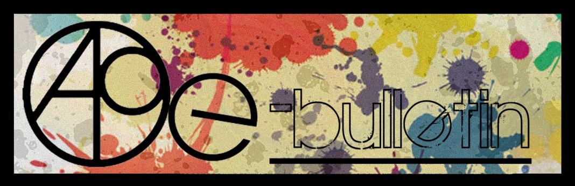

**Kilkenny County Council Arts Office E-bulletin 12th June 2015**

Dear All,   
  
Welcome to the fortnightly e-bulletin from Kilkenny County Council's Arts Office. Each bulletin is packed with the latest information on Kilkenny Arts Office activities, county events as well as news and opportunities for arts practitioners from around the country.

This service will be provided fortnightly. To include an item in the next e-bulletin please send a brief outline of your advert with relevant contact details, including any websites or pages with links to [**niamh.brophy@kilkennycoco.ie**](mailto:niamh.brophy@kilkennycoco.ie) **before 24th June**. The next e-bulletin will be on the **26th June.**

While every effort has been made to ensure the accuracy of our information, we strongly advise readers to verify all details to their own satisfaction.

Regards,

Niamh Brophy  
Arts Office,  
T: 056 7794138  
E: [niamh.brophy@kilkennycoco.ie](mailto:niamh.brophy@kilkennycoco.ie)   
W: [www.kilkennycoco.ie/eng/Services/Arts/](http://www.kilkennycoco.ie/eng/Services/Arts/)

BECOME PART OF IT, SUBMIT A POEM.....[www.rhymerag.net](http://kk-moss/Sites/arts_office/Shared%20Documents/Julianne%20Morgan/E-bulletin/30th%20May%20e-bulletin/www.rhymerag.net)  
Kilkenny County Council Arts Office Partner Local Authority of the ArtLinks Programme [www.artlinks.ie](http://www.artlinks.ie)

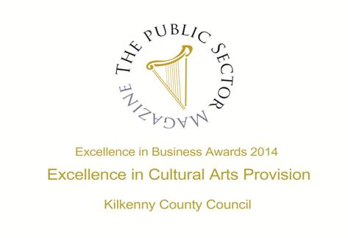

|  |  |
| --- | --- |
|  |  |
|  |  |

**Arts Office**

* Still We Work Touring Exhibition coming to Kilkenny

**Kilkenny Events**

* Laoise O'Brien and Guitarist Michael O'Toole at St. Canice’s Cathedral 14th June
* “The Art of Ability” exhibition by the Irish Wheelchair Association
* Meadow’s Bloom Hedge School
* Ale Mercado’s Illustrating Exhibition ‘Exile’ at Cork Community Printshop
* Starburst Summer Camp
* Cartoon Saloon workshops in Libraries
* Children's Card Making Workshop Saturday 13th June
* [Ciclovia Kilkenny](http://www.krsp.ie/news/ciclovia-2015/) 2015
* On the Bright Side Retrospective Exhibition of Andrew Pike
* Summer Art Courses at Rothe House
* **Young Makers Music Programme with Ossory Youth**
* **Hollow Sounds at Ballykeeffe Amptheatre**
* **Street Fest, Callan**
* **Blackwatch Studio, Kilkenny Seeks Arts and Crafts Workshop Facilitators**
* Carnegie Trust "Test Town" competition
* **At a loss for Words – Workshop**
* Ballykeeffe Amphitheatre Kilmanagh Summer Concert Schedule
* **Kilkenny International Gospel Choir Festival**
* **National Craft Gallery – Appetite for Design**
* New Living City Initiative for Kilkenny
* **Stone Carving Workshop, with James Horan and Aileen Anne Brannigan, Kilkenny**
* Devious Theatre Company: The Union performs this July
* Vultures – A New Radio Series
* **Kilkenny County Council Community and Cultural Facilities Capital Funding**
* Coming Soon to the Watergate Theatre
* KOZO Workshop Programme 2015

**Courses / Training / Jobs / Internships**

* **Dance Theatre of Ireland are currently recruiting for a Marketing & Finance Administrator**
* **Drama League of Ireland 50th Annual Summer School**
* **MA in Socially Engaged Art, NCAD - Deadline for applications extended**
* **Information event on EU supports for youth arts**
* **Designing Exhibitions: Exhibiting Design Seminar at Chester Beatty Library**
* **International Directing Workshop**

**Call for Submissions / Residencies**

* FOUNDATION15 presents QUANTUM LEAP – Call for Submissions
* [Wicklow Arts Office, Call for Artists Proposals, 2016](http://visualartists.ie/jobs-ops/funding-awards/wicklow-arts-office-call-for-artists-proposals-2016/)
* [Trinity Creative Funding Awards: Call for Artists Proposals](http://visualartists.ie/jobs-ops/funding-awards/trinity-creative-funding-awards/)
* [Qualia Dublin’s Art & Culture Magazine Issue 2: IDENTITY | Call for Submissions](http://visualartists.ie/jobs-ops/opportunities-ireland/submission-call-for-qualia-dublins-art-culture-magazine-issue-2-identity-call-for-submissions/)
* [‘There is No Alternative’ | Ormston House & 126 Members’ Call for Submissions](http://visualartists.ie/jobs-ops/opportunities-ireland/there-is-no-alternative-ormston-house-126-members-call-for-submissions/)
* The 101 - Flash Fiction Competition
* 2015 Over The Edge New Writer of The Year competition
* **Claremorris Open Exhibition 2015, Call for Artist Entries**
* **Hospital Arts Festival 2015: Open Call to Artists**
* The Moth Short Story Prize and The Caterpillar Short Story Prize
* The Soloist – Call for Musicians
* **Social Mhuire National School, Barnstown, Wexford, Percent for Art Commission: Call for Artists**

**Awards / Bursaries / Schemes**

* [2015 Valerie Earley Residency Award | Call for Applicants](http://visualartists.ie/vai-news/2015-valerie-earley-residency-award-call-for-applicants/)
* [The Arts Council Project Awards, 2015](http://visualartists.ie/jobs-ops/funding-awards/the-arts-council-project-awards-2015/)
* Bursary Awards next closing date – 5.30pm, Thursday, 16 July 2015
* **Arts Council’s Artist in the Community Scheme – Deadlines 2015**

**Arts Office**

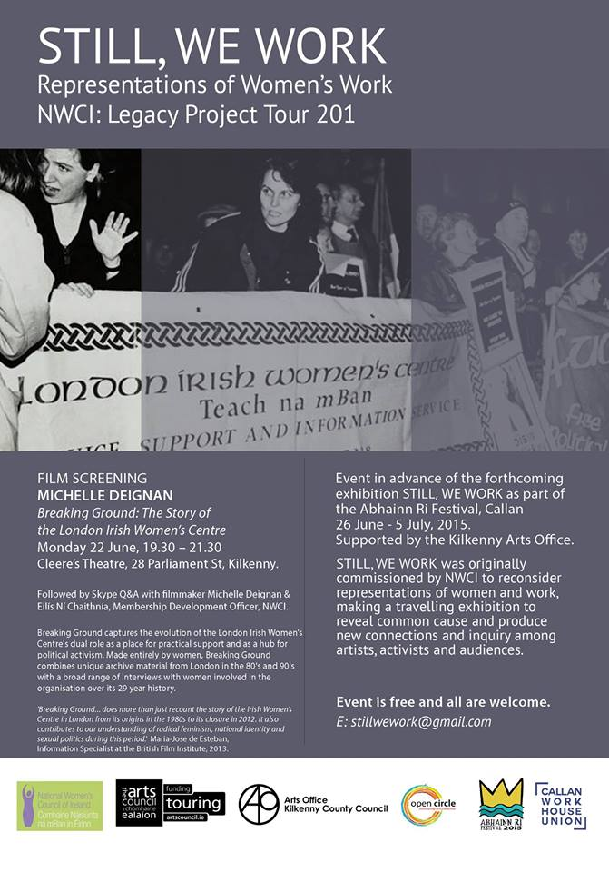

**Kilkenny Events**

**Laoise O'Brien and Guitarist Michael O'Toole at St. Canice’s Cathedral 14th June**

Chapter Room, St. Canice's Cathedral - Sunday 14 June at 4 pm

Recorder player Laoise O'Brien and Guitarist Michael O'Toole will give a recital this Sunday afternoon (14 June) at 4 pm in the Chapter Room of St. Canice's Cathedral.

Tickets: €15.00 (€10 concession) on sale from 3.30 onwards

Refreshments will be served after the recital.

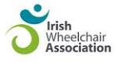

**“The Art of Ability”**

**An Exhibition of Paintings**

**By Artists**

**In The Irish Wheelchair Association**

**Claddagh Court Kilkenny.**

**Venue: Estate Yard,**

**Castlecomer Demesne**

**26th - 30th June 2015**

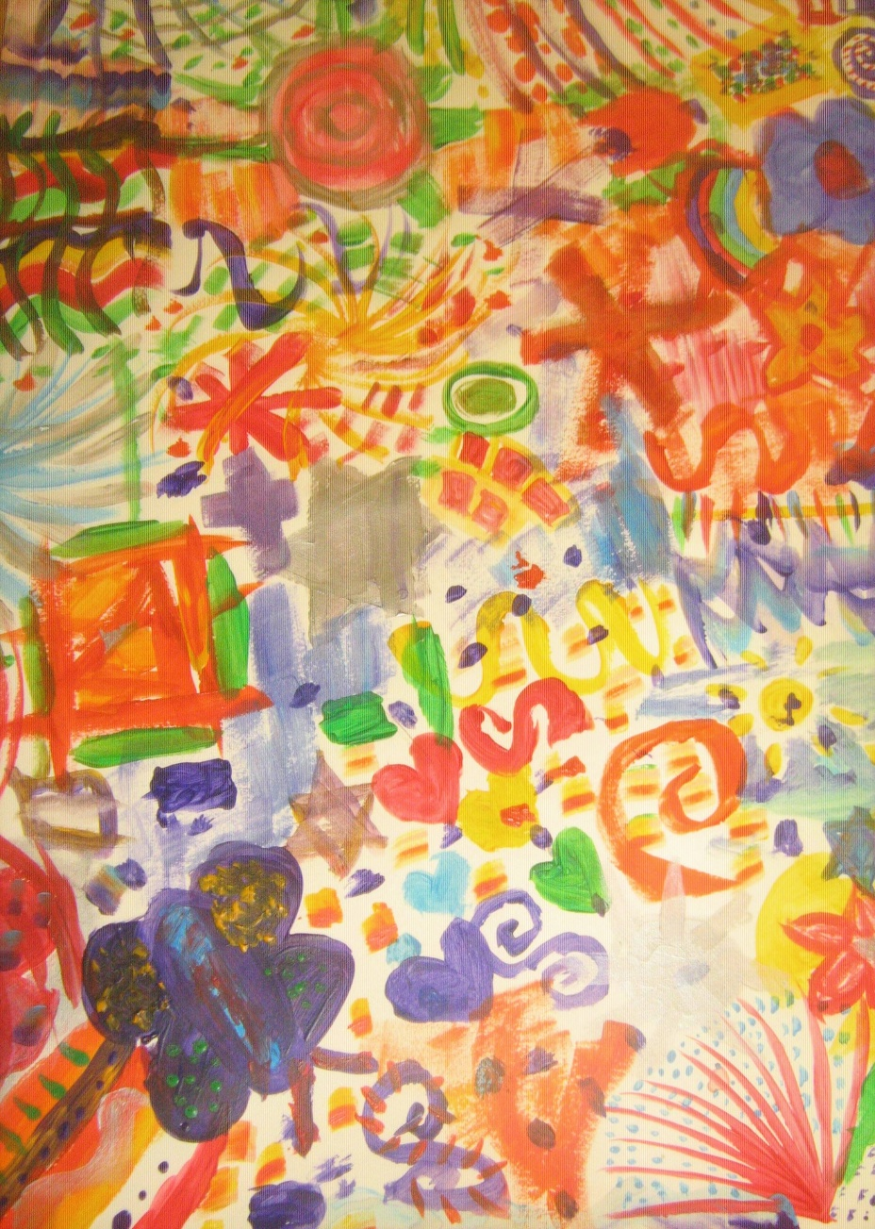

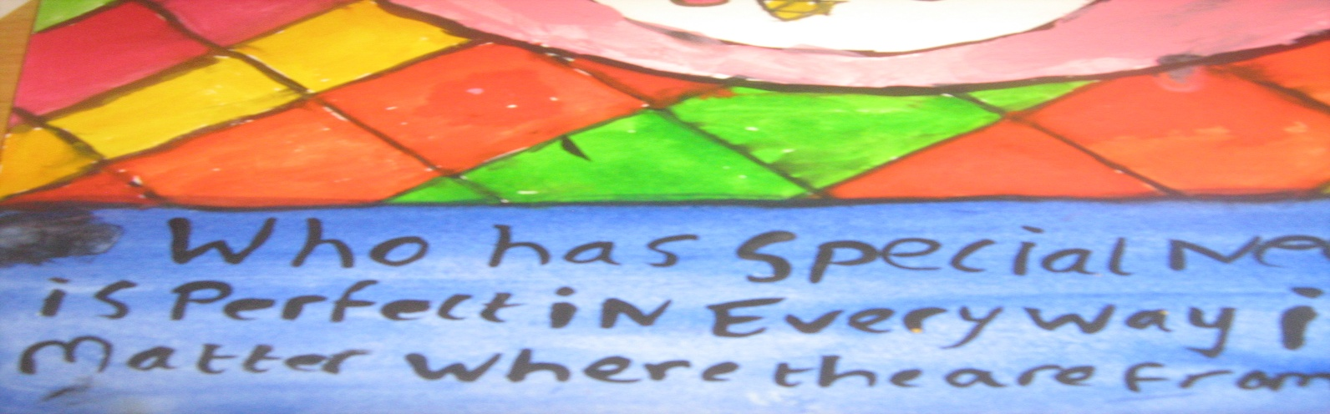

**‘The Art of Ability’**

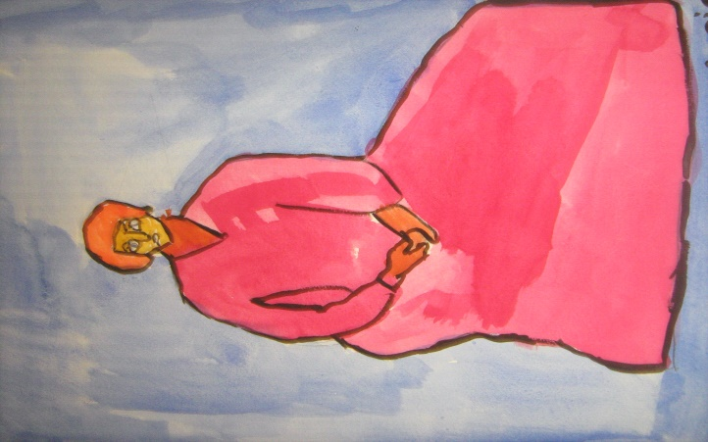‘The Art of Ability’ is an Exhibition of Paintings by Artists in The Irish Wheelchair Association, Claddagh Court Kilkenny.This exhibition highlights the unique creativity of individual ability. And the ability to create, in itself, is an art which is not exclusive, or confined to any one group. The artwork in this exhibition showcases the unlimited expression of creative imagination and motivation.

Hosted within the beautiful surrounds of the Castlecomer Demesne, and with much gratitude to Mr. Errol Delaney, the Exhibition will be open to the public from 26th –

30th June in the Estate Yard Venue. Come and visit this wonderful work.

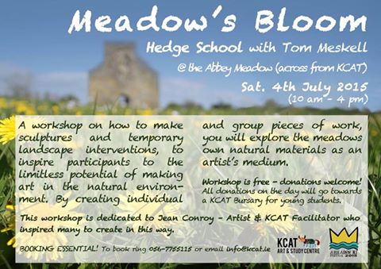

**Ale Mercado’s Illustrating Exhibition ‘Exile’ at Cork Community Printshop**

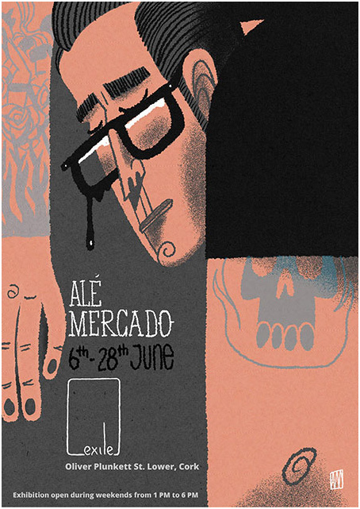

Cork Community Printshop welcomes [Alé Mercado/Atticus/Pitercios](https://www.facebook.com/AleMercadoAtticusPitercios) into ‘Exile’ from 6th – 28th June.

Creating his illustrations from pen and digital work, Alé Mercado has developed a strong personal style. Dark and witty, his work is merged with the screen and woodblock printing processes. For this exhibition, Mr Mercado is presenting his latest pieces inspired by cult films, German expressionist cinema but also the medieval dark ages.   
  
Plus, we are hosting a special event when the artist will present his work on Saturday 13th June. It will be followed by live music, food and drinks. Make sure you don't miss it.   
  
[Exhibition open during weekends from 1 to 6 PM.]

For full event details see: <https://www.facebook.com/events/852520394793913/>

For more info on Ale Mercado see: <http://alemercado.com>

**Starburst Summer Camp**

Dates:6th, 7th & 8th July  
Times:10am-1pm daily  
Art, Drama, Music and Games  
Suitable for children aged 4-11yrs  
Price: €50 per child (sibling discount applies)  
Location: St. Patrick's Parish Centre, Loughboy, Kilkenny.

<https://www.facebook.com/events/1591803234441320/>

**Cartoon Saloon workshops in Libraries**

Kilkenny Libraries are delighted to partner with Oscar Nominated Cartoon Saloon to offer **FREE** Animation workshops this summer.

**Open to adults and children.**

There may be **limited availability** in the following libraries:  
Ring for information on availability:

Castlecomer: Tuesday 16th June. 056/4440561  
Ferrybank: Friday 19th June 051/897200  
Graignamanagh: Tuesday 23rd June 056/7794178  
Loughboy: Tuesday 30th June 056/7794176  
Thomastown: Tuesday 7th July 056/7794331  
John's Quay: Thurs 16th July 056/7794174

**Children's Card Making Workshop Saturday 13th June**

Retail Centre, James Street, Kilkenny 2pm to 5pm

Children are making 4 cards. Cost €10 for first child and €5 for each child in same family  
Names to Phil at (087) 9101769.  
Places will be limited so book early

Ciclovia log as tiff

**Sunday June 14th &  Sunday June 21st**

**2 to 4pm, High Street Kilkenny**

Ciclovia is returning to Kilkenny! Kilkenny is leading the way with the only temporary park! A strictly no car zone filled with corridors of fun such as:

* *Free children’s entertainment*
* *street basketball and samba soccer*
* *martial arts display and taster sessions*
* *bling your bike for children*
* *a balance bike challenge for 2-7 year olds*
* *mountain bike demonstrations with ramps and jumps*
* *local music and entertainment*
* *spinning demonstration*
* *inline skating*
* *hand cycling, plus lots more!*
* *So come in and join the fun……*

Please note: To facilitate this, High Street will be closed to all motorised traffic from 1 to 5pm on both Sundays.

**On the Bright Side Retrospective Exhibition of Andrew Pike**

KCAT Art & Study Centre

Callan

Sat 27 June - Sun 5 July, 12 – 5 daily

Andrew Pike has been a KCAT studio artist since its founding in 1999. This retrospective exhibition presents an extensive and broad selection of his work made during that period, including sketches for the 2006 Big River parade, self portraits, animations and commissions and highlighting his ongoing dedication to the artistic process. On the Bright Side is part of Abhainn Rí Festival 2015 programme.

KCAT Art & Study Centre

Mill Lane

Callan

Co. Kilkenny

056-7755115

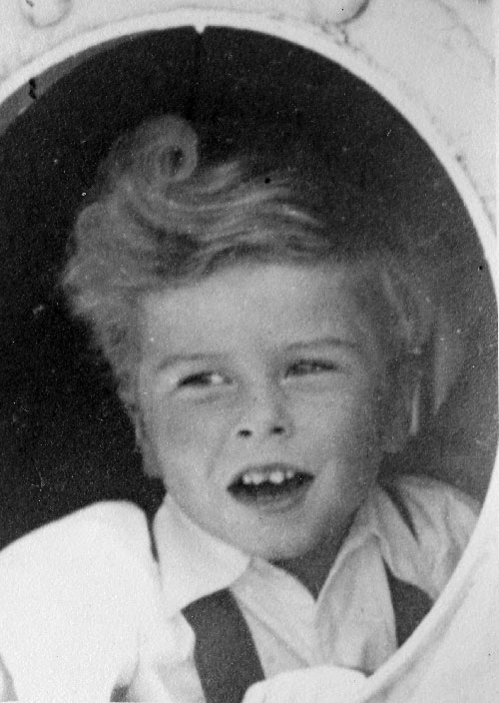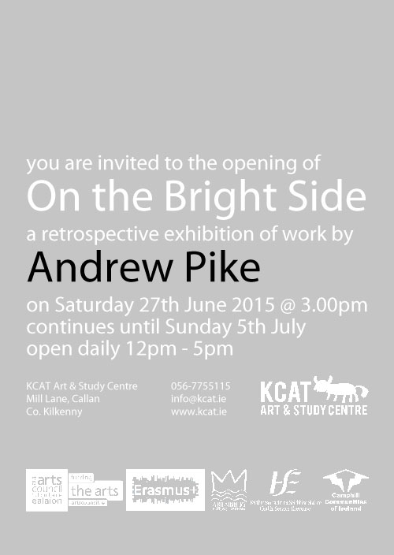

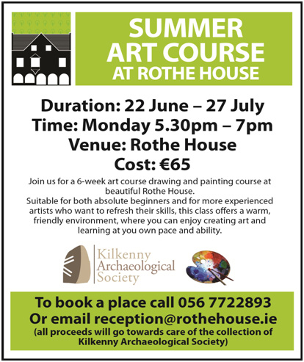

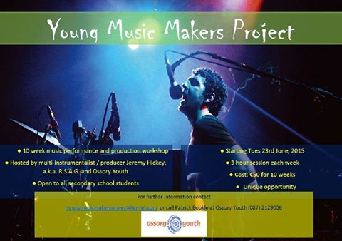

Hi Young musicians of Kilkenny - The Ossory Youth Young Music Makers Project starts Tuesday 23rd June and will run for 10 weeks for 3 hours each week. This is a...n amazing opportunity to work on performance and production with one of Ireland's best musicians; i.e. [RSAG](https://www.facebook.com/RarelySeenAboveGround). Cost for entire project is €50. Contact Pat on 0872129006 or [Mick Greene](https://www.facebook.com/mickgreene) on 085-1668149 for more information.

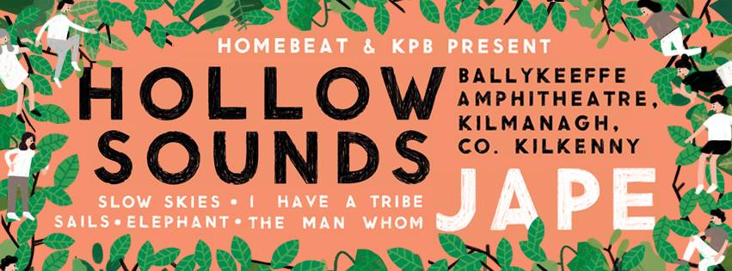

HOLLOW SOUNDS  
July 03rd & 4th 2015 / Ballykeeffe Amphitheatre, Co. Kilkenny.   
  
Independent promoters KPB & Homebeat are delighted to announce Hollow Sounds - a new two day event of film, music, food and fun set in the stunning Ballykeeffe Amphitheatre, Co. Kilkenny.  
  
Ballykeeffe is a wonder of the Irish countryside, a majestic sweeping stage set amongst the amphitheatre nestled in a beautiful old quarry just a few kilometres outside Kilkenny City.   
  
Hollow Sounds brings a fantastic line up of cutting edge Irish music & classic cinema to this incredible setting at the height of summer on July 3rd & 4th.   
  
On Friday, July 03, Happenings making their Kilkenny debut and will screen the classic ‘Goonies’. An evening... for one and all to enjoy in the magical surrounds of Ballykeeffe.   
  
-------------------------------------------------------------------------------  
  
LINE UP:  
  
FRI JULY 3rd | 8pm - 23.00   
  
Happenings Outdoor Screening of ‘The Goonies’. 9.00 pm (€5)   
  
SAT JULY 4th | 13.00 - 23.00   
  
Jape I Slow Skies I Elephant | The Man Whom | Sails | I Have A Tribe |   
  
AFTER PARTY w Jape (DJ SET) / Taste DJs & more in The Set Theatre from 23.00  
  
STAYING:   
  
This is a non camping event - Hollow Sounds patrons will be able to avail of associated accommodation deals in Kilkenny City & surrounds.   
  
GETTING TO / FROM :   
  
Parking is available at Ballykeeffe.   
  
Busses will run from Kilkenny City from 7.30 pm Friday July 3rd (Returning after the movie) & from 13.00 - 15.00 on Sat July 4th (returning from 23.00 after Jape).   
  
  
TICKETS :  
  
Website : www.eventbrite..   
  
Happenings present : ‘The Goonies’. €5 (€10 w return bus from / to Kilkenny)   
  
Hollow Sounds Saturday day pass :   
  
Early birds : €30   
  
Regular : €38.50  
  
Regular + Return bus from Kilkenny : €45

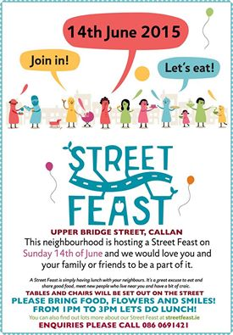

**Blackwatch Studio, Kilkenny Seeks Arts and Crafts Workshop Facilitators**

Blackwatch Studio, just 7 km from the Kilkenny city in the rural north, is seeking arts and crafts facilitators to deliver workshops.  
For further information contact Vicki:  
T:086 837 0205  
E: [blackwatchstudiokk@gmail.com](mailto:blackwatchstudiokk@gmail.com)

**Carnegie Trust "Test Town" competition**

This competition organised by the Carnegie Trust is open to Ireland as well as UK and is seeking ideas from innovative people to hold local activities that support start-ups in ways that are appropriate and effective for each community. They will provide 10 towns with funding of up to £3,000 each to run a skills development activity for entrepreneurs that uses the town centre. Closing date is 15th June.

<http://www.testtown.org.uk/testtown-2015/>

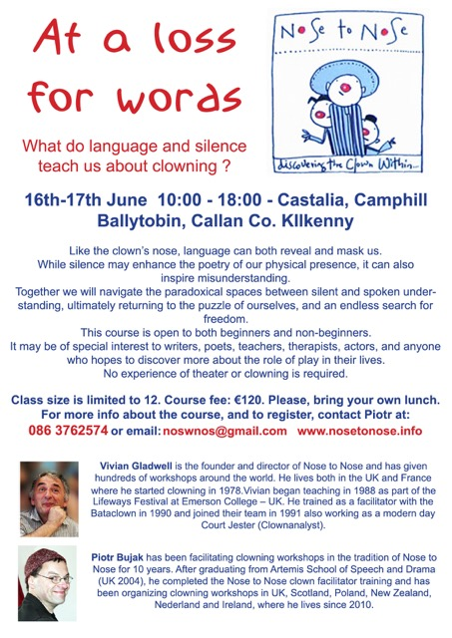

**Ballykeeffe Amphitheatre Kilmanagh Summer Concert Schedule**   
  
**Nathan Carter** June 12th   
**Goldilocks and the Three Bears (children's theatre show)** June 28th  
**Sharon Shannon** ,July 25th  
**Jane Eyre** by Chapterhouse Outdoor Theatre July 31st  
**Damien Dempsey** Aug 8th.  
  
More acts to be added.  
Tickets for Nathan Carter are now on sale at Ticketmaster ,Kilkenny Book Centre, Rollercoaster records and locally.  
@ 25 euro  
  
Events contact is Matt O'Sullivan - 087 6261134

**[Kilkenny International Gospel Choir Festival](http://kilkennygospelchoirfestival.com/" \o "Kilkenny International Gospel Choir Festival)**

[19-21 June 2015](http://kilkennygospelchoirfestival.com/" \o "Kilkenny International Gospel Choir Festival)

Programme 2015

**Friday, June 19th (Ormonde Hotel)**

10 – 12 am  Workshop for Primary School Children, Mr. Marcanthony Henry, Director/Musician/Singer from New York City

5.00 pm      Official Opening of the Festival performed by Mayor Andrew McGuinness in Kilkenny City Hall.   Complimentary light refreshments will be available.

8 – 9 pm       Introductory workshop with Mr. Marcanthony Henry.

**Saturday, June 20th (Ormonde Hotel)**

09.30 am  Morning Praise – Rev William Purcell, Musical Director, Kilkenny Gospel Choir

10.00 am  Workshop 1 – Mr. Marcanthony Henry

11.00 am  Tea/Coffee

11.30 am  Workshop 2 – Mr. Marcanthony Henry

12.30 pm  Lunch

02.00 pm  Workshop 3 – Mr. Marcanthony Henry

03.30 pm  Tea/Coffee

04.30 pm Concert Rehearsal

05.30 pm  Break

08.00 pm Celebration Concert in the  Black Abbey

**Sunday, June 21st (St. Mary’s Cathedral)**

11.00 am  Worship – Special Festival Mass

03.00 pm  Gospel Singing/Walking Tour of Kilkenny’s Medival City

Costs: $40.00 (€35.00) per person for weekend.

Children €5.00

All food and accommodation will be extra.  There will be a discounted menu available to participants during the workshops in the Ormonde Hotel.



[**APPETITE FOR DESIGN**](http://www.nationalcraftgallery.ie/exhibitions)

**8 MAY 2015 – 30 JUNE 2015**

[Appetite for Design](http://www.nationalcraftgallery.ie/exhibitions) features the work of leading Irish and international designers, cooks and restaurateurs, documenting, discussing and speculating about the design of food and our experience of it.   Food is no longer merely about the simple act of eating, and the pure experience of smell and taste. New trends and materials have led to unique opportunities for the designers of today to enhance and elevate one's culinary experience by speaking to our minds as well as our stomachs. Engaging all our senses in a holistic culinary experience.

[Appetite for Design](http://www.nationalcraftgallery.ie/exhibitions) showcases examples of the aesthetics, promotion, communication and representation of food, along with the equipment and tools used to prepare and consume food. Featured work includes Bompas & Parr, Marije Vogelzang, Omer Polek, The Decorators, Chapter One and Loam.

A series of culinary evenings and performances to accompany the exhibition will hosted by [Godless Domestic](http://www.thedomesticgodless.com/), [Dublin Pop-up,](https://www.facebook.com/dublinpopup) [Culinary Counter](https://www.facebook.com/theculinarycounter) and Barry Fitzgerald.

The exhibition is curated by [Designgoat](http://wearedesigngoat.com/) and explores the very best of Food Design and builds on the increasing global recognition of outstanding Irish produce from coast to coast, and seabed to soil.

**APPETITE FOR DESIGN Eating Experiences**

[Eating Experience Programme](http://www.nationalcraftgallery.ie/news/article/eating-experience-programme)

As part of Appetite for Design exhibition curators, Designgoat, invite chefs, food designers and artists to create a series of Eating Experiences, presented in the National Craft Gallery. Each individual Eating Experience will be a totally different culinary encounter; showcasing seasonal, wonderful and bizarre foods.

[Eating Experience 4 with Dublin Pop-Up](http://www.nationalcraftgallery.ie/news/article/eating-experience-programme) - Sat 20  June, 6.30pm.

Cúán Greene and Harry Colley of Dublin Pop Up offer innovative and extraordinary fine dining catering experiences, which play with traditional dining formats through dramatic food and unique locations.

**Booking for the Eating Experience series is through** [**eventbrite.com**](http://www.eventbrite.com/e/appetite-for-design-eating-experience-1-tickets-16675895051?aff=es2)**, which will be open from Monday 27th April. Limited places available. Unfortunately, special dietary requirements cannot be accommodated.**

Families are invited to investigate, explore and discover new ways of seeing with our fun range of experimental drawing workshops and activities inspired by our current exhibition [Appetite for Design.](http://www.nationalcraftgallery.ie/) Take part in one of our free craft and design-based workshops, **Yummy Prints**, **Giant Fibre Portraits** and **The Drawing Banquet** with plenty more self guided activities for all ages to enjoy.

**YUMMY PRINTS** *with textile print-maker Caroline Ryan*

Inspired by our exhibition Appetite for Design textile print-maker Caroline Ryan of [PRINTBLOCK](http://printblock.ie/) Collective will explore all things foodie through silk-screen printing. Explore line, colour, design and cook up a colourful textile print on the day to take home. Suitable for all the family

**GIANT FIBRE PORTRAITS** *with textile artist Caroline Schofield*

Transform the Castle Yard into a magical large-scale drawing with Caroline Schofield using the grass as a giant canvas. Strike a pose on the grass while the shape of your body is mapped using brightly colored yarns. Watch the map grow bigger and brighter through out the day. How about a unique family fiber portrait!

**DRAWING BANQUET** *with artist Mella Cahill*

Let the tablecloth be your canvas and the food your drawing tools at this dinner party like no other. Artist Mella Cahill will lead this imaginative drawing workshop inspired by the dinner table, suitable for all the family.

**All Drop –in, Ideal family activities. No booking required**

<http://www.nationalcraftgallery.ie/news/article/national-drawing-day>

[**Family Day: Mad Hatter’s Tea Party**](http://www.nationalcraftgallery.ie/exhibitions)

Sat 13 June 10.30am & 12noon

Children are invited to a Mad Hatter’s tea party were creativity and food will collide to create a magical eating experience.

[**Late Date: Public Spaces & Food**](http://www.nationalcraftgallery.ie/exhibitions)

Thurs 25 June, 6.30pm

Suzanne O’Connell of [The Decorators](http://the-decorators.net/About) and John Mahon of [The Locals](http://www.thelocals.ie/about), talk eating spaces.

[**Schools**](http://www.nationalcraftgallery.ie/learn/schools)

Tuesday – Friday, 10am & 12noon

Food Design focused tour and activities for Primary School students.

**WEEKENDS: DISCOVER & DESIGN**

Visitors of all ages can design, draw, build, and create with self-guided activities at the weekend. Drop in and get creative.

**Eating Experience tickets are available through eventbrite.com**

**To book our other events please contact us at 056 7796151 or email** [**events@nationalcraftgallery.ie**](http://kk-moss/Sites/arts_office/Shared%20Documents/Internal/Niamh/2015%20projects/E-bulletin/Downloads/events@nationalcraftgallery.ie)

**[nationalcraftgallery.ie](http://www.nationalcraftgallery.ie)**

[**facebook.com/NationalCraftGallery**](https://www.facebook.com/NationalCraftGallery)

[twitter.com/NCGKilkenny](http://kk-moss/Sites/arts_office/Shared%20Documents/Internal/Niamh/2015%20projects/E-bulletin/Downloads/twitter.com/NCGKilkenny)

**New Living City Initiative for Kilkenny**

The Living City initiative focuses on the regeneration of retail and commercial districts and encouraging people to live in the historic centres of Cork, Dublin, Galway, Kilkenny, Limerick and Waterford. The aim of the Living City initiative is to bring life back into the heart of the relevant cities by offering tax relief for qualifying expenditure incurred on the refurbishment or conversion of certain buildings where conditions are met. For further information see <http://www.kilkennycoco.ie/eng/Services/Planning/The-Living-City-Initiative/Living-City-Initiative.html>

**Stone Carving Workshop, with James Horan and Aileen Anne Brannigan, Kilkenny**

Beginners course in letter carving or sculpting in stone  
13th & 14th June 10am – 4.30pm both days  
Cost €150

Venue: Mill Lane, Callan, Co Kilkenny

Tools and stone provided. Each student should bring home a finished piece, basic stone carving skills and good memories.

Tea and coffee provided but please bring a lunch!  
Design and carve your own sculpture/plaque/ sign

Further information:  
T:  0861676219  
E: [jameshsculpture@hotmail.com](mailto:jameshsculpture@hotmail.com)

|  |  |
| --- | --- |
| |  | | --- | | Devious Theatre Company: The Union performs this July | |

|  |  |
| --- | --- |
| |  | | --- | | [War Of Attrition at Project Arts Centre, Dublin](http://devioustheatre.us1.list-manage1.com/track/click?u=81e2bda1e5d5f4cf50d626fc9&id=2d603dff77&e=506f5f26a9) | |

|  |  |
| --- | --- |
| |  | | --- | | Adrian Kavanagh’s first play for us has been in the works for a while now and we’re looking forward to debuting the show in Kilkenny from July 29th to August 1st in Cleere’s Theatre.  The Union is a furiously funny dramatic retelling of the rise and fall of St. Dominic’s Student Union. The play takes place in the final days of the current student union regime in a failing regional college. Five erstwhile colleagues are locked in one room knowing that one of them stole the €10,060 fundraised cash that their reputations, hopes, dreams, careers and election campaigns are hinged on. Backs will be stabbed, hearts will be broke and throats will be cut.  The clock is ticking. We’re going to see how united this Union really is.  [https://gallery.mailchimp.com/81e2bda1e5d5f4cf50d626fc9/images/ecd90fe5-76de-41f3-9802-64513dc42a1d.jpg](http://devioustheatre.us1.list-manage2.com/track/click?u=81e2bda1e5d5f4cf50d626fc9&id=a28c77e273&e=506f5f26a9)  Alexandra Christle, Hazel Doyle, Kevin Mooney, Niall Morrissey and Colin O'Brien will take to the stage with John Morton directing Adrian Kavanagh's script. [Find out more details here](http://devioustheatre.us1.list-manage.com/track/click?u=81e2bda1e5d5f4cf50d626fc9&id=bb802837a4&e=506f5f26a9).  The show will preview in The Duiske Inn, Graiguenamanagh on July 24th and 25th. We're very excited to be making our debut trip to the beautiful village of Graig, hometown of the show's writer Adrian Kavanagh. | |

**Vultures – A New Radio Series**

The new radio serial from Devious Theatre has gone online in its entirety. *Vultures* is a 20 part murder mystery serial originally broadcast on KCLR96FM last month.

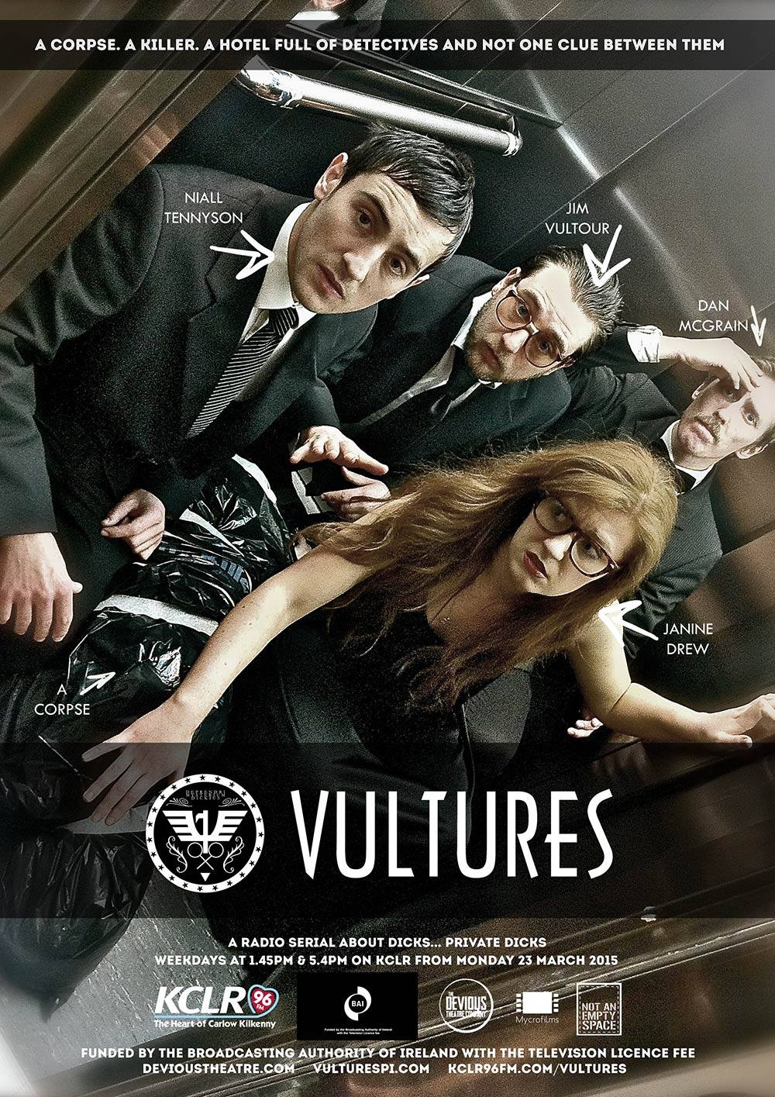

*Vultures* focuses on the private detectives of Vulture Private Investigations, a small time detective agency in south east Ireland. **Janine Drew, Dan McGrain, Jim Vultour** and **Niall Tennyson** are the detectives in question and the story follows them as they get caught up in a suspenseful murder mystery at the Detective Union Of Ireland AGM. The show follows the varying perspectives of the four bungling sleuths as they trawl the corridors of Wisteria Lodge, searching for a killer, quizzing a colourful cast of suspects and trying to figure out who killed Ireland’s most famous detective Basil Maguire? And why?

The cast for the series are **Stephen Colfer, Ross Costigan, John Doran, Amy Dunne, Seán Hackett, Ken McGuire, John Morton, Niamh Moyles, Suzanne O’Brien** and **David Thompson**. It is written and directed by John Morton, produced and engineered by Ken McGuire with **Alan Slattery** as associate producer and an original score from **David Sheenan**.

The first run of *Vultures* was a web series produced by **Mycrofilms** from 2007 – 2012 and was created and produced by **Paddy Dunne, John Morton** and **Alan Slattery.** You can listen to the entire series on **devioustheatre.com/past-shows/vultures-2015**

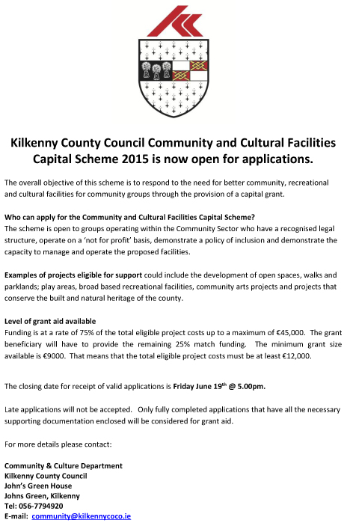

## Coming Soon to the Watergate Theatre

Here’s a look at some of the shows, gigs and other events taking place here at the Watergate Theatre in the next few weeks. You can speak to our helpful box office staff at any time by phoning [056 7761674](tel:+353567761674).

### [Jesters Stage Academy presents Movie Mayhem](http://watergatetheatre.com/programme/jesters-stage-academy-presents-movie-mayhem/) (11/06/2015)

An evening of movie blockbusters with Jesters.

[**Book Online**](http://watergatetheatre.com/programme/jesters-stage-academy-presents-movie-mayhem/)

### [Dancewise Academy presents Movie Magic](http://watergatetheatre.com/programme/dancewise-academy-presents-movie-magic/) (25/06/2015)

A night of dance from your favourite movies and musicals..

[**Book Online**](http://watergatetheatre.com/programme/dancewise-academy-presents-movie-magic/)

### [Moll](http://watergatetheatre.com/programme/moll/) (02/07/2015)

Performing 2-4 and 9-11 July.

<http://watergatetheatre.com/>

**KOZO Studio WORKSHOP Programme  
for adults (incl. young people from 16 years)**

**MAY - JULY 2015**

**PRESS RELEASE** For immediate release (May 2015)

The **WORKSHOP PROGRAMME** at KOZO Studio continues – designed and facilitated for small groups of participants at KOZO Studio in The Estate Yard, Castlecomer Discovery Park, Co. Kilkenny.

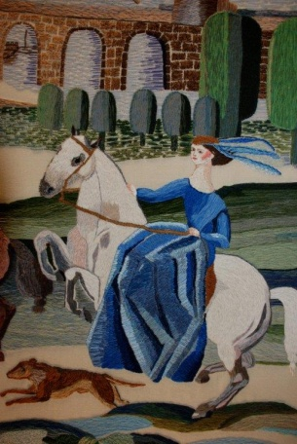**!! NEW !!** courses added:

**EMBROIDERY WORKSHOPS**

with ***ALEXIS BERNSTORFF*, artistic director of the ROS TAPESTRY**

**20 JUNE (Saturday) 10.30am - 5pm**

*Beginners and Participants with Previous Experience ++*

This workshop will teach 6 principal stitches and their variations - using wool, cotton/silk and metallic threads. Participants will be inspired by a range of techniques to realise various designs. Alexis has 15 years experience teaching crewelwork embroidery and is the guide behind the dynamics of the Ros Tapestry.

€ 70 for the full day - including all materials

*++ This workshop is tailored to the interests and experience level of those taking part*

**********  
**14 June (Sunday)**  
**11am - 5.30pm BATIK Workshop** - ***Beginners***A full day programme introducing an ancient technique of fabric dyeing where hot wax is used as a resist.  
Participants will learn all necessary basic techniques - and complete three small/medium batik pieces with up to 4 colours on cotton fabric and/or paper.  
€ 70 for the full day, including all materials

**********

**12 July (Sunday): PAPER MAKING DAY**- ***Beginners*  
10.30am - 1.30pm HAND PAPER MAKING**

**2.30 - 5.30pm SILK FIBRE PAPERMAKING**

COURSE DETAILS as ABOVE (Please see Paper Making Day on 7th June)

**GIFT VOUCHERS are available for the workshop of your choice!**

BOOKINGS are confirmed with € 30 deposit paid in advance.*  
Courses are run for small groups of participants only so please call to book early.  
**With any questions, for advice or check availability and for all BOOKINGS please contact TUNDE directly:**  
  
**Tunde Toth –** Artist, Arts Educator **087-2543362  
E:** [tundetune@gmail.com](mailto:tundetune@gmail.com)[www.tundetoth.com](http://www.tundetoth.com)

[www.tundetothpaperart.blogspot.com](http://www.tundetothpaperart.blogspot.com)

[www.kozostudio.wordpress.com](http://www.kozostudio.wordpress.com)

* DEPOSITs are returned if the Studio has to cancel a workshop. Cancellations from participants will be accepted up to 2 weeks before the course date and deposits will be returned. In other cases participants may be offered rescheduled dates/options.

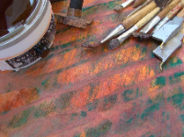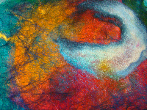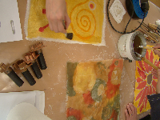

* **BATIK Workshop** on Sunday **14th of June** at KOZO Studio!
* An example of a beautifully made **SILK FIBRE PAPER piece** - created at one of our previous workshops - by one of the many talented and enthusiastic participants!

**Courses / Training / Jobs / Internships**

**Dance Theatre of Ireland are currently recruiting for a Marketing & Finance Administrator**

This multifaceted role includes marketing, social media, accounts management, development and public contact.  
  
Dance Theatre of Ireland is a professional contemporary dance theatre production company based in a purpose built Centre for Dance in Dún Laoghaire, with extensive educational and community Outreach programs in dance, working locally, nationally and internationally.  
  
This is a multifaceted, full-time position that supports all aspects of the Company’s work, including the Centre for Dance's programme of classes, Educational Outreach, Productions and Touring. Experience in Marketing, and Social Media, PR, Payroll & Book keeping; fluency in Excel, Word, Publisher and Mail Chimp necessary. Digital Photo & Video editing is a plus as is knowledge of Quickbooks.  Excellent keyboard and numeracy skills are essential.  
  
Responsibilities include creating and delivering e-marketing and social media campaigns, database management, website updates, and creating in-house flyers, as well as PR / media contact to promote the activities of the Company.  Financial responsibilities include book keeping, bank reconciliations, budgeting, day-to-day accounts, and production research. Minimum 3-5 years experience.  
  
This is an ideal role for a person who likes multi-tasking, helping people, has a visual, as well as technical flair and a passion for dance.  
  
Please send Application Letter and CV to  
The Artistic Directors  
E: [recruitdanceire@iol.ie](mailto:recruitdanceire@iol.ie)  
W: [www.dancetheatreireland.com](http://dancetheatreireland.us2.list-manage.com/track/click?u=7d83175b6ac780a428173c290&id=beab0f8395&e=cabb2dfbd5)  
T: 0872231455

**Closing Date: 26 June, 2015**

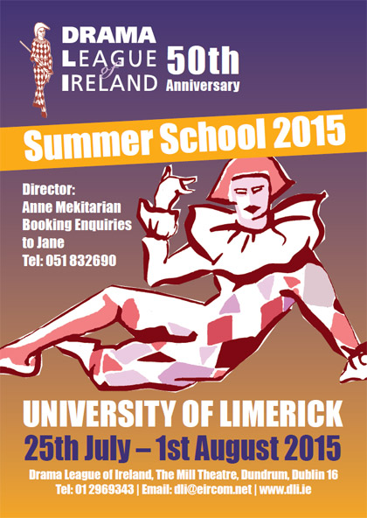

We are so excited about our 2015 50th DLI Summer School!  Read all about the courses on offer on the [**DLI Summer School page**](http://www.dli.ie/summerschool.htm) and [**check out our online brochure**](http://www.dli.ie/downloads/DLI%20SS%20brochure%202015.pdf).

**Here’s a message from Anne with the latest update!**

Hi everyone!  Nearly there now!  Just a few places left on each of the following courses:

**Course F:  The Articulate Body: An Introduction to Physical Theatre    
Tutor:  Sue Mythen**  
Sue’s group achieves the most amazing work, all under her gentle and supportive guidance.  This will be a lively, dynamic and quite thrilling experience.  Not to be MISSED!

**Course H:  Walking the Tightrope                             
Tutor:   Louise Lowe**  
One of the most highly regarded alternative practitioners, Louise’s courses are action-packed, stimulating roller-coaster rides. If you are up for a challenge – THIS is the one for you!

**Course A:  Stepping Out: Introduction to Acting  
Tutor:   David Horan**  
Hugely popular with all of his students, David is lively, personable, VERY knowledgeable and has an excellent sense of fun!  Ideal for Beginners/Improvers - you’ll LOVE him!

**Course C:  Serious Fun . . . .  
Tutor:   Chrissie Poulter**  
DLI Summer School is never the same without Chrissie – her serene (and impish!) presence is decidedly therapeutic.  We are THRILLED that she is with us to celebrate our 50th! A few places remaining . . .

**Course E:  Meeting Ourselves Meeting the Text   
Tutor:   Andy Crook**  
Highly and warmly regarded by all of his students, Andy makes a very welcome return to us for our special anniversary year. Make no mistake: his will be a GREAT course!  Just a few places left  . . .

Now is the time to reserve your place.  Make a choice; send me an application form and deposit:  and you’re IN!   Do it today! Don’t miss the great DLI Annual Experience at UL - plus the extras Jane and I have planned for this year’s celebrations.  What plans?  You’ll just have to come and see!

**MA in Socially Engaged Art, NCAD - Deadline for applications extended**

Applications are now being sought for the MA Socially Engaged Art (Further, Adult and Community Education). The MA SEA focuses on the dynamic relationship between socially

 engaged arts practice and pedagogy, particularly within further education, non-formal educational and community settings, with an embedded qualification to teach in the FE sector.

Recognising the range of methodologies used in socially engaged art that draw on educational concepts and forms, the MA SEA is a site for experimental learning and critical debate

 in socially engaged art and education practice. The course is coordinated by artist Fiona Whelan and Nuala Hunt - Head of Continuing Education in NCAD. Other staff include: artists

 Chris Maguire, Glenn Loughran, Ailbhe Murphy.

Marie Barrett as well as adult educator Anne Gallagher and community worker John Bissett.

The MA SEA will attract students from a range of disciplines who want to immerse themselves in a trans-disciplinary enquiry. Applicants should have a Level 8 (BA Hons) degree in art or design or in another discipline with a personal and demonstrable commitment to the arts in social contexts. Deadline for applications has been extended to 30th June 2015.

For further information, see <http://www.ncad.ie/postgraduate/school-of-education/ma-in-socially-engaged-art>

**Information event on EU supports for youth arts**

**Creative Europe Desk (CED) Ireland Culture Office and Léargas**

Date: 16 June 2015

Time: 10am-2pm

Venue: European Union House, Dawson Street, Dublin 2

Email: [cedculture@artscouncil.ie](mailto:cedculture@artscouncil.ie)

Creative Europe Desk (CED) Ireland Culture Office and Léargas joint information event on EU supports for youth arts - Tuesday 16th June 2015.

The event will focus on the EU's Creative Europe Culture sub-programme and the Erasmus+ programme (focusing on Youth and Adult Education sectors).

An overview of each programme will be given along with details of how to apply. There will be speakers who are representatives of arts organisations

presenting their experience of applying for and carrying out activities under each of the programmes.

This is an excellent opportunity to explore international opportunities for yourself, the artists and practitioners you work with and importantly

the young people taking part in your activities.

Register by 9 June 2015.

Programme

10am Registration, tea, coffee & networking

10.30 Creative Europe Presentation

11am Project example - Weather Stations, Tallaght Community Arts

11.30 Break

11.45 Erasmus+ Presentation

12.15 Project examples - Erasmus+

1pm Workshops (including lunch)

2pm Event close

Further information

Audrey Keane, CED (Ireland) Culture t: 01 618 0256 e: [cedculture@artscouncil.ie](mailto:cedculture@artscouncil.ie)

**International Directing Workshop**

**July 6-11 -**Intensive summer school recommended to directors, choreographers   
and artists interested in learning about ensemble building, directing, structuring the rehearsal process,   
applying new techniques and methodologies, networking with practitioners from different countries   
and finding future creative partnerships with like-minded people.

The training is designed as the **multidisciplinary intensive lab**   
with participation and practice together with performers from different parts of the world and various artistic techniques.

**The working language is English.**

**Participants can receive the Certification.**

**About the place:**  
The workshop will take place in the **XVth century castle**, today the international multi arts centre, located in the beautiful Austrian countryside. **Comfortable accommodation at the castle guest house and three meals per day are available for the group (bio vegetarian food as well).**

**Travel information:**  
**Nearest airports**: Graz or Vienna. From the airport participants can take a train.

**To see full program details and application, please visit:**

[**https://twitter.com/iugte_art**](https://twitter.com/iugte_art)

**Call for Submissions / Residencies**

**FOUNDATION15 presents QUANTUM LEAP – Call for Submissions**

[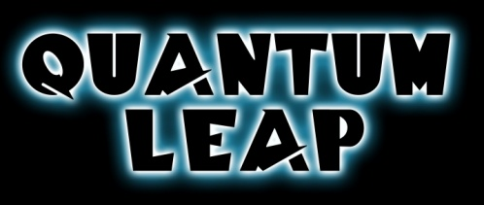](http://www.foundationartsfestival.com/wp-content/uploads/2015/05/0301f696_Quantum_Leap_title_by_maggot216.jpeg)

We are delighted to invite submissions for this year’s **Foundation15 Arts Festival** exhibition. This year the exhibition takes it’s cue from the cult sci-fi television show [**Quantum Leap**](http://foundationartsfestival.com/f15-brief/) (1989-1993). The protagonist Dr. Sam Beckett is a brilliant scientist who, following his quantum experiment in time travel, leaps through space-time, temporarily inhabiting the bodies of other people and altering the events of history.

“Dr Beckett’s space-time travel parallels the investigative nature of an artist’s practice. Artists also travel through time, referencing, appropriating or challenging concepts and aesthetic notions of their predecessors, often interpreting these ideas through a contemporary filter. Inherent in our comprehension of appropriation is the concept that the new work recontextualises whatever it references, it may ultimately even alter our perception of art history. Beyond this, Quantum Leap’s concern with science, the passage of time, identity, gender and the inhabitance of the ‘other’ has also been a fertile playground for artists.” – Brendan Fox, Curator

This year artists exhibiting in the exhibition have the opportunity to win three prizes,  the **Foundation15 Critics Choice Award**, the **Foundation15 People’s Choice Award**, and for artists who have graduated since 2013 the **Foundation15 Undergraduate Award**. More information about these awards can be found on the [Awards page](http://foundationartsfestival.com/awards/).

Submissions can be made via the [online application form](http://foundationartsfestival.com/f15-artist-submission/) up to 11.59pm on Tuesday the 30th of June. A €10 submission fee will apply and can be paid by PayPal or debit/credit card during the application process. For more information see the [terms and conditions page](http://foundationartsfestival.com/f15-terms-conditions/) or email us at [submit@foundationartsfestival.com](mailto:submit@foundationartsfestival.com)

[**Wicklow Arts Office, Call for Artists Proposals, 2016**](http://visualartists.ie/jobs-ops/funding-awards/wicklow-arts-office-call-for-artists-proposals-2016/)

Call for proposals: new initiatives for WAO programme 2016

As part of its plan for the development of the arts, Wicklow County Arts Office invites applications from interested parties for funding to develop and deliver new projects of high quality and impact during 2016 which will enhance and complement the strategic development of the arts in the County.

This call is open to organisations and individuals from any part of Ireland across all arts disciplines. Proposals should add significant value to arts practice, experience and/or participation in the arts in County Wicklow and support the Council’s strategic goals for the arts 2014-2016. 2016 is the third year that this initiative has been offered. Reflecting the balance of other elements of its programme, the Arts Office would particularly welcome strong applications in literature, film, architecture, and artist development. The Arts Office is also interested in proposals in the visual arts and music. The Arts Office is particularly interested to hear from national resource organisations, individual curators and artist collectives who have the potential to propose projects which will nurture practice, create connectivity, generate new perspectives and voices within the cultural life of the county and support a diversity of approach.

The total fund available is subject to the finalisation of Wicklow County Arts Office funding for 2016, but is likely to be a maximum of €30,000. It is intended that a number of projects may be supported through this call to a maximum of €15,000 per project.

The closing date for applications is Friday the 26th of June at 5pm  
Further information and application details:  
E: [dcarroll@wicklowcoco.ie](mailto:dcarroll@wicklowcoco.ie)[www.wicklow.ie/strategic-art-projects](http://www.wicklow.ie/strategic-art-projects)

[**Trinity Creative Funding Awards: Call for Artists Proposals**](http://visualartists.ie/jobs-ops/funding-awards/trinity-creative-funding-awards/)

Trinity College have launched funding awards designed to support the creation of new work and foster the development of interdisciplinary projects, ideally involving a collaboration with Trinity College Dublin. The awards are open to non-Trinity applicants and the focus is on interdisciplinary creative arts practices across forms including performance, visual art, music, film, design, new media, animation, and creative technologies. Up to four awards of up to €10,000 will be granted to support the development of projects which will then be presented within an exhibition or performance context in Trinity in 2016.

Further information:  
E: bcass@tcd.ie  
<http://www.tcd.ie/trinity-creative/>

[**Qualia Dublin’s Art & Culture Magazine Issue 2: IDENTITY | Call for Submissions**](http://visualartists.ie/jobs-ops/opportunities-ireland/submission-call-for-qualia-dublins-art-culture-magazine-issue-2-identity-call-for-submissions/)

Qualia Dublin Art & Culture Magazine is a artist-run publication that bases its ethos on the spreading of ideas and opinions on the creative industry and cultural matters.

The magazine looks for submissions to showcase and promote the work of upcoming artists and students, and to create opportunities for possible collaborations between disciplines outside of the college environment. This is our main objective.

We’re looking for visual artists, graphic designers, photographers, writers, poets, fashion designers, musicians, journalists and more for this exciting new publication.

The magazine is published and distributed to all Art & Design colleges around Dublin.

The theme for Issue 2 is IDENTITY and submission deadline is 21/6/2015.

Please send submissions to qualiadublin@gmail.com. Any images must be jpeg. and no smaller than 400 x 300 please.

Feel free to send video work also for our online version. Please include a short artists biography and short description of the work.

[issuu.com/qualiadublin/docs/qualia_mag2](http://issuu.com/qualiadublin/docs/qualia_mag2)

[**‘There is No Alternative’ | Ormston House & 126 Members’ Call for Submissions**](http://visualartists.ie/jobs-ops/opportunities-ireland/there-is-no-alternative-ormston-house-126-members-call-for-submissions/)

Ormston House, in partnership with 126 Gallery, is delighted to launch a joint call for submissions to members of both organisations for an exhibition opportunity at 126 Gallery in Galway later this year.

In preparing submissions, we invite our members to read the following texts co-authored by Davies, Dillemuth & Jakobsen which are available online for free:

There is no alternative #1: <http://bit.ly/1Gu8mX0>  
There is no alternative #2: <http://bit.ly/1EnSyPE>

During the exhibition, we will host an event at 126 Gallery inviting members of both organisations to reflect together on the purpose and value of both membership schemes, taking an earnest approach to questions described by Davies, Dillemuth & Jakobsen as a bogus consultation process: What work can we do? How do we find alternative ways of thinking about production and labour? How can we act collectively?

There is No Alternative will be the fifth edition of Primary Resource, an umbrella project initiated by 126 Gallery following the 126 FOOTFALL research on artist-led organisations in Ireland.

Information on Ormston House membership: info@ormstonhouse.com  
Information on 126 Gallery membership: contact@126.ie  
Information on the FOOTFALL research: <http://126.ie/footfall-research-report/>

Please send your submission(s) via email with the subject title “There is No Alternative” to oh126.submissions@gmail.com or by post (with return SAE) to There is No Alternative, Ormston House Gallery, 9-10 Patrick Street, Limerick City. There are no guidelines for submission. You can send us as much or as little information as you like and in any format you choose.

Deadline for submissions: Friday 26 June 2015 at 5pm.

Please note: Applicants must be a member of at least one of the organisations.

[www.ormstonhouse.com](http://www.ormstonhouse.com)

**The 101 - Flash Fiction Competition**

We’re also excited to announce our annual Flash Fiction Competition **"The 101"**. We’ve added a new challenge this year by giving you two extra words to play around with. All you flash-enthusiasts will know the power of two more words. We like to think it is a word-perfect flash challenge.  
  
Every story entered must be EXACTLY 101 words. No more. No less.  
  
With only 101 words on the page there are very few places to hide so send us your best. It can be shocking or touching, brutal or heart wrenching – we want flash that moves the reader. Whether you’re a flash fiction newbie or a total flash expert, this is an evening of creativity and inspiration not to be missed!  
  
The deadline for 101 submissions is **8th June** and 2 stories max can be sent (in separate emails please!) to [flash@bigsmokewritingfactory.com](mailto:flash@bigsmokewritingfactory.com?subject=101%20Submission).  
  
As always this event is FREE and will be held in Arthur’s Pub, Dublin 8. All are welcome. So come along and bring a friend, bring two if you’ve got them! We look forward to seeing you all there!

**2015 Over The Edge New Writer of The Year competition**

*OPEN TO POETS & FICTION WRITERS*

*WORLDWIDE*

NOW TAKING ONLINE PAYMENTS

COMPETITION JUDGE: DAVE LORDAN

Major Sponsor*: Charlie Byrne’s Bookshop,*

other sponsors to date:

Dock No. 1 Bar*, ISupply, Quay Street;* Ward’s Hotel Lower Salthill*;*

*Clare Daly TD,* Kenny’s Bookshop & *Derek Nolan TD*

Closing date: Wednesday, August 5th, 2015

Over The Edge: Open Reading in Galway City Library on Thursday, October 29th, 2015 (6.30-8pm).

For further details contact Over The Edge on 087-6431748,

e-mail [over-the-edge-openreadings@hotmail.com](mailto:over-the-edge-openreadings@hotmail.com)

or to make an online payment see [http://overtheedgeliteraryevents.blogspot.com](http://overtheedgeliteraryevents.blogspot.com/)

Major Sponsor: *Charlie Byrne’s Bookshop*,

other sponsors to date: Dock No. 1 Bar, *ISupply, Flood Street*;

Ward’s Hotel, Salthill; *Clare Daly TD*, Kenny’s Bookshop & *Derek Nolan TD*

**Claremorris Open Exhibition 2015, Call for Artist Entries**

Please note an entry fee applies and artists will not receive a fee for taking part  
COE ’15 12th September to 3rd October  
Curated by Brian Cass  
Applications are now sought from artists working in any medium including painting, print, photography, sculpture, installation, video, light, sound, performance and multi media.

We are delighted to announce that Brian Cass will curate COE ’15. Brian Cass is the Curator for Creative Arts, Trinity College, Dublin. He was previously responsible for managing the Turner Prize and delivering it in Derry in 2013. He managed the Changing States: Contemporary Irish Art and the Francis Bacon Studio exhibition programme at BOZAR Centre for Fine Arts, Brussels, as part of Culture Ireland’s programme for Ireland’s presidency of the EU in 2013.

He held curatorial and project management roles with the Irish Museum of Modern Art, Dublin, leading on projects such as Time out of Mind: Works from the IMMA Collection (2012); The Moderns: The Arts in Ireland from the 1900s to the 1970s (2010); Anne Tallentire: this and other things 1999-2010 (2010); Philippe Parreno: November (2009) and James Coleman (2008). He has written for and edited exhibition catalogues and artist books, directed and produced programmes for RTE and was gallery manager of The Model, Sligo.

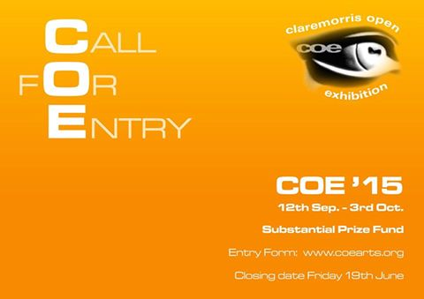

For an application form, [www.coearts.org](http://lists.visualartists.ie/lt.php?c=1346&m=4383&nl=1&s=d3c261c0eeb6b48867f449d29e09414b&lid=113872&l=-http--www.coearts.org)**Deadline 19th June 2015**Postal entries to COE Office, Main Street, Claremorris, Co. Mayo  
E: Email entries to [coe15.entries@gmail.com](mailto:coe15.entries@gmail.com)

**Hospital Arts Festival 2015: Open Call to Artists**

Please Note A Submission Fee Applies

Submission for the visual arts section of Hospital Arts Festival 2015 is now open.This year we will be working in collaboration with guest curator Moran Been-noon.  
With consideration to the heritage of Hospital’s 800 years, ideas in the relation to the concept of Land, Labour, Industry are welcome for this year’s festival.

Also, For One Night Only, a video open call specifically for film, video and animation shorts, invites artists to submit, electronically, video works of no longer than 15 minutes, with the narrative relevant to the overall working theme for Hospital Arts Festival 2015, Land, Labour, Industry.

Each submission must be accompanied by a submission fee of €10 payable by Paypal:  
to [hospitalartsfest@gmail.com](mailto:hospitalartsfest@gmail.com)  
Please include your Paypal receipt number or forward on email acknowledgment of the payment with your submission  
Deadline: **Monday, 20 July at 5pm**

Further information:  
[www.hospitalartsfest.com](http://lists.visualartists.ie/lt.php?c=1346&m=4383&nl=1&s=d3c261c0eeb6b48867f449d29e09414b&lid=113874&l=-http--www.hospitalartsfest.com)

**The Moth Short Story Prize and The Caterpillar Short Story Prize**

With just 6 weeks left to enter this year’s Moth Short Story Prize, judged by Donal Ryan, it’s time to get writing! The word limit is 6,000 (no minimum length) and it can be on any subject.

The prizes: 1st €3,000; 2nd a week-long writing retreat at [Circle of Misse](http://www.circleofmisse.com/) in France (including a €250 stipend); 3rd €1,000

The winning stories will be published in the autumn 2015 issue of The Moth.We’re also running the new Caterpillar Short Story Prize – with a single prize of €1,000 (and publication in *The Caterpillar*) for the best story written by an adult for children (aged 7-11).   
  
You can enter The Moth Short Story Prize and The Caterpillar Short Story Prize at <http://www.themothmagazine.com/a1-page.asp?page=0>

**The Soloist**

|  |
| --- |
|  |
|  |
|  |

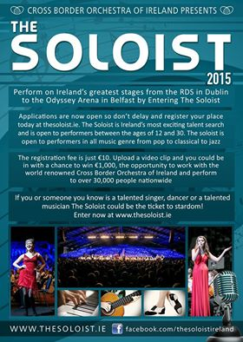

**Social Mhuire National School, Barnstown, Wexford, Percent for Art Commission: Call for Artists**

The Board of Management of Scoil Mhuire National School, Barntown wishes to commission two site specific public artworks under the Per Cent for Art Scheme, funded by the Department of Education and Science. Scoil Mhuire Barntown is a parish, co-educational primary school which caters for pupils from junior infants to sixth class. The school serves the community of Barntown which encompasses the outer reaches of Wexford town. We think of ourselves as a rural school and love the way our school nestles under Forth mountain. The view from our new front door is a fabulous panoramic view of the mountains from Mount Brandon and the Blackstairs to the Wicklow mountains.

Budget €18,000

Applicants are requested to read the full content of the Artist Brief, [CLICK HERE](http://lists.visualartists.ie/lt.php?c=1342&m=4379&nl=1&s=e784eec6bf8bb9680747b324b9c9eee1&lid=112531&l=-http--visualartists.ie/wp-content/uploads/2015/05/Artist-Brief-Scoil-Mhuire-Barntown.pdf), carefully as it contains important information pertaining to all stages of the commission.

**Stage 1**  
Artists are invited to express their interest in being considered for this project at the first stage of this commission.  
Please submit  
•            CV  
•            Images /recordings of previous work, no more than 5  
•            Artist’s proposal/sketch, no more than 500 words

These should be combined into a single PDF file of no more than 10MB.  
**Deadline**: stage 1 completed application form together with supporting documentation and material is **26th June 2015, 12 noon.**

**Stage 2**  
From the completed stage 1 applications, a shortlist of not more than six artists will be selected by panel jury. This panel, whose decision is final, has the right to clarify any issue which may arise in the course of selection.  A fee of €500 will be paid to shortlisted artists if further work is required to prepare a detailed submission including written outline, budget outline, feasible timeline/schedule and visual representation. The shortlisted artists will also be invited to present/develop their proposals in a way that will be easily accessible to staff and pupils. The committee will actively seek input of pupils and staff in the selection process.

Site Visits  
Site visits will be arranged for shortlisted artists at Stage 2 of the commissioning process.

Shortlisted artists will be required to submit a **Tax Clearance Certificate** and subject to **Garda vetting**  
Social Mhuire, Barnstown reserves the right not to proceed with any of the submissions received.

Further information and digital submissions to:  
E: [info@barntownns.ie](mailto:info@barntownns.ie)  
Hard copy submissions to be posted to:  
Scoil Mhuire Nation School, Barntown, Co. Wexford  
**Deadline 26th June 2015, 12 noon**

**Awards / Bursaries / Schemes**

[**2015 Valerie Earley Residency Award | Call for Applicants**](http://visualartists.ie/vai-news/2015-valerie-earley-residency-award-call-for-applicants/)

In 2013 Visual Artists Ireland put in place a commemoration of our late friend and colleague Valerie Earley, who worked with us as Membership Manager for over 17 years. We wanted to provide a lasting memory of Valerie and hope that this award is one way that Valerie’s care for our artist members will continue into the future.

The Valerie Earley Residency award is open to all members of Visual Artists Ireland and takes the form of a two-week residency in the Tyrone Guthrie Centre. The Tyrone Guthrie Centre is set in a tranquil, beautiful setting amid the lakes and drumlins of County Monaghan. The residency is self-catering and includes accommodation and a studio facility.

The application process is subject to the standard terms and conditions of the Tyrone Guthrie Centre.

Further information and to apply, contact:Tyrone Guthrie Centre, Annaghmakerrig, Newbliss, Co. Monaghan

Further information and to apply:  
T: 00 353 47 54003  
E: info@tyroneguthrie.ie  
[www.tyroneguthrie.ie](http://www.tyroneguthrie.ie)

**Closing date: 26 June 2015**

[**The Arts Council Project Awards, 2015**](http://visualartists.ie/jobs-ops/funding-awards/the-arts-council-project-awards-2015/)

The Arts Council’s Project awards support specific project activities under each of the following art form and arts practice areas. The award guidelines for each award can be downloaded from the [available funding](http://www.artscouncil.ie/available-funding/) section of the Arts Council’s website.

Visual Arts Project Award  
Music Project Award  
Opera Project Award  
Theatre Project Award  
Traditional Arts Project Award

Applications will only be accepted through the Arts Council’s [online services website](https://onlineservices.artscouncil.ie/Secure/Login.aspx?lang=en-ie) and all supporting material must be submitted online. Applicants who have not previously used the online services site must [register in advance](https://onlineservices.artscouncil.ie/Register.aspx) of making an application. It may take up to five working days for your registrations to be confirmed so it is very important that you register as early as possible.

We now provide updates and assistance on the use of online services through our new [Facebook page](https://www.facebook.com/artscouncilireland). Feel free to post or send us a message via the page if you need online services support when making a Project Award application: [www.facebook.com/artscouncilireland](http://www.facebook.com/artscouncilireland)

The awards are open to individuals and organisations. However, organisations in receipt of funding under any of the main Arts Council grant programmes (Regularly Funded Organisations, Annual Funding, Annual Programming Grant) will not be eligible to apply.  
**Deadline 5.30pm, Thursday, 20 August, 2015**

**2014/2015 Dates and Deadlines for Culture Ireland Grant Rounds**

Please note Culture Ireland has set funding rounds and deadlines for 2015. There will be three funding rounds in 2015 and seperate calls for showcasing opportunities and Edinburgh Festivals will be announced during the year.

**Application Deadline | Timing of Project/Event | Decision Due**

* 15 June 2015  | September 2015 onwards | Early August
* 15 October 2015 |  January 2016 onwards | Early December

[http://www.cultureireland.ie/](http://lists.visualartists.ie/lt.php?c=1232&m=4271&nl=1&s=d3c261c0eeb6b48867f449d29e09414b&lid=96096&l=-http--www.cultureireland.ie/)

**Bursary Awards next closing date – 5.30pm, Thursday, 16 July 2015**

|  |
| --- |
| http://newsletter.artscouncil.ie/nwstatic/spacer.gif |

The window for making an application opens on Tuesday, 16 June 2015. The deadline for the Arts Council's Bursary Awards is **Thursday, 16 July 2015 at 5.30pm.**

The Bursary Award is available in the following artforms:

* Literature (Irish & English Language)
* Theatre
* Traditional Arts
* Visual Arts
* YPCE

The Arts Council provides Bursary Awards in order to assist individual artists in the development of their art practice. The award emphasises the value and benefit to an artist’s development that is derived from a focused period of engagement with their practice.

Guidelines for each award are published on the [available funding](http://newsletter.artscouncil.ie/1i2sre0kp1s14rbsgtdsq9?a=6&p=48727903&t=28179891)section on our website.

***Please note***

Applications will only be accepted through the Arts Council’s [online services](http://newsletter.artscouncil.ie/1pxvszvni3w14rbsgtdsq9?a=6&p=48727903&t=28179891) website. Applicants who have not previously used this system must register in advance of making an application. It is recommended that applicants allow five working days for registration prior to making an application.

**Arts Council’s Artist in the Community Scheme – Deadlines 2015**

Twice yearly, the Arts Council offers grants to enable artists and communities of place/or interest to work together on projects. The Artist in the Community Scheme is managed by Create, the national development agency for collaborative arts.

The scheme is open to artists from any of the following artform disciplines: architecture, circus, street art and spectacle, dance, film, literature (Irish and English language), music, opera, theatre, visual arts and traditional arts. The projects can take place in a diverse range of social and community contexts eg arts and health; arts in prisons; arts and older people; arts and cultural diversity.

The aim of the scheme is to encourage meaningful collaboration between communities of place and/or interest and artists. It is essential that consultation take place between the artist and the community group, so that both parties are involved in deciding on the nature of the project realisation. Group ownership of the art should be maintained at every stage. The Project Realisation may result in a variety of outcomes.

There are two phases to the scheme. Phase One [Research & Development,](http://lists.visualartists.ie/lt.php?c=1289&m=4326&nl=1&s=d3c261c0eeb6b48867f449d29e09414b&lid=101957&l=-http--www.create-ireland.ie/artist-in-the-community-scheme-research-and-development-award.html) is open to artists who wish to research and develop a project in a community context.

There is also a [Research & Development/Mentoring](http://lists.visualartists.ie/lt.php?c=1289&m=4326&nl=1&s=d3c261c0eeb6b48867f449d29e09414b&lid=101958&l=-http--www.create-ireland.ie/artist-in-the-community-scheme-research-and-development/mentoring-award.html) strand, open to artists who wish to develop a community based project and who have identified an artist mentor they want to work with during the research and development phase.

Phase Two [Project Realisation](http://lists.visualartists.ie/lt.php?c=1289&m=4326&nl=1&s=d3c261c0eeb6b48867f449d29e09414b&lid=101959&l=-http--www.create-ireland.ie/artist-in-the-community-project-realisation-award.html) , is open to communities of interest or place (or their representative organisations) with an artist.

**2015 Deadlines:  
(Round 2)   29 June 2015**

For information on the Scheme and advice on applying, contact Katherine Atkinson, [support@create-ireland.ie](mailto:support@create-ireland.ie) or phone 01-4736600  
Visit [http://www.create-ireland.ie/about-the-artist-in-the-community-scheme.html](http://lists.visualartists.ie/lt.php?c=1289&m=4326&nl=1&s=d3c261c0eeb6b48867f449d29e09414b&lid=101960&l=-http--www.create-ireland.ie/about-the-artist-in-the-community-scheme.html)