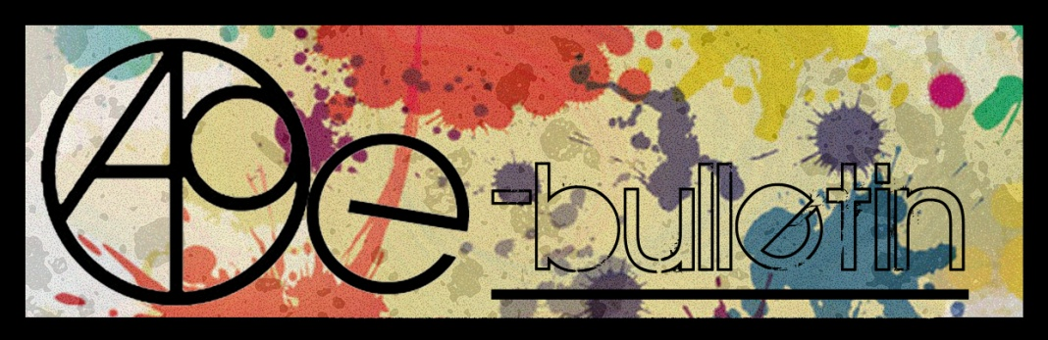

Kilkenny County Council Arts Office E-bulletin 6th May 2016

Dear All,
Welcome to the fortnightly e-bulletin from Kilkenny County Council's Arts Office. Each bulletin is packed with the latest information on Kilkenny Arts Office activities, county events as well as news and opportunities for arts practitioners from around the country.

This service will be provided fortnightly. To include an item in the next e-bulletin please send a brief outline of your advert with relevant contact details, including any websites or pages with links to niamh.brophy@kilkennycoco.ie before 20th May. The next e-bulletin will be on the 25th May.
While every effort has been made to ensure the accuracy of our information, we strongly advise readers to verify all details to their own satisfaction.

Regards,

Niamh Brophy, Arts Administrator

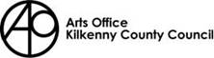
5 Dean Street, Kilkenny
T: (056) 7794138
E: niamh.brophy@kilkennycoco.ie
W: www.kilkennycoco.ie/eng/Services/Arts



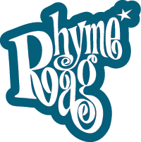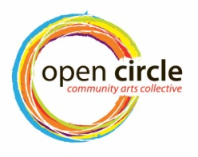
www.rhymerag.net https://opencirclearts.ie/ www.artlinks.ie

Kilkenny County Council Cultural Services -
Creating and Sustaining Great Communities and Places

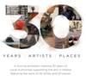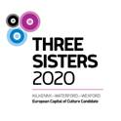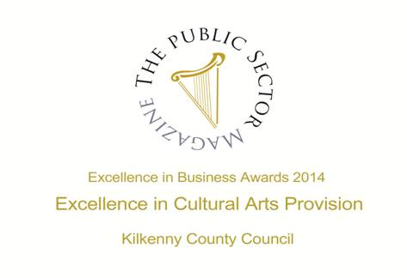

Arts Office
- PLACES AVAILABLE - Short Story Writing Weekend with Dr. Hilary Lennon, May 21st and 22nd
- Call for Submissions: Issue 16 Kilkenny Poetry Broadsheet
- Three Sisters 2020
Kilkenny Events

- Callan Workhouse Union Funded Research Residency Open Call, Co. Kilkenny
- City Library Events
- Loughboy Library Events
- Bealtaine Festival Events with Kilkenny Libraries
- Ghosts of Grangegorman at the RHA by Kilkenny artist Alan Counihan
- National Craft Gallery News
- Citizen | Anita Groener at Butler Gallery, Kilkenny
- ‘The Courage to Be’ Course
- Stone Sculpture Workshop with James Horan | KCAT Arts Centre, Co. Kilkenny
- George Brown Memorial Committee - Photography Competition
- Grennan Mill Craft School, Thomastown: Graduate Show 2016
- Introduction To Glass Painting with Bernie McAuley | Blackwatch Studio, Kilkenny
- Painting Workshops with Eamon Colman | Blackwatch Studio, Kilkenny
- Kilkenny Community Orchestra at Castalia Hall 13th May at 8pm
- Duiske Concert Graighnamanagh
- KCAT - The Laughing Heart || Galway Arts Centre || Thursday 28 April 2016
- Music at Castalia Hall
- Upcoming Events at the Watergate Theatre, Kilkenny
- Exhibition space is available in City Library, John’s Quay
- Kilkenny Artist Lucy McKenna Talk at The Artist Observatory, Co. Armagh
- Kilkenny Arts Festival News
Courses / Training / Jobs / Internships

Performative Curating Course at Fire Station Summer School, Dublin 1

University College Cork: Masters in Voluntary and Community Sector Management

Health & Safety for Visual Artists with Vincent Kiely – Dublin

‘Over the Edge’, online poetry workshops

Open Call | 126 Internship Placements 2016
Call for Submissions / Residencies / Public Art

- Curatorial Residency | Goethe-Institut, New York
- Open Call | Art and Science Residency at the European Space Agency
- Open Call | Artist in Residency Programme | Valencia, Spain
- Open Call for Exhibition Proposals | Art at The Ivy House
- Open Call | Enniskillen Visual Arts Open 2016
- Royal Ulster Academy 135th Annual Exhibition Open For Entries
- Open Call | Public Art Commission, The Liberties, Dublin 8.
- Per Cent for Art Commission | Gaelscoil Shliabh Rua, Dublin 18
- Per Cent For Art Commission | Scoil Mhuire National School, Tullamore, Co. Offaly
- Open Call for Commission | Irish National Stud, Kildare
- Living Arts Project - Arts in Education
- Call for Submissions | PhotoIreland Open Programme 2016
- Call for Submissions: The Fool For Poetry International Chapbook Competition

Awards / Bursaries / Schemes

- Arts Council of Ireland: Upcoming Funding Deadlines
- Applications Open for Most Promising Graduate Award, Talbot Gallery, Dublin
- Engaging with Architecture Scheme | Arts Council Ireland
- Emerging Visual Artist Award
Of Interest

- Call for Submissions: The Fool For Poetry International Chapbook Competition
- Great listing of jobs available.....
- May / June Visual Artists’ News Sheet (VAN) available soon
- All Ireland Workspace Survey 2016 | For Individual Artists, Artists Groups, and Arts Organisations
- A New Website Listing Irish Nonprofits at Benefacts.ie
- Blackstairs Film: Saturday night film in Rathanna: The Grump

Arts Office

PLACES AVAILABLE - Short Story Writing Weekend with Dr. Hilary Lennon, May 21st and 22nd

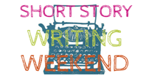

Location: Butler House, Patrick’s Street, Kilkenny
Date & Time: Saturday 21st May: 10am-5pm (with break for lunch) Sunday 22nd May: 10am-5pm (with break for lunch)
Fee: €100/€70 (conc)

Weekend Workshop Outline
Suitable for the beginner as well as the more experienced writer, this workshop provides a fun and friendly introduction to writing. Participants are given the opportunity to explore their own creative imaginations. The focus of the class includes:

• Workshop triggering ideas to help become comfortable in expressing yourself creatively.
• In-class exercises to explore your own writing style.
• Class writings supported by lively group discussion.
• Participants examining some very short examples from literature, to help develop an awareness of various literary techniques.

Overall, this workshop serves as a stimulating and informative way to learn about how to explore your creative imagination and bring out your own voice as a writer. Encouragement, advice, feedback, on-going tips, and group support all form part of this class. Opportunity to develop and improve your own written work will also be provided. Throughout the weekend, participants will also receive handouts and discussion on the following writing elements:
Getting Started; Observation; Character; Setting; Dialogue; Pacing; Plot; Similes; Metaphors; Style.

This workshop is taught by Dr. Hilary Lennon, School of English, University College Cork. In this workshop, Hilary will lead a series of four 3-hour workshops over the course of the Saturday and Sunday, on writing short stories, and will be encouraging and guiding participants’ own writings through class exercises, feedback, and group discussion.

Hilary is a very experienced teacher of creative writing courses and has taught numerous writing workshops for Triskel Arts Centre, and for University College Cork. Several of her beginner participants in 2013, 2014 and 2015’s creative writing workshops made their very successful reading debut at the Cork World Book Festival each year, reading stories that were worked on in her classes, and her participants have also been very successful in winning writing competitions and in getting published, which included three of her beginner participants last winter getting published in book-form after succeeding in the RTE ‘short-short story’ competition.

To secure a place on the above courses please contact the Arts Office on 056 7794138 or email: niamh.brophy@kilkennycoco.ie

Call For Submissions: Kilkenny Poetry Broadsheet Issue 16 – DEADLINE 17TH MAY
Kilkenny County Council Arts Office is delighted to announce a call for submissions for the publication of the sixteenth issue of the very popular KILKENNY POETRY BROADSHEET. The aim of the publication is to give local writers a platform for their work. Each poem selected is included in the broadsheet which is available free throughout the County. Seventy-eight poems were submitted for consideration by twenty eight writers with thirteen poems by nine poets selected by Editor Tony Curtis in 2015 with the publication launched as part of the Kilkenny Arts Festival by American poet Robert Pinsky.
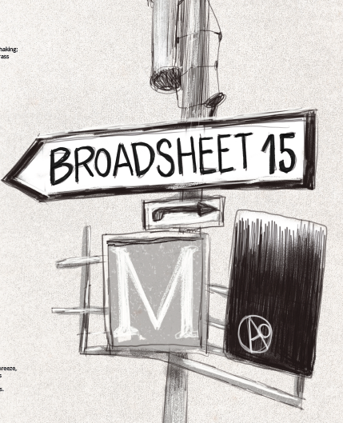
This sixteenth issue of Kilkenny Poetry Broadsheet will be edited by Kimberly Campanello.
Kimberly Campanello was born in Elkhart, Indiana, and is a dual American and Irish citizen. Her publications include Spinning Cities (Wurm Press, 2011), Consent (Doire Press, 2013) and Imagines (New Dublin Press, 2015), a limited edition book recently exhibited at the Dublin Art Book Fair. In October 2015, The Dreadful Press launched Strange Country, her collection on the sheela-na-gigs. MOTHERBABYHOME, a book of conceptual and visual poetry on the St Mary's Mother and Baby Home in Tuam, will appear with zimZalla Avant Objects this year. Kimberly has taught Creative Writing and literature courses at Florida Gulf Coast University, the National University of Ireland (Maynooth), Middlesex University, the University of East London, CityLit (London), the Irish Writers' Centre and Big Smoke Writing Factory (Dublin). In autumn 2015, she joined York St John University as a Lecturer in Creative Writing.
We are now accepting submissions from poets born or based in Kilkenny City and County.
Application forms and submission rules are available from the Arts Office5 Dean Street, Kilkenny. T: 056 7794547 E: niamh.brophy@kilkennycoco.ie
Or can be downloaded from the Kilkenny Coynty Council Website, Arts Page http://www.kilkennycoco.ie/eng/Services/Arts/
No electronic submissions accepted.
Closing date for receipt of submissions is no later than 4pm on Tuesday 17th May.

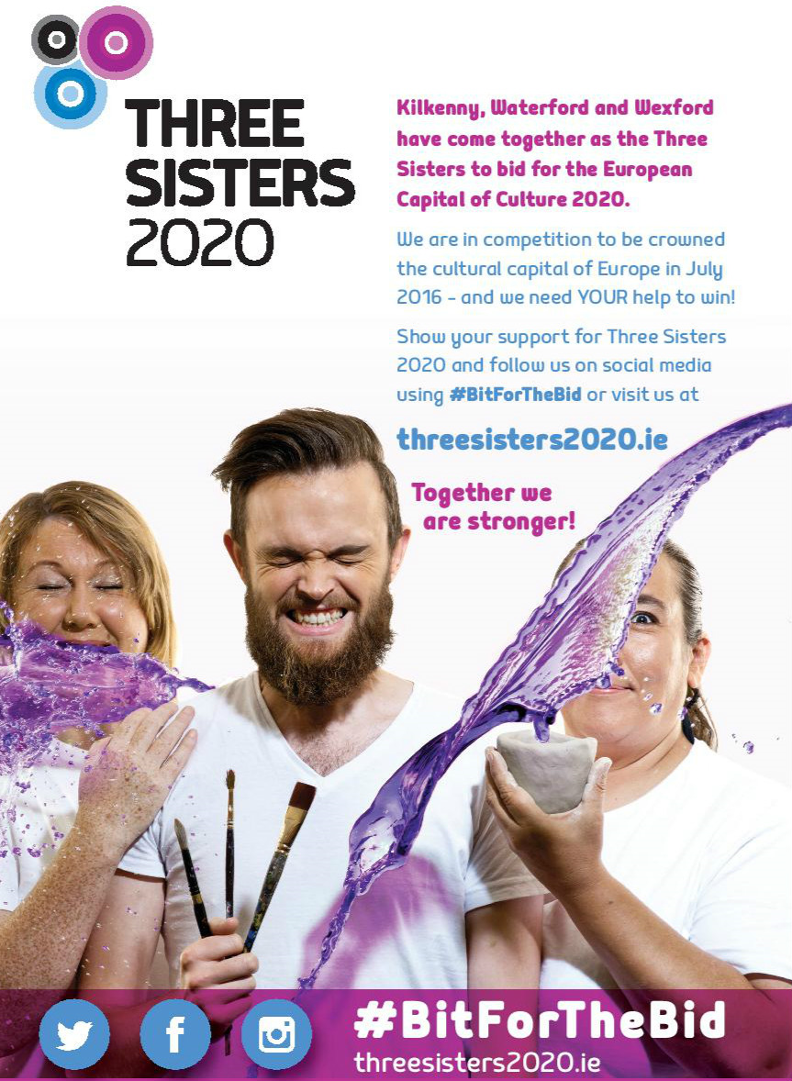
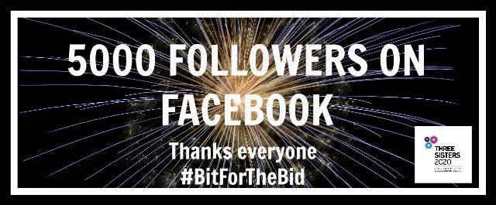

Kilkenny Events

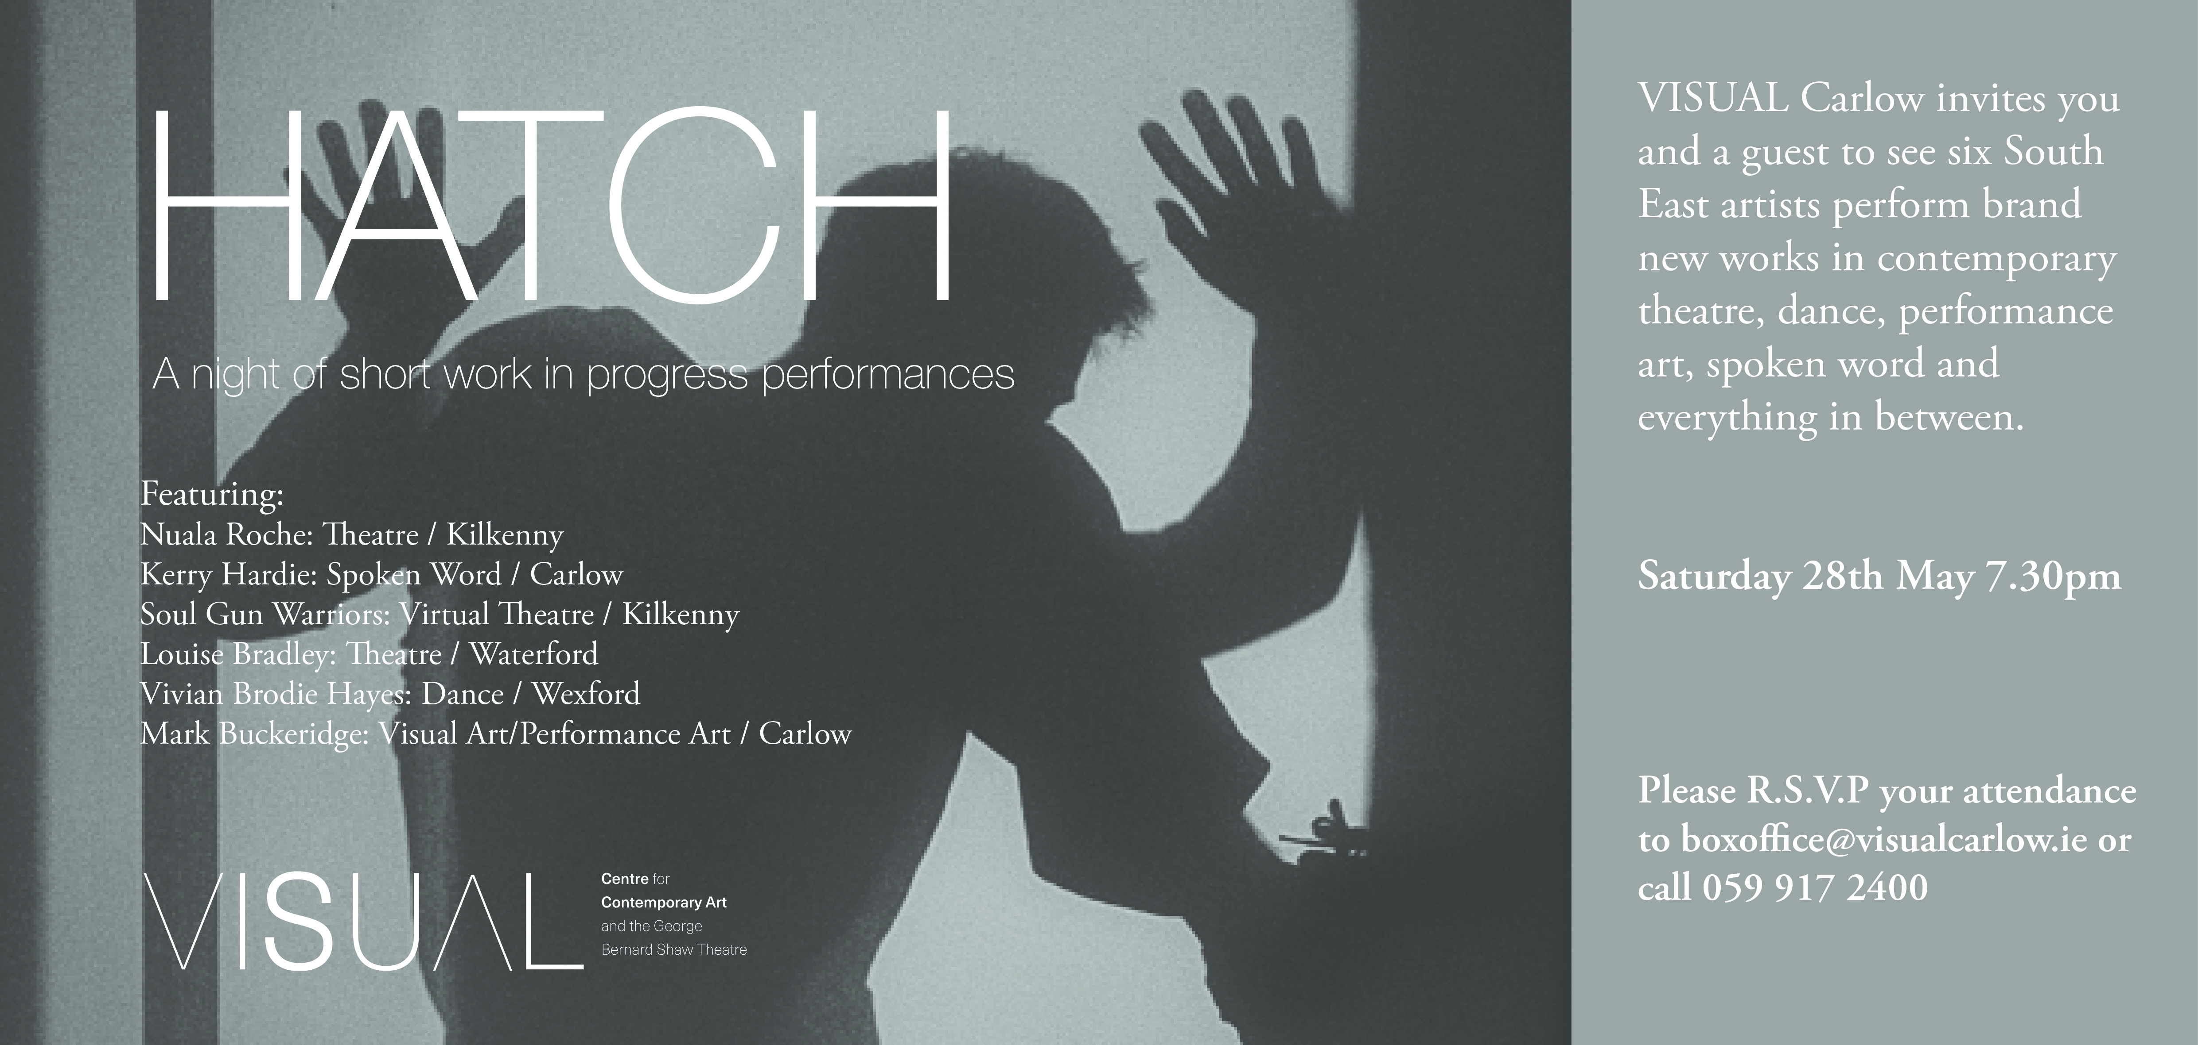

Callan Workhouse Union Funded Research Residency Open Call, Co. Kilkenny
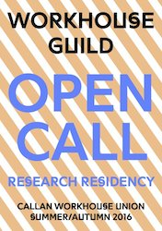
Application deadline: 10 May 2016, 5pm

Callan Workhouse Union (CWU) is a shared space for art, design, research and community activities within a very specific heritage context. We are now inviting applications for Workhouse Guild. This two-week residency programme is open to visual artists to develop research within the context of CWU research library, studios and environs.

Workhouse Guild examines the role of making, skill and craftsmanship in contemporary visual arts practice. Since medieval times guilds have had an enduring legacy on design and craft traditions. In his book ‘The Craftsman’, Richard Sennett describes guilds as ‘joined skill in community’ allowing creative developments through partnerships and communal participation. Workhouse Guild residency programme is focused on self-directed practice and context specific exploration but applicants are encouraged to draw on the wider context of Kilkenny and its craft and design heritage. Artists will have the freedom to work on a research-based project with access to research facilities, shared dialogue and curatorial support.

What we offer:
This programme is open to visual artists and proposals should demonstrate how the situation and context of CWU would benefit their work. We are offering three visual artists (national and international) the opportunity to undertake a two-week period at CWU. The opportunity includes access to the research library and studio space at CWU, self-catering accommodation in a shared house and support from our curatorial team. A research stipend of €400 plus a supplement of €100 towards travel and/or material costs. At the end of the residency, artists will be invited to give an informal presentation of their research. The format of the presentation is open and can be discursive or a short text or report.

Dates of residency: Dates available between 1 June and 30 September 2016

A short statement regarding your research and how it relates to the residence context (500 words max.)
– Up to date CV
– 4 – 6 examples of work, e.g. images or links to online content
– Please state your preferred residency dates
Appendix: The research residency forms part of the wider year-long Workhouse Guild programme, which includes a film commission by Deirdre O’Mahony and Soil Guild a week-long themed group residency programme in September (call out in June).

Workhouse Guild builds on the accumulation of previous work at CWU including Workhouse Assembly (2013) and Workhouse Union (2015). Workhouse Guild signposts towards our ambition to develop a dedicated workshop facility for art, design and craft collaboration and commissions at CWU. Workhouse Guild is led by the curatorial and producer team at CWU: Hollie Kearns, Eilis Lavelle, Rosie Lynch and Orlaith Treacy.

Callan Workhouse Union is a newly developing shared space for art, design, research and community activities at a semi-derelict wing of Callan workhouse. Since 2013, artist and designer-led projects have been accumulating use and meaning for the buildings new life, bringing access for the public to this significant historic building in our town.

Callan is a small town in Co. Kilkenny that has established itself as a centre for arts practice. For more than 16 years of ongoing development, the impact of arts activities has been far reaching, with a particular focus on social and cultural impact on our rural town and hinterland. Workhouse Guild is funded through an Arts Council Visual Arts Project Award.

Applications and any queries should be emailed to: workhouseunion@gmail.com
www.facebook.com/CallanWorkhouseUnion/

City Library Events

Places still remaining on the following events in City Library. Booking essential. Phone 056 779 4174
Wednesday 4th & Thursday 5th May @ 11am-12pm
Introduction to Borrowbox - our new ebook & e-audio service.
Friday:
Knitting for Charity: an Introduction to simple patterns by Knitwits.11am. FREE.
FREE computer classes for beginners and improvers. 2-4pm. (4 week course)
Monday 9th May:
Find my past Genealogy sessions:12-5pm. Booking essential on 056 779 4174

Loughboy Library Events

"Midwives of a Nation" at Loughboy Library

Loughboy Library is showing Carnation Theatre’s Show “Midwives of A Nation” on Tuesday May 31st at 11am. Free tickets are available at the library.

Carnation Theatre is proud to present: "Midwives of a Nation" co-written with Joe O'Byrne. “Midwives” celebrates the oft forgotten contribution of women to the events of 1916 - the big and the not so big characters of which there are so many: Elizabeth O'Farrell, Margaret Skinnider, Countess Markievicz, Winnie Carnie to name but a few. These ladies were the dispatchers, the doctors, the First-Aiders, the snipers, the tea makers, the gun runners...the list goes on!

Join Carnation theatre as we celebrate the women who were there at the birth of our nation.
Rose Cottage Exhibition at Loughboy Library May 3rd-16th 2016

This is a beautiful collection of hand-dyed, waxed fabric and handmade silk pieces by artists Jean Burke, Sheila Cantwell, Isabel Alvarez Gomez, Christina Shanahan, Alice Bennett and Karolina Danilaite.

Bealtaine Festival Events with Kilkenny Libraries

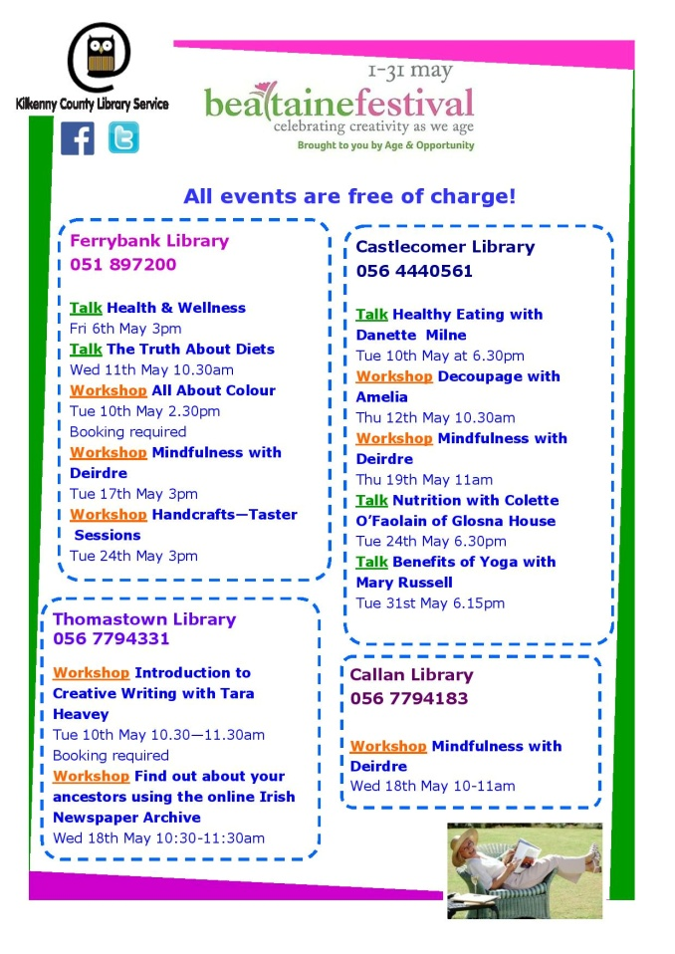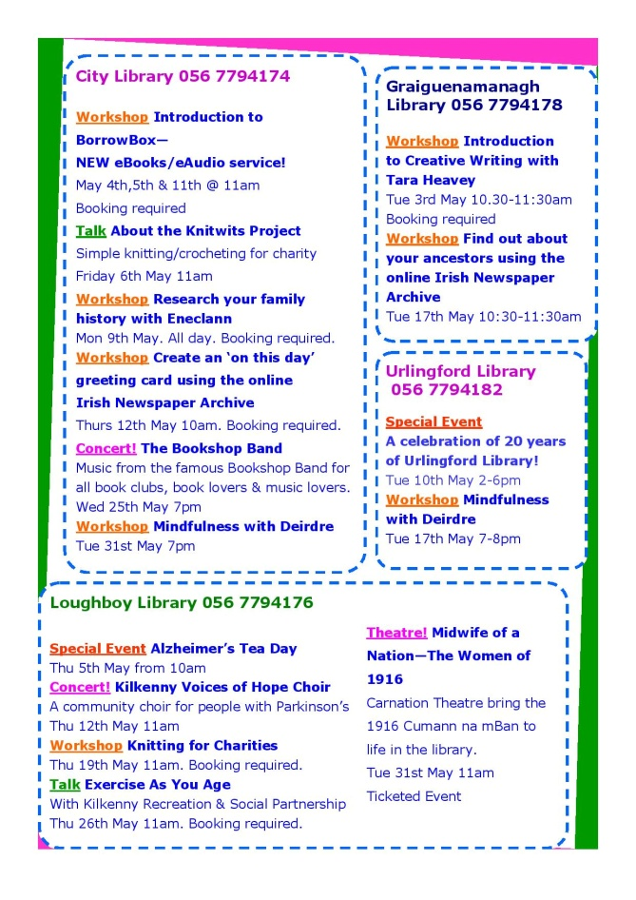

Ghosts of Grangegorman at the RHA by Kilkenny artist Alan Counihan

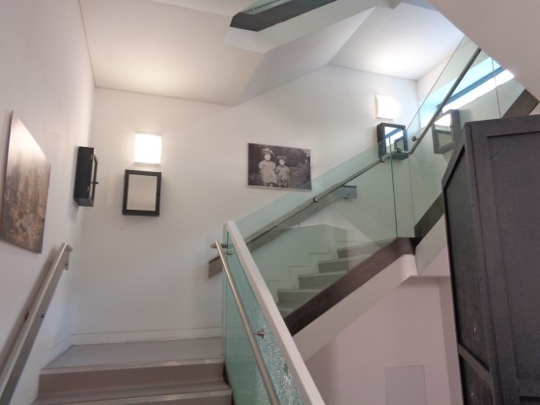

Ghosts of Grangegorman, a space-specific installation by Alan Counihan based on the belongings of dead or discharged patients of Grangegorman Mental Hospital, (later St Brendan’s Hospital) is now showing at the Royal Hibernian Academy, Ely Place, Dublin as part of the RHA Annual Open Exhibition until 11 June 2016.

Alan was invited to create a space-specific work based on the Personal Effects project for the gallery during the Annual Open Exhibition. The Personal Effects project is an ongoing work that began as an exploration of the personal effects of dead or discharged patients of Grangegorman Mental Hospital which were discovered in an attic of that institution in 2010. The fruit of that research and exploration was exhibited as a multi-media installation that was first shown in 2014 at the Long Stores of St Brendan’s Hospital, Grangegorman, Dublin.

Details at the front desk of the RHA as to location of the installation.



Exhibition

Liminal: Irish Design at the Threshold 8 April 2016 – 3 July 2016
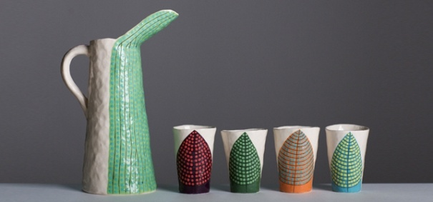
Liminal – Irish design at the threshold, presents some of Ireland’s most exciting design, from product to scientific, architecture to animation, and food to furniture. The exhibiting designers, companies and studios have been selected for the innovative outlook of their work, its connectivity and ability to transcend disciplinary boundaries to address the issues of today. Presenting a pivotal chapter in Irish design, Liminal explores, identifies and showcases Irish creativity, and how designers, companies and studios are moving across disciplinary boundaries and the limits of what design has been, into what design can become. As design increasingly seeks to create holistic experiences and narratives, Ireland is placed to play a significant role in 21st century design, helping meet the challenges of tomorrow. The exhibition demonstrates Irish design excellence across disciplines and considers the possibilities for the future.
The evolving flagship exhibition from ID2015, Liminal – Irish design at the threshold, is presented in Kilkenny after its tour of design weeks in Eindhoven, Milan, New York and Dublin. The exhibition features over 20 designers, companies and studios involved in collaborations across disciplines.
Co-curated by Louise Allen, Alex Milton and Angela O’Kelly

Education & Outreach

NATIONAL DRAWING DAY: ALL AGES WORKSHOPS Sat 21 May, 12noon - 4pm
National Drawing Day 2016 celebrates drawing and creativity - join us in the Castle Yard for a day of workshops and drawing installations for all ages with a craft and design edge

FAMILY DAY: CHARACTER DESIGN* Sat 18 June 10.30am, 12 noon & 2.30pm
Learn what shapes make a cartoon look happy or sad, quiet or energetic, then design your own character inspired by Cartoon Saloon's Song of the Sea with animator Rory Conway. Book Now

BEALTAINE: TOUR & CRAFTERNOON TEA* Fri 6 & Fri 20 May, 12noon
We invite you to join us for an informal tour of our exhibition Liminal and 'Crafternoon Tea' to mark Bealtaine the festival celebrating creativity as we age. Book Now

WORKSHOP: DRAWING AS RESEARCH - PART 2* (€5) Wed 27 April & 18 May, 10.30am
Designer maker Inga Reed leads workshops exploring drawing as a tool for developing ideas, following from previous sessions.

LATE DATE: EVOLVING DESIGN, FROM KDW TO THE FUTURE with LINDA KING, PJ WHITE, JOHN CLEERE Wed 25 May, 6.30pm
Kilkenny Design Workshops marked a change in what design meant in Ireland, 50+ years on and after the last year celebrating design and innovation through Irish Design 2015 we reflect on where we have come and how we envisage design in Ireland in the future.

LATE DATE: STORY-LED DESIGN EXPERIENCES Thurs 30 June, 6.30pm
Design consultancy Design Partners talk about the development of products such as the Calor Mini Bbq and Silvair Smart Control System, sharing the story-led design approach they utilise to create exceptional design experiences.

DROP-IN: DESIGN DISCOVERY Daily
Drop-in with the family to discover design through Liminal:
Liminal Explorer: Become a design detective, seeking out visual designs
ARCKIT Play: Test your architectural design ideas with ARCKIT

SCHOOLS: GUIDED VISITS & WORKSHOPS 12 April – 30 June (Tues-Fri)
Our educators introduce students to design and craft through a tailored exhibition tour and invite you to book a class workshop:
Primary: Line Shape Pattern
Secondary: ARCKIT Modular Homes
Leaving Cert: Art, Craft & Design Gallery Question
Third Level: ARCKIT Modular Builds

Gallery Tours
CRAFTERNOON TOURS* Sat, 3pm Visitors are invited to book for our informal afternoon tour. GUIDED EXHIBITION VISITS* Would you like to bring a group to the National Craft Gallery? We accommodate groups from 5 to 25 people. No fee applies. Contact us and we will tailor a tour suit the needs of your visit. *Booking required - email events@nationalcraftgallery.ie or call 056 7796151

Citizen | Anita Groener at Butler Gallery, Kilkenny

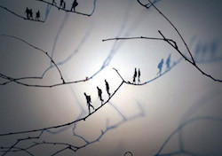
7 May to 12 June | Opening 7 May, 2.30pm

Citizen, a multi-media exhibition of drawings, video and silhouette installations by Dutch born and long-time Dublin-based artist, Anita Groener.

Citizen explores the phenomenon of, and our consciousness about refugees, based on the current global crisis and how a renewed collective alienation is emerging. Homelessness is ubiquitous in the world yet homeless people are perceived as invisible. Citizen builds on the central theme running through Groener’s work: that is a consideration of home and displacement as situated within current geopolitical realities. Scale, physical presence and the nature of human endeavor are present throughout Groener’s work, but never more so than the voyage we are taken on with this body of work.

Groener’s work is fundamentally grounded in drawing, where she weaves together a continuum of thinking, developing and making. The drawings made within the framework of Citizen are without colour and incorporate strong lines in black gouache on paper. Clusters of arms lay or hang together, hands reach upwards and outwards, all intertwined in an attempt to translate terror’s destabilising impact.

Butler Gallery, The Castle, Kilkenny
T: +353 (0)56 7761106
E: info@butlergallery.com
W: butlergallery.com

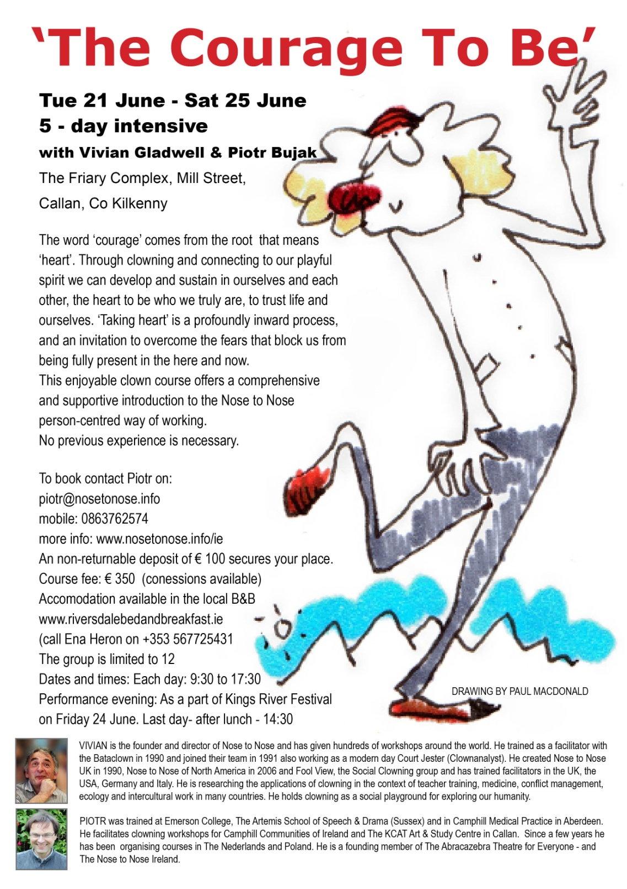

Stone Sculpture Workshop with James Horan | KCAT Arts Centre, Co. Kilkenny
7 and 8 May, 10am to 4.30pm
Learn to make sculpture in stone. Fun workshop, all materials and tools provided.
The course is aimed at beginner- intermediate level, but all levels can be catered for.
Carve your own design in relief or 3D, soft limestones are used, or bring your own stone if its suitable. I can help you with design if needed.
Tea and Coffee provided but please bring a lunch.
Venue: KCAT arts centre , Callan, Co Kilkenny
Tutor: James Horan
Cost: €150 booking essential
Contact James
T: 0861676219
E: jameshsculpture@hotmail.com

George Brown Memorial Committee - Photography Competition
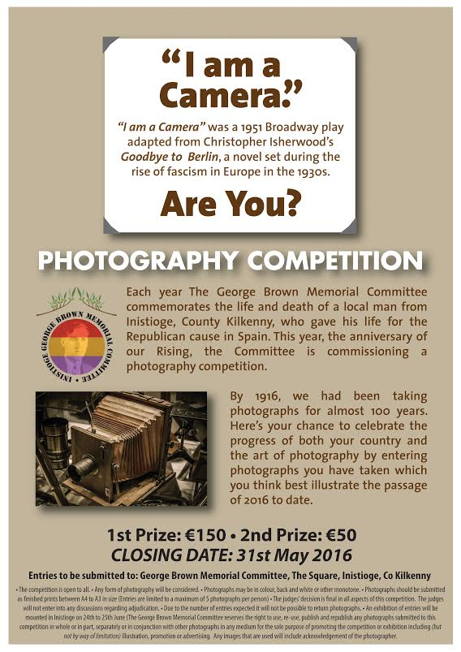

Grennan Mill Craft School, Thomastown: Graduate Show 2016

FRIDAY May 27th through to THURSDAY June 2nd
10.00am – 6.00pm daily

Grennan Mill Craft School is delighted to present their annual Graduate Show which will take place this year for 7 DAYS - PLEASE NOTE - we are NOT OPEN over the June Bank Holiday this year.

These new opening dates would suit school groups in particular, who normally would have closed for the Summer break in previous years.

This annual exhibition is a showcase of craft produced over 2 years by the graduating students.

Grennan Mill Craft School prides itself in teaching age-old crafts to a very high standard using traditional tools and techniques. The crafts include Batik, Ceramics, Metalcraft, Printmaking & Woven Textiles and each craft will be well-represented in the exhibition which is laid out throughout the mill. It is a great opportunity to see some high quality pieces of work which have been created by very talented students who have completed over two years, QQI / FETAC Level 5 Art, Craft and Design and Level 6 Art. Some works by the students will be for sale at very reasonable prices. The Graduating students this year come from Ireland, France, Austria, Spain & Germany.
Admission to the exhibition is free, and all ages are welcome. The ground floor only is wheelchair accessible. Car parking facilities are available on Mill Street within a short walking distance from the school as there is limited car parking at Grennan Mill Craft School itself.

There will be a café serving a selection of home-made baking and cooking which will be open only on Saturday 28th & Sunday 29th May.

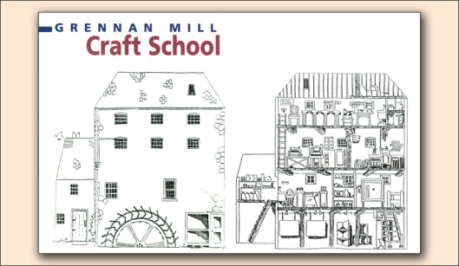

For additional information on both the exhibition and upcoming Summer Courses in Metalcraft & Jewellery, Introduction to Pottery Wheel Throwing, Weaving, Drawing & Life Drawing Courses - all suitable for Beginners & Improvers please contact Course Director at tele: 056 7724557 or email: grennanmillcraftschool@gmail.com
All are very welcome.

Introduction To Glass Painting with Bernie McAuley | Blackwatch Studio, Kilkenny
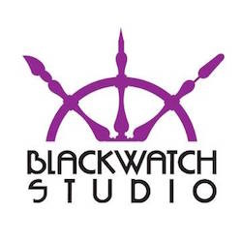
Weekend workshop, 28 and 29 May, 10am to 5pm
Cost: €65 per day (including materials).

DAY 1: Introduction to glass and plate and basic techniques
- Use of brushes
- Basic holding techniques glass/plate
- How to make a design
- Transferring design to glass

DAY 2: Recap/Painting on Plates
- Preparing surface
- Making a design
- Painting free hand
- Use of acrylic liners

Complementary tea, coffee and biscuits, but please bring own lunch.
For bookings and further information contact Vicki O’Donoghue on 086 837 0205 or email blackwatchstudiokk@gmail.com. (€50 deposit required on booking).

Blackwatch Studio
Freneystown, Clifden
Co.Kilkenny RX28 R95
www.blackwatchstudio.ie

Painting Workshops with Eamon Colman | Blackwatch Studio, Kilkenny
Five week course, Mondays 7 to 9pm, commencing 9 May
Cost: €100

Workshop focusing on colour mixing, light and transparency techniques. This series of two hour workshops will focus on colour mixing, light and transparency. Using the same methods as the Old Master layering of colour will be explored to create transparent and translucent tonal layers, building a depth of field using opposite colours from the colour wheel.
Eamon will discuss how the eye reads colour looking at colourist Josep Albert techniques and experiments. From the first pencil marks through to the finished painting this class will suit all abilities no matter what your chosen medium is.

For bookings and further information contact Vicki O’Donoghue on 086 837 0205 or email blackwatchstudiokk@gmail.com. (Deposit required on booking).

Blackwatch Studio
Freneystown, Clifden
Co.Kilkenny RX28 R95
www.blackwatchstudio.ie

Upcoming Events at the Watergate Theatre, Kilkenny

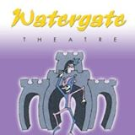

Here’s a look at some of the shows, gigs and other events taking place here at the Watergate Theatre in the next few weeks. You can speak to our helpful box office staff at any time by phoning 056 7761674.

7th May - 8 :00 pmIn The Spotlightwith Stagedoor
8th May - 3:00 pmIn The Spotlightwith Stagedoor
12th May - 8:00 pmCorner BoysMend & Makedo Theatre Co.
13th May - 8:00 pmThe Big FellowA Michael Collins story
14th May -2:30 pmStarmanA One Man Circus Comedy Theatre show
19th May - 7:00 pmCinderella - Dance Spectacularwith Kilkenny Academy of Dance
20th May - 7:00 pmCinderella - Dance Spectacularwith Kilkenny Academy of Dance
21st May - 2:00 pmCinderella - Dance Spectacularwith Kilkenny Academy of Dance
21st May - 7:00 pmCinderella - Dance Spectacularwith Kilkenny Academy of Dance
22nd May - 8:00 pmMuzyka Agus CraicPolska Éire Festival Closing Concert

http://watergatetheatre.com/

Exhibition space is available in City Library, John’s Quay

For more information, contact Aisling Kelly on 056 779 4175 or email aisling.kelly@kilkennylibrary.ie

Music at Castalia Hall

The the U.K. based York Trio will perform works by Beethoven, Rebecca Clarke and Brahms at 4.00 pm on Sunday 8th in Castalia Hall, Ballytobin, Co. Kilkenny. Throughout their long careers the members of the York Trio have performed with many leading ensembles including The Academy of St. Martin-in-the-Fields, the Orchestra of the Age of Enlightenment, the London Philharmonic and the London Mozart Players.

''Apples in Winter' with Uilleann Piper David Power and Fiddle Player Willie Kelly at Castalia Hall on Sunday 5 June at 8 pm. Their long anticipated CD entitled 'Apples in Winter' has just been released.

Kilkenny Community Orchestra at Castalia Hall Friday 13th May 2016 at 8pm

Friday 13th May 2016 at 8pm

Conductor - Sonja Cadogan Leader – Esther Hackett

Narrator – Hugh Campbell

Peter and The Wolf by Prokofiev - A musical tale for children

Programme also includes music by Handel, Mozart, Schubert, Brahms and Mussorgsky

Admission by donation

Enquiries: 086 359 2897, 087 986 1367, 086 863 2292
www.facebook.com/Kilkenny Community Orchestra

Other dates for your diary:
Castalia Hall, 4 pm Sunday 15 May - Royal Irish Academy of Music Symphony Orchestra
Castalia Hall, 8 pm Friday 10 June - Chamber Choir Ireland conducted by Paul Hillier
For further information http://www.musicinkilkenny.com

Duiske Abbey Concert

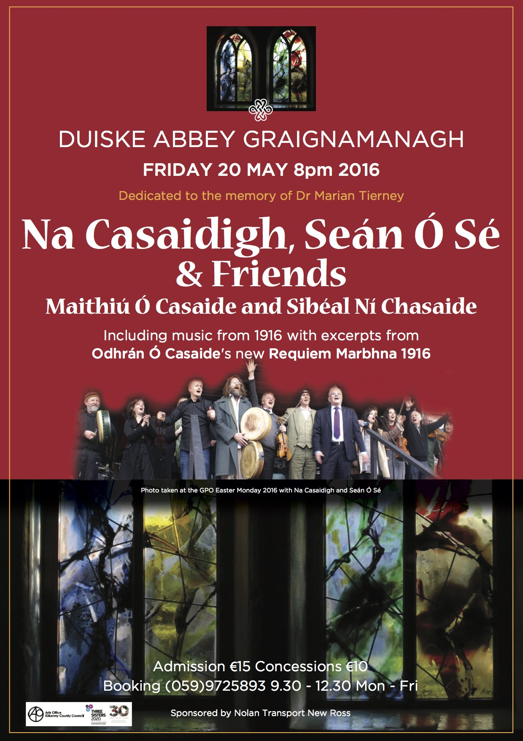

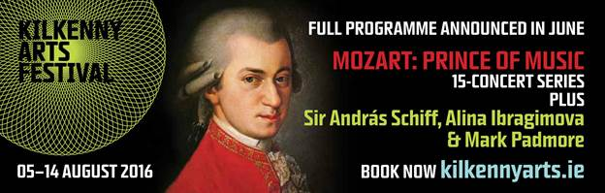

KCAT - The Laughing Heart || Galway Arts Centre || Thursday 28 April 2016

The Laughing Heart || April 28 – May 14 2016 || Galway Arts Centre
Thomas Barron | Declan Byrne | Mary Cody | Sinéad Fahey | Fergus Fitzgerald | Karl Fitzgerald | Andrew Pike

“there is a light somewhere”

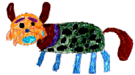

The Laughing Heart is a group exhibition featuring seven artists from KCAT Studios, Callan, Kilkenny. The exhibition has been curated as a result of studio visits by GAC’s curator Maeve Mulrennan over the past eight months. Although a broad range of practices are represented, The Laughing Heart focuses on the duration and process involved in studio based practice through painting, sculpture and animation.

The paintings of Thomas Barron endure a process from figurative mark-making into the abstract, with each large canvas undergoing countless layers of drawing and painting. Declan Byrne’s work in painting and sculpture mediate on the materiality of paint itself, with colour broken down, echoing pointillist techniques. Mary Cody’s painting has developed over her career to incorporate different materials such as wool working with multiple layers of paint. The abstract work speaks of time, landscape and ritual, with Cody making visible the lengthy process of layering materials. Karl Fitzgerald’s semi-abstract paintings on paper also focus on practice, time and ritual, with new work being made by the artist each day he spends in the studio. It is Karl’s work that links again to Bukowski’s The Laughing Heart: ‘there is a light somewhere’. Each work, featuring a sunset or sun rise, and most often a body of water, may, on their own, present as melancholic, particularly with Karl’s choice of colour. However it is when a whole week, month, or indeed a year’s worth of daily paintings are presented that the viewer can contemplate the subtle changes each day. Also the fact that there are many, and many more to come, gives an overall optimism. Fergus Fitzgerald combines text and image to present a multi-faceted approach to landscape for the audience; encouraging engagement and careful attention to detail. Sinéad Fahey’s work is full of colour and light. Playing with composition and perspective, Sinéad’s everyday observations are transformed into a kaleidoscopic world, leading the viewer to pay close attention to form, line and texture. The ever sardonic Andrew Pike presents two animations, referencing global politics via tennis and a love affair in one, and James Joyce and friends in another. Plays on words, puns and literal representations of metaphors, delivering Pike’s caustic wit via the lengthy and painstaking process of stop-motion animation.

Galway audiences will be familiar with Andrew Pike and Sinéad Fahey, who co-designed Macnas’ 2006 parade, The Big River, working with familiar faces such as Dave Donovan and Pete Casby. The parade also toured to Callan and the Kilkenny Arts Festival in 2006.

The title of the exhibition comes from the poem of the same name by Charles Bukowski. The title was chosen to represent the different processes of each artist: the poem speaks of light, duration and affirmation. What was apparent from the very beginning of the curation process was the dedication and focus each artist brings to their practice. Each artist works fulltime in KCAT Studios, something which is reflected in their multiple past solo and group exhibitions and projects. KCAT Studio, part of the KCAT Arts and Study Centre Kilkenny, supports each artist and their practice.

The Laughing Heart will open at 6pm on Thursday April 28th and run until Saturday 14th May.

Contact: 091 565886 || info@galwayartscentre.ie || www.galwayartscentre.ie

Kilkenny Artist Lucy McKenna Talk at The Artist Observatory, Co. Armagh
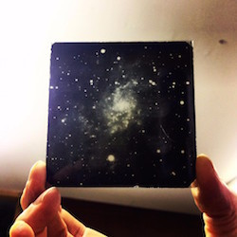
Friday 29 April | 11.30am to 12.30pm
Armagh Observatory | College Hill, Armagh BT61 9DG

Lucy McKenna will be discussing her time at the Armagh Observatory and Planetarium as an artist in residence, the research she undertook and some of the ideas that have developed since.
‘The Artist Observatory’ was the second edition of a new alternative residency programme piloted by Catalyst Arts. The residency offered the rare opportunity to access first hand the processes carried out at the Observatory and Planetarium in Armagh, engaging with astronomers for discussion and research, diffusing the boundaries between artist and researcher and supporting the mutable position of the artist as observer.

The event is free to attend however booking is essential due to limited capacity. To book a place visit: www.eventbrite.com/e/artist-observatory-lucy-mckenna
or contact Catalyst at catalystarts@gmail.com or phone 028 9031 3303.

Course / Training / Jobs / Internships

Performative Curating Course at Fire Station Summer School, Dublin 1
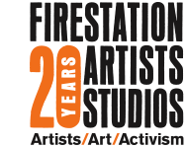

Deadline for applications: 27 May 2016 (Email applications only)

Tuesday 19 to Friday 22 July 2016 | Fee: € 200 (includes lunch/ refreshments x 4 days)
Fire Station Artists’ Studios, Dublin 1

Hosted by Florian Malzacher and Joanna Warsza with guest speakers Gregory Sholette and Olga Kopenkina.
Open to all Artists, Curators and Cultural Practitioners working in an interdisciplinary and / or socially engaged practice, who would like to develop new working methodologies.

This summer school hosted by international practitioners Florian Malzacher and Joanna Warsza, evolves around the concept of performativity as a methodology of incorporating theatre-inspired methods in the curating process. How can the creation of temporary communities, the impact of time and space, the tactics and strategies of theatre, dance and performance contextualise artistic work?

For more information please visit: www.firestation.ie

University College Cork: Masters in Voluntary and Community Sector Management

Applications are now being accepted for this Masters which has been running since 2008. It is being offered to voluntary and community sector workers who would like to improve their knowledge and skills base. The course may also be of interest to public sector workers who work closely with the voluntary and community sector.

Starting in September 2016, the course is taught one day a week (Wednesday 10.00-4.30) over two years. Eight different Depts across UCC contribute modules to the programme - Applied Social Studies, Law, Management, Business Information Systems, Accounting, Economics, Government, Food Business and Development

Further information on this programme is available on our online prospectus at www.ucc.ie/en/CKE75, or by contacting Dr. Féilim Ó hAdhmaill, School of Applied Social Studies, on 021 490 2616 or email f.ohadhmaill@ucc.ie

Applications can be made online through the Postgraduate Admissions Centre at http://www.pac.ie .

Health & Safety for Visual Artists with Vincent Kiely – Dublin

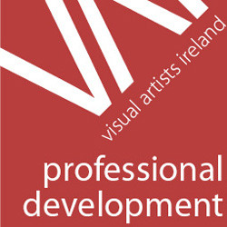
September 1, 2016 – September 1, 2016

Description:
As self-employed individuals artists have a duty under health and safety law to ensure that their working environment complies with health and safety legislation. The nature of artistic practice is such that artists use a very eclectic mix of materials and processes in their day-to day work, which can be detrimental to an artist’s health and safety, quality of life and career. This session with Health & Safety Consultant Vincent Kiely addresses these concerns looking at Health & Safety from an artist friendly perspective.

To give us a sense of your work processes and the health and safety issues that you’d like to see addressed in this session please follow the registration link on http://visualartists.ie/

Vincent Kiely is an independent Health & Safety Consultant and Trainer. He has developed training in Health & Safety and implemented Health, Environmental and Quality procedures for clients such as: the Dublin Airport Authority; Intel; Bristol Myer Squibb; University College Galway Hospital and Pfizer. He holds Higher Diploma in Occupational Safety and Health Technology from UCD (2013). He is a

Open Call | 126 Internship Placements 2016
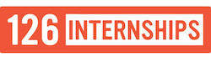
Deadline for applications: 1 June

126 extends an open call to graduates who wish to participate in their 2016 Internship programme. Four interns will be selected for a six month internship running from July to December 2016. The interns will be mentored by the board members and will gain experience in all aspects of running the gallery including (but not limited to): fundraising, applications, curation, marketing, archiving, web design and arts administration. The internship culminates in a project, exhibition or event to be developed and curated by the interns under the mentorship of the 126 board and to take place at 126 in December.

* PLEASE NOTE: 126 is an artist led, non profit organisation run voluntarily by a board of professional artists who undertake all aspects of running the gallery. As such, this is an unpaid opportunity.

For more information see http://126.ie/

Please contact internship coordinators, Cliodhna Timoney or Blaithin Hughes with any inquiries, by emailing: contact@126.ie
Call for Submissions / Residencies

‘Over the Edge’, online poetry workshops

Starting in May, Over The Edge is offering aspiring poets worldwide a ten week online poetry workshop with poet Kevin Higgins.

Each of the ten weeks Kevin will email participants a poetry writing exercise for the following week and participants will submit one of their poems to Kevin for constructive criticism. Kevin will work with participants on making each of their poems the best possible poem it can be.

Kevin is a highly experienced workshop facilitator and several of his students have gone on to achieve publication success. He has facilitated poetry workshops at Galway Arts Centre for the past ten years. One of his workshop participants won the prestigious Hennessy Award for New Irish Poetry; two have been shortlisted for the Shine/Strong Award for Best First Collection by an Irish poet; two have won the Cúirt New Writing Prize; and another the Cúirt Poetry Grand Slam; several have published collections of their poems with reputable publishers.

Kevin also teaches poetry on the NUI Galway Summer School programme and mentors poetry students on the NUIG BA Creative Writing Connect programme. Kevin is co-organiser of the successful Over The Edge: Open Reading series which specialises in promoting new writers.
The workshop will run for ten weeks, commencing Wednesday May 18th, 2016. The cost to participants is €110. There are no refunds. The workshop will be conducted in English only.

For queries, email over-the-edge-openreadings@hotmail.com

YOU CAN REGISTER ONLINE NOW
Here http://overtheedgeliteraryevents.blogspot.ie/2014/02/over-edge-offers-poets-worldwide-online.html

Open Call | Art and Science Residency at the European Space Agency
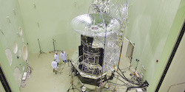
Deadline: 6 June

After three successful cycles of the Art and Science Residency Award, European Digital Art and Science Network present a new scientific partner for the fourth residency in the framework: ESA – the European Space Agency.

Artists above the age of 18 from all countries are invited to apply for a residency at ESA. The winning artist is subject to obtaining clearance to work on site at ESA-ESTEC. This call is open to digital artists to propose innovative concepts and ideas in the field of art, science and technology.

The EDASN are looking for digital artists who will be truly inspired by the scientific work enabled and achieved by ESA. This competition is open for artists to propose all kind of innovative concepts and ideas in the field of art and technology: interactive art, digital music/sound art, computer animation / Film / VFX, digital communities, hybrid art, performance & choreography, digital design.

Full details can be found here: www.aec.at/artandscience/en/open-call/

Open Call | Artist in Residency Programme | Valencia, Spain
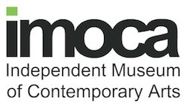

STANDARD Galería y Estudios and the Independent Museum of Contemporary Arts have launched their International Artist-in-Residency programme in Valencia, Spain. The programme is flexible in duration, although two-to-three months is typical, as the time is designed for the development of an exhibition, performance, artist talk or some other form of distribution. In some instances, residencies of a shorter duration that are not designed to result in an exhibition will also be considered- e.g. artist research retreats, etc. Exhibitions and documentation of the residency will be included in the related annual catalogue published with an ISBN. The residency is open to artists at any stage in their career and working in any medium, and include a private studio, living quarters, access to staff and equipment. Curators are also welcome to apply.

It is an ongoing open call and there is no fee to apply.

For full details, term and conditions and application form see: the.imoca.ie/international-artist-residencies/

Open Call for Exhibition Proposals | Art at The Ivy House
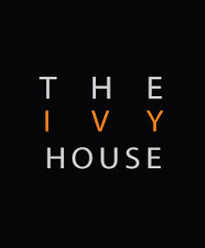
Deadline: 30 May

Art at The Ivy House is currently looking for exhibition proposals from artists for solo, two-person or group exhibitions for 2016-2017.
The Ivy House is a modern bar with an active programme of events, live music, pub theatre, movies and art exhibitions.
For all details see www.theivyhouse.ie

Open Call | Enniskillen Visual Arts Open 2016
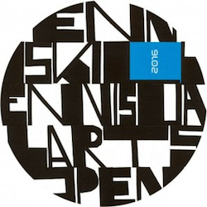
Deadline for applications: Monday 13 June, 12 noon
Exhibition dates: 16 September to 15 October
Venue: The Higher Bridges Gallery, at The Clinton Centre, Belmore Street Enniskillen & Enniskillen Town (further venues tbc / post submission and selection process)

Applications are now being sought from Artists working in any medium including painting, print, photography, sculpture, installation, video, light, sound, performance, multimedia and applied arts to participate in a major exhibition of Visual Art due to be sited at the Higher Bridges Gallery and Enniskillen town centre. The exhibition will also coincide with the 2016 Fermanagh Arts Festival.

Interested artists can download the application form and terms and conditions from the following link:
www.fermanaghomagh.com/arts-and-culture/higher-bridges-gallery/enniskillen-visual-arts-open-2016/

Please read terms and conditions carefully. The organisers state: subject to the availability of funds and at the discretion of the arts festival, funding may be provided for production/installation.

Royal Ulster Academy 135th Annual Exhibition Open For Entries
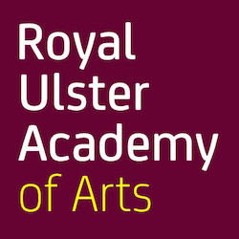

The Royal Ulster Academy 135th Annual Exhibition will take place at the Ulster Museum, Belfast from the 14 October 2016 to 15 January 2017. With over 81,000 visitors in 2015, this long standing event aims to expand contemporary approaches to the visual arts.
The Annual Exhibition showcases works by members of the Academy and works selected through open submission and by invitation.

To enter please visit: www.royalulsteracademy.org/annual-exhibition

Over £7,000 in prize money will be awarded to exhibiting artists of merit. Independent adjudicator Christopher Le Brun PRA, will select recipients of the Academy’s gold, silver and bronze medal prizes. All other prizes will be awarded by the prize sponsors.

Open Call | Public Art Commission, The Liberties, Dublin 8
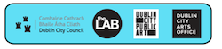
Deadline: 9 June
Budget: €75,000 (inc. VAT)

Dublin City Council and Fáilte Ireland invite proposals for public artworks to be located along the thoroughfare that runs from High Street to James Street in Dublin 8. The work forms part of a programme of public realm improvements to these streets which are now part of The Dubline – a major discovery trail through the city, exploring its history over the past 1000 years. The recent public realm improvements have an opportunity to renew the streets and create a more inviting and engaging route for the people who live, work and visit the area.

Artists are welcome to submit queries to the Public Art Manager (who is managing the commissioning process on behalf of Dublin City Council). Contact publicart@dublincity.ie. The closing date for queries is May 26th 2016 at 12pm.

Please carefully read the information in the Commission Brief provided. Detailed guidelines, application forms and procedures can be found in the document The Liberties Art Commission Brief at
http://www.dublincityartsoffice.ie/content/files/The_Liberties_Art_Commission_Brief_.pdf

Per Cent for Art Commission | Gaelscoil Shliabh Rua, Dublin 18
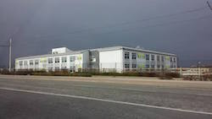

Deadline: Friday 17 June, 12 noon
Budget: €25,000

Gaelscoil Shliabh Rua Public Art Working Group have made the decision to commission a permanent artwork that is process focused and involves all the young children in this school for their Per Cent for Art project. This artwork can be sited internally or externally to the building.

For the full Brief and Queries:
Applicants can make enquiries regarding the commission to Rina Whyte, email rinawhyte@yahoo.com or by telephone + 353 87 238 9591.

Per Cent For Art Commission | Scoil Mhuire National School, Tullamore, Co. Offaly
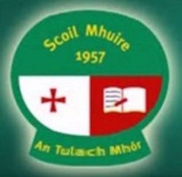

Deadline for Stage 1 Applications: 10 June
Budget: €34,000 inclusive of all fees, costs and VAT

Under the Per Cent for Art Scheme, Scoil Mhuire National School wishes to commission new visual artwork to celebrate and coincide with the construction and opening of the drop-down and collect area for both Scoil Mhuire and Scoil Bhríde and the complete refurbishment/extension of Scoil Mhuire. This is a 2 Stage Commission process, applicants are requested to read the full content of the Guidelines Document carefully as it contains important information pertaining to all stages of the commission.

Artists Brief:
The aim of the commission is to provide an opportunity for artists to develop new work influenced by the history, context and aspirations of the students, teachers, parents and community of both schools and the surrounding area. The Project financed under this scheme should maintain the highest level of artistic excellence, be innovative in nature and display a high level of understanding of the context of the commission.

The commission is for a piece or pieces of fixed permanent public sculpture of resilient and weather resistant material with minimal maintenance requirement, reflecting the spirit of the brief. Refer to the red zone in the attached site layout plan. The proposed setting of the work is to be situated outside and visible from both schools as well as passers-by.

Guidelines
Scoil Mhuire Per Cent Art Scheme Guideline Document
Site Map
Kilcruttin, Tullamore, Co. Offaly.
(057) 9321222 / www.scoilmhuiretullamore.ie

Open Call for Commission | Irish National Stud, Kildare
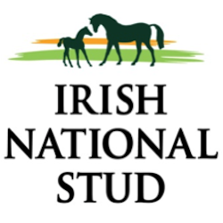
Deadline for Round one: 31 May 2016
Total budget for artwork: €75,000 (inc. VAT)

The Irish National Stud (INS) wishes to commission an outdoor sculpture, inspired by the title “Invincible Spirit”, to be sited within the grounds of the Stud farm at Tully, Kildare.

The Irish National Stud (INS) is a state-owned and world renowned thoroughbred stallion farm, trading for over 100 years as such. The stud is at the forefront of the development of thoroughbred breeding, an area in which Ireland is considered the world leader.

The Irish National Stud wishes to commission an outdoor sculpture, inspired by the title “Invincible Spirit”, to be sited within the grounds of the Stud farm at Tully, Kildare. Although Invincible Spirit is a highly successful stallion, standing at the Stud, the artwork need not be a representation of an identifiable horse but could perhaps express allegorically what the words Invincible Spirit evoke.

The project should be innovative in nature and display a level of understanding of the context of the commission while maintaining the highest level of artistic excellence.

Expressions of interest are now sought from suitably qualified artists for round one of the two part selection process.

Email and queries to: art@irishnationalstud.ie
irishnationalstud.ie

Living Arts Project - Arts in Education
CALL FOR EXPRESSIONS OF INTEREST: Schools & Visual Artists, 2016-17
Wexford County Council Arts Department, in partnership with Wexford Arts Centre and the Arts Council, is seeking applications from primary schools and visual artists to participate in the Living Arts Project commencing in October 2016.

Under this scheme, selected primary schools have the unique opportunity to host an artist in residence during the school year.
We are now receiving applications from primary schools and visual artists interested in participating in the programme. In order to submit an application to this year's projects.

Deadline for expressions of interest is 4pm Thursday 26th May 2016.
Established in 2013, the Living Arts Project is a long-term visual arts educational scheme which consolidates the existing partnership between the Arts Department of Wexford County Council and Wexford Arts Centre. It makes engagement with the fundamentals of contemporary visual art accessible for local audiences.
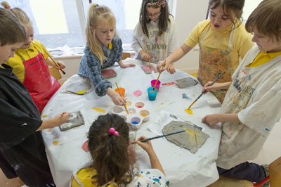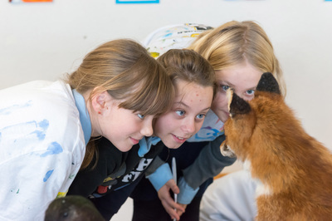

For further information on the Living Arts Project and/ or any questions you may have please email catherine@wexfordartscentre.ie.
For further information on Wexford County Council’s full arts programme please visit www.wexford.ie/arts or call 053 9196441 / email arts@wexfordcoco.ie.

Call for Submissions | PhotoIreland Open Programme 2016
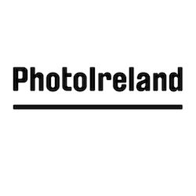
Deadline: midnight 8 May

The Open Programme 2016 offers artists, photographers, curators and organisations the opportunity to put forward events and join the festival celebrations. We welcome submissions of events relating to Photography and contemporary image culture, from national and international individuals and organisations, looking to develop their own events in Dublin during the month of July. The events could be exhibitions, installations, performances, films, shorts, videos, talks, workshops… the limit is your imagination!

All participants will be featured in the festival catalogue and website, and will receive festival catalogues to distribute during the event.

Submissions are free and open now. There is a contribution fee of €125 towards the marketing materials.
To submit, email a brief description of your proposed event or exhibition and the venue where the event will be held to pif.submissions@gmail.com with OPEN PROGRAMME as the subject.
photoireland.org/festival/year-2016/open/

Call for Submissions: The Fool For Poetry International Chapbook Competition

The Fool For Poetry International Chapbook Competition is now open for submissions, deadline 31 May. The first and second prize winners will receive a cash prize (1st prize: €1000, 2nd prize: €500), chapbook publication, 50 free copies of their chapbooks. The winning poets will be offered a reading and given three nights' accommodation at the 2017 Cork Spring Poetry Festival. This is a great opportunity for both established and emerging poets, as at least one of the top two winners is guaranteed to be a debutante publication. The judges will be a panel selected from the Southword Editions board of management. Submission guidelines and further details can be viewed here: http://munsterlit.ie/Fool%20for%20Poetry.html , and queries sent to me at info@munsterlit.ie are very welcome.

Awards / Bursaries / Schemes

Arts Council of Ireland: Upcoming Funding Deadlines

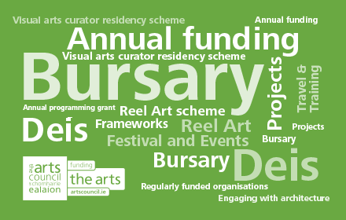
http://www.artscouncil.ie
Application deadline  Ongoing | Dámhachtain sparánachta litríochta  Dámhachtain sparánachta litríochta | Maximum award €0  Accepting applications
Application deadline  Ongoing | Travel and Training award  Please note maximum amount awarded differs between artforms. There are three strands to this award: Travel and Training Outbound; Travel and Training Inbound; Creative Europe (Culture sub-programme) Travel Award. | Maximum award €3,000  Accepting applications
Application deadline  Ongoing | Visual artists in prisons scheme  The scheme allows artists to work with prisoners in prison/ detention centres for a period of 10 days and complements an existing arts and education programme in the Education Units within the prison system. | Maximum award €2,400  Accepting applications
Application deadline  Ongoing | Writers in prisons scheme  The scheme offers writers the opportunity to work with prisoners in prison/detention centres and complements an existing arts and education programme in the Education Units within the prison system. | Maximum award €1,000  Accepting applications
Application deadline  Ongoing | Writers in schools scheme  The Writers in Schools Scheme part-funds visits by writers and storytellers to schools throughout the island of Ireland. | Maximum award €200  Accepting applications
Application deadline  9 June 2016 17:30 | Deis  Deis is a scheme established under the Arts Councils Traditional Arts Initiative, 2005-2008. Deis is aimed at encouraging and facilitating the traditional arts community to seek funding from the Arts Council for a range of projects. | Maximum award €20,000  Opens 10 May 2016
Application deadline  9 June 2016 17:30 | Engaging with architecture scheme  The purpose of the scheme is to support ambitious, innovative and creative, high quality initiatives that specifically aim to enhance and extend the public’s experience of architecture. The Engaging with Architecture Scheme also seeks to build an expert network of architects, curators, arts programmers, festivals and arts centres working in this area. | Maximum award €20,000  Opens 10 May 2016

ieiMedia/IWC Scholarship Opportunity for Writers aged 18–25

ieiMedia and the Irish Writers Centre are pleased to offer one full and one half scholarship to a writer in the playwriting strand of this four-week residential course in Armagh and Dublin during the month of July.
This is a fantastic opportunity to gain valuable training and experience with professional writers in a group setting and to take part in the John Hewitt Summer School.
Deadline for applications: 10 June at 5pm.
http://irishwriterscentre.ie/collections/writing-opportunities/products/ieimedia-irish-writers-centre-joint-scholarship?mc_cid=96d8ccee98&mc_eid=055476dad7

Applications Open for Most Promising Graduate Award, Talbot Gallery, Dublin

Application deadline: 23 May, 5pm
Talbot Gallery Studios, 51 Talbot Street, Dublin 1

Talbot Gallery Studios are accepting submissions for our Most Promising Graduate Award 2016. The winner of the award shall receive a twelve-month studio residency rent free. The competition is open to graduating students from the Dublin Institute of Technology, the Dun Laoghaire Institute of Art, Design and Technology and the National College of Art and Design. The award shall be presented to an outstanding candidate who is considered to display talent, flair, innovation and potential by Talbot Gallery & Studios.
The winner of the award shall receive a residency within the Talbot Gallery & Studios premises which is located in the heart of Dublin City, on Talbot Street. The graduate in receipt of this accolade and private studio use shall be instantly transported into a professional setting from which to launch their creative career. This residency shall last for an eleven-month period running from the beginning of July 2016 until beginning of July 2017.

www.talbotgallery.com

Engaging with Architecture Scheme | Arts Council Ireland
Closing date: Thursday, 9 June, 5:30pm
Applications open from 10 May

The purpose of the Engaging with Architecture Scheme is to support ambitious, innovative and creative, high-quality initiatives that specifically aim to enhance and extend the public’s experience of architecture.
The Arts Council announces the Engaging with Architecture Scheme 2016, with the purpose of engaging the public with architecture. Projects must take place before 28 April, 2017.

The scheme comprises two separate strands: strand 1 is designed to support the research and development of a project, while strand 2 is intended to support the realisation of a project.

For more information see: www.artscouncil.ie/Funds/engaging-with-architecture-scheme/

Please note
Applications will only be accepted through the Arts Council’s online services website. Applicants who have not previously used this system must register in advance of making an application. It can take up to five days for registrations to be confirmed so it is very important that you register as early as possible.

Emerging Visual Artist Award

An Arts Council, Wexford Arts Centre and Wexford County Council Partnership Initiative
CALL FOR APPLICATIONS
Wexford Arts Centre and Wexford County Council are pleased to announce a call for submissions for the annual Emerging Visual Artist Award.
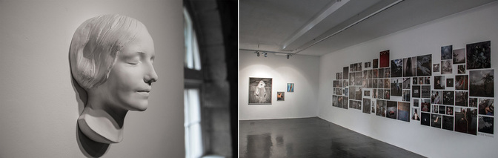
My Own Unknown by Dragana Jurisic in situ at Wexford Arts Centre, February 2016
The Emerging Visual Artist Award is a partnership initiative between Wexford County Council, Wexford Arts Centre and the Arts Council. The initiative supports promising visual artists in Ireland with an award of €5,000 and a solo exhibition at Wexford Arts Centre.This award is aimed at recognising and supporting the development of committed emerging artists, in kick starting their career and achieving professional recognition.
The successful recipient will be required to create a new body of work during the period October 2016 - December 2017, which will be exhibited at Wexford Arts Centre during January - February 2018.
Who is eligible to apply for the Award?
- Applicants practicing any visual art form are eligible to apply;
-Applicants must have resided in Ireland for a minimum twelve month period to be eligible to apply;
- Applicants cannot be currently enrolled in an undergraduate programme in their art form at the time of the application deadline;
What selection criteria will be used?
- Applicant's demonstrated commitment as a serious professional to her/his art form;
- Overall excellence of the applicant's art work;
- Demonstration of exceptional talent;
Submissions must be emailed to emergingvisualartistaward@gmail.com and include the following:
1) An up to date CV;
2) A statement about your work detailing themes, working methods and medium - 300 word limit;
3) A proposal in relation to the body of work which you intend to undertake - 350 word limit;
4) Timescale breakdown - research, production, delivery;
5) Budget breakdown - materials, travel, studio hire, etc.;
6) Examples of work to date i.e. documentation in the form of 10 Jpeg images.
Full details for each image are required, i.e. title, medium, measurements, date of work. Three copies of each film, video or audio work can be sent by post marked as Emerging Visual Artist Award, Wexford Arts Centre, Cornmarket, Wexford Town, Co. Wexford, Ireland.
Notes on Submissions
Please adhere to the following notes whilst preparing your application:
- Please format all information in one document and keep to the word limit on the artist statement and proposal;
- Please save each Jpeg image with the following details: Artist's Name_Title_Medium_Dimensions_Year;
For example: NoelSmith_LandscapeInBlue_AcrylicOnWoodenPanel_43x30cms_2013
- Please label each film, audio or video work with your name and contact number, work title, and duration or alternatively send Youtube or Vimeo links with relevant information;
- Do not submit any hard-copy material, for example catalogues, invitations, artist books, etc.;
Please enclose a €7.50 processing fee with your application. Payments can be made through our website: https://wexfordartscentre.ticketsolve.com/#/shows/873554420 or you can ring the Box Office at Wexford Arts Centre on +353 (0)53 9123764 with your debit card details.
The deadline for receipt of email submissions is 4.00p.m. Thursday 2nd June 2016. For gallery plans and images please download file below see the Wexford Arts Centre Website.

Of Interest

Great listing of jobs available.....

Lots of listings added to the blog by Emily Mark - FitzGerald https://artsmanagement.ie/
— including coordinators for Culture Night; Art Registration Officer for the OPW; Open House Dublin Coordinator for the Irish Architecture Foundation; Outreach Officer for the National Museums of Northern Ireland; and Project Manager for a Creative Europe-funded project run by RUA-RED South Dublin Arts Centre — just to name a few!

May / June Visual Artists’ News Sheet (VAN) available soon
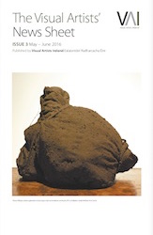The May/June Visual Artists’ News Sheet (VAN) will be circulated soon. Selected articles on art criticism, artist-led spaces, funding in Northern Ireland and online works are up on the new VAN blog at: http://visualartistsireland.com

All Ireland Workspace Survey 2016 | For Individual Artists, Artists Groups, and Arts Organisations

PLEASE ASSIST US IN OUR SURVEY INTO ARTISTS WORKSPACES

Since our foundation, Visual Artists Ireland has provided support to artists and to workspaces both practically and in our advocacy work. Over this period we have seen many changes and a wide range of challenges. We have seen different solutions provided… some of which continue and some which have fallen by the wayside as other ways of thinking have come to the fore.

The current acknowledged difficulties of finding suitable buildings or spaces is no longer new news. For the past year, we have been looking both at home and abroad to see what things are working and how we can learn from them so that we can provide concrete suggestions and assistance. What is missing is clear quantifiable evidence of both the supply and the demand… and the precise needs of both across Ireland.
The next step in this is to ask artists, artist groups, and organisations to assist us in putting together a clear view of what is currently available and what are the real needs out there – both for artists and for organisations/groups.

To do this we have put together two surveys. In these surveys we ask the key questions that will provide us with a wider understanding of the entire country and also local areas. The findings of this survey will be combined with our other research so that we can provide a formal report that can be used by all to clearly identify what we are talking about…

For Artists – https://www.surveymonkey.com/r/DSHDMV6
For Workspaces/Artists Groups https://www.surveymonkey.com/r/DF3LVGC
Deadline to complete is 12th May 2016

At the 2016 Get Together we will have a specific forum to discuss our own findings and also to invite decision makers to come and see various models that can be developed around the country.
As always, if you are having a local discussion about this subject, then please let us know, and if we can’t make it to the actual meeting then please let us know the outcomes.

All of the information that you provide will be used only for this report and will be fully anonymised when published.

A New Website Listing Irish Nonprofits at Benefacts.ie | Check Your Organisations Information Before Official Launch

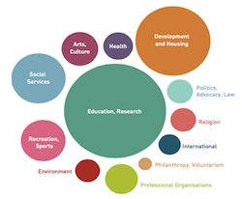

The beta version of the Benefacts website is available at beta.benefacts.ie until May 18th when the full site goes live. Benefacts is a new, free online information service which will provide everyone with up to date facts and figures about Irish civil society organisations. The aim of introducing the site in Beta is to give listed nonprofits a view of their own data before it goes live to the general public. This edition of the website will include the Search and About menu options. In Search mode, users can search for any term and receive a list of relevant results which they can then sift through further by using the filter menu. They can also find governance, financial and regulatory information through the Search function. The first release of the website will provide financial data from 2013 and 2014.

The About section is where users can learn more about the project, get answers to FAQs, view the articles, blog, knowledge base etc.

The full website with the Explore and API menu options will go live to the public on May 18th. The Explore function allows users to view nonprofit organisations by sector in terms of income, age, institutional profile, and public funding amongst other factoids and pieces of information. The API menu function is a link to our public API (Application Programme Interface) which is where people can generate data for themselves based on publicly available information.

Since the middle of 2015 Benefacts has been building this database of Irish nonprofits. Work is still ongoing, and new organisations will be included right up to the end of 2016. Benefacts plan is to issue a second release of the website before the end of 2016, when financial data from 2015 will be available.

Blackstairs Film: Saturday night film in Rathanna: The Grump

See you at our Saturday night movie on 7th May in Rathanna Hall. [Traveling from Borris to Rathanna, take the R 702 at the bottom of the Town, under the old railway viaduct, for 6.2 kilometres]
Door open at 8pm, screening is shortly after.
Tickets at the door €8.50 per person, members free.
OUR MOVIE - THE GRUMP
If you liked ‘The 100-Year Old Man Who Climbed Out the Window’, you’ll enjoy this tale of another elderly rascal.
After a bad fall, a stubborn old farmer moves in with his career-focussed daughter-in-law, where he’s confronted with the modern world. This bittersweet culture-clash satire from director Dome Karukoski (Lapland Odyssey) was the biggest homegrown Finnish box-office hit last year.
http://blackstairsfilmsociety.com/sat-may-7th-the-grump-rathanna-hall/
Follow us on https://www.facebook.com/blackstairsfilmsocietyborris

