Kilkenny County Council

Anti-Litter and Anti-Graffiti Awareness Community Grant 2024

Kilkenny County Council is offering community groups an opportunity this year to promote anti- litter and anti-graffiti awareness in their local community. The grant is to mobilise community groups to care for their local environment by decreasing the impact of litter by its removal and to promote a social message locally to encourage everyone to put litter in its rightful place – in a bin.

If the grant application relates to anti-graffiti, the application must be accompanied with photos to illustrate the project location and the extent of the problem. Projects relating to painting derelict buildings are not eligible under this grant scheme.

As funding comes directly from the Department of Communications, Climate Action & Environment there are funding restrictions which must be adhered to.

This grant cannot cover
- the purchase structural items such as street furniture
- the purchase of litter bins
- the purchase of dog bag dispensers
- the purchase of signage
- the purchase or rental of CCTV cameras

The grant can cover expenses such as
- The purchase of bags for dog bag dispensers if dispensers are already installed at are under the care of the group
- The expense of litter disposal resulting from litter picks and the expense of disposal of rubbish from public street bins which are under the guardianship of the community group
- Awareness events highlighting the issue of litter and dog fouling in your local community

Projects under this scheme can vary greatly and the funding levels reflect this. Factors such as the number of participants, the location of the project, the level of assistance a community receives from its Local Area Office and the length of the project period is reflected in the grant allocations.

Previous tidy town applicants have received funding for frequent litter clean ups in their community ranging from €350-€1,500, these groups purchase their own litter supplies and pay for the disposal litter collected in their local area throughout the year. Other previous projects include youth awareness projects and workshops specifically addressing the impact of litter on the local environment.

The closing date for grant applications is the 24th of May 2024 and Kilkenny County Council has allocated approx. €12,000 towards community projects. The grant scheme supports the following local policy; Kilkenny County Council Litter Management Plan 2024-2026.

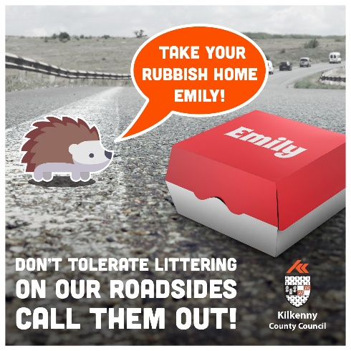
Applicant Information

1. | Name of Organization
2. | Contact Name
3. | Position in Group
4. | Contact Number
5. | Email Address
6. | Postal Address

Project Details (Use separate sheet)

Describe the project you are seeking funding for and at a minimum include the following;

- Project Overview;

- Project Location;

- Project Duration (No. of Hours);

- Start Date/End Date

- Estimate Number of Participants;

- How will your project promote greater public awareness and education in relation to litter and/or graffiti in your local community?

Financial Details

Expenditure Breakdown (Itemised): | €
Applicant Contribution (Itemised): | €/In Kind
Other Sources
Total

If your group has members under 18 years or will work with persons under 18 years please advise if this group is compliant with Children’s First Act 2015:

Yes No

If No, please sign Kilkenny County Council’s Child Protection Policy Declaration Form. (Appendix X of Kilkenny County Council’s Policy for the Protection of Children)

The closing date for applications is the 24th of May 2024, please submit completed application forms to:
Deirdre Trait
Environment Section, Kilkenny County Council
County Hall
John Street
Kilkenny City

Email applications are also acceptable before 5pm on the 24th of May 2024, Deirdre.trait@kilkennycoco.ie

Conditions and criteria used in selecting anti-litter and anti-graffiti awareness community grant:

- All projects should seek to promote greater public awareness and education in relation to litter and/or graffiti and should have a particular focus on involving schools, youth groups, environmental groups, voluntary groups or community groups.

- Grants should be used, where possible, to influence local business co-funding of anti-litter or anti-graffiti education/awareness measures.

- Projects that receive funding may be obliged to submit a project completion report in 2024 detailing expenditure.

- Projects should be to a high standard and should aim at establishing or replicating best practice in relation to litter or graffiti education/awareness measures and be in line with the policy actions within Kilkenny County Council Litter Management Plan 2024-2026.

This application is available in Irish upon request

Tá an t-iarratas seo ar fáil i nGaeilge nuair a iarrtar é

