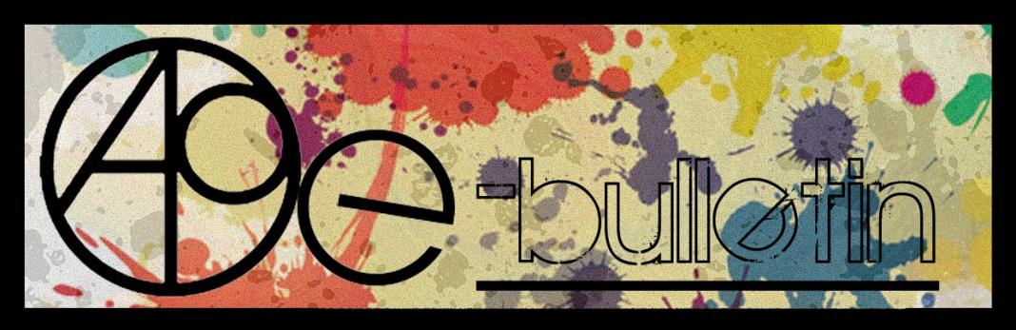

**Kilkenny County Council Arts Office E-bulletin 8thAugust, 2014**

Dear All,   
  
Welcome to this week’s e-bulletin from Kilkenny County Council's Arts Office. Each bulletin is packed with the latest information on Kilkenny Arts Office activities, county events as well as news and opportunities for arts practitioners from around the country.

This service will be provided fortnightly. To include an item in the next e-bulletin please send a brief outline of your advert with relevant contact details, including any websites or pages with links to [**niamh.brophy@kilkennycoco.ie**](mailto:niamh.brophy@kilkennycoco.ie) **before 3rd September**. The next e-bulletin will be on **5th September**.

While every effort has been made to ensure the accuracy of our information, we strongly advise readers to verify all details to their own satisfaction.

Regards,  
Niamh Brophy  
Arts Office,  
T: 056 7794138  
E: [niamh.brophy@kilkennycoco.ie](mailto:niamh.brophy@kilkennycoco.ie)   
W: [www.kilkennycoco.ie/eng/Services/Arts/](http://www.kilkennycoco.ie/eng/Services/Arts/)

BECOME PART OF IT, SUBMIT A POEM.....[www.rhymerag.net](http://kk-moss/Sites/arts_office/Shared%20Documents/Julianne%20Morgan/E-bulletin/30th%20May%20e-bulletin/www.rhymerag.net)  
Kilkenny County Council Arts Office Partner Local Authority of the ArtLinks Programme [www.artlinks.ie](http://www.artlinks.ie)

**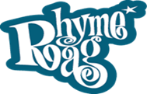**

Our latest wonderful installment on our Rhyme Rag for the month of August is ‘Falling’ by Laura Nash.

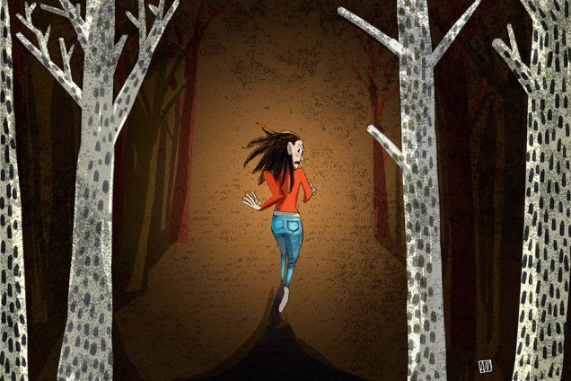

Selected by Editor John W. Sexton and Illustrated by Alé Mercado

Read all poems selected so far here:

<http://www.rhymerag.net/category/poems/>

Thanks to all for submitting poems. And don’t forget to submit work or encourage others you may know to do so.

**BECOME PART OF IT, SUBMIT A POEM.....**[www.rhymerag.net](http://kk-moss/Sites/arts_office/Shared%20Documents/Julianne%20Morgan/E-bulletin/30th%20May%20e-bulletin/www.rhymerag.net)

**\_\_\_\_\_\_\_\_\_\_\_\_\_\_\_\_\_\_\_\_\_\_\_\_\_\_\_\_\_\_\_\_\_\_\_\_\_\_\_\_\_\_\_\_\_\_\_\_\_\_\_\_\_\_\_\_\_\_\_\_\_\_\_\_\_\_\_\_\_\_\_\_\_\_\_\_\_\_\_\_\_\_\_\_\_\_\_**

**‘Ambushed by irresistible poetry from 13 different directions’**

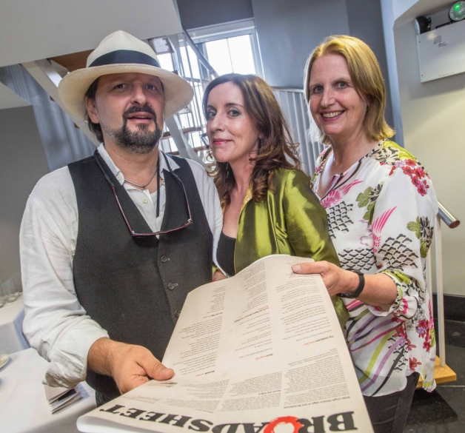

(Carol O'Coill, Anne O'Connor and Elinor Mountain pictured at the launch of the Poetry Broadsheet during the Kilkenny Arts Festival last week. Photo: Pat Moore.)

Kilkenny’s Arts Officer, Mary Butler and those involved in bringing out Kilkenny Poetry Broadsheet No 14 staged a coup at the Parade Tower of Kilkenny Castle on Friday evening by getting American poet laureate and one of the world’s best selling writers, Billy Collins to launch the impressive collection of poems.

He was witty, engaging and spoke of the need to get poetry out of the classroom and into public places and said the broadsheet was a perfect way to do this. He regaled the audience which included Kilkenny’s Minister for Rural Affairs, Ann Phelan, by saying he agreed with inserting poetry on the back of cereal boxes.

“People have a resistance to poetry, so give them no time to resist it - Ambush them with poetry so they don’t have time to deploy their anti-poetry deflector shields,” he said before unashamedly, reciting some of his own work which was an absolute treat.

This latest instalment of the broadsheet is hugely impressive and it is the last poem on the broadsheet that caught my eye first, composed by actor, Rachael Hanaphy-Pigott:

Apple of his eye

I fell for him

To the dirt

Of disappointment.

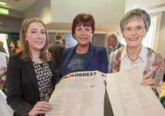

(Julianne Morgan, Minister Ann Phelan and Nora Brennan. Photo: Pat Moore)

Every piece in this A3 piece of paper is strong, worthy of inclusion and worth investigating.

Established poet Gerry Moran returns to one of his favourite themes in the 14th installment of the broadsheet - The bond between father and son. “Burying The Cat” is superb and personal.

The farmer’s son from Inistioge, Larry Cotter’s nine liner, Who I Am, is a gem and is now posted on my fridge. Reading it is a good way to start off the day.

Another beautiful piece comes from the hand of Nuala Roche and already being a fan of her earlier work, her take on Steve McQueen’s role in the Great Escape is fascinating and unexpected.

The Last Walk by Noel Howley is sombre and a familiar story.

Michael Massey is one of our finest writers and his piece, A Lot Can Happen Between The Bridges allows you to travel with him on his nature trail.

To Mary Butler, Niamh Brophy and Julianne Morgan, well done.

As always design is excellent by Atticus with a thoughtful illustration by Ale Meecado.

Editor, Enda Coyle-Greene did a great job.

By Sean Keane, Kilkenny People

Published on the 21 August 2014

**\_\_\_\_\_\_\_\_\_\_\_\_\_\_\_\_\_\_\_\_\_\_\_\_\_\_\_\_\_\_\_\_\_\_\_\_\_\_\_\_\_\_\_\_\_\_\_\_\_\_\_\_\_\_\_\_\_\_\_\_\_\_\_\_\_\_\_\_\_\_\_\_\_\_\_\_\_\_\_\_\_\_\_\_\_\_\_**

**Kilkenny Events**

**\_\_\_\_\_\_\_\_\_\_\_\_\_\_\_\_\_\_\_\_\_\_\_\_\_\_\_\_\_\_\_\_\_\_\_\_\_\_\_\_\_\_\_\_\_\_\_\_\_\_\_\_\_\_\_\_\_\_\_\_\_\_\_\_\_\_\_\_\_\_\_\_\_\_\_\_\_\_\_\_\_\_\_\_\_\_\_**

**“*Generations Exploring Heritage Together”* Heritage Week 23rd – 31st August**

The theme of this year’s Heritage Week which runs from Saturday 23rd – Sun 31st August is “*Generations Exploring Heritage Together”.*

Why not bring the kids to see the acclaimed film “Project Wild Thing” – a feature length documentary film about reconnecting children with nature. According to the Guardian newspaper, “*Funny, alarming and uplifting.* *This film will change your life*”.

There’s a chance for kids to “sow and grow” at Jerpoint Abbey, hunt for mini-beasts in Woodstock Gardens, dig for medieval archaeology in Rothe House, become an art detective in Kilkenny Castle, and explore Kilkenny’s newest Pop Up Museum at the Parade.

Local heritage groups have compiled a fabulous programme of events. There’s a rare chance to see a traditional lime kiln in operation. The kiln, last used in the 1930’s, is being brought back to life especially for Heritage Week. Why not take a guided walk through Inistioge, Kells, Mount Juliet and Tullahought; explore Freshford’s forgotten history; hear the stories and see the exhibitions of old fieldnames, folklore and past lives in Lisdowney, Castlecomer, Goresbridge and Ferrybank; hike the heights of Brandon Hill; and trace the steps of the famine victims in Callan and Newmarket.

And not forgetting past generations, our military heritage is also very well represented in the programme, and includes guided walks and talks about the contribution that Kilkenny men and woman made to both World War 1 and the War of Independence.

According to Dearbhala Ledwidge, Heritage Officer, “*This is the most diverse and comprehensive Heritage Week programme to date. It’s a great opportunity for people to experience and enjoy the wonderful heritage we have on our doorstep in County Kilkenny*”.

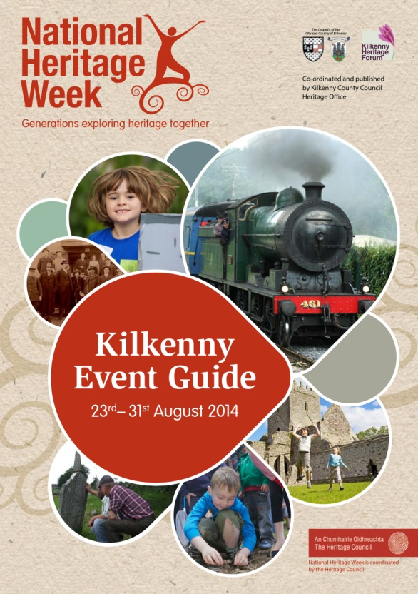

The Kilkenny Heritage Office has compiled a free County Kilkenny 'Heritage Week' Event Guide which outlines over 70 'Heritage Week' events taking place in the County.

To find out what’s happening in your area and to request a free copy of the Kilkenny Heritage Week brochure, contact Dearbhala Ledwidge, Heritage Officer, Kilkenny County Council. Tel: 056 7794925. dearbhala.ledwidge@kilkennycoco.ie or download a copy from the heritage section of our website [www.kilkennycoco.ie](http://www.kilkennycoco.ie).

Heritage Week is co-ordinated in County Kilkenny by the Heritage Office of Kilkenny County Council, and nationally by the Heritage Council, in conjunction with the Department of Arts, Heritage and the Gaeltacht and is part of European Heritage Days, which is celebrated in 40 countries across Europe.

## Young Irish Film Makers After School Workshops

## Inline image 1

## AFTER SCHOOL WORKSHOPS

## REGISTRATION DAY

Monday 22nd September (10:00am – 5:00pm)

YIFM Studios, St. Joseph's, Waterford Road, Kilkenny

T: 05677 64677

**COST:**€80 for 10 week term

**Classes Start:**

* Tuesday 24th September for Juniors
* Wednesday 25th September for Seniors

**TUESDAYS 4-6pm**

Juniors (9-12yrs)

**WEDS & FRI 4:30 – 6:30pm**

Seniors (13-18yrs)

## NEW TERM PROJECTS:

## Autumn Term – Drama production

## Spring – Film & Drama

## Summer – Open Door Policy – Personal & Group projects

## \*\*\*BIG NEWS\*\*\*

**NYCI YOUTH ARTS SHOWCASE:**

This year YIFM have been asked to bring 10 members of the cast and crew of the film ‘Still’ to Dublin to promote the work of YIFM.  YIFM candidates chosen to attend will speak to the Minister for Arts and other politicians about the importance of programmes such as Young Irish Film makers.

**TRIP TO INDIA:**

In April 2015, we are planning a trip to Calcutta, India with the senior group.  This trip is being planned in association with  [THE HOPE FOUNDATION](http://www.hopefoundation.ie/) as a film and photo documentary trip to promote the work of the foundation in helping street and slum children of Calcutta.  Provisionally booked for **April 2015 (dates to be confirmed)**, this unique trip will be a once in a lifetime experience for the young people involved.  **Spaces will be limited** and there will be a selection process put into place, so express your interest soon to make sure you are eligible to apply for a place.

**"Litter Bin Stories" By Javier Iglesias Ramos at the Upstairs Gallery Opening August 8th**

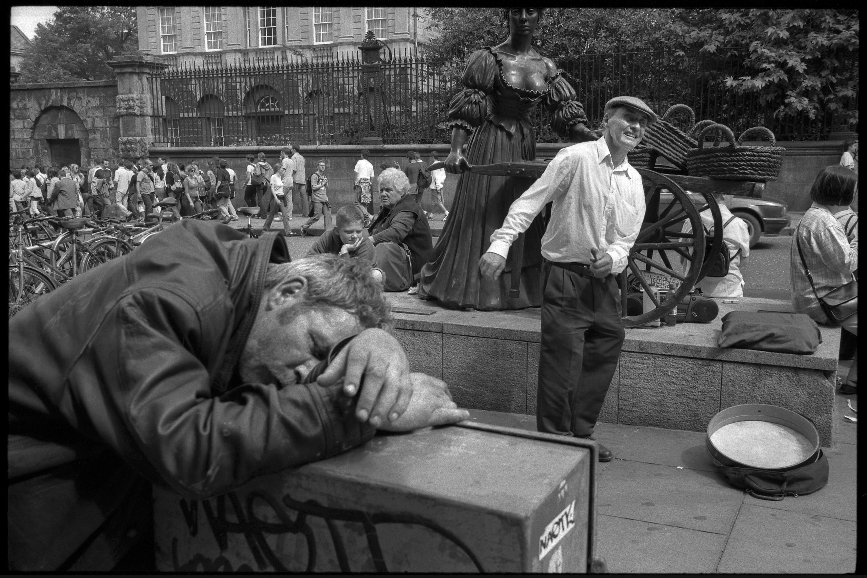

Opening Friday August 8th @ 5pm all welcome!

These photographs were mostly taken on the streets of Dublin 2002 - 2007. Javier Iglesias Ramos joined groups of people living on the streets at various intervals. He explored a particular view of life and photographed his experiences. A premonitory and instinctive account of a society in crises is what he managed to capture before the actual fall of The Celtic Tiger.

“The Celtic Tiger has vanished out of sight whilst street people still remain”,

Javier Iglesias Ramos (June 2014).

Javier was born in A Baña, Galicia, Spain in 1965. He studied Art Photography at the Escola de Artes Maestro Mateo, (Santiago de Compostela, Galicia, Spain) and completed his training by way of multiple workshops, courses and seminars with renowned photographers such as Alberto García Álix, Stuart Franklin, Cristina García Rodero, Chris Steele Perkins, Ricky Davila, Hunberto Rivas, Luís de Las Alas.

The core of his work is social photography, addressing topics such as drug addiction on the streets of Santiago de Compostela, poverty in Quito (Ecuador), ecological disaster of the Prestige in Galicia, misery and desolation in the refugee camps of Tinduf (Algeria).

Between 2002 and 2007 Javier carried out this current work on the streets of Dublin. At various intervals, he joined a group of people living on the margins and photographed the atmosphere presented to him.

This show is coming to Kilkenny after being very well received at the Galway Fringe Festival in July, where it was exhibitied in Áras na nGael.

This is the artists' first time to show in Kilkenny, so we hope you will join us to extend a warm welcome to his work on Friday August 8th at 5pm at the Upstairs Gallery, Watergate Theatre, Parliament Street Kilkenny.

The exhibition will run until September 3rd. Opening hours are Mon-Fri 10am - 6pm and Saturday 2pm-6pm

Late opening for the Kilkenny Arts Festival and during theatre show days all month

Suitable for all ages.

This space is not wheelchair accessible.

Find out more and keep up to date on the exhibition at [www.facebook.com/upstairsgallerykilkenny](http://www.facebook.com/upstairsgallerykilkenny)

**\_\_\_\_\_\_\_\_\_\_\_\_\_\_\_\_\_\_\_\_\_\_\_\_\_\_\_\_\_\_\_\_\_\_\_\_\_\_\_\_\_\_\_\_\_\_\_\_\_\_\_\_\_\_\_\_\_\_\_\_\_\_\_\_\_\_\_\_\_\_\_\_\_\_\_\_\_\_\_\_\_\_\_\_\_\_**

**'CRAFT in Hand' Jerpoint Glass Attic Gallery (7 Aug - 30 Sept)**

[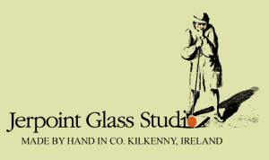](http://www.jerpointglass.com/)

'CRAFT in Hand' is an exhibition of work by nine local craftspeople curated by Jerpoint Glass Studios. Both Mark Campden and Caroline Dolan will be exhibiting work in the Glass Attic Gallery.

W: <http://www.jerpointglass.com/>

**\_\_\_\_\_\_\_\_\_\_\_\_\_\_\_\_\_\_\_\_\_\_\_\_\_\_\_\_\_\_\_\_\_\_\_\_\_\_\_\_\_\_\_\_\_\_\_\_\_\_\_\_\_\_\_\_\_\_\_\_\_\_\_\_\_\_\_\_\_\_\_\_\_\_\_\_\_\_\_\_\_\_\_\_\_\_**

**'ELEMENTS' @ The Bridge Pottery**, **9-30th August**

[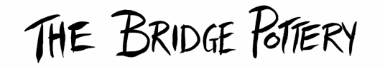](http://www.bridgepottery.com/)

Official Opening: **Sunday 10th August at 2pm** (invite to follow soon!)

Our clay is composed of the elements of the Earth, our glazes too, and the pigments that give the beautiful surface decoration.  These Earth elements, when combined with the elements of Nature - Air and Fire are magically transformed. This exhibition of our new work celebrates the magic of this ceramic process.

[Location:](http://carolinedolanceramics.us2.list-manage.com/track/click?u=23828ca96341938eb4885bfca&id=7fbead3e4c&e=9c0b33db3a)[Coalsfarm, Burnchurch, Co Kilkenny, Ireland](http://carolinedolanceramics.us2.list-manage.com/track/click?u=23828ca96341938eb4885bfca&id=f18556b0d4&e=9c0b33db3a)

W: <http://www.bridgepottery.com/>

**\_\_\_\_\_\_\_\_\_\_\_\_\_\_\_\_\_\_\_\_\_\_\_\_\_\_\_\_\_\_\_\_\_\_\_\_\_\_\_\_\_\_\_\_\_\_\_\_\_\_\_\_\_\_\_\_\_\_\_\_\_\_\_\_\_\_\_\_\_\_\_\_\_\_\_\_\_\_\_\_\_\_\_\_\_\_\_**

**Library News**

**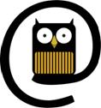**

Exhibition: A selection of paintings by local artist Shona Hehir

Venue: City library, John’s Quay

Date: **Month of August**

Contact person: Aisling Kelly

Email: [citylibrary@kilkennylibrary.ie](mailto:citylibrary@kilkennylibrary.ie)

Craft Group Workshops in Kilkenny Libraries

* City Library, John’s Quay: Tuesday evenings **6-8pm**
* Castlecomer Library: Thursday mornings, year round, **10-12pm**
* Graiguenamanagh Library: Wednesday mornings **10.30am to 12.30pm**
* Ferrybank library: Patchwork quilting – Tues morning at **11.45-1.20**

Knitting – Thurs mornings **10-12.00**(Both groups taking a break for the summer.)

We also have once off workshops e.g. Origami class **Wed 6th, 13th & 20th Aug – 11.30 -1pm**

Contact details for libraries:

<http://kilkennylibrary.kilkenny.ie/eng/Libraries_Locations/>

**\_\_\_\_\_\_\_\_\_\_\_\_\_\_\_\_\_\_\_\_\_\_\_\_\_\_\_\_\_\_\_\_\_\_\_\_\_\_\_\_\_\_\_\_\_\_\_\_\_\_\_\_\_\_\_\_\_\_\_\_\_\_\_\_\_\_\_\_\_\_\_\_\_\_\_\_\_\_\_\_\_\_\_\_\_\_**

**Butler Gallery**

MARILYN LERNER**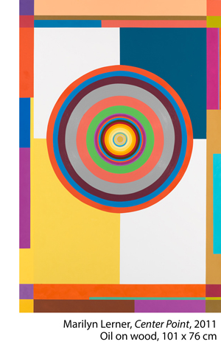  
August 9 – October 5, 2014**

The Butler Gallery is delighted to host Ireland’s first exhibition of the New York based painter Marilyn Lerner.

Lerner is an extraordinary artist who has been committed to making abstract geometric paintings for over forty years. Her oil paintings are painted on wooden panels with bevelled edges so that they almost float off the wall. They are highly skillful compositions that articulate her experiences through form, pattern and colour. Lerner has travelled extensively through North Africa and South East Asia and these trips have informed her work and made the language of geometry the focus of her work.

**\_\_\_\_\_\_\_\_\_\_\_\_\_\_\_\_\_\_\_\_\_\_\_\_\_\_\_\_\_\_\_\_\_\_\_\_\_\_\_\_\_\_\_\_\_\_\_\_\_\_\_\_\_\_\_\_\_\_\_\_\_\_\_\_\_\_\_\_\_\_\_\_\_\_\_\_\_\_\_\_\_\_\_\_\_\_\_**

### KOZO STUDIO is REOPENING in September 2014!

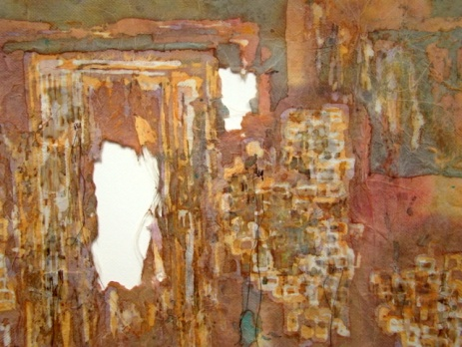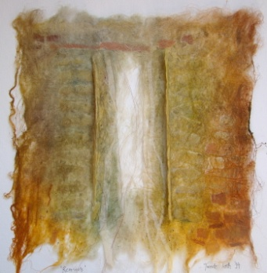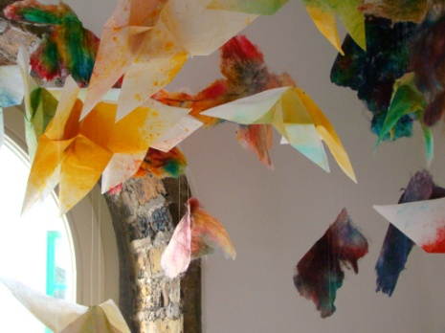​

Aafter more than 5 years KOZO STUDIO is REOPENING in September 2014!

Tunde Toth is starting a new studio and gallery space at the Estate Yard of Castlecomer Discovery  Park in Co. Kilkenny!

OPENING RECEPTION:

The Studio will be launched with **a solo exhibition of her new and recent works in mid -**September

- invitations and full info will be sent out to everyone on my mailing list very soon

Kozo Studio hopes to be a creative, inspiring space that will continue to organize art and craft workshops along arts events, interactive projects and participatory programmes.

So watch this space - an exiting programme is to follow!

Tunde Toth

[www.tundetoth.com](http://www.tundetoth.com/)

[www.tundetothpaperart.blogspot.com](http://www.tundetothpaperart.blogspot.com/)

### cid:ii_hz5op2470_147fe628ee8d47c0

### Watergate Theatre: What Happened Bridgie Cleary

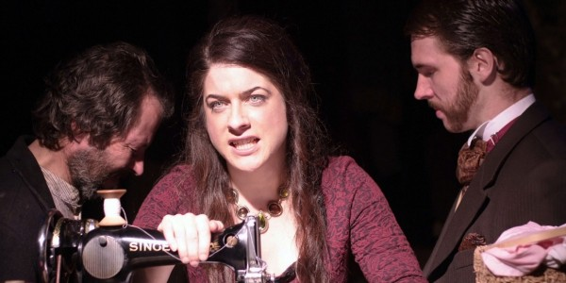

Date(s) – **3rd Sep 2014**Time: ***8:00 PM - 10:00 PM***

Tickets: **€15/€12**

In 1895, Tipperary woman Bridget Cleary was burnt to death by her husband.

His defence? She was a fairy, replaced by a changeling. Her crime? Being a sensual independent woman who didn’t conform to what was expected of her.

 What Happened Bridgie Cleary by Tom MacIntyre is a poetic and dramatic interpretation of this important story.

View more at <http://watergatetheatre.com/>

Want tickets? Call the box office now on 056-7761674 or click here to book online: [https://www.ctb.ie/tickets/watergate/?shows=%](https://www.ctb.ie/tickets/watergate/?shows=%25)

**\_\_\_\_\_\_\_\_\_\_\_\_\_\_\_\_\_\_\_\_\_\_\_\_\_\_\_\_\_\_\_\_\_\_\_\_\_\_\_\_\_\_\_\_\_\_\_\_\_\_\_\_\_\_\_\_\_\_\_\_\_\_\_\_\_\_\_\_\_\_\_\_\_\_\_\_\_\_\_\_\_\_\_\_\_\_\_**

**Courses / Training / Jobs, Internships**

**\_\_\_\_\_\_\_\_\_\_\_\_\_\_\_\_\_\_\_\_\_\_\_\_\_\_\_\_\_\_\_\_\_\_\_\_\_\_\_\_\_\_\_\_\_\_\_\_\_\_\_\_\_\_\_\_\_\_\_\_\_\_\_\_\_\_\_\_\_\_\_\_\_\_\_\_\_\_\_\_\_\_\_\_\_\_\_**

**CIT Crawford College of Art and Design: Creativity & change course**

[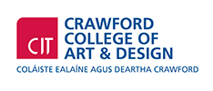](http://www.cit.ie/aboutcit/facultiescollegesanddepartments/citcrawfordcollegeofartanddesign/)

This is a CIT approved Special Purpose Award at Level 8 (10 credits) certificate supported by Irish Aid.

**ABOUT**  
Creativity & Change is about creativity and its power to ignite empathy, passion and learning about our interconnected and interdependent world.  
It is about imagining more humane, just and viable ways to live in the world. It connects how we think, live and act in the world and considers how we can live as connected global citizens becoming part of the changes we want to see.

**WHO IS IT FOR?**  
Artists, community workers, youth workers, activists educators, volunteers and anyone who is interested in exploring the connection between creativity, learning and change in the world and in nurturing possiblities to grow as connected global citizens.

**COURSE CONTENT**  
The course has several main strands of learning within the context of global citizenship & global and local justice themes.

* Development of confidence in personal creativity
* Creativity & learning strategies
* Creative strategies for public engagement.

**DURATION**  
Seven  2/3 day blocks Oct 2014 to May 2015

**APPLY**  
Applications accepted by email. Go website, [http://www.creativityandchange.info](http://www.creativityandchange.info/) and go to ‘get involved’ page to download application form. Closing date: Sept 19th 2014

**FEE**  
The course fee is subsidized through Irish Aid funding so it can be offered at reduced rate of €680

**ENQUIRIES**  
Enquiries to [creativityandchange@cit.ie](mailto:creativityandchange@cit.ie) or call Nora on 086 3765686

**WHAT PAST PARTICIPANTS HAVE SAID**  
*"I have a much greater understanding of how my own practice can be used as a means of critically examining the world/community around us, and also take away lots of practical skills and ideas“  
“One of the things that the course does best is combining theoretical knowledge with practical approaches and bridging the gap between those two areas. In doing so the course serves in itself as a great example."  
"It challenges the way you think and also many of the attitudes you have. This is done in a non confrontational way, self-reflecting way."  
"I got new energy...improved my understanding and expanded my horizons and opened my eyes to the world as a bigger picture."  
"Love that it can make learning fun even though the issues are very serious”  
“Very inspiring to see the power of art and creativity"*

[http://www.creativityandchange.info](http://www.creativityandchange.info/)

**\_\_\_\_\_\_\_\_\_\_\_\_\_\_\_\_\_\_\_\_\_\_\_\_\_\_\_\_\_\_\_\_\_\_\_\_\_\_\_\_\_\_\_\_\_\_\_\_\_\_\_\_\_\_\_\_\_\_\_\_\_\_\_\_\_\_\_\_\_\_\_\_\_\_\_\_\_\_\_\_\_\_\_\_\_\_\_**

**VAI: Professional Development Training Programme Autumn/Winter 2014**

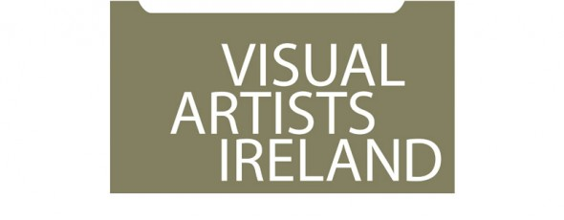

Visual Artists Ireland operates a wide range of professional development training and events throughout the year including **workshops, peer discussion groups, seminars and talks**. The delivery of this programme is greatly supported by our relationship with local and international visual art professionals and partner organisations throughout the island of Ireland. VAI works in partnership with Local Authorities, visual arts venues and others, combining resources to support the professional development of visual artists at regional level.

To register and for further information see: [http://visualartists.ie/professional-developmentp/](http://lists.visualartists.ie/lt.php?c=1191&m=4230&nl=1&s=d3c261c0eeb6b48867f449d29e09414b&lid=91545&l=-http--visualartists.ie/professional-developmentp/)

\*\*\*\*\*\*\*\*\*\*\*\*\*\*\*\*\*\*\*\*

**Dublin**

**Towards Sustainability – Mapping your Career** with Patricia Clyne-Kelly, John Daly and Brian Kennedy hosted *by Fingal Arts*

Thur. 9 Oct (10.30 – 16.30)

Venue to be confirmed

Places: 25 - 30

Cost: €60 / 30

[http://visualartists.ie/professional-developmentp/?ee=155](http://lists.visualartists.ie/lt.php?c=1191&m=4230&nl=1&s=d3c261c0eeb6b48867f449d29e09414b&lid=92517&l=-http--visualartists.ie/professional-developmentp/--Q-ee--E-155)

**Writing about Your Work** with Niamh O'Malley

Thur. 16 Oct (10.30 – 16.30) tbc

@ Visual Artists Ireland

Places: 10 - 12

Cost: €80 / 40 (VAI Members)

*Further information available on this session online in early Sept.*

**Developing Creative Proposals** with Annette Moloney

Wed. 19 Nov. (10.30 – 16.30)

@ Visual Artists Ireland

Places: 12 – 16

Cost: €80 / 40

[http://visualartists.ie/professional-developmentp/?ee=164](http://lists.visualartists.ie/lt.php?c=1191&m=4230&nl=1&s=d3c261c0eeb6b48867f449d29e09414b&lid=92518&l=-http--visualartists.ie/professional-developmentp/--Q-ee--E-164)

**Arts Council Funding Information Session -** Dublin

Wed. 5 Nov (time to be confirmed)

@Visual Artists Ireland

Places: 20 – 25

[http://visualartists.ie/professional-developmentp/?ee=166](http://lists.visualartists.ie/lt.php?c=1191&m=4230&nl=1&s=d3c261c0eeb6b48867f449d29e09414b&lid=92519&l=-http--visualartists.ie/professional-developmentp/--Q-ee--E-166)

\*\*\*\*\*\*\*\*\*\*\*\*\*\*\*\*\*\*\*\*

**Dundalk**

*Events in partnership with Creative Spark Louth*

**Socially Engaged Visual Art Practices** with Niamh O'Connor

Wed. 10 Sept (10.30 – 16.30)

@ Louth Creative Community Hub

Places: 10 - 12

Cost: €80 / 40 (VAI Members)

[http://visualartists.ie/professional-developmentp/?ee=152](http://lists.visualartists.ie/lt.php?c=1191&m=4230&nl=1&s=d3c261c0eeb6b48867f449d29e09414b&lid=92520&l=-http--visualartists.ie/professional-developmentp/--Q-ee--E-152)

**Presenting Yourself and Your Work** with Kerry McCall

Wed 17 Sept and Wed 24 Sept (2 half-day sessions)

@ Louth Creative Community Hub

Places: 10 - 12

Cost: €80 / 40 (VAI Members)

[http://visualartists.ie/professional-developmentp/?ee=150](http://lists.visualartists.ie/lt.php?c=1191&m=4230&nl=1&s=d3c261c0eeb6b48867f449d29e09414b&lid=92521&l=-http--visualartists.ie/professional-developmentp/--Q-ee--E-150)

**Developing Opportunities for your Work**

Date to be confirmed

@ Louth Creative Community Hub

*Further information available on this session online in early Sept.*

\*\*\*\*\*\*\*\*\*\*\*\*\*\*\*\*\*\*\*\*

**Galway**

*Event in partnership with Galway City & County Councils*

**Child Protection Awareness for Artists working with Young People** with Olive Ring

Wed. 3 Sept. (12.30 – 17.00)

@ Menlo Park Hotel, Galway City

Places: 12 - 20

Cost: *Free to Galway based artists*

[http://visualartists.ie/professional-developmentp/?ee=161](http://lists.visualartists.ie/lt.php?c=1191&m=4230&nl=1&s=d3c261c0eeb6b48867f449d29e09414b&lid=92522&l=-http--visualartists.ie/professional-developmentp/--Q-ee--E-161)

**Arts Council Funding Information Session** - Galway

Nov date (to be confrimed)

[http://visualartists.ie/professional-developmentp/?ee=168](http://lists.visualartists.ie/lt.php?c=1191&m=4230&nl=1&s=d3c261c0eeb6b48867f449d29e09414b&lid=92523&l=-http--visualartists.ie/professional-developmentp/--Q-ee--E-168)

\*\*\*\*\*\*\*\*\*\*\*\*\*\*\*\*\*\*\*\*

**Limerick**

*In partnership with LCGA, Limerick City & County Council and Clare and Tipperary County Councils*

**Developing Creative Proposals** with Annette Moloney

Tues. 21 Oct. (10.30 – 16.30)

Venue to be confirmed

Places: 12 - 16

Cost: €10 / 5 (VAI Members)

[http://visualartists.ie/professional-developmentp/?ee=162](http://lists.visualartists.ie/lt.php?c=1191&m=4230&nl=1&s=d3c261c0eeb6b48867f449d29e09414b&lid=92524&l=-http--visualartists.ie/professional-developmentp/--Q-ee--E-162)

\*\*\*\*\*\*\*\*\*\*\*\*\*\*\*\*\*\*\*\*

**Meath**

*Events in partnership with Meath County Council Arts Office*

**Presenting yourself & Your Work** with Patricia Clyne-Kelly

Tues. 18 Nov (10.30 – 16.30) tbc

Places: 10 - 12

Cost: €80 / 40 (VAI Members)

*Further information available on this session online in early Sept.*

**Developing Opportunities for your Work** with Elaine Grainger and Elaine Leader

Tues. 11 Nov (10.30 – 16.30)

Places: 15 - 20

Cost: €50 / 25 (VAI Members)

[http://visualartists.ie/professional-developmentp/?ee=158](http://lists.visualartists.ie/lt.php?c=1191&m=4230&nl=1&s=d3c261c0eeb6b48867f449d29e09414b&lid=92525&l=-http--visualartists.ie/professional-developmentp/--Q-ee--E-158)

**Documenting your Work** with Tim Durham

Date to be confirmed

Places: 10 - 12

Cost: €80 / 40 (VAI Members)

*Further information available on this session online in early Sept.*

\*\*\*\*\*\*\*\*\*\*\*\*\*\*\*\*\*\*\*\*

**Portloaise**

*In partnership with Dunamaise Arts Centre*

**Web and Social Media Strategies for Visual Artists** with Mary Carty

Fri. 5 Sept

@ Dunamaise Arts Centre

Places: 20

Cost: €60 / 30 (VAI Members)

[http://visualartists.ie/professional-developmentp/?ee=141](http://lists.visualartists.ie/lt.php?c=1191&m=4230&nl=1&s=d3c261c0eeb6b48867f449d29e09414b&lid=92526&l=-http--visualartists.ie/professional-developmentp/--Q-ee--E-141)

\*\*\*\*\*\*\*\*\*\*\*\*\*\*\*\*\*\*\*\*

**Roscommon**

*Event in partnership with Roscommon Visual Artists Forum*

**Presenting Yourself and Your Work** (half day) with Kerry McCall

Tues. 10 Sept (11.30 – 15.30)

@ Roscommon Arts Centre

Places: 10

[http://visualartists.ie/professional-developmentp/?ee=154](http://lists.visualartists.ie/lt.php?c=1191&m=4230&nl=1&s=d3c261c0eeb6b48867f449d29e09414b&lid=92527&l=-http--visualartists.ie/professional-developmentp/--Q-ee--E-154)

**Developing Opportunities for your Work** with Geraldine O'Reilly and Elaine Grainger

Thur. 2 Oct (11.30 – 17.00)

@ Roscommon Arts Centre

Places: 12 - 16

[http://visualartists.ie/professional-developmentp/?ee=153](http://lists.visualartists.ie/lt.php?c=1191&m=4230&nl=1&s=d3c261c0eeb6b48867f449d29e09414b&lid=92528&l=-http--visualartists.ie/professional-developmentp/--Q-ee--E-153)

**Protecting and Caring for Your Work** (half day) with Alan Ragget

Wed. 22 Oct (11.30 – 17.00)

@ King House, Boyle

Places: 15 - 20

[http://visualartists.ie/professional-developmentp/?ee=165](http://lists.visualartists.ie/lt.php?c=1191&m=4230&nl=1&s=d3c261c0eeb6b48867f449d29e09414b&lid=92529&l=-http--visualartists.ie/professional-developmentp/--Q-ee--E-165)

FREE to visual artists based in Roscommon

**Visiting Curators Sept & Nov, 2014**

**Dublin Live Art Fesitival**

In addition to these events above we also look forward to welcoming visiting Curators **Jonas Stampe** in September working in conjunction with the Dublin Live Art Festival.

**Bea de Souza** from The Agency Gallery London who will meet with artists connected with our regional partners in Galway in November.

**To register and for further information see:** [http://visualartists.ie/professional-developmentp/](http://lists.visualartists.ie/lt.php?c=1191&m=4230&nl=1&s=d3c261c0eeb6b48867f449d29e09414b&lid=91545&l=-http--visualartists.ie/professional-developmentp/)

 \*\*\*\*\*\*\*\*\*\*\*\*\*\*\*\*\*\*\*\*

**Bookings  Payments**

Booking and payment is required in advance for all sessions.  We encourage artists to register online where possible and if you wish to make payments off line following registration please do provide a mobile phone number on the registration form. We accept payment in the following ways: through PayPal online; by stg£ or Euro cheque made out to Visual Artists Ireland or by credit card over the phone.

If an event is not listed on our online system please email [monica@visualartists.ie](mailto:monica@visualartists.ie) to register interest in an event. State the full title of the event, the location and date and provide your name and mobile number in your email.   
  
To register online for Republic of Ireland training: [http://visualartists.ie/professional-developmentp/](http://lists.visualartists.ie/lt.php?c=1191&m=4230&nl=1&s=d3c261c0eeb6b48867f449d29e09414b&lid=91545&l=-http--visualartists.ie/professional-developmentp/)  
To register online for Northern Ireland training: [http://visualartists.org.uk/services/professionaldevelopment/current/](http://lists.visualartists.ie/lt.php?c=1191&m=4230&nl=1&s=d3c261c0eeb6b48867f449d29e09414b&lid=91546&l=-http--visualartists.org.uk/services/professionaldevelopment/current)

**Fees:**

VAI members receive preferential discount of 50% on fees for all training and professional development events.  
  
  
**Tell us about your training needs!**

If you are interested in training please do get in touch with us directly or forward an expression of interest in a topic/s through the Professional Development Training web page.  We often repeat workshops when there is a strong demand for a topic.    
  
**Artist & Tutors Panel**

Visual Artists Ireland has an ongoing open submission process for artists and arts professionals interested in being part of an available panel of tutors contributing to the VAI Professional Development Training Programme. For details go to our training registration page and click on Register for the PDT Artists Panel: [http://visualartists.ie/professional-developmentp/?ee=71](http://lists.visualartists.ie/lt.php?c=1191&m=4230&nl=1&s=d3c261c0eeb6b48867f449d29e09414b&lid=91547&l=-http--visualartists.ie/professional-developmentp/--Q-ee--E-71)

# National Youth Council of Ireland: Child Protection and Web Safety Training

#### [Child Protection Programme - National Youth Council of Ireland logo](http://www.childprotection.ie/)

#### [Websafety in Youth Work - Dublin](http://www.nycitraining.org/courses/websafety-youth-work-dublin)

Date: **15th September 2014**

**Description:** This 3.5 hour course is designed to raise awareness among youth leaders about young people’s online life, to identify on line risks and opportunities and to deal with cyberbullying. This training is supported by the free online resource website for youth workers <http://websafety.youth.ie/>  
**Venue:** Carmelite Centre, Dublin 2

#### [Child Protection Awareness Programme](http://www.nycitraining.org/courses/child-protection-awareness-programme-1)

Date: **24th September 2014**

**Training Event:** Child Protection Awareness Programme  
**Venue:** Carmelite Centre  
   
This four hour basic awareness course is the standardised child protection training programme for the youth work sector. It aims to create a basic awareness about the key issues in relation child protection. It is suitable for volunteers and staff members in youth work organisations.

#### [Websafety in Youth Work - Cork](http://www.nycitraining.org/courses/websafety-youth-work-cork)

Date: **1st December 2014**

**Description:** This 3.5 hour course is designed to raise awareness among youth leaders about young people’s online life, to identify on line risks and opportunities and to deal with cyberbullying. This training is supported by the free online resource website for youth workers <http://websafety.youth.ie/>  
   
**Venue:** Metropole Hotel, Cork

Please contact Geraldine Mahon at 01-4784122 to register or email [training@nyci.ie](mailto:training@nyci.ie)

### Lir, Ireland’s National Academy of Dramatic Art at Trinity College Dublin

[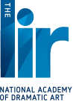](http://www.thelir.ie/)

Audition masterclass

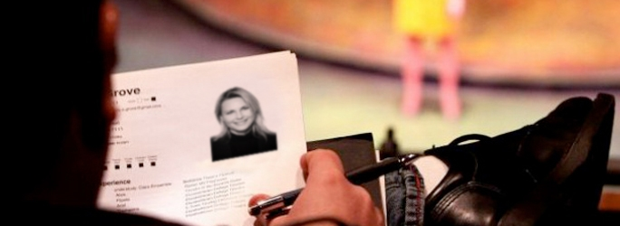

|  |  |  |  |
| --- | --- | --- | --- |
| Four days | **Sat 8th, Sun 9th, Sat 15th and Sun 16th November 2014** | 10.30am – 5.30pm | **€350** |
| Four days | **Sat 22nd, Sun 23rd, Sat 29th and Sun 30th November 2014** | 10.30am –5.30pm | **€350** |
| Four days | **Sat 6th, Sun 7th, Sat 13th and Sun 14th December 2014** | 10.30am - 5.30pm | **€350** |
| Four days | **Sat 17th, Sun 18th, Sat 24th and Sun 25th January 2015** | 10.30am - 5.30pm | **€350** |

### This is an intensive course for those considering auditioning for drama school and who wish to master audition technique and fully prepare their monologues.

More info at <http://www.thelir.ie/courses/view/audition-masterclass>

### The Master in Fine Art (Theatre Directing)

It was introduced following extensive consultation with the Irish theatre community and is a direct response to the stated needs of the industry and of talented emerging artists. The MFA programme aims to equip students of exceptional talent with the skills necessary to pursue a career in the professional theatre and related industries through the development of skills, professional practices and creative approaches to theatre directing.

More info at <http://www.thelir.ie/courses/view/master-in-fine-art-theatre-directing>

**\_\_\_\_\_\_\_\_\_\_\_\_\_\_\_\_\_\_\_\_\_\_\_\_\_\_\_\_\_\_\_\_\_\_\_\_\_\_\_\_\_\_\_\_\_\_\_\_\_\_\_\_\_\_\_\_\_\_\_\_\_\_\_\_\_\_\_\_\_\_\_\_\_\_\_\_\_\_\_\_\_\_\_\_\_\_\_**

**Call for Submissions / Residencies**

**\_\_\_\_\_\_\_\_\_\_\_\_\_\_\_\_\_\_\_\_\_\_\_\_\_\_\_\_\_\_\_\_\_\_\_\_\_\_\_\_\_\_\_\_\_\_\_\_\_\_\_\_\_\_\_\_\_\_\_\_\_\_\_\_\_\_\_\_\_\_\_\_\_\_\_\_\_\_\_\_\_\_\_\_\_\_\_**

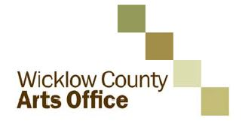

**Call for proposals: new initiatives for WCAO programme 2015**

As part of its plan for the development of the arts, Wicklow County Arts Office invites applications from interested parties for funding to develop and deliver new projects of high quality and impact during 2015 which will enhance and complement the strategic development of the arts in the County.

This call is open to organisations and individuals from any part of Ireland across all arts disciplines. Proposals should add significant value to arts practice, experience and/or participation in the arts in County Wicklow and support the Council’s strategic goals for the arts 2014-2016. 2015 is the second year that this initiative has been offered, for information on projects which were awarded in 2014 see [www.wicklow.ie](http://www.wicklow.ie), select Other Services and Arts Office. The information is under New Strategic Projects 2014. Projects include a new commission *Medicated Milk* for dance practitioner Áine Stapleton, a collaborative commission with Arklow Silver Band by composer Ian Wilson, a residency exchange between Wicklow and Cork based artists by Cork Printmakers and a series of Literary Events by Poetry IReladn.

Reflecting the balance of other elements of its programme, the Arts Office would particularly welcome strong applications in literature, film, architecture, and artist development. The Arts Office is also interested in proposals in the visual arts and music.

The Arts Office is particularly interested to hear from **national resource organisations, individual curators and artist** **collectives** who have the potential to propose projects which will nurture practice, create connectivity, generate new perspectives and voices within the cultural life of the county and support a diversity of approach.

The total amount of the fund available is subject to finalisation of Wicklow County Arts Office own funding for 2015, but is likely to be a maximum of €60,000. It is intended that a number of projects may be supported through this call to a maximum of €15,000.00 per project.

The closing date for applications is **4pm on Wednesday the 24th of September 2014**. Decisions will be made by Wicklow County Arts Office during September 2014 and applicants will be notified of the Arts Office decision shortly thereafter.

The application process is being managed for Wicklow County Arts Office by Interactions. Guidelines and application forms should downloaded from www.wicklow.ie under Other Services/Arts Office. Any queries on the application process should also be directed by email to: [wicklow@inter-actions.biz](mailto:wicklow@inter-actions.biz).

**Waterford Healing Arts Trust invites you to share your feel-good poetry and prose**

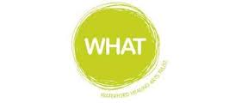

The Waterford Healing Arts Trust, Ireland’s leading arts and health programme, is inviting people to send them those pieces of poetry and prose that bring solace and joy in preparation for a public reading as part of the second Well Festival of Arts and Wellbeing in Waterford.

Cassandra Clare once said “it was books that made me feel that perhaps I was not completely alone” and it is in the spirit of this link between reading and wellbeing that the Waterford Healing Arts Trust is organising this very special event which they are calling ‘We haven’t had an earthquake lately…’ .

If you reach for a favourite poem or prose when you need cheering up, please e-mail it to [WHAT@hse.ie](mailto:WHAT@hse.ie) by **Wednesday 24 September** with ‘earthquake’ in the subject line.  State who the author is and why you chose it. Prose pieces should be no longer than 200 words.

A selection of submissions will be read at a public event in The Book Centre Waterford on World Mental Health Day, Friday 10 October at 6.30pm.

This is the second time that Waterford Healing Arts Trust is hosting this unique literary event which forms part of the programme of the Well Festival of Arts and Wellbeing.  The Well Festival, a joint initiative between Garter Lane and Waterford Healing Arts Trust, celebrates the benefits of participation in the arts for both individuals and the community. It is funded by the Arts Council and will run from 6 – 10 October.

For more information contact:

051-842664,

[WHAT@hse.ie](mailto:WHAT@hse.ie)

[www.waterfordhealingarts.com](http://www.waterfordhealingarts.com)

**The 2014 Plunkett Short Story Award**

**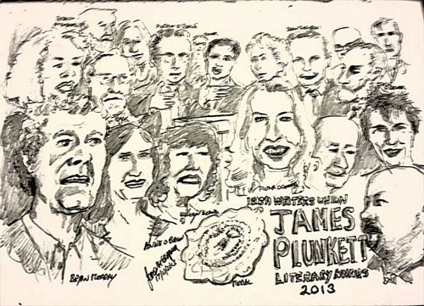**

Prizes: First Prize: **€2,000** / Second Prize: **€1,000** / Third Prize: **€500**

There is no restriction on theme or genre. Entrants are simply asked to recall Plunkett's skill as a social commentator when writing.

Closing date: **Friday, 12th September 2014**

Entries should be between 1,000 and 3,000 words

Entries should be addressed to: The Irish Writers' Union, 19 Parnell Square, Dublin 1

There is no limit on the number of submissions an entrant can make.

Entry costs **€10 per submission**. Please make cheques payable to the Irish Writers' Union.

A long list of 30 entries will be published on the website of the Irish Writers' Union before the winning entrants will be selected.

For more details, please visit [www.ireland-writers.com](http://r20.rs6.net/tn.jsp?f=001UJNU_4Udl_iojZmLs_IepzvH2QXBXuFT-fPIe6dgrajRDqQWMqXDuERTyxAXpZcrRTPu9ZNA6zd29TQc-_a7FAJR1t-Ke5M7cfdn8LAFdsDZPBWM3bVWcA_AmX3UNKM7vCrQFrC8pQfGQsXeCbDO5eX9gAT_66eiyIdXB2vwhm3Ea0afYW2ngQ==&c=it1jPOJakwM4WjPKopx6a3UZYGEgS4bpgWFoH7nUniAUyOPT6VTbRw==&ch=qm2z9y_QyA4gy4xlUkHhx8nE6M1dKjBj1WKa9L7-JjYpNNiWa6q8fw==)

**\_\_\_\_\_\_\_\_\_\_\_\_\_\_\_\_\_\_\_\_\_\_\_\_\_\_\_\_\_\_\_\_\_\_\_\_\_\_\_\_\_\_\_\_\_\_\_\_\_\_\_\_\_\_\_\_\_\_\_\_\_\_\_\_\_\_\_\_\_\_\_\_\_\_\_\_\_\_\_\_\_\_\_\_\_\_\_**

## [Open Call – Hospital Shop Window Festival (HSWF)](http://visualartists.ie/jobs-ops/opportunities-ireland/open-call-hospital-shop-window-festival-hswf/)

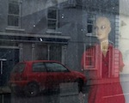

Hospital Shop Window Festival (HSWF) invites artists across all disciplines to submit work for their Festival which will be launched on Culture Night, **Friday 19 September, 2014** and run until Friday September 26, 2014.

The Festival will take place on the main street of Hospital, Co. Limerick and will utilize dormant and functional shop premises as showcases for visual arts with the aim of bringing art and culture to the street, allowing free and unrestricted access for all.

Works in any medium can be submitted. Up to a maximum of three works per artist may be submitted. There is NO submission fee.

For full details on the submission process please see [www.hswf.weebly.com](http://www.hswf.weebly.com)

Email: [hswf@outlook.com](http://www.kilkennycoco.ie/eng/Services/Arts/News/hswf@outlook.com)

**\_\_\_\_\_\_\_\_\_\_\_\_\_\_\_\_\_\_\_\_\_\_\_\_\_\_\_\_\_\_\_\_\_\_\_\_\_\_\_\_\_\_\_\_\_\_\_\_\_\_\_\_\_\_\_\_\_\_\_\_\_\_\_\_\_\_\_\_\_\_\_\_\_\_\_\_\_\_\_\_\_\_\_\_\_\_\_**

**The Little Museum 2016 Commissioning Programme**

**[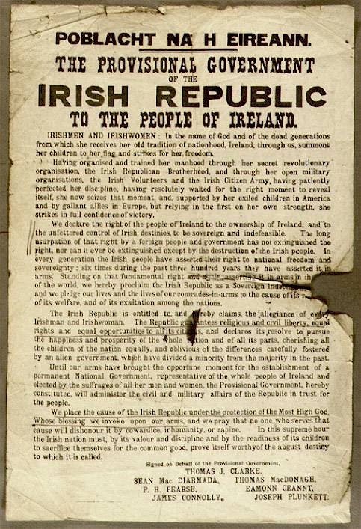](http://www.littlemuseum.ie/events/the-little-museum-2016-commissioning-programme/2152e9d20b)**

The Little Museum is delighted to announce a large scale commissioning programme to produce artworks for public exhibit in 2016. Inviting artists from all media, this exciting project will see the museum commission a large number of small scale art projects which will interrogate the history and legacy of the 1916 Rising and the individuals involved, as well as intersecting with present-day perspectives on commemoration, remembrance and the function of history as a component of civic awareness.

As a cultural institution whose primary goal is educational, the Little Museum is wary of providing simplistic accounts of the past. The archivist Catriona Crowe has spoken of the need to complicate the narrative during this decade of commemorations (which we are officially shortening to the Decorations). Taking Catriona’s advice as our cue, we want to create audacious public interventions that provoke, educate and entertain.

<http://www.littlemuseum.ie/events/the-little-museum-2016-commissioning-programme>

**This Is Not A Gateway 5th Festival: Call for Submission**

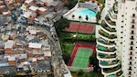

WHAT: This Is Not A Gateway 5th Festival  
WHEN: **01 November – 02nd November 2014**WHERE: London Bishopsgate Institute  
DEADLINE: **1st Sept 2014**

We are seeking submissions for our final Festival.

The festival is a platform for critical insights and proposals related to our ever-increasing urbanised lives.

The previous 4 Festivals have included installations, workshops, exhibitions, film screenings, walks, debates and roundtable discussions. An average of 150 people contribute and around 2000 people participate across the two days.

The Festival prioritises lived knowledge/experience; the proposals of the oppressed, overlooked and the fighter/warrior and anything by anyone that critically challenges the status quo understanding of ‘cities’.

The Festival is independent to ensure rigour and freedom of thought. It is free to apply, free to participate and free to attend the 2-day event.

W: [www.thisisnotagateway.net](http://www.thisisnotagateway.net)

**\_\_\_\_\_\_\_\_\_\_\_\_\_\_\_\_\_\_\_\_\_\_\_\_\_\_\_\_\_\_\_\_\_\_\_\_\_\_\_\_\_\_\_\_\_\_\_\_\_\_\_\_\_\_\_\_\_\_\_\_\_\_\_\_\_\_\_\_\_\_\_\_\_\_\_\_\_\_\_\_\_\_\_\_\_\_\_**

**CUISLE YOUNG POET OF THE YEAR COMPETITION**

**Closing Date 29th September 2014**

**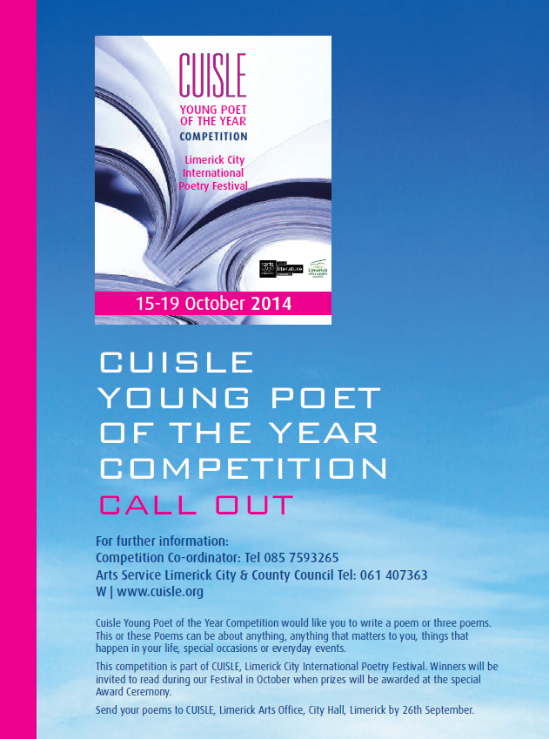**

CUISLE Young Poet of the Year Competition would like you to write a poem or three poems. This or these Poems can be about anything, anything that matters to you, things that happen in your life, special occasions or everyday events. This competition is part of CUISLE, Limerick City International Poetry Festival.

More info at <http://tinyurl.com/l84bncr>

**\_\_\_\_\_\_\_\_\_\_\_\_\_\_\_\_\_\_\_\_\_\_\_\_\_\_\_\_\_\_\_\_\_\_\_\_\_\_\_\_\_\_\_\_\_\_\_\_\_\_\_\_\_\_\_\_\_\_\_\_\_\_\_\_\_\_\_\_\_\_\_\_\_\_\_\_\_\_\_\_\_\_\_\_**

## [Call For: Entries for Film Limerick](http://filmireland.net/2014/07/18/call-for-entries-for-film-limerick/)

[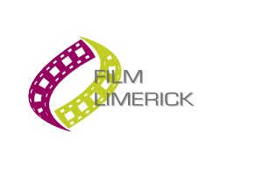](http://filmireland.net/wp-content/uploads/2014/07/film-limerick.jpg)

Limerick City of Culture in partnership with Behind the Scenes have announced the creation of Film Limerick. This project presents an opportunity for new and emerging filmmakers to have their short films produced with both funding and industry support.

Two successful applicants will receive up to **€15,000** towards production of their short film. The only stipulation being that filming must take place in Limerick. Each production will also receive advice and support for making the films.

Film Limerick is now open for entries. The closing date for applications is: **Monday 1st   September 2014.**

Anyone interested in applying should check out the [Behind the Scenes website](http://www.behindthescenes.ie/) or contact Ronan Cassidy at [filmlimerick@behindthescenes.ie](mailto:filmlimerick@behindthescenes.ie)

More info at [http://tinyurl.com/nn2d7nf](http://tinyurl.com/nn2d7nf%20)

# [Call For: New Competition: Writing for Children](http://filmireland.net/2014/07/15/call-for-new-competition-writing-for-children/)

[http://www.rocliffe.com/images/logo.png](http://www.rocliffe.com/index.php)

**Illustration: Adeline Pericart**

Rocliffe, in partnership with BAFTA, and supported by The London Book Fair, announced a call for scripts from emerging writers for the first ever BAFTA Rocliffe New Writing Forum focussed on children’s media, offering entrants the chance to present their work to influential members of the film and television industries.

The competition closes on **01 Sep – early bird entries close 21st July**. The panel will want to read your ten best pages of a full script and submission materials. You can submit by or email. Fees apply.

W: <http://www.rocliffe.com/submit_to_forums.php>

## \_\_\_\_\_\_\_\_\_\_\_\_\_\_\_\_\_\_\_\_\_\_\_\_\_\_\_\_\_\_\_\_\_\_\_\_\_\_\_\_\_\_\_\_\_\_\_\_\_\_\_\_\_\_\_\_\_\_\_\_\_\_\_\_\_\_\_\_\_\_\_\_\_\_\_\_\_\_\_\_\_\_\_\_\_\_\_

**Awards / Bursaries / Schemes**

**\_\_\_\_\_\_\_\_\_\_\_\_\_\_\_\_\_\_\_\_\_\_\_\_\_\_\_\_\_\_\_\_\_\_\_\_\_\_\_\_\_\_\_\_\_\_\_\_\_\_\_\_\_\_\_\_\_\_\_\_\_\_\_\_\_\_\_\_\_\_\_\_\_\_\_\_\_\_\_\_\_\_\_\_\_\_\_**

**The Arts Council – Funding**

**Reel art 2014**

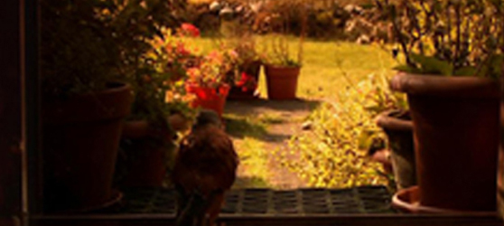

Deadline for receipt of applications: **Friday 17th October 2014, 17:00**.

Reel Art is an Arts Council scheme designed to provide film artists with a unique opportunity to make highly creative, imaginative and experimental documentaries on an artistic theme. Operated in association with Filmbase and the Jameson Dublin International Film Festival, Reel Art will support two films with a grant of **€70-80,000** per project.

Updated guidelines for Reel Art 2014, together with application forms for the scheme are available for download from the website [www.filmbase.ie/reelart](http://newsletter.artscouncil.ie/17xca9zxkab1eenva7sbzm?a=6&p=47682585&t=17684704)  as are details of previous Reel Art projects.

Visual artists in prisons scheme

Maximum awarded: **€2,400**

This scheme provides financial support to selected visual artists to conduct workshops over a period of 10 days in the education units in any of the Republic’s prisons.

Writers in schools scheme

Maximum awarded: **€304**

The Writers in Schools Scheme part-funds visits by writers and storytellers to schools throughout the Republic of Ireland.

[Writers in prisons scheme](http://www.artscouncil.ie/funds/Writers-in-prisons-scheme/)

Maximum awarded: **€1,000**

The scheme offers writers the opportunity to work with prisoners in prison/detention centres and complements an existing arts and education programme in the Education Units within the prison system.

Publications / Title - by – Title scheme

Maximum award: **€35,000**

**Opens 12th August**

Application deadline: **11th September 2014 17:30**

The Publications/Title by Title scheme assists publishers in the production of literary titles and journals.

More info of the above funding and contact details at <http://miniurl.com/4b062>

**\_\_\_\_\_\_\_\_\_\_\_\_\_\_\_\_\_\_\_\_\_\_\_\_\_\_\_\_\_\_\_\_\_\_\_\_\_\_\_\_\_\_\_\_\_\_\_\_\_\_\_\_\_\_\_\_\_\_\_\_\_\_\_\_\_\_\_\_\_\_\_\_\_\_\_\_\_\_\_\_\_\_\_\_\_\_\_**

**The Arts Council - Awards**

Project Awards

Opens **29th July**

Deadline: **28th August**

• Music Project Award - Maximum award **€35,000**

• Opera Project Award - Maximum award **€70,000**

• Theatre Project Award - Maximum award **€150,000**

• Visual Arts Project Award - Maximum award **€40,000**

Project award

Please note that the Arts Council will only be running one round of the Project Award in Visual Arts in 2015. This means that the upcoming deadline of **28th August 2014** for the Project Award Round 1 2015 will be the only available award for visual arts projects taking place in 2015.

Travel and training award

Maximum awarded: **€3,000**

Telephone: 01 61 80 200

Funding continues to be available to support applications in: architecture, arts participation, circus, dance, literature, music, opera\*, street arts and spectacle, venues and visual arts.  
  
\*Please note that applications for Opera will close at the end of July. Therefore the last date of submission for Opera Travel & Training in 2014 is **31st July at 17:30.**

Read more at <http://www.artscouncil.ie/available-funding/>

**\_\_\_\_\_\_\_\_\_\_\_\_\_\_\_\_\_\_\_\_\_\_\_\_\_\_\_\_\_\_\_\_\_\_\_\_\_\_\_\_\_\_\_\_\_\_\_\_\_\_\_\_\_\_\_\_\_\_\_\_\_\_\_\_\_\_\_\_\_\_\_\_\_\_\_\_\_\_\_\_\_\_\_\_\_\_\_**

|  |
| --- |
| **Announcing the Jack Harte Bursary** |

|  |
| --- |
| **We are delighted to announce the Jack Harte Bursary -**  **Awarded by the Irish Writers Centre in association with the Tyrone Guthrie Centre.**  The Irish Writers’ Centre and the Tyrone Guthrie Centre at Annaghmakerrig have come   together to offer a two-week fully resourced Writer-in-Residence Bursary to take place in spring 2015. The award is named in honour of Jack Harte, founder of the Irish Writers Centre, in celebration and acknowledgement of his contribution to Irish literature.  **Who Can Apply:**  This is an open call to writers resident in Ireland with a proven track record and at least one book of fiction or short stories published by a recognised publisher.  **How to Apply:** Applications are accepted by email only to [director@writerscentre.ie](mailto:director@writerscentre.ie) .    **Application Deadline:**  **26th September, 2014 at 5pm**.  No late applications will be considered. Applications will be acknowledged  For all other queries, please contact [events@writerscentre.ie](mailto:events@writerscentre.ie)  **\_\_\_\_\_\_\_\_\_\_\_\_\_\_\_\_\_\_\_\_\_\_\_\_\_\_\_\_\_\_\_\_\_\_\_\_\_\_\_\_\_\_\_\_\_\_\_\_\_\_\_\_\_\_\_\_\_\_\_\_\_\_\_\_\_\_\_\_\_\_\_\_\_\_\_\_\_\_\_\_\_\_\_\_\_\_\_** |
| **Cooperation Projects call for proposals 2015**  cid:image001.png@01CF3899.0AFEDBA0  The call for proposals for cooperation projects 2015, deadline 1 October, is now live: <https://eacea.ec.europa.eu/creative-europe/funding/cooperation-projects-2015_en>  The Creative Europe Desk will be hosting application workshops in Cork on 20 August, in Belfast on 27 August and in Dublin in September (date tbc). The workshops will cover a range of issues relating to applications for the main funding strand ‘Cooperation Projects – large and small’.  The intention is to provide technical assistance and practical advice as well offering networking opportunities.Along with members from the Culture Office we will be joined by some previous recipients of EU culture funding who will share their experiences and offer tips.If you are planning an application for a Cooperation Project for the October 2014 there will be an opportunity to register for a one-to-one meeting during our application clinic.We will be sending out details of how to register shortly. Please keep an eye on our website: <http://www.creativeeuropeireland.eu> In the meantime if you have any questions please do not hesitate to contact.   |  | | --- | | **Katie Lowry  |  Creative Europe Desk - Culture office  |  International Arts** | | Telephone: +353 (0)1 618 0248  |  e-mail: [katie.lowry@artscouncil.ie](mailto:your.name@artscouncil.ie)  / [cedculture@artscouncil.ie](mailto:cedculture@artscouncil.ie)  |  70 Merrion Square, Dublin 2.  [http://www.creativeeuropeireland.eu](http://www.ccp.ie/)**|  Twitter@CEDCultureIE** |  |  | | --- | | ****DANCE IRELAND**** ****COMMISSION AWARD****  EXPRESSION OF INTEREST (EOI) OPEN CALL [Dance Ireland](http://www.danceireland.ie/index.php) | |
|  |

|  |  |
| --- | --- |
| IMPORTANT DATES FOR YOUR DIARY **Closing Date for receipt of EOI:**  **12 noon, Friday 29th August**  **Shortlist Panel Meeting:**   **Tuesday 30th September**    **Announcement:**   **Friday 24th October**  A detailed information sheet can be [downloaded here](http://danceireland.us5.list-manage.com/track/click?u=5121d0fedd423c64bdbf0d66b&id=c1053868f5&e=1505fd3a45) or from [www.danceireland.ie](http://danceireland.us5.list-manage1.com/track/click?u=5121d0fedd423c64bdbf0d66b&id=05fb5eee8c&e=1505fd3a45)   |  | | --- | | Open to experienced choreographer members of Dance Ireland, working in any genre, with an established track record. The aim of the Dance Ireland Commission Award is to invest in creation of a new and original work, which both supports innovative choreographic practice and stimulates audiences. We wish to respond to proposals that are daring and imaginative.   The Dance Ireland Commission Award is a cash award of **€17,000** plus residency support from Dance Ireland, Dance Limerick and Firkin Crane. The premiere of the commissioned work will take place in Project Arts Centre, late 2015 or early 2016.     **The closing date for receipt of EOI proposals is** **12noon, Friday 29th August**. If you have further questions, please contact Paul Johnson on 01 855 8800 or [paul.johnson@danceireland.ie](mailto:paul.johnson@danceireland.ie) | |

**\_\_\_\_\_\_\_\_\_\_\_\_\_\_\_\_\_\_\_\_\_\_\_\_\_\_\_\_\_\_\_\_\_\_\_\_\_\_\_\_\_\_\_\_\_\_\_\_\_\_\_\_\_\_\_\_\_\_\_\_\_\_\_\_\_\_\_\_\_\_\_\_\_\_\_\_\_\_\_\_\_\_\_\_\_**

### Arts Council's Artist in the Community Scheme - Bursary Award 2014: Collaborative Dance

Deadline:  **24th October (5pm)**

Web: [www.create-ireland.ie](http://www.create-ireland.ie)

The Arts Council Artist in the Community Scheme Bursary Award 2014: Collaborative Dance aims to support individual professional dance artists working in the area of collaborative dance or with groups of non dancers . This is the fifth year that the Arts Council has provided a **€10,000** bursary award as part of the Artist in the Community Scheme, which is managed by Create. This year for the first time the focus will be art-form specific as opposed to focusing on a social or community context.

The Bursary Award of **€10,000** provides the selected artist with the time and resources to carry out research, and to reflect on and re-consider the questions associated with creating dance work with non dancers or those who are not professionally trained.It is expected that the successful applicant will share the learning arising from the Bursary with the wider dance community and collaborative arts sector.

Create will work in partnership with Dance Ireland in providing information sessions and on the selection process and details on the dates for the sessions will be announced on

[www.create-ireland.ie](http://r20.rs6.net/tn.jsp?f=001m_3HN6KNk-_p-lEuScFgF_UY6xVp4vNqCYfvI774zvPzJRuBVTviPmR0bhAhK4xEKkLqk7V1qB_nULsCET51obKdkVpOPftQSyf2BNHXd1BoAPVYvcbRMI1B7QkcCrbu_mu-VoT-BtoybBJfGs04rnhjzQLVlM0W6QdTSBfnhdquK8poMUydjg==&c=b3o4qYKY5DRFLoW7qs_or2gpbar_P3jxMjR9oNqZJG2uemcoc1SpNQ==&ch=V-wO1x9Pap4bDqoHf7ynABRbSPcRgTxqSOSf5GaLTsQnSKlON1G8ww==)

[www.danceireland.ie](http://r20.rs6.net/tn.jsp?f=001m_3HN6KNk-_p-lEuScFgF_UY6xVp4vNqCYfvI774zvPzJRuBVTviPm0ghaMIryxQhbp6zz_4FBRPZoJ39XwBzTHvIiwNKwoqGC3HlWBx8OoT_FRc84jCQPxI1SDDUIxecWzdycw44t-qt8veRy9wAaNlt5_BmQ9CXqmDkwkLs6I=&c=b3o4qYKY5DRFLoW7qs_or2gpbar_P3jxMjR9oNqZJG2uemcoc1SpNQ==&ch=V-wO1x9Pap4bDqoHf7ynABRbSPcRgTxqSOSf5GaLTsQnSKlON1G8ww==)

For further information on the application, contact Katherine Atkinson, Professional Development, [support@create-ireland.ie](mailto:support@create-ireland.ie)

**\_\_\_\_\_\_\_\_\_\_\_\_\_\_\_\_\_\_\_\_\_\_\_\_\_\_\_\_\_\_\_\_\_\_\_\_\_\_\_\_\_\_\_\_\_\_\_\_\_\_\_\_\_\_\_\_\_\_\_\_\_\_\_\_\_\_\_\_\_\_\_\_\_\_\_\_\_\_\_\_\_\_\_\_\_**

**Visual Artists' Workspace Scheme 2015**

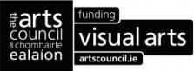

Visual Artists Ireland, on behalf of the Arts Council, invites applications for grants of up to a maximum of **€30,000** towards the running costs of visual artists' workspaces. In keeping with the Council's policy document [*Visual Artists' Workspaces in Ireland - A New Approach*](http://lists.visualartists.ie/lt.php?c=1174&m=4214&nl=1&s=d3c261c0eeb6b48867f449d29e09414b&lid=90450&l=-http--www.artscouncil.ie/uploadedFiles/Main_Site/Content/Research_and_Publications/Visual_arts/Visual_Artists_Workspaces_in_Ireland_policy_FINAL.doc) (DOC, 0.18 MB), this scheme has the aim of assisting artists’ workspaces throughout the country to provide the best possible environment for working visual artists and, where feasible, to enable a level of subsidy for resident visual artists.

Please refer to [www.visualartists.ie](http://lists.visualartists.ie/lt.php?c=1174&m=4214&nl=1&s=d3c261c0eeb6b48867f449d29e09414b&lid=90451&l=-http--visualartists.ie/advocacy-advice-membership-services/visual-artists-workspace-scheme/visual-artists-workspace-scheme-2015-call-applications/) for the Visual Artists Workspace Scheme 2015 Guidelines and Online Application Form.

The deadline for applications is **5pm** **Thursday 4th September 2014**.

**Contact details:**

Niamh Looney  
T: 01 6729488 | E: [niamh@visualartists.ie](mailto:niamh@visualartists.ie)

Visual Artists' Workspace Scheme 2015  
Visual Artists Ireland, Central Hotel Chambers, 7/9 Dame Court, Dublin 2

**\_\_\_\_\_\_\_\_\_\_\_\_\_\_\_\_\_\_\_\_\_\_\_\_\_\_\_\_\_\_\_\_\_\_\_\_\_\_\_\_\_\_\_\_\_\_\_\_\_\_\_\_\_\_\_\_\_\_\_\_\_\_\_\_\_\_\_\_\_\_\_\_\_\_\_\_\_\_\_\_\_\_\_\_\_**

**European Union Prize for Cultural Heritage / Europa Nostra Awards**

[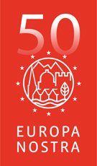](http://www.europanostra.org/)

The **European Union Prize for Cultural Heritage / Europa Nostra Awards** is Europe’s most prestigious prize in the heritage field. Every year, it honours the most outstanding heritage achievements from all over Europe. It recognises the excellence and dedication by architects, craftsmen, cultural heritage experts, volunteers, schools, local communities, heritage owners and the media. It stimulates creativity and innovation, through the power of example.

**DEADLINE 15th OCTOBER 2014**

In 2015, the Awards will be given to up to 30 remarkable heritage projects and initiatives in four categories. Up to seven will be selected as Grand Prix winners and receive **€10,000 each**. One will get the Public Choice Award.

More info at <http://www.europanostra.org/apply-for-an-award-2015/>

**European Cultural Foundation – STEP travel grants – ongoing**

[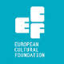](http://www.google.ie/url?url=http://sideshow-circusmagazine.com/research/funding-sources/step-beyond-travel-grants&rct=j&frm=1&q=&esrc=s&sa=U&ei=nYDGU4mnCtKe7AbIhYDoCw&ved=0CCAQ9QEwBg&usg=AFQjCNGnthfC8RitJQx109ixVGPR1pNiAA)

**STEP Beyond Travel grants fund up and coming artists and cultural workers – giving priority to individuals up to 35 years and/or in the first 10 years of their career – to travel between EU and countries bordering the EU.**

There is no deadline for this grant scheme, so you can apply at any time but at least one month before your planned travel. The selection process takes up to one month.

For more information on how to apply, a list of eligible travel destinations and to access the application form, go to the “how to apply guidelines”: [http://tinyurl.com/p26gd7n](http://tinyurl.com/p26gd7n%20)

These guidelines are also available in Russian but please note that the final application has to be in English. You can also access the application form directly here – [ecflabs.org/step-beyond-apply?gids[]=4707#group\_step\_1](http://ecflabs.org/step-beyond-apply?gids%5b%5d=4707#group_step_1)

**\_\_\_\_\_\_\_\_\_\_\_\_\_\_\_\_\_\_\_\_\_\_\_\_\_\_\_\_\_\_\_\_\_\_\_\_\_\_\_\_\_\_\_\_\_\_\_\_\_\_\_\_\_\_\_\_\_\_\_\_\_\_\_\_\_\_\_\_\_\_\_\_\_\_\_**

**The Golden Fleece Award - Call for Applications for the 2015 Award**

****

The Golden Fleece Award aims to support and promote the diversity of contemporary Irish creativity in the arts and crafts. Its mission is to help artists of innovative talent, needing support at strategic stages of their careers. Applicants will normally have been born on the island of Ireland and must maintain a strong connection with Ireland. They should be artists or researchers working in the area of figurative visual art or of the traditional crafts.

Closing date for applications: **Friday, 21st November 2014**

Full details of submission requirements and procedures can be found on our website at www.goldenfleeceaward.com.

# \_\_\_\_\_\_\_\_\_\_\_\_\_\_\_\_\_\_\_\_\_\_\_\_\_\_\_\_\_\_\_\_\_\_\_\_\_\_\_\_\_\_\_\_\_\_\_\_\_\_\_\_\_\_\_\_\_\_\_\_\_\_\_\_\_\_\_\_\_\_\_\_\_\_\_\_\_\_\_\_\_\_\_\_\_\_\_

**Fire Station's Sculpture Workshop and Digital Media Awards**

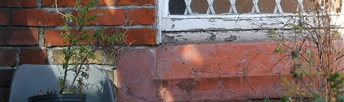

Fire Station established these awards in order to open up access to our facilities and resources for professional visual artists. We now have two awards. The Sculpture Workshop Award & Bursary provides use of and access to the workshop and its equipment, and includes a bursary up to **€500 each**. The Digital Media Award & bursary provides access to Fire Station's Resource Centre and digital media facilities (4 months & **€100 each**).

There is currently an open call for applications for these awards. **Deadline: 27th August 2014.**

Full details: [www.firestation.ie/opportunities](file:///C:\Documents%20and%20Settings\jmorgan\Desktop\www.firestation.ie\opportunities)

# \_\_\_\_\_\_\_\_\_\_\_\_\_\_\_\_\_\_\_\_\_\_\_\_\_\_\_\_\_\_\_\_\_\_\_\_\_\_\_\_\_\_\_\_\_\_\_\_\_\_\_\_\_\_\_\_\_\_\_\_\_\_\_\_\_\_\_\_\_\_\_\_\_\_\_\_\_\_\_\_\_\_\_\_\_\_\_

**Of Interest**

# \_\_\_\_\_\_\_\_\_\_\_\_\_\_\_\_\_\_\_\_\_\_\_\_\_\_\_\_\_\_\_\_\_\_\_\_\_\_\_\_\_\_\_\_\_\_\_\_\_\_\_\_\_\_\_\_\_\_\_\_\_\_\_\_\_\_\_\_\_\_\_\_\_\_\_\_\_\_\_\_\_\_\_\_\_\_\_

[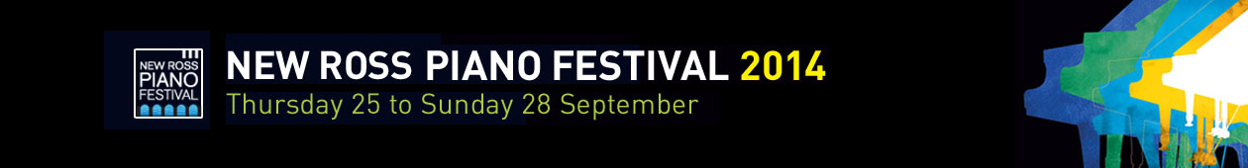](http://www.newrosspianofestival.com/NRPF/)



Beatrice Berrut (Photo: Aline Fournier)

The ninth New Ross Piano Festival will turn its attention to music for piano and wind instruments, as we welcome **Cassiopeia Winds**, a group of five bright stars from Dublin. They will partner our pianists in music by Mozart, Rimsky-Korsakov, Caplet and Poulenc. And what wonderful pianists we have for you this year! Young titans **Lise de la Salle** from France and **Joseph Moog** from Germany will make their Irish débuts, while seasoned Singaporean **Melvyn Tan** will make a long-overdue return. **Beatrice Berrut** is making waves in Switzerland. Artistic Director **Finghin Collins** needs no introduction.

This year we also launch a new project: The **Ros Tapestry Suite**. The first five panels of the Ros Tapestry have inspired the creation of five new solo piano pieces (each lasting five minutes) by five very different Irish composers: **Sebastian Adams, Elaine Agnew, Gerald Barry, John Kinsella and Gerry Murphy**. Five world premieres by five pianists across the weekend. This is an additional reason, if any is needed, not to miss this wonderful weekend.

Help us spread the word – follow us on Twitter and like us on Facebook. We will launch on board the Dunbrody Famine Ship in New Ross on Wednesday August 20th at 6.30pm. All are welcome.

<http://www.newrosspianofestival.com/>