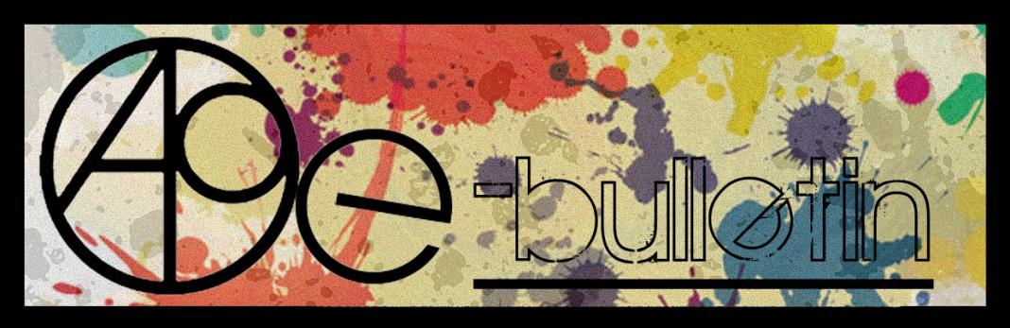

**Kilkenny County Council Arts Office E-bulletin 6th February 2015**

Dear All,   
  
Welcome to the fortnightly e-bulletin from Kilkenny County Council's Arts Office. Each bulletin is packed with the latest information on Kilkenny Arts Office activities, county events as well as news and opportunities for arts practitioners from around the country.

This service will be provided fortnightly. To include an item in the next e-bulletin please send a brief outline of your advert with relevant contact details, including any websites or pages with links to [**niamh.brophy@kilkennycoco.ie**](mailto:niamh.brophy@kilkennycoco.ie) **before 18th February**. The next e-bulletin will be on the **20th February.**

While every effort has been made to ensure the accuracy of our information, we strongly advise readers to verify all details to their own satisfaction.

Regards,

Niamh Brophy  
Arts Office,  
T: 056 7794138  
E: [niamh.brophy@kilkennycoco.ie](mailto:niamh.brophy@kilkennycoco.ie)   
W: [www.kilkennycoco.ie/eng/Services/Arts/](http://www.kilkennycoco.ie/eng/Services/Arts/)

BECOME PART OF IT, SUBMIT A POEM.....[www.rhymerag.net](http://kk-moss/Sites/arts_office/Shared%20Documents/Julianne%20Morgan/E-bulletin/30th%20May%20e-bulletin/www.rhymerag.net)  
Kilkenny County Council Arts Office Partner Local Authority of the ArtLinks Programme [www.artlinks.ie](http://www.artlinks.ie)

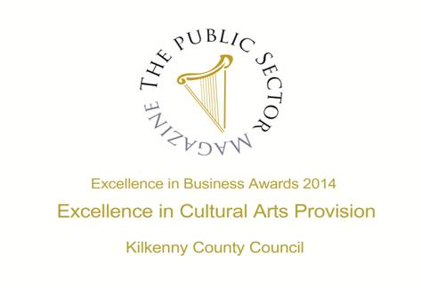

|  |  |
| --- | --- |
|  |  |
|  |  |

### Kilkenny Arts Office 2015 Grants

Kilkenny County Council Arts Office is delighted to announce their call out for applications for their Arts Act Grant and the Tyrone Guthrie Bursary Award 2015

**Arts Act Grants 2015**

The 2003 Arts Act permits a local authority to provide financial assistance for the purposes of stimulating public interest in the arts, promoting the knowledge, appreciation and practices of the arts or improving standards in the arts. In this act, the expression “the arts” means creative or interpretative expression (traditional or contemporary) in whatever form and includes in particular visual arts, theatre, literature, music, film, literature, dance and Multi-disciplinary events.

Who is eligible to apply:

1. **Groups and Organisations promoting the Arts**
2. **Individual Artists – all art forms -** to enable them to pursue their practice, to develop within their chosen discipline and deliver projects.

**Tyrone Guthrie Bursary 2015**

Kilkenny County Councils Arts Office in partnership with the Tyrone Guthrie Centre is now offering its annual residency opportunity for a practitioner in any art form currently based in Kilkenny to spend two weeks at the Tyrone Guthrie Centre artists’ workplace, Annaghmakerrig, Co Monaghan.

The aim of the Residency is to assist and encourage both established and emerging practitioners, in giving them an opportunity to work intensively on a project alongside others in a very unique environment.

**Closing date for receipt of completed applications for bothmis no later than 4pm on Monday 16th February 2015.**

Application forms, guidelines and criteria for all above may be obtained from: **Niamh Brophy,** **Arts Office, Kilkenny County Council, John’s Green House, John’s Green, Kilkenny. T: 056 779 4138 E:** [**niamh.brophy@kilkennycoco.ie**](mailto:niamh.brophy@kilkennycoco.ie)

**Application forms can also be downloaded from** [**http://www.kilkennycoco.ie/eng/Services/Arts/News/Kilkenny-Arts-Office-2015-Grants.html**](http://www.kilkennycoco.ie/eng/Services/Arts/News/Kilkenny-Arts-Office-2015-Grants.html)

**Kilkenny County Council Writer in Residence OPPORTUNITY**

Kilkenny County Councils Arts Office has a strong commitment to providing literary developments through partnerships and collaborations between the Arts Office, the Library Service, and Carlow / Kilkenny ETB. We focus on ensuring a balanced approach to the development of projects and activities across all art forms within Kilkenny city and county. Therefore we are now seeking applications to appoint a writer in residence.

Writers are invited to make applications focussing their submissions on the ability of the residency to further develop our literary programming to date, to enhance and generate new audiences and to attract new writers. Their concern should also include extending the appreciation of writing and literature and encouraging and supporting self initiated literary activity across the county. This is also vital to the the literary and cultural health and vitality of the City and County.

We expect that the residency will introduce Kilkenny based writers to new experiences, increase their prowess and expertise thus offering new opportunities and prospects into the future. This project is also part of the Art Office’s support of the continuing professional development of practitioners in Kilkenny. We also look forward to activities that will extend the appreciation of writing and literature and enhance accessibility to this art form.

Our monitoring and evaluation of our literary programmes over the last few years have enabled us to identify a number of areas and concerns that our literary community wish to be addressed. Applicants must give details on how they would approach and address these issues within their application for the position. This is contained in the application and supporting information details available from the Arts Office.

For further details and application and application forms please contact:

[niamh.brophy@kilkennycoco.ie](mailto:niamh.brophy@kilkennycoco.ie) Tel. 056 779 4138

Alternatively please download application forms and further information from: <http://tinyurl.com/kodwzrx>

**Deadline for receipt of applications is no later than 4pm Monday 9th February 2015.**

Late applications will not be considered. No e-mail applications will be accepted, hard copies only.

[logo](http://kilkennylibrary.kilkenny.ie/) 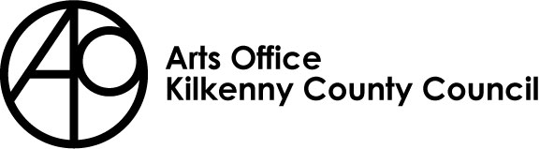

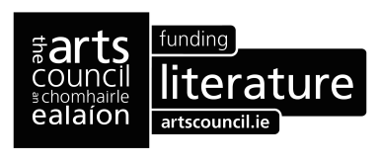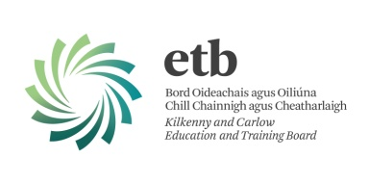

**Open Circle Community Arts Collective seeks Development Worker**

[www.opencirclearts.ie](http://l.facebook.com/l.php?u=http%3A%2F%2Fwww.opencirclearts.ie%2F&h=yAQE4mtR2&s=1)

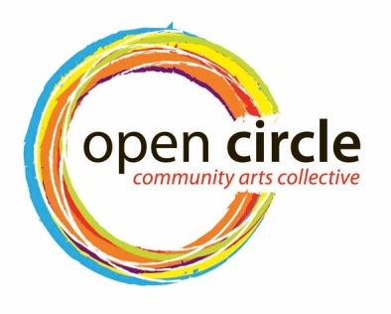

The Arts Office, Kilkenny County Council invites applications from interested individuals who have experience working with the community in a developmental... capacity for the delivery of a combined personal development and artistic programme, including community outreach, exhibitions and exchanges.

Invite and co-ordinate inputs to the group for the year and facilitate development of whole project ideas and capacity. They will also promote the project externally and maintain and further develop social media position for the project.

**Role of the Development Worker**  
The duties of the Development Worker will include:  
• Undertaking research for programme development   
• Guiding the development of an annual programme of work for the project participants and the wider public where appropriate   
• Co-ordinating and administering this programme  
• Acting as a Communication Liaison officer to and from the Project, the facilitating practitioners, the Arts Office and other outside sources   
• Invite and co-ordinate other inputs to the Project for the year   
• Facilitate development of whole project ideas and capacity   
• Promote and Market the Project locally and nationally   
• Support the implementation of the brand of the project   
• Maintain and further develop social media output for the project  
• Further develop the membership database  
• Assist with introducing new groups and new members to the project, taking social inclusion matters into consideration  
• Assist in the sourcing of funding for the Project and completing funding applications   
• Co-ordinate and develop a strategy for the future of project and all that this entails   
• The coordinator must forge and maintain a relationship between project, the Arts Office, the facilitating artists / practitioners and the participants  
• Monitor, evaluate and document all aspects of the Projects programmes  
• Any other duties deemed necessary and reasonable by the Kilkenny County Council Arts Office.  
• The Development Worker will   
o report to the Arts Officer on a regular basis  
o Submit a written annual report and analysis of the programmes including budgets to the Arts Officer   
  
This position is on a part time basis initially twelve hours weekly. tbc.  
  
Application by CV and Cover Letter to marking the envelope as Open Circle Development Worker and forward to Mary Butler, Arts Officer, Kilkenny County Council, County Hall, John Street, Kilkenny. No electronic applications accepted.

This project is currently supported by Kilkenny County Council Arts Office, the Arts Council of Ireland and Kilkenny / Carlow ETB.

Insurance and Tax: The successful applicant will be responsible for all taxes which arise from any payment by Kilkenny County Council of the agreed fee including and without prejudice the generality of this provision, all income tax and VAT .

**The deadline for receipt of applications is 23rd February 2015.**

The Arts Office, Kilkenny County Council and Open Circle Community Arts Collective acknowledges the support of the Arts Council/An Chomhairle Ealaíon and Kilkenny / Carlow ETB

**Siamsa Winter / Spring 2015: Workshop Update**

Kilkenny County Council Arts Office is delighted to announce the return of ‘Siamsa’ programme for 5 to12 year olds. Participants join professional artist Órla Bates and scientist Michelle Maher for a unique experience in **SPARK**.

‘Siamsa’ has been part of the Arts Office’s programme since 2011. This fun programme has supported children in developing numerous skills including drawing, painting and making in a diverse range of media. Our very popular Arts and Science workshops covering the laws of physics and environmental chemistry.

## Check out some pictures form the first two workshops Balloon Cars and *Ready, Steady…Rockets!*

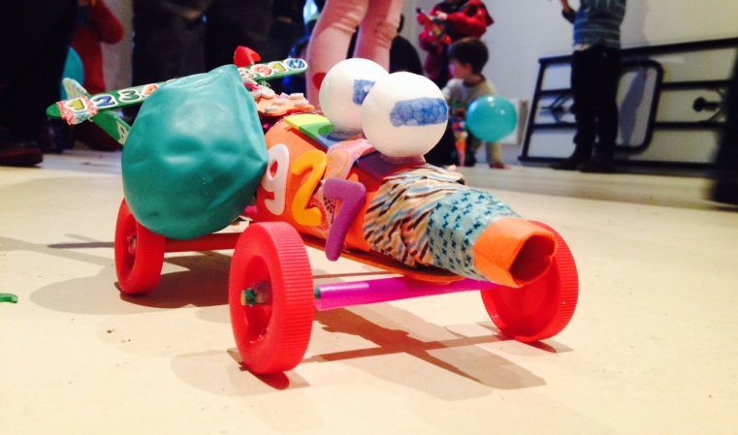 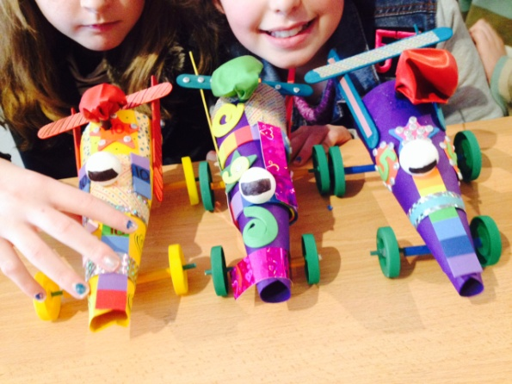

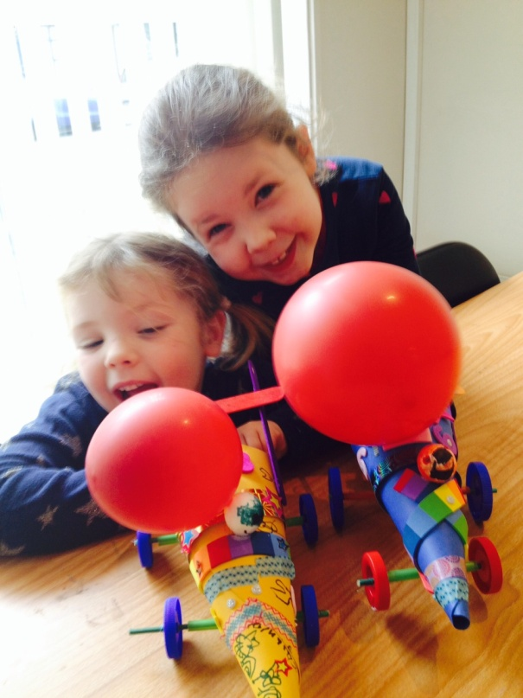 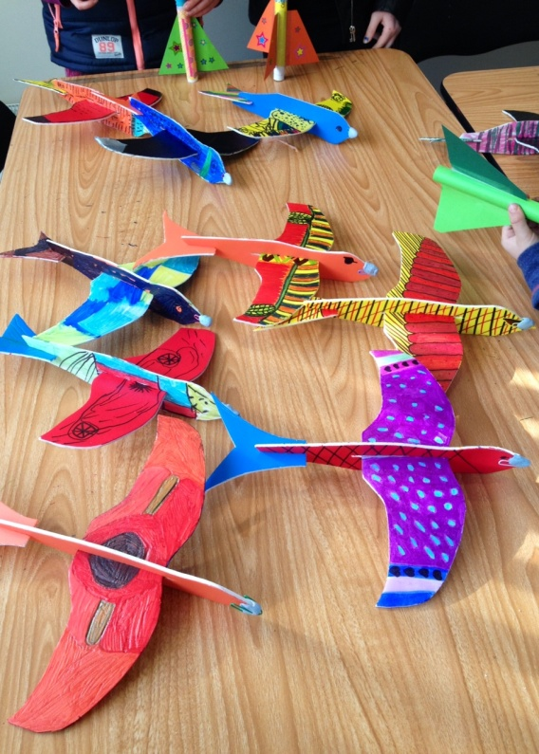

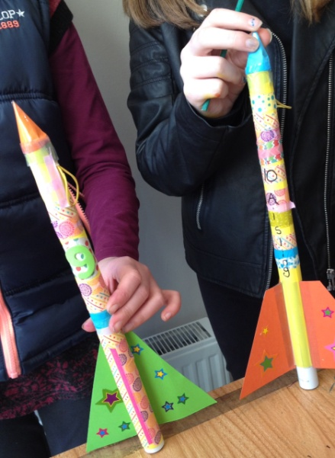 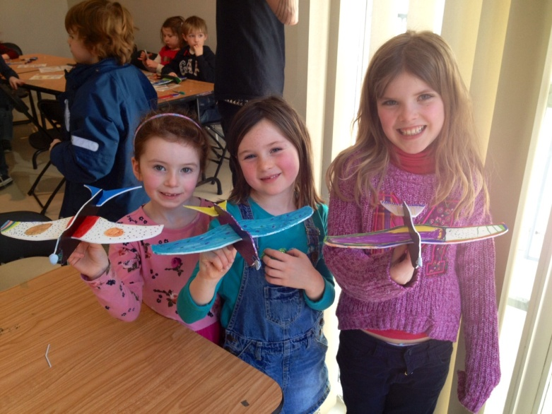

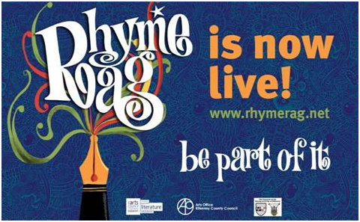

**Kilkenny Events**

[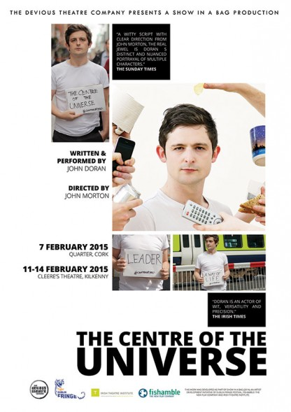](http://devioustheatre.com/assets/war-of-attrition-programme-6.jpg)



**Spring Literature Course at NUIM Kilkenny Campus**  
  
Continuing our exploration of Irish poetry and short story, this course will include some of Seamus Heaney’s most popular poems, and some less well known. From William Trevor’s celebrated collections of short fiction, we will discuss a number of key stories. This is a follow-on from our autumn course and newcomers are welcome.

Thursday evenings 7- 9pm, for six weeks from February 19th. Course fee €100.  
Venue: Kilkenny Campus at St Kieran’s College.  To book, email [margaret.irish@nuim.ie](mailto:margaret.irish@nuim.ie)

**‘Townlands 3’ an exhibition by Gypsy Ray and Alan Counihan**

12th February - 7th March 2015

Reception will take place on the 14th February, 3-5pm in The Old Market House Arts Centre, Lower Main Street, Dungarvan, Co.Waterford.

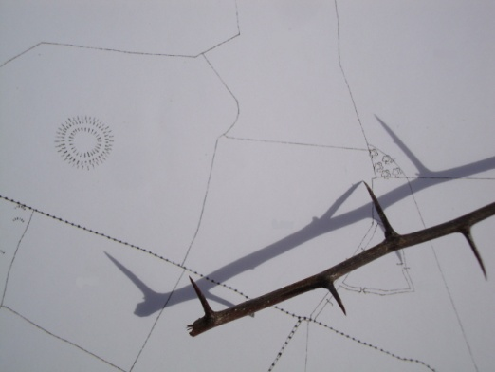

*Townlands* is an exhibition of works made over the past six years by artists Alan Counihan and Gypsy Ray as part of *The Townlands Project*. Works to be shown at the Old Market Arts Centre in Dungarvan, Co Waterford include photographs, drawings and sculpture, all of which have grown out of creative interaction with the artists’ local landscape. All of the works in this exhibition have their roots in an experience of the rural and have proved popular with viewers wherever they have been shown. *Townlands* exhibitions are constantly revitalised with new works born out of our ongoing explorations.

It is hoped that this exhibition will have the effect of encouraging all those who engage with it to explore their own places and communities and to discover what makes them unique in the world.

For more information see :

[www.townlands.net](http://www.townlands.net)

[www.gypsyray.wordpress.com](http://www.gypsyray.wordpress.com)

[www.alancounihan.net](http://www.alancounihan.net).

**Sharon Verrall Exhibition opening**

Opening reception on February 26th at 7pm in The Watergarden Gallery, Ladywell Street, Thomastown. A Year in Haiku is an exhibition of paintings & poetry by Kilkenny artist and writer Sharon Verrall. The series of work has evolved over the course of a year observing nature and the changing seasons, internally and externally. While the works pay homage to the traditional essence of Haiku & Haiga, they are the artist’s own vision of the world we live in. Techniques incorporated were painting with gesso and watercolour, dry-brush layering and screen-printing with collage and stitching. The haiku were transcribed using a vintage Continental typewriter. The show runs until March 27th.

**Exhibition Space available at City Library**

Exhibition space is available in City Library, John’s Quay for artists/photographers. Bookings are generally taken for a month. Groups and schools are also welcome.

Phone Aisling on 056 779 4174 to book.

## Coming Soon to the Watergate Theatre

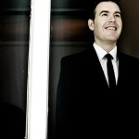

[The Three Tenors](http://watergatetheatre.com/programme/three-tenors/)  
Sat 7th February 2015  
Tickets: € 25/€22

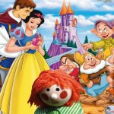

[Snow White And Bosco](http://watergatetheatre.com/programme/snow-white-bosco/)  
Sun 8th February 2015  
Tickets: € 10



[Eddi Reader](http://watergatetheatre.com/programme/eddi-reader/)  
Thu 12th February 2015  
Tickets: € 20

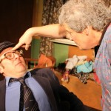

[It's The Real McCoy](http://watergatetheatre.com/programme/real-mccoy-2/)  
Fri 13th February 2015  
Tickets: € 20/€18



[The Music & Comedy Spectaular!](http://watergatetheatre.com/programme/music-comedy-spectaular/)  
Mon 16th February 2015  
Tickets: € 14/€12

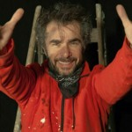

[Arthur's Dig](http://watergatetheatre.com/programme/arthurs-dig/)  
Thu 19th February 2015  
Tickets: € 15/€12



[Reeling In The Showband Years](http://watergatetheatre.com/programme/reeling-showband-years/)   
Fri 20th February 2015  
Tickets: € 30

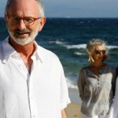

[Stories, Poetry and Dreams](http://watergatetheatre.com/programme/stories-poetry-dreams/)  
Fri 27th February 2015  
Tickets: € 20

For more details see <http://watergatetheatre.com>

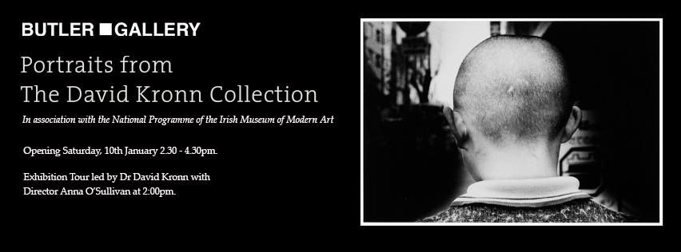

|  |  |
| --- | --- |
| **Fresh Talent at the National Craft Gallery, Kilkenny**  **FRESH TALENT**  **6 FEBRUARY 2015 – 18 MARCH 2015**  Fresh Talent shines a light on the creative new wave of designers emerging since 2011 who work within and across disciplines. The exhibition includes a mix of award winning graduate projects from Irelands major universities and from Irish students abroad and a selection of designers and practitioners who are establishing their businesses. The exhibition draws from a range of fields and incorporates a selection of design disciplines; Craft, Architecture, Set Design, Visual Communication, Product Design, Fashion, Design Engineering all feature.  All events are **FREE** but booking is required.  **EXHIBITION CURATOR’S TALK & LAUNCH**  Fri 6 Feb, 6pm, 7pm  Angela O’Kelly in conversation with guests.  [**DRAWING AS RESEARCH**](http://www.nationalcraftgallery.ie/news/article/drawing-as-research-with-jewellery-designer-inga-reed)  Fri 13 Feb, Wed 25 Feb, Wed 11 Mar, 10.30am -12.30pm  Explore drawing as a tool for developing creative ideas with Inga Reed  [**FAMILY DAY: POP PRINTS**](http://www.nationalcraftgallery.ie/news/article/fresh-talent-family-days)  Sat 14 Feb 10.30am & 12 noon  Design a unique pattern or drawing and learn to print it with Mella Cahill  [**ADULT WORKSHOPS: FRESH PRINTS**](http://www.nationalcraftgallery.ie/exhibitions)  Sat 14 Feb, 2.30pm -4.30pm  Design and produce your own linocut relief print with Mella Cahill  [**LATE DATE: MEET THE MAKERS**](http://www.nationalcraftgallery.ie/news/article/meet-the-makers)  Thurs 26 Feb, 6.30pm  Fresh Approaches to Jewellery with Arturo Borrego  [**SCHOOLS WORKSHOPS**](http://www.nationalcraftgallery.ie/news/article/schools-workshops)  Tues 3, Wed 4, Thur 5, Fri 6 March 10am & 1.30pm  Exhibition talk and hands on print workshop with Caroline Ryan  [**INTERNATIONAL WOMENS DAY WORKSHOP**](http://www.nationalcraftgallery.ie/news/article/object-portrait-assemblage-collage-juxtaposition-with-artist-kate-o-kelly)  Sun 8 March, 12- 2pm & 3pm -5pm  **Object: Portrait,** Assemblage, Collage, Juxtaposition with artist Kate O Kelly  [**FAMILY DAY: SET DESIGN CREATIONS**](http://www.nationalcraftgallery.ie/news/article/fresh-talent-family-days)  Sat 14 March, 10.30 & 12noon  Set Design Creations with Orla Reynolds  [**AFTERNOON TALKS: MEET THE MAKERS**](http://www.nationalcraftgallery.ie/news/article/meet-the-makers)  Sat 14 March, 2.30pm  Set & Furniture Designer with Orla Reynolds  **To book or regisiter your interest in any of our events please contact National Craft Gallery at 056 7796151 or email** [**events@nationalcraftgallery.ie**](events@nationalcraftgallery.ie)  **[www.nationalcraftgallery.ie](http://www.nationalcraftgallery.ie)**  [**https://www.facebook.com/NationalCraftGallery**](https://www.facebook.com/NationalCraftGallery)  <twitter.com/NCGKilkenny>  Description: Macintosh HD:Users:educationassistant:Desktop:w3b-641x300.jpg  Image of furniture work by Darragh Casey   |  | | --- | |  | |

**KOZO Workshop Programme 2015**

|  |  |  |  |  |  |
| --- | --- | --- | --- | --- | --- |
| |  |  |  |  |  | | --- | --- | --- | --- | --- | | |  |  | | --- | --- | | |  | | --- | |  | |  |  |  | | --- | --- | | |  | | --- | | **KOZO Studio WORKSHOP Programme** for adults (incl. young people from 16 years)  **GIFT VOUCHERS are available for the workshop of your choice!**  These courses take place at **KOZO Studio** The Estate Yard, Castlecomer Discovery Park, Co. Kilkenny  **FEBRUARY -  MARCH 2015**   **22 February (Sunday): PAPER MAKING DAY** - Beginners **10.30am - 1.30pm HAND PAPER MAKING** - Introduction to traditional and contemporary techniques of making beautiful handmade papers from pure plant fibres and a range of recycled materials. **2.30 - 5.30pm SILK FIBRE PAPERMAKING** - A truly fascinating, contemporary technique for making `fabric-like`, colourful silk papers using raw silk fibres and fabric dyes. Easy to continue and set up at home, this process is ideal to create unique interior decorations and striking silk papers for artworks, embroidery, collages, card making...etc.  Fees for each workshop: € 35  OR: € 65 for the full day - including all materials  **********  **1 March (Sunday)** **11am - 5.30pm BATIK Workshop** - Beginners A full day programme introducing an ancient technique of fabric dyeing where hot wax is used as a resist. Participants will learn all necessary basic techniques - and complete three small/medium batik pieces with up to 4 colours on cotton fabric and/or paper.  € 70 for the full day, including all materials  **********  **7 March (Saturday): PAPER MAKING DAY**- Beginners and participants with some previous experience in papermaking and/or textile processes. This programme is scheduled the same way as the Papermaking Day in February (please see above) but is designed for participants who have a little experience in similar techniques.  **********  **22 March (Sunday): PAPER ART and HAND PAPER MAKING  - *FOLLOW-ON, ADVANCED LEVEL COURSE -*** only for participants with previous experience. **10.30am - 5.30pm**  Designed for participants who already work with paper/fibre based processes, this course offers assistance and guidance in areas of three dimensional, sculptural and installation based works, experimental processes of batik, paper dyeing and texturing. It also covers ideas for the preparation and use of plant based pulps (without added chemicals). Participants are encouraged to bring their own ideas and questions into the workshop and invited to show and discuss previous works and projects. The day also includes a short slideshow presentation on examples of contemporary paper art and paper making. **Places are limited for 5 participants.**  € 80 for the full day, including all materials | | | |
| |  |  |  | | --- | --- | --- | | |  |  | | --- | --- | | |  | | --- | | **BOOKINGS are confirmed with € 30 deposit paid in advance.* Courses are run for small groups of participants only so please call to book early. With any questions, for advice or check availability and for all BOOKINGS please contact me directly:  Tunde Toth - Artist 087-2543362** [**tundetune@gmail.com**](mailto:tundetune@gmail.com)[**www.tundetoth.com**](http://www.tundetoth.com) | | | |

**Courses / Training / Jobs / Internships**

**_______________________________________________________________________________________**

**Box Office and Sales Manager: full time, fixed term (10 month cover) contract**

The Box Office and Sales Manager is responsible for the operation of the systems necessary to sell all tickets and associated products, performances and events at Dunamaise Arts Centre. Reporting to the Director, the successful applicant will be expected to maintain a high standard of excellence in all contacts with patrons, visitors and stakeholders.

Key responsibilities along with Candidate specifications and requirements can be found on [www.dunamaise.ie](http://www.dunamaise.ie) or contact [manager@dunamaise.ie](mailto:manager@dunamaise.ie) for full job description.

**TO APPLY** Please email a cover letter, addressed to the Director, outlining why you think you would be suited to the position of Box Office Manager, along with a detailed CV to [manager@dunamaise.ie](mailto:manager@dunamaise.ie) by **Friday 13 February 2015.** Shortlisted candidates will be interviewed the following week, with a view to role commencing soon after.

**Museum Curator (JobBridge Internship), Kilkenny**

The Irish Defence Forces have advertised a JobBridge Internship for a Museum Curator, based in the Military Museum, Stephens Barracks, Kilkenny City.

This is a 9-month placement (40 hours per week) and an allowance of €50 is paid on top of your current social welfare payment. The intern will gain experience in skills in curatorship at a practical level. The intern will receive formal/informal training in the administrative and logistical aspects of day to day Museum operation.

Candidates for the position must have Leaving Certificate or equivalent (Compulsory). Diploma/Degree in Museum Curatorship; Computer Literacy (Desirable). Personal Competencies: Initiative, Teamwork, Analytical Thinking, Achievement, Integrity, Customer Service Orientation, Conceptual Thinking, Empathy.

See JobBridge website, reference INTE-908456, live until 19 March 2015

**MA in Practice Based Play Therapy in 3 Stages**

The Postgraduate Diploma/Certificate in Practice Based Play Therapy has been developed to meet the identified needs of practitioners in the play therapy sector who wish to pursue accredited programmes of study in a flexible manner, complimenting and supporting continued employment.  This part-time blended learning programme of study builds on practical experience, enhancing the learner’s skills through exposure to theory, policy, research and work-based learning opportunities.

If interested please send your address details to [apacorg@aol.com](mailto:apacorg@aol.com) All information is also on [www.playtherapy.org.uk](http://www.playtherapy.org.uk/)  or the APAC web site: www.apac.org.uk and you can ring the Admissions office on [+44 1825761143](tel:%2B44%201825761143) for any further queries. For course content and entry requirements please refer to APAC’s website, www.apac.org.uk and Play Therapy Ireland [www.playtherapy.ie](http://www.playtherapy.ie)

 Introductory Day March 28th 2015 in Cork - An ideal introduction to the interventions and media used together with our experiential based training methods

**What a Difference a Year Makes (Writers Retreat)**

Manuscript Transformation: Four residential weekend workshop retreats paced through 2015, designed to support writers as they develop and enhance a prose manuscript. What a Difference a Year Makes Prose Dates: March 13-15th, May 15-17th, September 11-13th, November 13-15th. Retreats are limited to 4 participants.

Each weekend will include

* One-to-One individual mentoring with Grace Wells.
* Group workshops focused toward manuscript development and editorial craft.
* Set Daily Times for Writing in quiet.
* Space for Reflection & Dreaming into your manuscript.

Writers will be asked to submit a suggested minimum of 9000 words of prose, to their mentor Grace Wells, prior to each weekend workshop. Maximum word counts submitted can be negotiated, depending on the advancement of each individual project.

Total, All-inclusive cost of 4 Workshop Retreats €1200

To secure your place, a non-refundable deposit of €300 is by February 27th.

Full payment is acceptable at any time, or remaining instalments of €300 can be paid at the first 3 weekends.

Cost includes: workshops & mentoring, two nights accommodation at The Well-Spring, on the side of Sliabh na mBan, Co Tipperary. All meals, tea, coffee & snacks. Please note, these are alcohol-free retreats.

For Further Details Please Apply: gracewells@eircom .net 086-390-6330

# Bitesize arts and health training, Cornwall, UK

Are you interested in designing and delivering your own arts and health projects?

* **Delivering Creative Projects for Older People – Thursday, 26 February 2015**
* **Introduction to Arts and Health – Tuesday, 10 March 2015**
* **Delivering Creative Projects for Mental Health and Wellbeing –Thursday, 26 March 2015.**
* **Documenting, Reporting and Evaluating – Thursday, 16 April 2015**

**Cost:** Each session costs £12.50 including refreshments and training materials.  
**Time and location:** 1.00pm to 5.00pm at the Arts for Health Cornwall offices, Jubilee Wharf, Penryn.  
Bookings: [www.artsforhealthcornwall.org.uk/events-booking](http://www.artsforhealthcornwall.org.uk/events-booking)  
Booking is essential; only 8 places are available for each session.

**Seeking voices for the Irish Youth Training Choir**

IYTC provides young singers aged 14-17 with the opportunity to train with leading vocal and choral professionals during a weekend residential summer course and performance for Irish Youth Training Choir. After this they can expect to progress on and train in a week long residential Irish Youth Choir course for ages 18-28.

During the weekend residential course, members participate in a daily routine of physical and vocal warm-ups, sectional and full choir rehearsals - a complete singing experience!  Sports and recreational activities are organized as part of the course.

* Applicants to IYTC must be born or resident in Ireland.
* Aged 14 - 17 during the June 2015 course you may apply for Irish Youth Training Choir.
* Have relevant choral/singing experience
* Have a nominating music teacher or relevant equivalent
* In exceptional circumstances people not fitting these criteria may be considered.

Applicants must be available from Thursday 25th June to Sunday 28th June inclusive. Application forms and further information are available from Lily Mc Garry, Administrator, Association of Irish Choirs or Dermot O’ Callaghan, CEO, Association of Irish Choirs

W: [www.aoic.ie](http://www.aoic.ie) E: [aoic@ul.ie](mailto:aoic@ul.ie) T: 061 234823/ 061 202715

**Call for Submissions / Residencies**

**Lost Spaces 2015: Call for Ideas**

The Lost Spaces design competition asks professionals and students in the fields of art, architecture, design and engineering to respond to the diverse challenges of design, social sustainability and low impact design improvements. The ideas competition aims to explore alternatives improving the use, public realm and ecological value of a lost space.

A ‘lost space’ is any space that remains underutilized within our urban environment. They might be leftover pieces, a ghost of the planning past. Lost spaces are part of the public realm, rarely designed to function with both social and environmental benefit to the city.

You may consider a lost space as a passageway, a roundabout, space between two buildings, a highway shoulder, or tenants of the city’s history and memory. We’d like to ask you to dream, take risks and stretch what we think is possible.

Award $7500 CAD  
Registration and questions deadline: March 20, 2015  
Submissions due: March 30, 2015

This international ideas competition is open to artists and designers anywhere. Unique perspectives of diverse disciplines and collaborative teams is encouraged. See the call for ideas link for specifics about tailoring your idea to the local climate conditions.

[http://dtalks.org/call-for-ideas](http://lists.visualartists.ie/lt.php?c=1289&m=4326&nl=1&s=d3c261c0eeb6b48867f449d29e09414b&lid=101956&l=-http--dtalks.org/call-for-ideas)

### Hospitalfield Arts Interdisciplinary Residency March and August 2015

The application deadline for Hospitalfield's March and August Interdisciplinary Residency: 19 March 2015, midnight.

The Interdisciplinary Residency Programme at Hospitalfield has been devised to appeal across all art forms, it has been planned as an opportunity to support those working across the arts who recognise that they require some time to focus on the development of their work.

If you need information to support a funding application in advance of our selection dates please use the material on our website. <http://hospitalfield.org.uk/programme/events/interdisciplinary-residency-march-august-2015/>

**N.K.E.T.N.S Percent for Arts Commission | Call for Applicants**

North Kildare Educate Together National School wishes to commission an outdoor artwork with integrated learning opportunities that is creative, inspiring and reflects the ethos of Educate Together.

Applicants are strongly advised to visit the school before Wednesday 18th February, 2015. These visits are by confirmed appointment only and will run from 1pm until 3pm in 15 minute slots.

Please contact the school on 01 6274388 between 10am and 1pm to make an appointment. All costs associated with this visit must be met by the artist. There may be the requirement for the successful artist to attend meetings regarding the project proposals.

These will be kept to a minimum and scheduled in consultation with the artist. Artist’s fees for attending these meetings are included in the overall fee.

For more information, a full brief and application form, please visit: [www.nkets.ie](http://lists.visualartists.ie/lt.php?c=1280&m=4318&nl=1&s=d3c261c0eeb6b48867f449d29e09414b&lid=101265&l=-http--www.nkets.ie)

**Secrets of Offaly – Public Art Commission**

A multi disciplinary public art project. Offaly County Council wish to commission up to three artists, each to work with a community group to reveal an identified ‘Secret of Offaly’.

This is a multidisciplinary commission and applications are invited from professional visual artists, filmmakers, musicians, writers, theatre practitioners, dancers and more. Applicants can submit a proposal to work with one or more projects. Each project has a commission value of €10,000.

We are predominantly interested in the artist’s vision for how each story can be innovatively realised, interpreted, communicated and made public. We are open to these commissions being plays, publications, temporary installations, films, music or performance.

**Closing date for application is Thursday 12 February 2015 at 3pm**

Information brief and application form can be downloaded on [www.offaly.ie/arts](http://lists.visualartists.ie/lt.php?c=1273&m=4311&nl=1&s=d3c261c0eeb6b48867f449d29e09414b&lid=100422&l=-http--www.offaly.ie/arts)  
Further information from 057 9357400

**Navan Educate Together National School Per Cent for Art Commission**

Navan Educate Together National School wishes to commission a site specific public artwork/s under the “Per Cent for Art Scheme”, funded by the Department of Education and Science.

Budget: €35,148

The committee would like an installation for the outdoors area of the new school that might reflect a kineticism or alignment to the scientific, geographical, natural or astronomical elements associated with the county of Meath.

The selection process will take the form of a two-stage open competition. It is open to all interested professional artists. Selection will be based on the quality of the information, the feasibility of the proposal and track record of the artist/s involved. International submissions are welcome.

<http://www.navanet.ie/>

**Belfast Photo Festival | Call for Submissions**

Belfast Photo Festival is offering artist’s (using photography) and photographer’s the opportunity to exhibit their work in the main Festival gallery alongside some of the biggest names in the field, with a number also having the opportunity to be featured in the arts magazine Abridged. The winners will be eligible for a number of awards, including a cash prize of £1,000.

The theme has been left open to remove any restrictions; submissions must be photographic or lens-based but we also encourage incorporations of other art forms with the photographic medium (i.e. performance, painting, sculpture, music, literature etc).

Artists will benefit from:  
– Awards and cash prizes  
– Exhibition exposure at the Festival’s main city centre gallery  
– Inclusion in the special Festival issue of Abridged Magazine  
– Long term Festival representation and promotion  
– Exhibition alongside some of the biggest photographic names as part of the major photographic event  
– Publication  
– Being seen by a substantial number of visual arts professionals and the media  
– Having their work viewed by an international panel of influential experts in the field of photography

[www.belfastphotofestival.com](http://lists.visualartists.ie/lt.php?c=1273&m=4311&nl=1&s=d3c261c0eeb6b48867f449d29e09414b&lid=100436&l=-http--www.belfastphotofestival.com/)

**Light Work Artist-in-Residence Program**

Each year Light Work invites 12-15 artists to participate in its residency program, including one artist co-sponsored by Autograph ABP and one artist in conjunction with the Urban Video Project (UVP). Artists selected for the residency program are invited to live in Syracuse for one month. They receive a $5,000 stipend, an apartment to stay in, a private digital studio, a private darkroom, and 24-hour access to our facility.

Participants in the residency program are expected to use their month to pursue their own projects: photographing in the area, scanning or printing for a specific project or book, and so on. Artists are not obligated to lecture at our facility, though we hope that the artists are friendly and accessible to local artists and students. Work by each Artist-in-Residence becomes a part of the Light Work Collection and is published in a special edition of Contact Sheet: The Light Work Annual along with an essay commissioned by Light Work.

Questions? : Questions about the facility may be directed to [lab@lightwork.org](mailto:lab@lightwork.org) and questions about the application process or residency can be sent [toair@lightwork.org](mailto:toair@lightwork.org).

**Deadline 1 July 2015**

For information about our facilities, see [www.lightwork.org/lab](http://www.lightwork.org/lab)

**Yeats 2015 Architecture Competition**

‘…of Clay and Wattles Made’

An Open Submission International Architectural Competition Inspired by Yeats’ Poem ‘The Lake Isle of Innisfree’ – Also open to artists.

Presented by the Institute of Technology Sligo in association with the Model, Sligo, Yeats 2015, Hazelwood Demesne Ltd, and Sligo County Council.

Submissions are invited for conceptual interpretations of WB Yeats’ poem ‘The Lake Isle of Innisfree’. An International Architectural Competition open to regional, national and international practitioners of architecture and art, proposes a poetic architectural intervention for the island of Innisfree which will mediate between Yeats’ poetic vision and contemporary architectural ideas.

The winning design will be constructed on the island for 13th June 2015, as a realisation of Yeats’ vision – a gift on his 150th birthday.

For further information and to download a brief view website

[www.yeats2015-architecture-competition.com](http://lists.visualartists.ie/lt.php?c=1280&m=4318&nl=1&s=d3c261c0eeb6b48867f449d29e09414b&lid=101269&l=-http--www.yeats2015-architecture-competition.com)

Award value €30,000

**Deadline for Submissions 17.00 hours, 12th March 2015**

**axis: Ballymun 2016/2017 Gallery Programme | Call for Submissions**

axis: Ballymun is delighted to invite submissions from artists who are studying in, living in, working in, have a connection to or are originally from North Dublin. There is a focus on promoting artists and creative professionals at the beginning of their career. This call for submissions is open to artists working in across all mediums.

For full details: [niamh.fitzpatrick@axisballymun.ie](mailto:niamh.fitzpatrick@axisballymun.ie)

**Submissions are ongoing.**

[www.axis-ballymun.ie](http://lists.visualartists.ie/lt.php?c=1280&m=4318&nl=1&s=d3c261c0eeb6b48867f449d29e09414b&lid=101281&l=-http--www.axis-ballymun.ie)

**Summer Open Submission Exhibition at glór**

glór, Causeway Link, Ennis, Co. Clare

glór is delighted to invite submissions from artists, both established and emerging, who are resident in, or from, Co. Clare. The exhibition will be held at glór and will open on Wednesday 1st July 2015.

The exhibition will be selected by an independent curator and decisions are final. A curator’s award of €500 will also be made.

More than one piece may be selected for exhibit from successful submissions.

The exhibition is open to wall mounted work only (could include 2D&3D).

Please note that work in other formats, including digital, is not eligible.

Submissions & Queries to [gallery@glor.ie](mailto:gallery@glor.ie)

[www.glor.ie](http://lists.visualartists.ie/lt.php?c=1280&m=4318&nl=1&s=d3c261c0eeb6b48867f449d29e09414b&lid=101282&l=-http--www.glor.ie)

**Project Space at PP/S | Call for Submissions**

Submissions guidelines are now available for artists/groups who are interested in proposing artist-initiated projects, exhibitions, events or performances in the PP/S project space, to take place alongside our own curated programme. Submissions are ongoing.

Please visit the ‘get involved’ page guidelines and submission form, or email info@pallasprojects for more information.

Completed forms can be sent to [info@pallasprojects.org](mailto:info@pallasprojects.org) with the subject line: ‘Project Space Submissions’.

[www.pallasprojects.org/index.php/events/project-space-at-pp-s-open-call-for-submissions-2015](http://lists.visualartists.ie/lt.php?c=1280&m=4318&nl=1&s=d3c261c0eeb6b48867f449d29e09414b&lid=101283&l=-http--pallasprojects.org/index.php/events/project-space-at-pp-s-open-call-for-submissions-2015)

**Exhibition Opportunities at Mountmellick Art Gallery**

Mountmellick Art Gallery at Mountmellick Library is housed on the first floor of the library.

The 80m2 space is bright and spacious. The main room has curved glass walls and there are two additional smaller rooms. Exhibition changes monthly. We welcome applications from professional and amateur artists and we try to provide the public with a diverse range of artistic styles and media for their viewing.

Application form is available on the gallery website.

[www.laois.ie/leisureandculture/libraries/branchlibraries/mountmellick/](http://lists.visualartists.ie/lt.php?c=1280&m=4318&nl=1&s=d3c261c0eeb6b48867f449d29e09414b&lid=101284&l=-http--www.laois.ie/leisureandculture/libraries/branchlibraries/mountmellick/)

**Impressions Fine Art Print Expo 2015 | Call for Submissions**

Established in 1988, Impressions is Ireland’s longest running open submission print exhibition. It encourages, promotes and exhibits the best of printmaking in Ireland. As the first and longest running national Open Print exhibition ‘Impressions’ sees itself as a vital platform to make this creativity visible and a means to highlight the amount of activity in, and enthusiasm for this art form.

‘Impressions’ is already becoming a ‘landmark’ show in the Irish Arts Calendar and the aim is to continue to broaden the scope and ambition of the exhibition, to profile innovation and new technologies and to draw attention to the particular qualities and potentials of the medium.

**Online submissions are now open and will close on April 10th.**

[www.impressionsbiennial.com](http://lists.visualartists.ie/lt.php?c=1280&m=4318&nl=1&s=d3c261c0eeb6b48867f449d29e09414b&lid=101285&l=-http--www.impressionsbiennial.com/) | [www.facebook.com/impressionsprint](http://lists.visualartists.ie/lt.php?c=1280&m=4318&nl=1&s=d3c261c0eeb6b48867f449d29e09414b&lid=101286&l=-https--www.facebook.com/impressionsprint)

**“From the Well” - Short Story Competition 2015**

The Cork County Library and Arts Service have just launched their “From the Well” Short Story competition. The competition is open to people aged 18 or over, who are registered library members. To mark the UN’s International Year of Light 2015, the theme of this year’s short story competition is “Light”. Entrants may interpret the theme in its broadest sense.

The closing date for receipt of applications at your local library or the Arts Office, Library Headquarters, Carrigrohane Road, Cork is **Friday 17th February**

For further information and application form please contact Sinead Donnelly, County Arts Office on

021-4346210 [sinead.donnelly@corkcoco.ie](mailto:sinead.donnelly@corkcoco.ie)

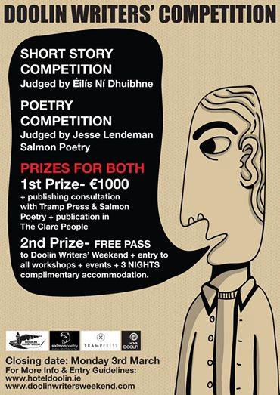

**The White Review**

**Deadline: 1  March 2015**  
Submissions opens on 1 December 2014  
First prize: £2,500 Judges: Ned Beauman   
The White Review Short Story Prize is an annual short story competition for emerging writers. We encourage submissions from all literary genres, and there are no restrictions on theme or subject matter. We would only emphasise that the prize was founded to reward ambitious, imaginative and innovative approaches to creative writing.    
More details <http://www.thewhitereview.org/prizes/the-white-review-short-story-prize-2015/>

**The Caterpillar International Poetry Prize**

**Closing date: 31 March 2015**  
Prize: €1,000 plus publication in The Caterpillar   
Details: To celebrate the first year of The Caterpillar, an arts & literature magazine for children, we're looking for a stand-out poem written by an adult for children (aged 7-11) to which we can award a prize of €1,000. The prize is open to everyone, as long as the work is original and previously unpublished. The entry fee is €12 per poem, and you can enter as many poems as you like. The prize will be judged by the publishers of The Caterpillar and The Moth. For further details go to [www.thecaterpillarmagazine.com](http://irishwriterscentre.us9.list-manage.com/track/click?u=b6ac145e44235d03eb0c4adb6&id=65c6e8f88d&e=055476dad7)

**Scottish Arts Club Short Story Competition**

**Deadline 31 March 2015**  
First Prize of £800 The competition is open to all writers worldwide aged over 16 years, published and unpublished. Stories entered for the competition should be 1,500 words or less and can be on any topic. The stories do not have to be associated with Scotland.    
All details <http://www.scottishartsclub.co.uk>

**2015 Bristol Short Story Prize**

Open to all published and unpublished writers, UK and non-UK based, over 16 years of age.  
Stories can be on any theme or subject and entry can be made online via the website or by  
post. Entries must be previously unpublished with a maximum length of 4,000 words (There is no minimum). The entry fee is £8 per story.

**The closing date for entries is April 30th 2015.**

Full details and rules at [www.bristolprize.co.uk](http://irishwriterscentre.us9.list-manage.com/track/click?u=b6ac145e44235d03eb0c4adb6&id=2ed33bae2e&e=055476dad7)

**Calling All Young Poets**  **- Seán Dunne Young Poets’ Award**

Waterford City and County Council’s Seán Dunne Young Poets’ Award is a long-term commemorative tribute to the memory of Waterford writer Seán Dunne. This award continues to promote the work and the vision of the poet, with emerging and aspiring young authors by recognizing their talents in the poetry genre. The Arts Office is also pleased to engage in a workshops programme for various secondary schools in the City & County using the works of Seán Dunne as inspiration**.**

**Deadline** **12 noon on the 20th March 2015.**

You can download full details and the Entry Form here: [Entry Form Seán Dunne Young Poets Award 2015 (Entry Form Seán Dunne Young Poets Award 2015, 191 kbs)](http://www.waterfordcouncil.ie/en/media/RESIDENT/Arts/Sean_Dunne_Young_Poets_Award_2015.pdf)

**Call for performers of various genres and techniques**

**Summer residential program "Arts Oasis", Tuscana, Italia**. The event is inviting artists **from all over the world.** The workshop will take place at the **XII century monastery,** famous as the place of seclusion for the outstanding **Dante Alighieri. Room, full board & local transportation** are provided for participants. There is a limited number of **partial scholarships.** If you wish to find out more:  [**https://twitter.com/iugte_art**](https://twitter.com/iugte_art)

**Call to artists to participate in On Sight 2015**

On Sight is an annual artist-led initiative which sees the installation of artworks in and around the grounds of Turlough Park, home of the National Museum of Ireland-Country Life, between May and September. This exhibition is a collaboration of the National Museum of Ireland and Mayo County Council and Mayo Arts Squad and involves a number of independent artists and community groups. The exhibition themes relate to the Mission of the Museum and are an integral part of the Museum’s Féile na Tuaithe festival and ongoing programme of events. In this, its fifth year, the theme for On Sight 2015 is: ‘Welcome to the Stranger: Migrant people, places and spaces’.

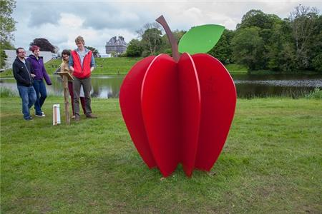

Proposals are invited from experienced community artists to design, produce and install a temporary visual artwork to be displayed for a minimum of 12 weeks in and around the grounds of Turlough Park, Castlebar, Co. Mayo, home of the National Museum of Ireland-Country Life.

Proposals should contain:

* Completed Application form: [On Sight 2015 Application form On Sight 2015 Application form.pdf](http://www.museum.ie/GetAttachment.aspx?id=f46db9a1-925c-40ff-8c0e-f0ab52031a94) (0.19 MB, Adobe PDF)
* CV
* Samples of artists work and description of artistic process/approach to a site specific work.

Submission of completed proposals:Return proposals to Rosa Meehan, National Museum of Ireland – Country Life. Email: [rmeehan@museum.ie](mailto:rmeehan@museum.ie) or phone Rosa Meehan on 094 903 1756 for further information

Closing date for submission is **12 noon on Friday 20th February, 2015.**

**Mayfield Lake Development**

Mayo County Council invites submissions for a public art project in Claremorris, County Mayo. The funding for this project has been provided by the Percent for Art Scheme through the Department of Environment, Community and Local Government.  This is an exciting opportunity for an artist to work with a forward thinking, creative and flexible housing association and residents of an impressive, innovative development.

Budget €28,500

Site Visit:  A site visit will take place on **Friday 6th February at 11am. SUBMISSION DEADLINE:  Friday 6th March 2015**

Full Brief and map attached, or accessed via <http://www.mayococo.ie/en/Services/ArtsOffice/Whatwedo/PublicArt/NewsEvents/>

**FOH Space at Garter Lane Arts Centre | Call for Submissions**

FOH Space is an opportunity for students, recent graduates and emerging artists to exhibit new work in Garter Lane Arts Centre’s front of house area to run alongside our 2015 exhibition programme in the gallery. Now in its third year, the FOH Space is again kindly supported by AIB Waterford and presents an exciting chance for experimentation and development in a historic and active space.

For more details: [gallery@garterlane.ie](mailto:gallery@garterlane.ie)

For full guidelines and detailed plans and images of spaces see [www.garterlane.ie](http://lists.visualartists.ie/lt.php?c=1289&m=4326&nl=1&s=d3c261c0eeb6b48867f449d29e09414b&lid=101965&l=-http--www.garterlane.ie/)

**OUST New Contemporary Culture Magazine: Call for Submissions**

OUST is a new contemporary culture magazine which will showcase international talent across the arts through a series of inspiring and experimental publications. Each issue will be curated around a word and will be open for international submissions that respond through photography, art, design, fashion, essays, short stories or poetry. Each issue will be a hand held exhibition of visual stimulus.

For more details: [hello@oustmagazine.com](mailto:hello@oustmagazine.com). **Deadline is Monday 23rd February 2015** [www.oustmagazine.com](http://lists.visualartists.ie/lt.php?c=1289&m=4326&nl=1&s=d3c261c0eeb6b48867f449d29e09414b&lid=101969&l=-http--www.oustmagazine.com)

**Irish Sound, Science and Technology Convocation: Call for Submissions 2015**

Don’t forget to submit art works, performances, papers, or workshop proposals to this years Irish Sound, Science and Technology Convocation.

RESONANCE AND RECAPITULATION: ECHO OF A RENAISSANCE

In 2011, the first ISSTC was held in Limerick. In 2014, Limerick was the City of Culture, regenerating the diverse and exciting arts practices in the city. In 2015, ISSTC returns to Limerick. In a moment of reflection and on returning to the city of the first convocation, next year’s theme of resonance, recapitulation and renaissance asks contributors to consider past works, old ideas unused, re-birthing projects through new ears and experiences. [http://issta.ie/index.php/call-2015/](http://lists.visualartists.ie/lt.php?c=1289&m=4326&nl=1&s=d3c261c0eeb6b48867f449d29e09414b&lid=101976&l=-http--issta.ie/index.php/call-2015/)

**Awards / Bursaries / Schemes**

**2014/2015 Dates and Deadlines for Culture Ireland Grant Rounds**

Please note Culture Ireland has set funding rounds and deadlines for 2015. There will be three funding rounds in 2015 and seperate calls for showcasing opportunities and Edinburgh Festivals will be announced during the year.

**Application Deadline | Timing of Project/Event | Decision Due**

* 15 February 2015 |  May 2015 onwards |  Early April
* 15 June 2015  | September 2015 onwards | Early August
* 15 October 2015 |  January 2016 onwards | Early December

[http://www.cultureireland.ie/](http://lists.visualartists.ie/lt.php?c=1232&m=4271&nl=1&s=d3c261c0eeb6b48867f449d29e09414b&lid=96096&l=-http--www.cultureireland.ie/)

**Young Ensembles Scheme 2015**

|  |
| --- |
| http://newsletter.artscouncil.ie/nwstatic/spacer.gif |

The Young People, Children and Education (YPCE) Team wishes to advise that applications will be accepted for the Young Ensembles Scheme 2015 from Tuesday 10 March 2015 for projects taking place between July 2015 and June 2016.

The primary purpose of this award is to support groups of young people between the ages of 12 and 23 to create ambitious and original work together in any art form (e.g.; circus, dance, digital media, film, music, theatre, literature, visual arts, architecture or any combination of the above). Groups/ensembles must be made up of 3 or more members. The maximum award available is €10,000. The deadline for the Young Ensemble Scheme 2015 is Thursday 9 April 2015 at 5:30pm.

**Further information**

 Young Ensembles Scheme 2015 guidelines are available to download at [www.artscouncil.ie](http://www.artscouncil.ie) If you require further information, please contact Karen Whelan, YPCE Assistant at 01 619 7805 or [Karen.whelan@artscouncil.ie](mailto:Karen.whelan@artscouncil.ie)

**Opera Production Award 2016**

|  |
| --- |
| http://newsletter.artscouncil.ie/nwstatic/spacer.gif |

The Arts Council's Opera Production award is intended to support the making and presentation of opera productions during 2016, in line with the Arts Council’s published policy for opera.

Applicants may seek support for the production of opera at varying scales, such as:

* Main scale opera for presentation to audiences in larger venues
* Small and medium scale opera, for presentation to audiences in small/medium venues

The deadline for applications for the [Opera Production Award](http://newsletter.artscouncil.ie/fblvn33re2014rbsgtdsq9?a=6&p=48378402&t=28179891) is **Thursday 19 March 2015**.

All details at: [www.artscouncil.ie](http://www.artscouncil.ie)

**Project awards – deadline 5.30pm Thursday 19 March 2015**

|  |
| --- |
| http://newsletter.artscouncil.ie/nwstatic/spacer.gif |

The Arts Council will offer the following Project awards. The Arts Council's Project awards support specific project activities under each of the listed artform/arts practice areas.

* [Arts Participation Project Award](http://newsletter.artscouncil.ie/rny35784thg14rbsgtdsq9?a=6&p=48378403&t=28179891)
* [Circus Project Award](http://newsletter.artscouncil.ie/15od13o61re14rbsgtdsq9?a=6&p=48378403&t=28179891)
* [Dance Project Award](http://newsletter.artscouncil.ie/n6b20btqax214rbsgtdsq9?a=6&p=48378403&t=28179891)
* [Film Project Award](http://newsletter.artscouncil.ie/chkw40hek0e14rbsgtdsq9?a=6&p=48378403&t=28179891)
* [Music Project Award](http://newsletter.artscouncil.ie/f9ckbpqj20414rbsgtdsq9?a=6&p=48378403&t=28179891)
* [Street Arts and Spectacle Project Award](http://newsletter.artscouncil.ie/1eycw0e2gmy14rbsgtdsq9?a=6&p=48378403&t=28179891)
* [Theatre Project Award](http://newsletter.artscouncil.ie/jvhmw1p41y414rbsgtdsq9?a=6&p=48378403&t=28179891)

The award guidelines for each award can be downloaded from the [available funding](http://newsletter.artscouncil.ie/1jvp40uf0jq14rbsgtdsq9?a=6&p=48378403&t=28179891) section of the Arts Council's website. [www.artscouncil.ie](http://www.artscouncil.ie)

The deadline for all the above awards is **5.30pm on Thursday 19 March 2015.**

**Arts Council announces deadlines for schemes in Dance and Theatre**

|  |
| --- |
| http://newsletter.artscouncil.ie/nwstatic/spacer.gif |

The application window for the next round of Dance and Theatre Schemes will open on **Tuesday 17 March** next. The deadline for the new schemes is **5.30pm on Thursday, 16 April 2015**. Applications will be accepted through the Arts Council’s Online Services Website.

The schemes are:

[**Dance Artist Residency**](http://newsletter.artscouncil.ie/1fd29db4i6l14rbsgtdsq9?a=6&p=48378404&t=28179891) – The purpose of this scheme is to stabilise and support a network of dance artists in residence across the country.

The aims of this scheme are:

* to consolidate both professional and community based dance practice in a variety of regional contexts;
* to offer opportunities to dance artists around the country to engage in a programme of artistic work relevant to their own practise;
* to offer opportunities to local authorities and venues to develop dance practise in their area;
* to encourage the development of long-term planning and sustainability of independent dance activities.

[**Theatre Artist Residency**](http://newsletter.artscouncil.ie/66nhpk8pt3f14rbsgtdsq9?a=6&p=48378404&t=28179891) – The purpose of this scheme is to offer theatre artists the opportunity to create a year-long work programme in partnership with venues and local authorities. The specific contents of the work programme will be designed by the theatre artist on collaboration with the local authority and/or venue.

The aims of this scheme are:

* to offer opportunities to theatre artists across the country to engage in a  programme of artistic work relevant to their own practice;
* to offer opportunities to venues and local authorities to develop theatre practice in their area;
* to encourage the development of long-term planning and sustainability of independent theatre activities;
* to encourage a co-ordinated approach between key arts providers at local/ regional level.

[**Theatre Artist Development Funding**](http://newsletter.artscouncil.ie/q8b7p8r9v3t14rbsgtdsq9?a=6&p=48378404&t=28179891) – the purpose of this scheme is to offer theatre and other arts organisations the opportunity to offer developmental or training programmes to groups of individual theatre artists in a mentored environment, or to offer opportunities to groups of theatre artists to propose their own developmental ideas to organisations.

The aims of this scheme are as:

* to offer opportunities to theatre artists to develop their practice in a supported way;
* to offer opportunities to organisations who undertake development and/or training initiatives to fund those activities directly;
* to encourage the development of long-term planning and sustainability of development and training activities within professional theatre.

[**Theatre Resource-Sharing Funding**](http://newsletter.artscouncil.ie/1asxmnk9gt314rbsgtdsq9?a=6&p=48378404&t=28179891) – The purpose of this award is to offer organisations the opportunity to share administrative and production resources with a number of individual theatre artists over a specified period of time.

The aims of this scheme are:

* to offer administrative and/or production assistance to theatre artists[[1]](http://newsletter.artscouncil.ie/1nu9u48qr9214rbsgtdsq9?a=6&p=48378404&t=28179891" \o ") in developing projects and ideas;
* to offer opportunities to organisations who facilitate and support the development of theatre artists’ projects to fund those activities directly;
* to encourage the strategic planning and sustainability of resource sharing activities within professional theatre.

Guideline documents offering details on each scheme will be available on the website in advance of the closing date. [www.artscouncil.ie](http://www.artscouncil.ie)

**Arts Council’s Artist in the Community Scheme – Deadlines 2015**

Twice yearly, the Arts Council offers grants to enable artists and communities of place/or interest to work together on projects. The Artist in the Community Scheme is managed by Create, the national development agency for collaborative arts.

The scheme is open to artists from any of the following artform disciplines: architecture, circus, street art and spectacle, dance, film, literature (Irish and English language), music, opera, theatre, visual arts and traditional arts. The projects can take place in a diverse range of social and community contexts eg arts and health; arts in prisons; arts and older people; arts and cultural diversity.

The aim of the scheme is to encourage meaningful collaboration between communities of place and/or interest and artists. It is essential that consultation take place between the artist and the community group, so that both parties are involved in deciding on the nature of the project realisation. Group ownership of the art should be maintained at every stage. The Project Realisation may result in a variety of outcomes.

There are two phases to the scheme. Phase One [Research & Development,](http://lists.visualartists.ie/lt.php?c=1289&m=4326&nl=1&s=d3c261c0eeb6b48867f449d29e09414b&lid=101957&l=-http--www.create-ireland.ie/artist-in-the-community-scheme-research-and-development-award.html) is open to artists who wish to research and develop a project in a community context.

There is also a [Research & Development/Mentoring](http://lists.visualartists.ie/lt.php?c=1289&m=4326&nl=1&s=d3c261c0eeb6b48867f449d29e09414b&lid=101958&l=-http--www.create-ireland.ie/artist-in-the-community-scheme-research-and-development/mentoring-award.html) strand, open to artists who wish to develop a community based project and who have identified an artist mentor they want to work with during the research and development phase.

Phase Two [Project Realisation](http://lists.visualartists.ie/lt.php?c=1289&m=4326&nl=1&s=d3c261c0eeb6b48867f449d29e09414b&lid=101959&l=-http--www.create-ireland.ie/artist-in-the-community-project-realisation-award.html) , is open to communities of interest or place (or their representative organisations) with an artist.

**2015 Deadlines:  
(Round 1): 19 March 2015  
(Round 2)   29 June 2015**

For information on the Scheme and advice on applying, contact Katherine Atkinson, [support@create-ireland.ie](mailto:support@create-ireland.ie) or phone 01-4736600  
Visit [http://www.create-ireland.ie/about-the-artist-in-the-community-scheme.html](http://lists.visualartists.ie/lt.php?c=1289&m=4326&nl=1&s=d3c261c0eeb6b48867f449d29e09414b&lid=101960&l=-http--www.create-ireland.ie/about-the-artist-in-the-community-scheme.html)

**Open to all tourism businesses, entrepreneurs and events**  
  
The **Irish Tourism Industry Awards 2015** takes place on April 24th 2015 and is the first ever national scheme to identify and celebrate those who are making a difference in the tourism industry.  
  
Entry is **open to all tourism businesses, entrepreneurs, visitor attractions, organisations and events**, in Ireland or in overseas markets, and applications must be submitted by **Monday 16th February.** Full details of the awards and the application process are available at: <http://www.irishtourismindustryawards.ie>  
  
**Categories are as follows:**  
Best International Marketing Initiative  
Best International Access Initiative  
Best Leisure Tourism Innovation  
Best Business Tourism Innovation  
Best Environmental Tourism Innovation  
Best Local Authority Tourism Innovation  
Best Festival / Event Experience  
Best Adventure Experience  
Best Food Experience  
Best Cultural Experience  
Best Urban Experience  
Theme Award - Best Design in Tourism  
  
The Awards give recognition to and promote people, companies and organisations – overseas and at home – that have made significant contributions to developing, marketing, selling and delivering improved visitor experiences in Ireland and to increasing the number of visitors from overseas.

**Support for European Platforms**

The Slovenian based [Kibla Multimedia Centre](http://www.kibla.org/en/about-us/about-ace-kibla/) intend to apply with a project to the Creative Europe programme under the **Support for European Platforms** strand which has an upcoming **deadline on 25th February.**

This strand of funding is for the support of platforms to showcase emerging talent and stimulate Europe-wide programming of cultural and artistic activities. An example of a platform funded under the last round is [Aerowaves - dance across europe](http://www.aerowaves.org/) (of which Dublin Dance Festival is a member).

This call is for two year funding agreements. Coordinating entities that have a minimum of 10 member organisations in at least 10 different eligible countries are eligible to apply. Applicants can request up to EUR 500,000 which should represent a maximum of 80% of the eligible costs. 20% of the eligible costs must be found from other sources. Kibla have outlined further details below.

You need to contact Kibla directly if you are interested in discussing the possibility of being part of this project application.  
   
If you require more information or have any queries please see <http://www.culturefund.eu/about-creative-europe/creative-europe-culture-funding/>

**The search is on for 2015 Epic Award winners**  
  
Run by Voluntary Arts, the Epic Awards recognise and reward excellence and innovation in the amateur cultural sector. The 2015 Epic Awards are now open for entries and groups have until 16 March to nominate themselves.

Last year’s Epic Award winners included a drumming group who came together for the London 2012 Olympic Opening Ceremony, an arts festival in a remote Scottish village, an Irish poetry group that held sessions in their local park, and a Welsh knitting project that brought their entire community together, from farmers to ferrymen.

Across the UK and Republic of Ireland over 60,000 voluntary arts groups provide regular opportunities for cultural engagement in their local areas – the Epic Awards shine a spotlight on their achievements.  
All voluntary-led arts groups are eligible to apply. Entries might include:

* groups that formed interesting collaborations;
* projects that engaged with their local community or beyond;
* creative activity that inspired others or increased participation;
* groups that used new ideas in innovative ways.

The Epic Awards is supported by the Spirit of 2012 Trust and Voluntary Arts also acknowledges funding from Arts Council England, Arts Council Wales, Creative Scotland and Arts Council Northern Ireland. Epic Awards 2015 partners are Making Music, Arts Development UK, People’s Voice Media, Audiences NI, Arts and Business NI, Ulster Association of Youth Drama, Dance Resource Base, Volunteer Now, Volunteer Ireland, Association of Irish Choirs, Association of Irish Festival Events, Arts & Business Cymru, Sue Isherwood, Rosemary Curtis and BBC Outreach.

Application forms can be downloaded from www.epicawards.co.uk.   
**Closing date for entries – 16 March 2015**

See more at: <http://www.voluntaryarts.org/2015/01/12/the-search-is-on-for-2015-epic-award-winners/#sthash.oGnAV3ZF.dpuf>

**Arts Council announces Round 2 of Festivals and Events Scheme 2015**

|  |
| --- |
| http://newsletter.artscouncil.ie/nwstatic/spacer.gif |

The Arts Council announces Round 2 of the 2015 Festivals and Events Scheme (FES). The Council recognises the distinctive role arts festivals play in sustaining a vibrant arts profile at a local level.  Festivals provide opportunities for audiences and artists to experience new work and ways of making work. The Council acknowledges the valuable contribution made by voluntary committees in developing these festivals.

The Festivals and Events Scheme is open to multi-disciplinary festivals, single art form festivals, once-off events and concert series.

There are two strands of funding available:

Strand 1:  Up to €10,000

Strand 2:  Between €10,001 and €20,000

The Festivals and Events Scheme is open to all organisations that promote festivals or events with a clear artistic purpose that will take place in the second half of the calendar year 2015 (July – December).

**The closing date for Round 2 is 26 February 2015.**

All applications are assessed in a competitive context and within available resources.  Applications are assessed against the following criteria:

1. Artistic merit and ambition
2. Meeting the objectives and priorities of the scheme
3. Feasibility (including financial and other support)

**First Time Applications**  
First time applicants to the scheme are advised to contact the team prior to submitting an application: by email to [firsttime@artscouncil.ie](mailto:firsttime@artscouncil.ie)

Guidelines and criteria for this scheme will be available on our website at the end of December 2014 and the window for applying will open from 27 January 2015 on our online services.

For all details see: [www.artscouncil.ie](http://www.artscouncil.ie)

**Commissions Award next closing date - 5:30 p.m, Thursday 19 February 2015**

|  |
| --- |
| http://newsletter.artscouncil.ie/nwstatic/spacer.gif |

The deadline for the next round of the Arts Council's Commissions Award is **Thursday 19 February, 2015 at 5.30pm**. The window for making an application opens on Tuesday 20 January 2015.

The following awards are available:

* **Music Commissions Award**
* **Traditional Arts Commissions Award** (includes traditional music, song, dance or oral arts)

For all details see: [www.artscouncil.ie](http://www.artscouncil.ie)

**Deis Award next closing date - 5:30 p.m, Thursday 19 February 2015**

|  |
| --- |
| **http://newsletter.artscouncil.ie/nwstatic/spacer.gif** |

The deadline for the next round of the Arts Council's Deis Award is **Thursday 19 February, 2015 at 5.30pm**. The window for making an application opens on Tuesday 20 January 2015.

The objective of the Deis Award is to provide support for traditional arts projects or traditional arts-led projects involving collaboration with other artforms.  Deis supports one-off or short-term projects only and other funding will not be granted under the award.

Priority will be given to projects that demonstrate:

=    Attention to artistic quality

=    Innovation

=    Significant benefit to the traditional arts community.

For all details see: [www.artscouncil.ie](http://www.artscouncil.ie)

**_______________________________________________________________________________________**

**Of Interest**

**Play Resource Centre – Arts and Craft Shop – now open to non-members**

The Art and Craft offer a wide range of arts and craft products with discounted prices – up to 50% cheaper**.** The profit we make goes directly towards the development of our services.Our staff are always on hand to help customers with arts and craft ideas as well as advice.Why not save time and order online. Visit [www.playresource.org](http://www.playresource.org/) and place your order

Telephone: 028 9035 7545  
Email: shop@playresource.org  
Visit: North City Business Centre, Duncairn Gardens, Belfast, BT15 2GG

For more information contact: Nicola Hobson, Membership Services Officer, Play Resource – Centre of Creativity  
Play Resource Warehouse Limited

T 028 9035 7546  
F 028 9075 5596  
E nicola@playresource.org  
W [www.playresource.org](http://www.playresource.org/)

**News from Arts Audiences**

**THE ARTS IN IRISH LIFE REPORT-**

We recently published this major report on attendance rates at arts events and on attitudes towards the arts in Ireland. The research was commissioned by Arts Audiences on behalf of the Arts Council and carried out by Kantar Media. The presentation of the report was one of the most commented on sessions at the recent **‘Focus On Audiences’** day at Dublin Castle. To access the full report seeour website.

**AUDIENCES FOR OPERA**

We recently published the **Opera Audience Development Guide, 2014.** This capacity-building project took the form of training, support and guidance in the area of audience development, tailored to the needs of the participating organisations. You can read the report on this fascinating project [here](http://newsletter.artscouncil.ie/gj2hlmjgz0y14rbsgtdsq9?a=6&p=48378407&t=28179891)

The report also contains a ‘**How to market Opera in Ireland’ guide.**The opera development guide is worth reading for these *top ten tips for getting bigger audiences* alone, which include: ‘Go local’ and ‘Don’t assume they’re posh’. To access the full guidet seeour website.

**MARKETPLACE REPORT**

**If you tour or receive work, then this report will be of interest to you.** Promoters and venues were hard at work from October to December 2014,  building a framework for venues and networks to articulate their needs in terms of tours and audience response; and for promoters to respond and test programme ideas. 44 organisations from all over Ireland participated in the 2014 Marketplace initiative.  Marketplace was project managed by Audiences Northern Ireland and this year we were delighted to have four participating organisations from the North of Ireland among the forty four who took part.

For all details see: [**http://artsaudiences.ie**](http://artsaudiences.ie)

**The Cork Spring Poetry Festival**

**The Cork Spring Poetry Festival is taking place 11 – 14 February, with readings by Jo Shapcott, Lavinia Greenlaw, Don Share, David Wheatley, Grace Wells, Martina Evans, and many more. Additionally, we'll have events focussing on Irish poetry publications including the** Poetry Bus**, the** Penny Dreadful **and** Southword Journal**. This year will also feature multiple book launches, including the 'Fool for Poetry' chapbook competition winners Victoria Kennefick and Virgina Astley. All are welcome. Visit** [**corkpoetryfest.net**](http://www.corkpoetryfest.net/workshops.html) **for more information.**