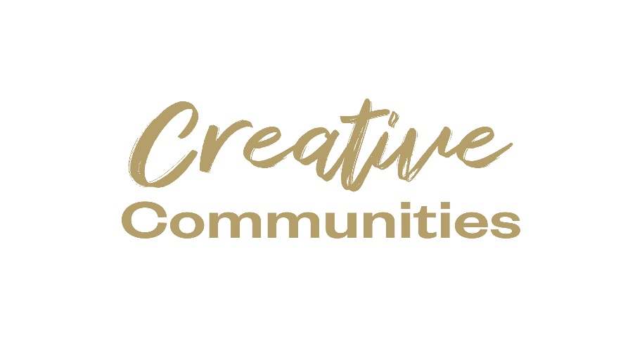

Kilkenny County Council
Creative Ireland
Grant Scheme 2024
Application Form

Closing date: Monday 12th of February, 2024 at 4.00pm.
N.B. READ GUIDANCE NOTES PRIOR TO COMPLETING

LATE AND INCOMPLETE APPLICATIONS (SECTIONS NOT COMPLETED/ALL RELEVANT SUPPORTING MATERIALS NOT ENCLOSED) WILL BE INELIGIBLE.
Return completed applications to: creativeireland@kilkennycoco.ie

Community & Culture Section, Kilkenny County Council, Patricks Court, Kilkenny.
Telephone: 056 -7794338 or Email: creativeireland@kilkennycoco.ie

An independent assessment panel will award funding on a competitive basis; therefore, all applications submitted must be accompanied by comprehensive supporting information. If you do not provide the relevant documentation we will consider your application ineligible.
An independent assessment panel will award funding on a competitive basis; therefore, all applications submitted must be accompanied by comprehensive supporting information. If you do not provide the relevant documentation we will consider your application ineligible.

Purpose of the Scheme
All Local Authorities under Creative Ireland support the delivery of Pillar 2 of the national Creative Ireland Programme; “Creative Communities - Enabling creativity in every community”. Its vision is:
“That every person living in Ireland will have the opportunity to fully realise his or her creative potential.”

In partnership with Creative Ireland, Kilkenny County Council invite groups to apply for funding for the Creative Ireland projects. The Creative Ireland Programme is a culture-based programme which defines creativity as: A set of innate abilities and learned skills: the capacity of individuals and organisations to transcend accepted ideas and norms and, by drawing on imagination, to create new ideas that bring additional value to human activity. When considering projects / events / initiatives to fund via your core allocation, it is essential that creativity is at their core. Before engaging an artist, creative or organisation to deliver a project and uploading it to the portal, you must ask yourself, what is creative about this event / initiative? It is important to remember that the Creative Ireland Programme is not a funding agency, but is there to support the embedding of creativity in public policy. Creative Communities is an opportunity for unique and relevant engagement in creativity at a local level. Local Authorities should look to support initiatives that include creative or interpretive expression (whether traditional or contemporary) from across communities, arts, cultural and creative sectors.

These are comprised of all sectors whose activities are based on cultural values, or other artistic individual or collective creative expressions. Many forms of creativity are welcome. They may include, but are not limited to: Circus, Film, Literature, Creative Writing, Music (all genres), Dance (all types), Street Arts and Spectacle, Theatre Traditional Arts, Visual Arts, Cultural Heritage, Multidisciplinary Arts, Architecture, Podcasting, Murals, Augmented and Virtual Reality, Fashion, Comedy, Design (all kinds), Digital Games, Creative Digital Technology, Animation and Graffiti.

While the Programme does take a very broad view of creativity, it is important to note that there are categories of events which we would not consider eligible for funding. These would include, for example, those dedicated solely to sport and fitness.

The aim of this Scheme is to encourage new, ambitious and meaningful collaborations between people and communities and artists/archaeologists/historians/archivists/everyone else involved in the culture and creative sectors within Kilkenny.

Kilkenny’s Creative Ireland Programme aims to empower creatives and communities to express creativity throughout society and relevant programmes and policies. We ask you to directly link your idea/proposal/initiative to one (or more) five strategic priorities with clear objectives to fulfil the Council’s creative vision for Kilkenny:
Your application must align with the County Kilkenny – Culture and Creativity Strategy 2023-2027

- Enable best practice delivery of culture and creativity.
- Increase and diversify participation in culture and creativity.
- Support culture and creativity in rural and urban areas.
- Engage children and young people in culture and creativity.
- Communicate the value of culture and creativity.

For the purposes of the Creative Youth plan, the most appropriate skills and behaviours are those which support development and learning such as curiosity, resilience, imagination, discipline, and collaboration.

Click link to view:
- kilkenny-culture-and-creativity-strategy-2023-2028.pdf (kilkennycoco.ie)

What items and expenses are ineligible?
- Publications.
- Spend on alcoholic beverages, fines, penalty payments, legal cost, audit fees, financial consultancy fees.
- Any proposal where it is determined that the main beneficiary would be a private entity.
- In general, the cost of items for resale.
- Assets or equipment e.g.: vouchers, memoirs for participants, art works, projectors, laptops, tablets etc.
- Accommodation.
- Projects that do not relate to the Kilkenny’s Culture and/or the Creative Ireland Programme
- If in doubt please contact creativeireland@kilkennycoco.ie.
Guiding Principles for Creative Ireland Grant Scheme

Creative Ireland a culture-based programme which connects people, creativity and individual and national wellbeing. Established in 2017, Creative Ireland stemmed from the successful Ireland 2016. The Programme drew inspiration from the extraordinary public response to the Centenary and the thousands of largely culture-based events exploring identity, community, culture, heritage and citizenship.
Creative Ireland’s priority is to inspire and transform people, places and communities through creativity. The Creative Kilkenny team are committed to ensure opportunities are available for people and communities to achieve their creative potential. This year we are also welcoming projects which consider actions which promote climate changes in behaviours and/ or active engagement on climate action in the community through creativity.

- Broadening access to, and participation in, cultural and creative activities.
- Using culture and creativity as a catalyst for collaboration and innovation in achieving community, wellbeing, social cohesion and economic development.
- Strengthening and integrating culture and creativity across the county for the purposes of the development of more vibrant, creative and sustainable places to live.
- Promotion of creative and cultural projects that support environmental, social and economic sustainable communities.
- Rural Communities.
- Targeted groups and minorities.
- Develops economies, sustainability, connectivity.
- Highlighting culture, heritage, and identifying opportunities.
- Active engagement of communities networking and development of skills and talents.
- Collaboration with communities to develop and promote opportunities and experiences for engaging communities.
- Promoting health, wellbeing, heritage and biodiversity.

Click link: Kilkenny - Creative Ireland Programme
Grant applications will be assessed using the following criteria:

- The extent to which the proposed event/project is aligned to the Creative Ireland Programme/ Creative Ireland programme and the priorities of Kilkenny’s Culture and Creativity Strategy 2023- 2027 programme. (20 marks)
- The scope of the project/event and the extent to which it maximises community/citizen engagement (including inclusivity and diversity in approach) (20 marks)
- The legacy potential of the proposed event/project in terms of benefiting the wider community, ambition, innovation and the fostering of creativity (20 marks)
- The quality, feasibility, cost of the proposed event/project and its proven capacity to see it through to fruition. (20 marks)
- Potential to promote Health, Wellbeing, Heritage, Biodiversity or Creative Climate Action projects (20 marks)
Eg: Creative Climate Action projects. Projects will be assessed on the extent to which they creatively aim to improve or engage in actions that enable behavioural change towards climate action or active engagement on climate action in the community. This may include engaging with and mobilising communities to rethink lifestyles, understand climate change, adapt places, ensure a just transition, connect the biodiversity and climate crises.
Health, Wellbeing. Projects will be assessed on the extent to which they creatively aim to improve or engage in actions that promote health and wellbeing. (Sports are not eligible)

Click link to view:
kilkennycoco.ie/eng/search/?q=Heritage
Kilkenny County Council Climate Action Plan

Monday 12th of February, 2024 at 4.00pm.
Creative Ireland Creative Ireland Grant Scheme 2024 - APPLICATION FORM
* Indicates compulsory field.
Projects must be completed by Friday the 11th of October, 2024

- APPLICANT DETAILS * Please fill in all sections.

Name of Applicant/Lead contact: _________________________________________________________

Organisation (if applicable) ______________________________________________________________

Name and Title of contact person (for payment purposes):

____________________________________________________________________________________

Tel: ______________________________ E-Mail_____________________________________________

Website: (if applicable) _________________________________________________________________

Social media: (if applicable) _____________________________________________________________

Address: ____________________________________________________________________________

___________________________________________________________________________________

2. Project Name and Type * Please fill in all sections.
Title of project: (The name that your project should be short and snappy. For advertising samples please look on the Creative Ireland website)

Genre: (Film, archaeology, music, comprehensive list detailed in the guidelines)

Type of Initiative: (e.g. Festival, talk, exhibition comprehensive list attached in guidelines)

Target Audience: (Artists, Creatives, Children, Young Adults, Targeted Groups, Older Audiences, General Public etc) N.B. Please indicate age categories. (eg. 0-4, 5-8, 9-12, 13-18)

3. Project Description Please summarise in no more than three short points what you intend to do, how and why (max 500 words). Successful, summaries will be used in reports regarding Who & what we have funded during the year. * Please fill in all sections.
Please give a brief description of the project, addressing each of the following:
- An outline of your project/initiative.
- Demonstrate how your project promotes active participation in creativity and culture across all ages, communities and abilities throughout Kilkenny. Please see page 13 of our Kilkenny Culture and Creativity 2023-2027 Strategy.
- Demonstrate how it addresses the 5 Priorities and Key Principles outlined in Kilkenny’s Culture and Creativity Strategy 2023-2027 programme.
For example one or more of the following:
- Rural Communities.
- Targeted groups and minorities.
- Develops economies, sustainability, connectivity.
- Highlighting culture, heritage, and identifying opportunities.
- Active engagement of communities networking and development of skills and talents.
- Collaboration with communities to develop and promote opportunities and experiences for engaging communities.
- Promoting health, wellbeing, heritage and biodiversity.

- Project Team, Audience and Outcomes * Please fill in all indicated sections.
* Who is facilitating the project? (please also indicate the number of artists, musicians, writers etc)
* Who will be involved in organising the project/event? (other team members, or partners)
* Please provide details of your experience in delivering projects of this nature. (please attach relevant documents)
* Who are the target audience(s) for your project? (communities, children, families etc)
If you intend on collaborating please include details of groups or organisations.
* Estimated audience figures: (based on realistic estimates) (communities, children, families, specific audience – e.g. targeted groups, children under 12 etc) Communities, including young people and hard to reach voices.
* Describe the anticipated impact/outcome of the event for your community and audience: For example:
- Increased participation of older generations, diverse groups, intercultural projects from both rural and urban areas.
- Increased engagement in traditional arts and cultural activities and include for example heritage, biodiversity, climate action for example.
- Consideration was given to climate friendly approaches and sustainable projects.
- Increase access to marginalised groups.
* You must submit an image to publicise this event which must be in line with GDPR legislation. 128 MB limit. Allowed types: jpg gif jpeg png.
N.B. Consent form must be provided. Not typed. Hand signed scanned only: Word, docx pdf.
5. Finance: NB: Income and expenditure must balance. NB: Approval from the Creative Ireland team must be sought for alterations to proposed budget if successful. Please note that receipts (marked paid) are required on completion of the project.
Are you applying for funding from any other sources? Yes _______  No__________
If YES, please give details below
If NO, please indicate how you intend to fund the balance of your costs below in the income section
Describe Details of Income.  Please provide a detailed breakdown of all income sources, if any: ITEM (e.g. sponsorship, own resources, other funding sources) | € Income | Describe details of Expenditure. N.B. Please refer to the list of items and expenses are ineligible.  Please provide a detailed breakdown of costs. Where relevant, supply quotes or tenders if available.  Element of Work /Programme/ Item | €  Expenditure PROJECT Estimated COSTS.
What is the estimated overall cost of the event/project? | € xxxxx | Artists fees | € xxxxx
Any other Public Funding? | € xxxxx | Organisations | € xxxxx
Source of Other Public Funding (Other Departments of Stage Agencies/Bodies) if applicable for example: Arts Council | €xxxxx | Staffing/Project management | € xxxxx
Any Private Funding?  (Advertising Sales) | € xxxxx | Marketing/Branding/PR | € xxxxx
Any Philanthropic Funding? | € xxxxx | Overheads | € xxxxx
Box Office Income? | € xxxxx | Venue Hire | € xxxxx
Any Benefit in Kind? | € xxxxx | Other expenses: | € xxxxx
 |  | Details: materials/consumables. | € xxxxx
Total Estimated Income | € xxxxx | Total Estimated Expenditure | € xxxxx

6. ACKNOWLEDGEMENT
Recognition must be given to Kilkenny County Council and Creative Ireland in all promotional material associated with the project/event. Relevant logos will be provided to projects which are awarded grants. Attendance records and consent forms will be provided with relevant logos attached.
Please state how your organisation proposes to publicly acknowledge Kilkenny County Council’s Creative Ireland Community Event contribution?
___________________________________________________________________________
___________________________________________________________________________
___________________________________________________________________________

- DISCLAIMER
Kilkenny County Council will not be liable in respect of any loss, damage or costs of any nature arising directly or indirectly from this application or the subject matter of the application. Kilkenny County Council, its servants or agents shall not at any time in any circumstances be held responsible or liable in relation to any matter whatsoever arising in connection with the development, planning, construction, operation, management and/or administration of individual projects.

I/we have read the above terms and conditions and I certify that the information supplied here is a true and fair representation of this organisation’s position.

Signed: -__________________________________ Date: ___________________________

- DATA PROTECTION
Kilkenny County Council collects some personal data during the application and processing of this grant scheme, particularly, names, addresses and contact details (emails and telephone numbers). These details are necessary for the consideration and adjudication on the grants scheme. The grant applications are sometimes shared between relevant County Council Departments for the purpose of supporting the application and also to ensure that similar events are not double funded, and in relation to other festival/events funded by the Council. At all stages the personal data is handled in full accordance with the Data Protection Legislation.
Your express consent is required, acknowledging that you understand that you may be submitting personal data. Please sign here by way of agreement.
Signed: ________________________________ Date: _____________________________

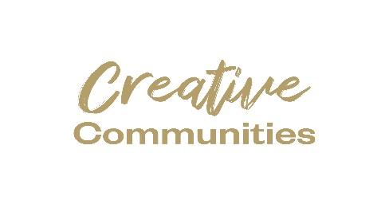
Part A
To be completed and returned by Friday, 1st of March, 2024, if and when application is accepted and deemed successful. Groups will be notified of the outcome of the panel review by mid March.
- Booking Generic phone numbers should not be provided for the public to book an event. A much more useful tool is to provide an email address or preferably a clickable link to, for example, an Eventbrite listing. It is hard to gauge the actual numbers that will turn up for events even with
adequate booking systems in place
- When events change and need to be updated, do not forget to update and notify us without delay. For example, if an event is being held at two different times, or in two different locations, then there should be two different entries below.

9. Promotion, Dates and Venue. * Please fill in all sections.
NB: please note if there are multiple events you must duplicate this section and supply the relevant dates venues and details outlined below.
* How will you access participants/audiences?

* How do participants get involved? (How do they sign up?)
* Where can participants access online projects / events? (YouTube, Zoom etc.)
* What kind of ticketing is used for this event? Where do you acquire tickets?
Free but booking required?
Free event?
Ticketed event?
N/A?
* What equipment do participants need? (if any)
* What links will you use for bookings/more info: (e.g http://)
* How will the project be promoted? (posters, radio, social media, newspaper, etc.)
* Start date
* End date: (Note: Projects must be completed by Saturday, 8th of June. This Part A reports a must be returned by Friday the 1st of March, 2024)
Start & End Time (if relevant)
* Total running time (hrs/mins/ days as appropriate)

