ECONOMIC DASHBOARD

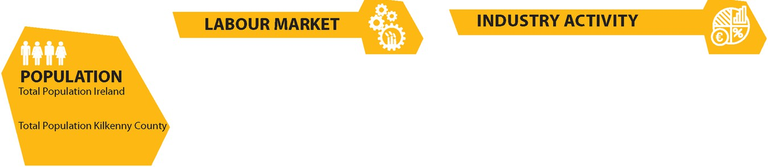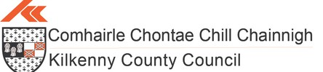

**November 2024**

5,149,139

up 8% since Census 2016

104,160

up 5% since Census 2016

46,196

2,190

169,000

4.2%

# Total Labour Force Live Register Kilkenny,

October *2024*

**Source: CSO.ie**

Seasonally Adjusted National Live Register *October 2024, up by 0.4% from September*

# Adjusted Unemployment Rate

*Down from 4.5% October 2023*

S**ource: CSO.ie October 2024**

300,583

225,495

+2%

1,077

6,159

Employed in IDA companies

15,301 in the South East (**Source: IDA 2023)**

Employed in EI companies Nationally in 2023, with positive net jobs of 5,011 nationally

Employment growth in EI companies in the South East in 2023

**Source: EI 2023 Y/E**

Employed in 182 Local Enterprise businesses in Kilkenny

Active Enterprises in Kilkenny, 9 >250 employees (Source: CSO.ie)



**National Rents**

274

€308,431

|  |  |
| --- | --- |
| €1,576 | **Properties For Rent**  Average monthly rent |
| 19% | Kilkenny, *up 11.7% y-o-y*  Lower than national ave |
| 35% | Lower than Dublin City |

rage

€344,828

€438,462

**Houses for Sale in Kilkenny**

FOR RENT

(85 in Kilkenny City) **(Source: Daft.ie** Nov **2024)**

Average house asking price Kilkenny,

National average asking price

Average house asking price Dublin City

**Source Daft.ie, Q3 2024**

* 4,570 students from Kilkenny were enrolled in a third level institution in 2023/2024
* 31% of all Kilkenny students enrolled in third level are attending SETU. The number of Kilkenny students enrolled in SETU is more than double the number enrolled in any other third level institution. The institution with the second highest enrollment from Kilkenny students is UCC at 12%.

FOR

SALE

**Source: HEA.ie, October 2024**

7.2*% y-on- y change in average listed rents nationally (approx. half the rate of inflation in mid*

*-2022) 43% higher than pre- Covid levels*

S***ource: Daft.ie Q3 2024***

**Housing Stock Growth Kilkenny**

# **5.2%** since census 2016 versus state average of 6%

**Source: CSO.ie**

WHAT'S HAPPENING

Over 68,000 visitors visited Kilkenny as the city came alive once again for the Savour Festival at the end of October - one of Ireland’s best-established and longest-running food festivals

**Planning/Multi-Unit Developments October 2024**

**123** multi-unit housing developments with planning permission secured in County Kilkenny/ **55** of these within Kilkenny City, **33** of these in larger County Towns. **3,366** units within the **123** schemes in the County & City. **60 housing schemes active in County Kilkenny with valid commencements notices for 1,633 units/ 12** housing schemes active within Kilkenny City with valid commencement notices for **79** units

Kilkenny’s Medieval Mile featured in a National article and video in October outlining the fantastic retail offering in Kilkenny as part of the shopkilkenny campaign

As part of the Kilkenny Going Green campaign, four case study videos were launched on 24th October through the LEO and made available on KCC channels Kilkenny County Council’s first Digital Strategy is currently being drafted with the first implementation period beginning at the start of 2025

A Kilkenny photobook was launched in December, featuring local photography

and poetry celebrating the city and county, it will be online soon.



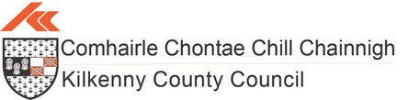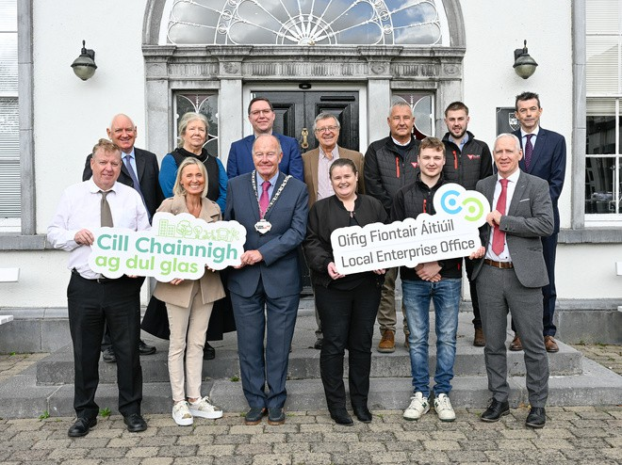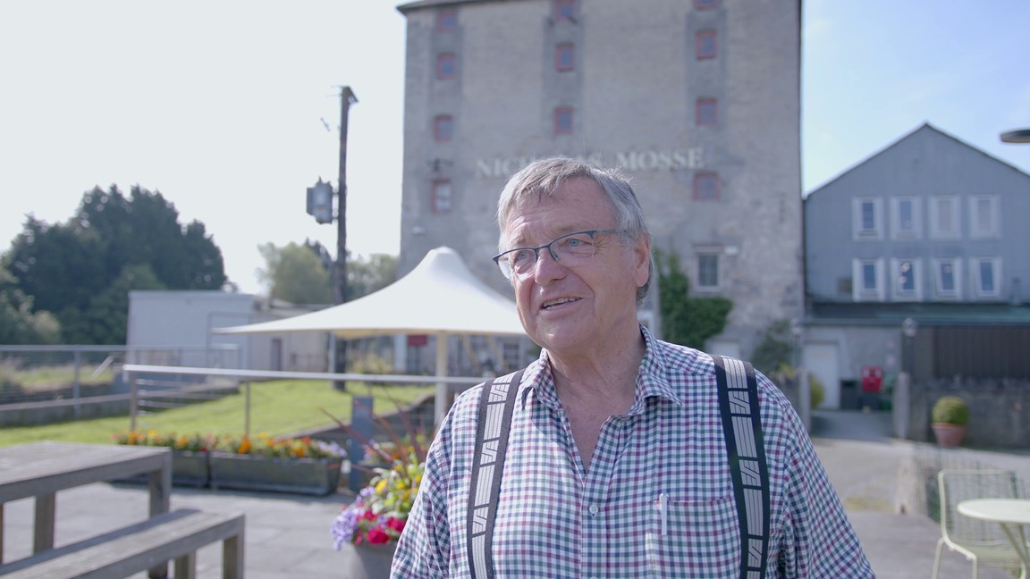

**ECONOMIC DASHBOARD**

**November 2024**

