

Report for Elected Members & Stakeholders on Year 2 of implementation of the 5-year Kilkenny County Council Climate Action Plan 2024-2029

Contents
Acknowledgements 1
Executive Summary 2
Achievements At-a-Glance 3
Introduction 4
Climate Action Plan Overview 7
Decarbonising Zone Overview 10
Delivery of Strategic Commitments 11
Leadership & Governance 11
Climate Mitigation Targets 23
Climate Adaptation 32
Delivery Across Services 34
Community Engagement & Activation 40
Appendices
Appendix 1: Actions Delivering on Sustainable Development Goals 44

Acknowledgments:
The Climate Action Office wish to acknowledge the work being undertaken and the continued buy-in across Kilkenny County Council under the stewardship of the Senior Management Team of Kilkenny County Council. We acknowledge the work and assistance of the Elected Members, Strategic Policy Committee 4 (Environment Protection, Climate Action & Energy), the Corporate Policy Group, all of the Service Areas across the Council who deliver on climate action, and also the wider community we serve. We also thank our partner organisations and Government Departments, including the Climate Action Regional Office (CARO), the South East Energy Agency, the South East Regional Energy Unit, the Sustainable Energy Authority of Ireland, the Department of Climate, Energy and Environment, and the Department of Housing, Local Government and Heritage.

Executive Summary
This is the second progress report of the Kilkenny County Council Climate Action Plan 2024-2029 since the Plan was adopted in February 2024. It looks at progress on delivering climate action across five strategic commitments, i.e. leadership and governance, climate mitigation, climate adaptation, delivery across services, and community activation and engagement. This report provides performance statistics relating to 2025 which supplements performance statistics from 2024 provided in the Year 1 Implementation Report.
The Plan contains 99 actions, comprising 13% adaptation actions, 34% mitigation actions, and 53% which are both adaptation and mitigation. 89% of actions have commenced since the Plan was adopted (compared to 82% of actions commenced in 2024).
A key focus for 2025 was ensuring strong climate action Governance and Leadership across the Council. This comprised meetings of the Council-wide Climate Action Steering Committee, and meetings with the Council Plenary, and Strategic Policy Committee 4 (Climate Action, Energy and Environmental Protection). The South-East Regional Energy Unit was established in 2024 by the five local authorities in the South East to collaborate on and secure funding from the SEAI Pathfinder Programme to retrofit council buildings. Service Level Agreements and other partnership agreements are in place with Government Departments, and national and local partner organisations to secure funding and resources. Climate action has been integrated into many Council plans, strategies and programme, and also into the budgetary processes. Staff climate action training and capacity building has been delivered. A robust framework of reporting obligations, at EU, national and local level, has been delivered, as well as a communications programme for the public and stakeholders.
Significant work has been undertaken on Climate Mitigation actions across the Council in 2025. The Council achieved an 4.8% reduction in total greenhouse gas emissions since 2024, and a 39.8% reduction since the 2016-2018 baseline. In terms of energy efficiency targets, the Council achieved a 5.5% reduction in energy consumption since 2024, and a 45.6% improvement in energy efficiency compared to the 2009 baseline. The Plan outlines range of key projects which will be undertaken over the next 5 years to further reduce energy use and greenhouse gas emissions in order to meet the 2030 targets.
Progress has also been made on Climate Adaptation actions in the Plan, informed by a Climate Risk Assessment of Council services. A range of actions were undertaken in 2025 including Flood Relief Projects, incorporating nature-based solutions in Council projects, Fleet management strategy, publication of the Biodiversity Plan and Severe Weather Emergency Planning.
Delivery of Climate Action across all services has been achieved in 2025. Case studies of some of the actions delivered by Housing, Safer Routes to School and Active Travel, Council Fleet, Emergency Services and Arts Office are highlighted.
The Council played a key role in Community Activation and Engagement in relation to climate in 2025, in particular, under Phase 1 of the Community Climate Action Programme. This programme was a government initiative and funding was provided by the Department of Climate, Energy and Environment. It was managed by Kilkenny County Council who allocated €511,000 in 2024 to 22 communities across Kilkenny. Phase 2 of the programme with a similar funding amount was advertised Autumn 2025 with approved projects expected to commence in Spring 2026.
Finally, the report demonstrates how the actions in the Plan align with and deliver on the United Nations Sustainable Development Goals (SDG’s) at a local level. A total of 13 of the 17 UNSDGs are supported through actions the Plan.
   | 5 full-time staff |  |  | 410 Farm Visits (+37%)
 | 47 (+12%) Members Steering Committee covering 28 service areas |  |  | 39.8% Reduction in Greenhouse Gas Emissions (+4.8%)
 | 99 Actions |  |  | 45.6% Improvement in Energy Efficiency (+2.9%)
 | 8 Meetings with Council, SPC and Steering Committee |  |  | 10,232 LED Public lights (+57%)
 | 139 Staff trained (+54%) |  |  | 3 Energy Audits on Council Buildings with 7 Display Energy Certificates
 | 89% Actions Started (+9%) |  |  | 3 Flood Relief Schemes
 | 1 Regional Energy Unit  1 ZEVI Coordinator  1 PLEEP Coordinator |  |  | 38 Local Authority Houses Retrofitted (+0%)
 | 1 Kilkenny County Council Green Team |  |  | 7 no. of EV’s in fleet (+350%)
 | 3 waste audits |  |  | 10 Vehicles running on zero emission HVO
 | 1 ISO50001 surveillance audit |  |  | 22 Community Climate Action projects funded (€511,000)
 | 13 New Plans/Strategies climate proofed (+116%) |  |  | 44 Green for Business support (+200%)  26 Energy Efficiency grants (+371%)
 | 2,327 participants in Bike Week |  |  | 4,416 users of the Community Energy Hub on line platform
 | 13 Sustainable Development Goals (SDG’s) |  |  | 18 Severe Weather Emergency Team Meetings (+300%)
 | 7 Service Level Agreements |  |  | 4 videos of Sustainable Businesses
Figure in brackets is 2024 data

Introduction
This is the second progress report of the Kilkenny County Council Climate Action Plan 2024-2029. The report reflects the second year of the Plan implementation since its adoption by the Elected Members of Kilkenny County Council in February 2024, i.e. the period from January to December 2025.
Data and information contained within this report offer an accurate and transparent picture of progress in the second year of the Plan implementation against the ambition of the Plan.

The Climate Action Plan is a statutory 5-year Plan which outlines the measures that Kilkenny County Council will take to reduce energy use and carbon emissions, and adapt to the changing climate across its governance, services and operations. By delivering the 99 actions in the Plan Kilkenny County Council will reduce its greenhouse gas emissions by 51% and improve its energy efficiency by 50% by 2030.
In addition, the Plan sets out how Kilkenny County Council will facilitate, support and inspire stakeholder climate action in the County through leadership, collaboration and advocacy.
The Plan was prepared in close collaboration with the Kilkenny County Council Climate Action Steering Committee, relevant staff from every service area in the Local Authority and Elected Representatives. Input has been provided by Strategic Policy Committee 4 (Environmental Protection, Climate and Energy), the Public Participation Network, the Climate Action Regional Office, adjoining Local Authorities, business and community stakeholders and the public.
The Plans’ Vision is that the Council will be:
“A climate resilient organisation that inspires and supports the County’s transition to a climate resilient, biodiversity rich, sustainable and carbon neutral economy by 2050.” (Vision Statement of Kilkenny County Council Climate Action Plan)
This ambition aligns with the Government’s National Climate Objective to achieve the transition to a climate resilient, biodiversity rich, environmentally sustainable and climate neutral economy by 2050.
The Mission Statement of the Plan is
“To deliver Kilkenny County Council’s statutory emissions and energy targets, embed climate action in all Council governance and operations, and thereby inspire and facilitate climate action in the County.”

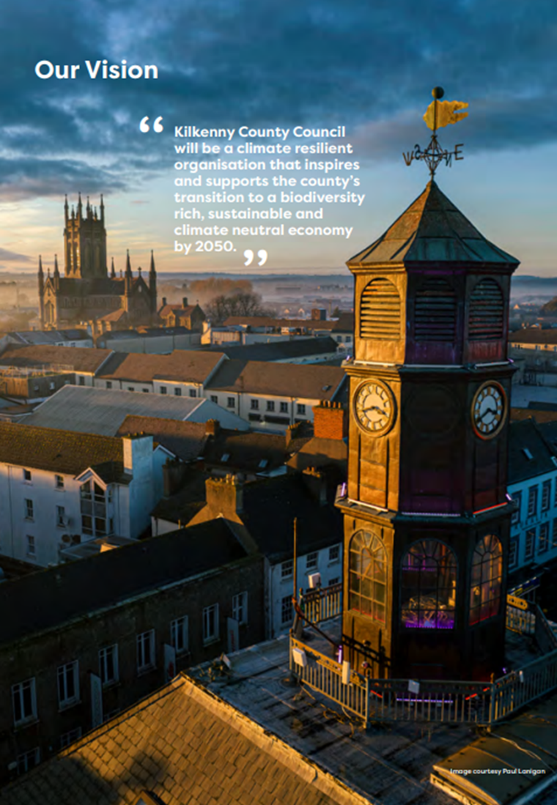
Methodology and Format of Report
The format of this report is informed by the reporting requirements for Local Authority Climate Action Plans (LACAP), the Kilkenny County Council LACAP, recommendations of broader sustainability reporting frameworks^{[1]} and alignment with United Nations Sustainable Development Goals (UN SDG’s). Accordingly, this report provides progress updates on the actions of the Plan delivered and commenced in 2024 and 2025, and it includes case studies to highlight the value of actions.

The information is presented in line with the following five strategic commitments:

Governance & Leadership | Oversight and procedural aspects of integrating climate action into governance processes, business and operational models and organisational and local policy instruments.
Climate Mitigation Targets | Progress on delivering prescribed emission reduction targets established by national climate policy for all public sector entities in line with reporting methodology of the Sustainable Energy Authority of Ireland (SEAI).
Climate Adaptation Goals | Measures to plan for and reduce vulnerability of Local Authority services and functions to climate change impacts, minimise risks and costs and protect lives and assets by building resilience into natural and human systems.
Delivery Across Services | Progress on delivery of climate action measures across Council services and functions which support, facilitate and enable Government Departments, agencies and stakeholders to meet their climate goals at the local level and influence the value chain through Green Public Procurement.
Community Engagement & Activation | Actions that support community engagement, activity and capacity to build resilience to climate change impacts, reduce energy consumption and emissions and protect, restore and/or enhance biodiversity and work to achieve the objectives of the Decarbonising Zone(s) (DZ).


Climate Actions and UN Sustainability Goals
The report demonstrates how the actions in the Plan align with and deliver on the UN Sustainable Development Goals (SDG’s) at a local level. The SDGs represent 17 social, economic and environmental priorities designed to combat the global challenges facing humanity by 2030.
The LACAP has identified the relevant SDGs relating to each of the actions in Plan. A total of 13 of the 17 SDGs are supported through the Plan. Details of the SDGs delivered under each of the five Strategic Goals of the Plan, and the Decarbonising Zone, are provided in Appendix 1.

Local Authority Climate Action Framework
The implementation of the LACAP delivers on commitments provided for under a local authority framework for climate action. This includes the national Climate Action Plans and the Climate Action and Low Carbon Development (Amendment) Act 2021, the Local Authority Climate Action Charter (2019, currently under review) and the Local Government roadmap for climate action, “Delivering Effective Climate Action 2030. Local authority sector strategy for delivering on the Climate Action Charter and Climate Action Plan.”

Climate Action Plan Overview
The Climate Action Plan contains a total of 99 actions. These comprise 95 actions arranged under the 5 Strategic Goals of the Plan, plus an additional 4 actions which relate solely to the implementation of the Kilkenny City Decarbonising Zone (DZ).
The actions were developed following extensive consultation with all service areas in the Council, the Elected Members, Strategic Policy Committee 4 (Environment Protection, Climate Action and Energy) and with stakeholders and the wider public. They were also informed by baseline data on climate risks to Kilkenny County Council service delivery, along with baseline data on the Council’s energy and emissions.

19
Governance & Leadership

36
Built Environment & Transport

11
Natural Environment & Green Infrastructure

13
Communities: Resilience & Transition

16
Sustainability & Resource Management

4
Breakdown of the 99 actions across the five Strategic Goals and Decarbonisation Zone
Decarbonisation Zone

Types of Actions in the Climate Action Plan
The Plans actions address climate mitigation, climate adaptation (actions which prepare for the impacts of climate change) and a combination of both.
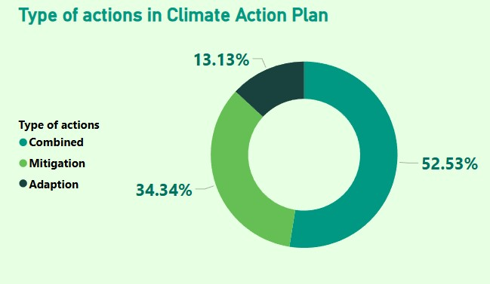
Breakdown of types of actions in the Climate Action Plan (mitigation, adaptation, combined mitigation & adaptation)
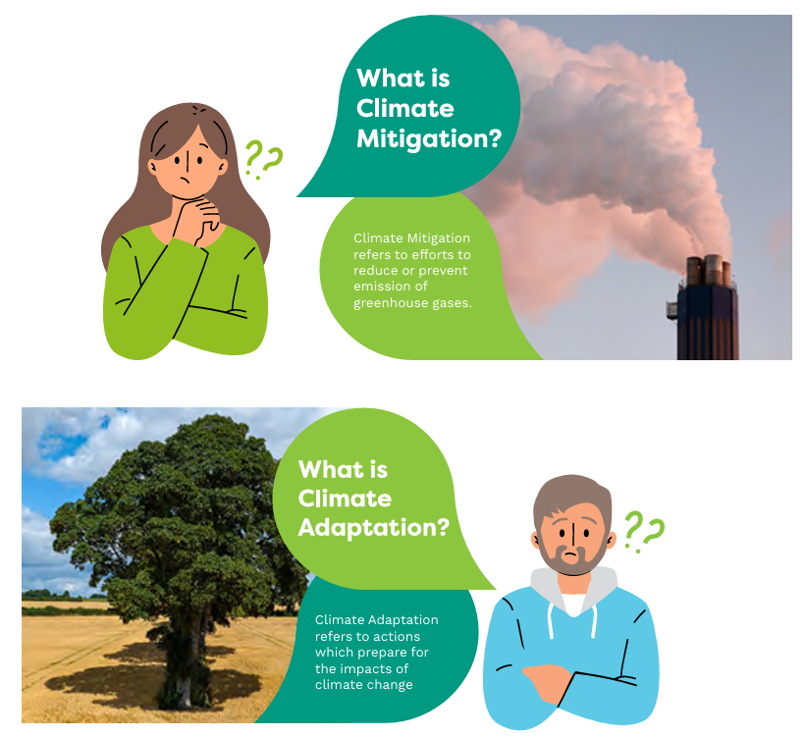

Status of Actions in 2025
Approx. 89% (increased from 82% in 2024) of actions have commenced since the Plan was adopted in 2024. This includes actions that were fully completed between 2024 and 2025, and recurring actions that will be implemented beyond 2025.
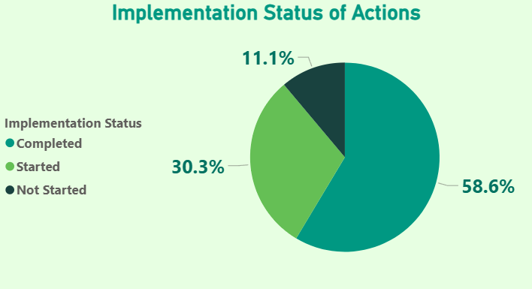
Status of actions implemented in 2025 (figure in bracket is 2024 data)
 | Governance & Leadership | Built Environment & Transport | Natural Environment & Green Infrastructure | Communities: Resilience & Transition | Sustainability & Resource Management
Actions started (started or in progress) | 15 (14) | 35(33) | 10 (9) | 11 (10) | 14 (12)
Actions Completed  (incl. recurring actions) | 10(9) | 22(20) | 7(5) | 10(9) | 9(6)
Actions started that will be completed after 2025  (in progress) | 5 (4 recurring) | 13 (9 recurring) | 3(4)  (2 recurring) | 1  (1 recurring) | 5(6)  (4 recurring)
Actions to be commenced after 2025  (not started) | 4 (5) | 1 (3) | 1 (2) | 2 (3) | 2 (4)
Total No. Actions | 19 | 36 | 11 | 13 | 16

Decarbonising Zone Overview
A Decarbonising Zone (DZ) is a test bed for trialling different decarbonisation and climate action measures at a local and community level. It is a demonstration area for collaboration and for innovative approaches to reducing emissions, preparing for climate change and enhancing biodiversity.
The role of Kilkenny County Council in relation to the DZ is similar to that for the Climate Action Plan. Kilkenny County Council is required to:
- Deliver its own emissions and energy reductions targets of 51% and 50% respectively
- Identify a Register of Opportunities and actions
- Support, advocate and influence stakeholders and the community within the DZ to deliver emission reductions and energy efficiencies
The Kilkenny City DZ is approx. 20km² in extent. It encompasses Kilkenny City and the Dunmore Countryside Park and Civic Amenity site, 5km north of the city. Dunmore Countryside Park was included in the DZ because it is in the ownership of Kilkenny County Council and provides significant potential to trial decarbonisation measures.
Kilkenny County Council commissioned a Baseline Emissions Inventory, stakeholder consultation and Decarbonisation Plan for Kilkenny City DZ. A Register of Opportunities was also developed for the Kilkenny City DZ. This comprises:
- a ‘technical register’, i.e. opportunities which are quantified in terms of emissions reduction (e.g. retrofitting of dwellings, electrification of vehicles); and
- ‘enabling’ opportunities (e.g. behavioural change, awareness, capacity building) which are more difficult to quantify, but which will support the delivery of ‘technical’ opportunities and will be key levers in meeting emission reduction targets.
Four actions were identified in the DZ Plan. The first action (DZ1) is to establish a Kilkenny City Decarbonisation Working Group to coordinate the implementation of the DZ Plan. Further actions, based on the Register of Opportunities, will be identified by the Working Group, in consultation with the stakeholders.


Delivery of Strategic Commitments

Leadership & Governance

Governance Structure
Cathaoirleach
& Elected Members

Chief Executive & Senior Management Team
Climate Action Regional Office Eastern & Midlands)
Strategic Policy Committee 4 (Climate Action, Energy & Environmental Protection)
South East Regional Energy Unit
Climate Action Office

Local Authorities Water Programme Office
Climate Action Steering Committee
South East Energy Agency

Climate Action Governance Structure in Kilkenny County Council, plus supporting partners
Kilkenny County Council has established and operates within a robust governance structure in relation to delivery of climate action. At a national level this includes the Department of Climate, Energy and Environment, the Department of Transport, the Department of Housing, Local Government and Heritage, and the Sustainable Energy Authority of Ireland. At a regional level it includes the Climate Action Regional Office, the South East Energy Unit, the South East Regional Energy Unit, the Local Authorities Water Programme Office, and the Regional Assembly. At a local level it includes the Elected Members, Senior Management Team, Strategic Policy Committee 4 (Climate Action, Energy & Environmental Protection, Climate Action Office, and Climate Action Steering Committee.

Internal Engagement
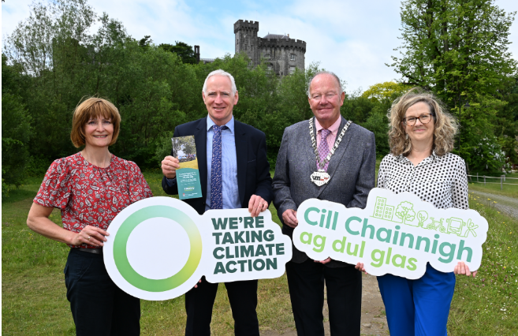
Elected Representatives

The Climate Action Office presented to the Council Plenary in April 2025 to adopt the first implementation report of the Climate Action Plan and again in June 2025 to present a Climate Action grants leaflet.

Strategic Policy Committee 4 (Climate Action, Energy & Environmental Protection)
The Climate Action Office presented to the SPC in March 2025 to give an overview of the first implementation report on the Climate Action Plan. An update on the progress of the District Heating Feasibility study was presented in December 2025.
Management team
The Climate Action Office presented to the Chief Executive and Senior Management Team in relation to Fleet Decarbonisation Strategy in October 2025.
Climate Action Steering Committee
Kilkenny County Council established the Climate Action Steering Committee in 2023. 47 (+12% on 2024) Council staff are members of the Committee, comprising the Chief Executive, the five Director of Services, and key staff from all service areas in the Council who are responsible for delivering climate action. 28 service areas are represented on the Committee. An Energy Engineer from our partners the South-East Energy Agency is also a member of the committee.
The role of the Committee is to provide leadership within Kilkenny County Council to help deliver on our climate action targets, and to support the preparation and implementation of the Climate Action Plan by undertaking actions in each of their service areas. The Committee met four times in 2025.
The following 28 Service Areas are represented on the Committee:
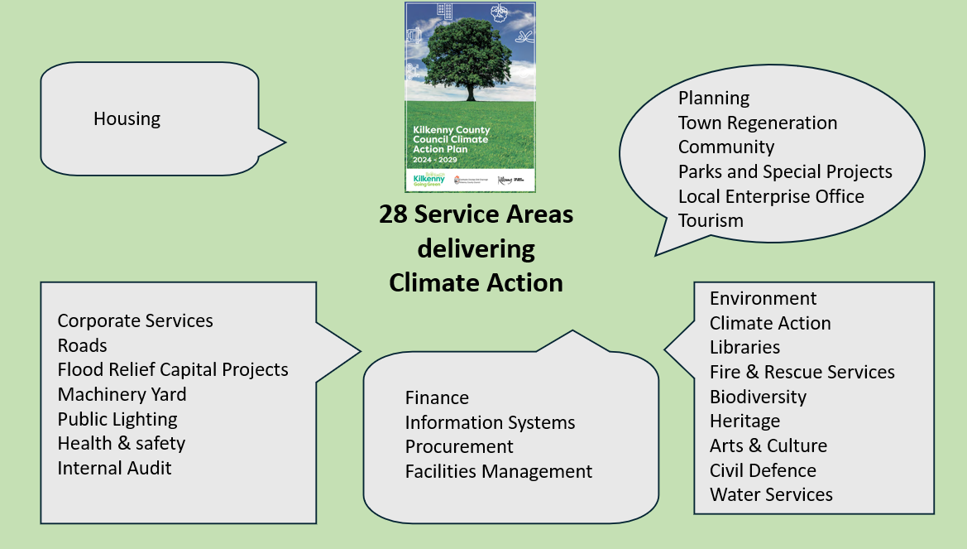
Climate Action Office
There were 5 full time staff in the Climate Action Office in 2025 comprising the following: Climate Action Coordinator, Climate Action Officer, Community Climate Action Officer, Energy Engineer (appointed in 2025), and Clerical Officer. In 2025 the team also benefitted from the addition of the new Regional Climate Action Officer (CARO).

The role of the Climate Action Office is to co-ordinate, support the mainstreaming of climate action across all services of Kilkenny County Council and to monitor and report on the implementation of the actions in the Climate Action Plan. Increasingly, the team is collaborating with communities and other stakeholders to drive climate action in the broader economic and community development of Kilkenny.

South-East Regional Energy Unit
The South-East Regional Energy Unit was established in 2024 by the five local authorities in the South-East, in order to support the Authorities to meet their 2030 energy efficiency and carbon emission targets under three main pillars:
- Implement and progress energy efficiency upgrades to utilise Pathfinder Capital Support in each of the Authorities.
- Maintain and develop further a collaborative approach for energy efficiency across the Authorities.
- Establish and embed Energy Management in the local authorities.
The unit is hosted by Tipperary County Council, and supports the Local Authorities of Kilkenny, Carlow, Waterford, Wexford and Tipperary to collaborate and access funding from the SEAI Pathfinder Programme, which offers up to 50% funding towards the energy retrofit design and works on buildings and up to €100,000 towards the completion of district heating feasibility studies.
In 2025, a Funding Agreement between the SEAI and the Energy unit was signed. This agreement includes the delivery of energy efficiency improvement and decarbonisation works on 8 no. buildings for Kilkenny and a notional budget of €4.8 million. Additionally, it includes the delivery of a district heating feasibility study for Kilkenny City, for which tender document have been prepared.
During 2025, the process of establishing a framework of integrated design teams and project managers started, funding for the building fabric upgrade on the Watergate Theatre was secured and works started in December 2025.

The Energy Management Team
The Energy Management Team is composed of the managers of Kilkenny County Council significant energy users (Public Lighting, Fleet, Watershed, County Hall and Machinery Yard), Director of Services, Energy Officer and senior staff from the Environment department. The team was amalgamated inside the Climate Action Steering Committee and met 4 times as part of this group. The team met once in alone in preparation of the ISO50001 surveillance audit.

Climate Action Regional Office (CARO)
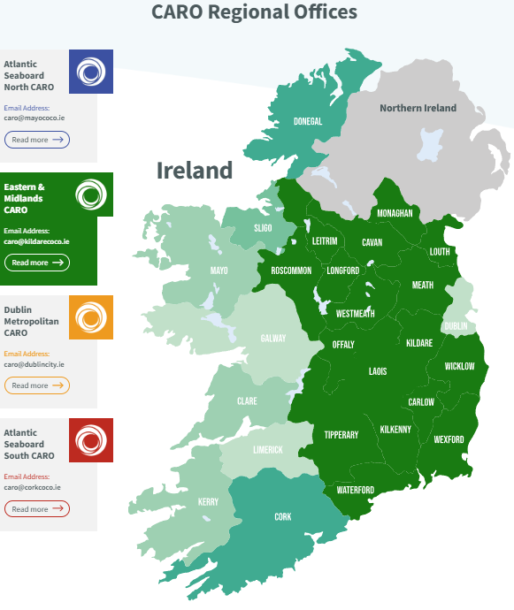
The CAROs provide guidance, advice and support to Local Authorities on climate change across Ireland. The Eastern & Midlands (E&M) CARO, one of the 4 CARO Offices, supports and coordinates climate action undertaken by the seventeen Local Authorities of Carlow, Cavan, Kildare, Kilkenny, Laois, Leitrim, Longford, Louth, Meath, Monaghan, Offaly, Roscommon, Tipperary, Waterford, Westmeath, Wexford and Wicklow. It is hosted by Kildare County Council as the lead authority and is supported by Kilkenny County Council as a partner local authority.
The E&M CARO coordinates quarterly sub-regional meetings with the five local authorities in the South East Region (Kilkenny, Carlow, Waterford, Wexford and Tipperary). The CARO also coordinates, develops and procures training courses under the Local Authority Climate Action Training Programme in conjunction with the LASNTG (Local Authority Services National Training Group).
Four Regional CARO offices support Local Authority Climate Action. Kilkenny County Council is a partner local authority to Kildare County Council which hosts the Eastern and Midlands CARO highlighted in green above.

South East Energy Agency

The South East Energy Agency (SEEA) provides energy services to Kilkenny County Council through an agreed Annual Work Programme, underpinned by a Service Level Agreement. An Elected Representative and Director of Service represent Kilkenny County Council on the Board. An Energy Engineer from the SEEA sits on the Kilkenny County Council Climate Action Steering Committee.

Local Authority Waters Programme Office
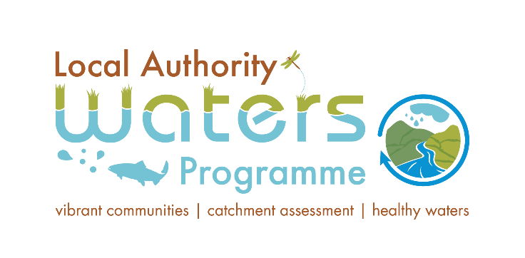
Local Authority Waters Programme Office (LAWPRO) is a shared service which works on behalf of Ireland’s 31 local authorities to protect and restore good water quality in our rivers, lakes, estuaries, ground and coastal water through catchment science and local community engagement. LAWPRO was established to fulfil requirements under the European Union Water Framework Directive and is funded by the Department of Housing, Local Government and Heritage.
LAWPRO coordinates the efforts of local authorities and other public bodies in the implementation of the River Basin Management Plan.
The South East Region LAWPRO is jointly managed by Kilkenny and Tipperary County Council’s.

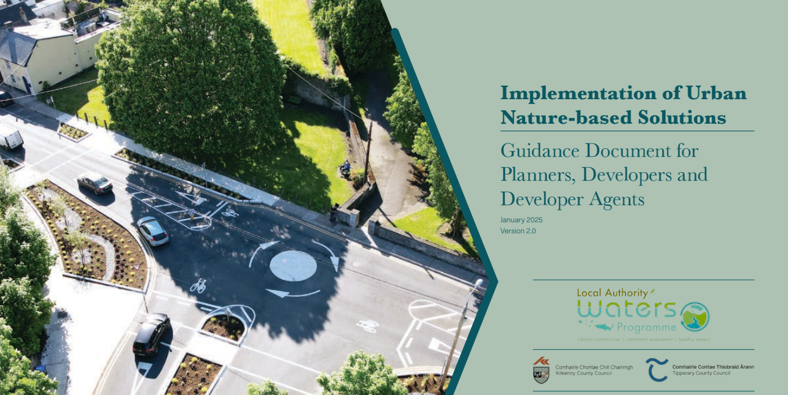

Service Level Agreements
Kilkenny County Council has several Service Level Agreements (SLA) and Grant Agreements in place with organisations and Government Departments in relation to the delivery of the Council’s climate action programme. In 2025 these included the following:

SLAs/Agreements between Kilkenny County Council and partner organisations in relation to the delivery of Climate Action (2025)

Organisation | SLA/Agreement
Department of Climate, Energy and Environment | Delivery of Local Authority Climate Action Plan
Department of Climate, Energy and Environment | Delivery of Community Climate Action Programme
South-East Energy Agency | Delivery of energy services
Tipperary County Council | Co-partner in provision of South-East Regional Energy Unit to access SEAI Pathfinder Programme for Local Authorities
Sustainable Energy Authority of Ireland (SEAI) | Provision of bridge funding to Sustainable Energy Communities
Local Authority Water Programme Regional Office | Agreement for Kilkenny and Tipperary County Council’s to jointly manage SE LAWPRO
Kildare County Council | Agreement to deliver on SLA for the Eastern & Midlands Climate Action Regional Office with the Department of Climate, Energy and Environment

Integration of Climate Action Objective into Strategies and Plans
Kilkenny County Council prioritises climate action in existing Plans and Strategies, including:

- Kilkenny County Council Corporate Plan 2024-2029
- Kilkenny City and County Development Plan 2021-2027
- Kilkenny Local Economic and Community Plan 2023-2028
- Full Forward Kilkenny 2030
- Kilkenny Culture and Creativity Strategy 2023-2027
- Kilkenny County Council Digital Strategy 2025-2027
- Kilkenny County Council Strategic Policy Committee Scheme 2024-2029
- Kilkenny Biodiversity Action Plan 2025-2030
- Kilkenny County Council Workforce Plan
- Fleet Decarbonisation Strategy 2025-2029
- Implementation of Urban Nature-based Solutions 2025
- River Basin Management Plan 2022-2027
- Library Service Development Plan 2025-2029
In addition, in 2025, the Climate Action Office reviewed new Council Plans, Strategies and Programmes and provided recommendations to strengthen them re climate action, including:
- Ferrybank/Belview Local Area Plan incorporating Blue Green Infrastructure Strategy (in preparation)
- Kilkenny County Council Grants Booklet 2026
- Electric Vehicle Charging Infrastructure (EVCI) Strategy (in preparation)
- Kilkenny Sustainable Urban Mobility plan (in preparation)
- Kilkenny City Rainwater Management Plan (in preparation)
- Kilkenny County Heritage Strategy 2026 – 2030 (in preparation)

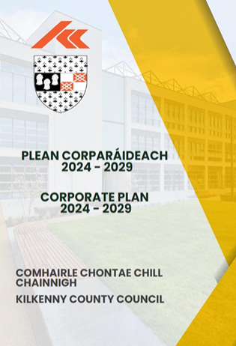

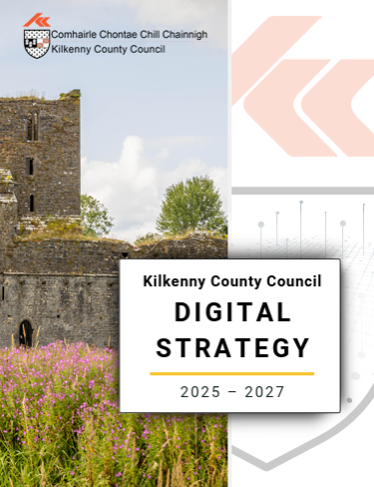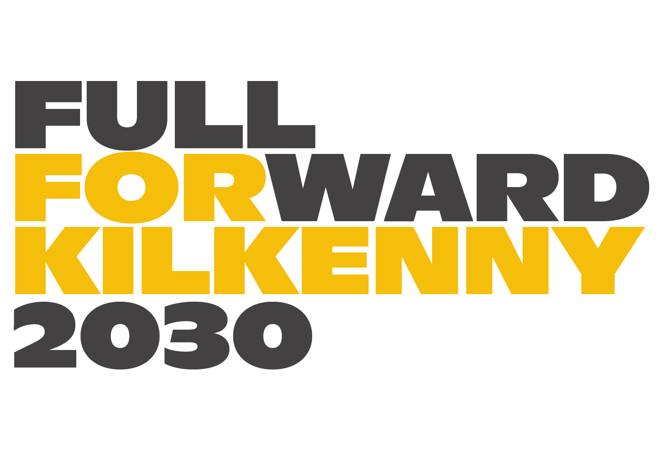


Staff and Elected Members Training and Capacity Building
In 2025, 139 (+ 54% on 2024) Council staff successfully completed a range of climate action training. This included the training provided by the Local Government National Services Training Group in partnership with CARO under the Local Authority Climate Action Training Programme, Raising Awareness course. Participants included both indoor & outdoor staff across all grades.

In addition, the Climate Action Office provided climate action awareness briefings at staff induction training events for new staff, LAWPRO delivered Nature-based Solutions training and Green Public Procurement training was provided for relevant staff.

Training and Capacity Building Events | Staff trained  2024 | Staff trained 2025
LA Climate Action Raising Awareness | 30 | 35
Staff Induction | 58 | 22
Climate Action-Delivering Action |  | 56
Nature based Solutions | 2 | 3
Climate Change Adaptation - Planning for climate resilience |  | 7
Implementing Green Public Procurement |  | 10
National EPA Green Teams | 9 | 0
Urban Water - Nature based Solutions |  | 6
Grand Total | 99 | 139

The Building Capacity Local Authority Climate Action Webinar Series consisted of 14 webinars in the 2025 series. The objective of the series was to:
- Foster local authority climate leadership
- Implement adaptation and mitigation measures
- Promote behavioural change
- Optimise funding opportunities
All webinar recordings and presentations from the Series are accessible via the newly launched Climate Action Training Programme LMS available on the Local Authority Services National Training Group (LASNTG) LMS Moodle platform as reference material for staff.

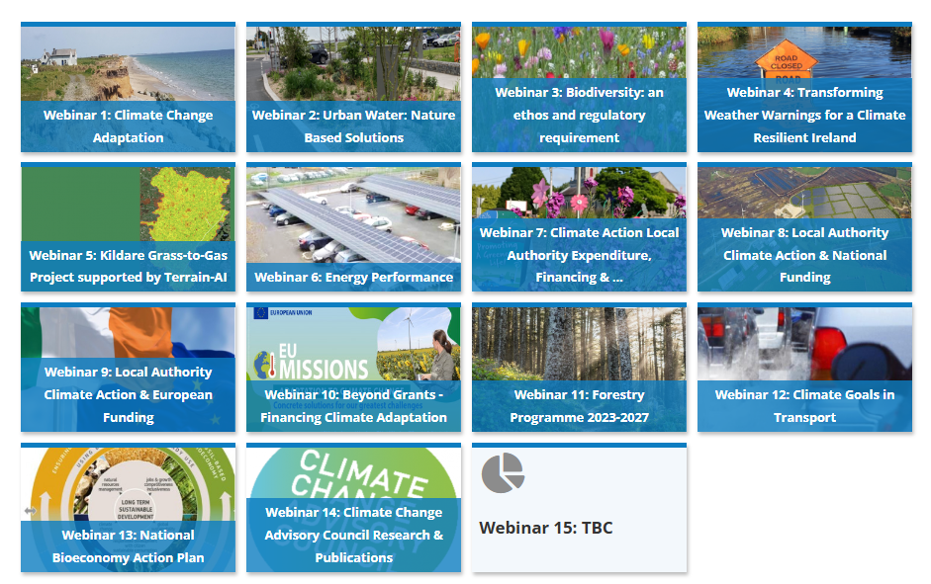

Integration of Climate Action into Budgetary Processes

Climate Change and Climate Action were funded through a combination of Kilkenny County Council’s revenue and capital budget to match external grant funding sources and this was integrated into the Annual Budget 2025. Kilkenny County Council (KCC) wish to extend gratitude to the external funding providers-Sustainable Energy Authority Ireland (SEAI), National Transport Authority (NTA), Transport Infrastructure Ireland (TII), Office of Public Works (OPW), Department of Climate, Energy and Environment (DCEE), Department of Housing, Local Government and Heritage (DHLG), Urban Regeneration Development Fund (URDF)
This includes provision for the Climate Action Office, the Climate Action Plan and a range of projects including:

- Pathfinder projects- Retrofitting of key Council building stock - SEAI
- Bridge Street, Callan active travel measures – NTA
- South East Greenway & links to Glenmore, Slieverue & Inistioge - TII
- North Quays Project (Active travel) – NTA
- Graiguenamanagh active travel measures “Safe routes to Schools” projects - NTA
- Graiguenamanagh-Tinnahinch and Ballyhale Flood Relief Scheme – OPW
- Minor Flood Mitigation Scheme at Ardaloo – OPW & KCC
- Abbey Quarter public realm – URDF & KCC
- Mayfair Library - Department of Arts, Culture & Gaeltacht
- Lacken Boardwalk – active travel measure – NTA
- Kilkenny City Active Travel programme – NTA
- Local Authority Housing Retrofit Programme – DHLG
- Public Lighting Energy Efficiency Programme – KCC & DCEE
- Green Schools Programme - KCC & An Taisce

Climate Action Reporting Framework
A key requirement for Kilkenny County Council is to report on progress on delivering the Climate Action Plan, and progress in meeting its climate action targets and goals. Kilkenny County Council reports to a range of national organisations, as well as reporting internally to staff, Elected Representatives and Strategic Policy Committees. In addition, the Council communicates with the public and stakeholders.
Internal Reporting

The Climate Action Office reports on the implementation of the Plan to a range of internal reporting structures. In 2025 this included the following:

Reporting Mechanism/Structure | No. | Dates
Council Plenary Meetings | 2 | 28th April, 16th June
SPC 4 Meetings | 2 | 6th March, 11 Dec
Climate Action Steering Committee Meetings | 4 | 19th Feb, 14th May, 10th Sept, 10th Dec
Chief Executive Reports | 11 | Monthly
Annual Report | 1 | Annual
Management Team | 1 | 21st October
Reports on delivery of actions in LECP, County Development Plan |  | Annual

National Reporting Obligations
In 2025 Kilkenny County Council reported on the implementation of the Plan to a range of national bodies including the following:
Reporting System | Organisation | Details | Frequency
Annual Report on implementation of Climate Action Plan | Climate Action Regional Office (CARO)  KCC Council Plenary | All service departments | Annual
Climate Action Key Performance Indicators | Local Government Management Agency (LGMA) | Staff  Steering Committee  Severe Weather Emergency Response Team  Greenhouse Gas Emissions Active Travel  Social Housing Retrofit  Training  Green for Micro Business | Annual
Public Sector Monitoring & Reporting (M&R) | Sustainable Energy Authority of Ireland (SEAI) | Energy performance  Emissions targets  Vehicle inventory  Vehicle Procurement  Energy Projects  Building Register  Business Travel | Annual
Energy Efficiency Directive (EED) Compliance Portal - SEAI | Sustainable Energy Authority of Ireland (SEAI) | Energy Audits | Annual
Public Sector Reduce Your Use Campaign | Sustainable Energy Authority of Ireland (SEAI) | Voluntary initiative to reduce energy use over the winter months | Annual
Critical Success Factors | Sustainable Energy Authority of Ireland (SEAI) | Strategy  Energy Management  Project Pipeline  Energy Performance | Annual
Local Authority Performance Indicators Programme | National Oversight Audit Committee (NOAC) | Energy Efficiency  Public Lighting  Staff & Steering Committee | Annual
ISO50001 Energy Management System | National Standards Authority of Ireland (NSAI) | Energy audit of services and operational performance for public buildings, public lighting, fleet & machinery | Annual

Communicating and Reporting to the Public
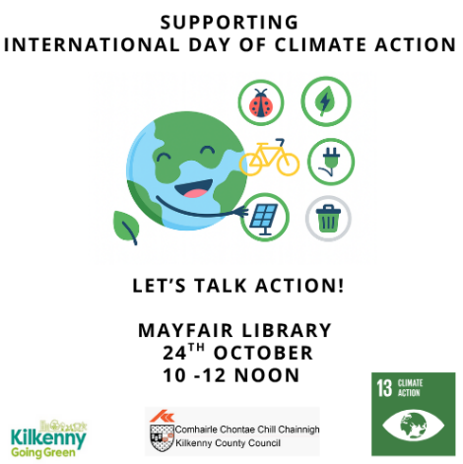
Kilkenny County Council recognises the need to, and value of, engaging with the public and stakeholders in relation to our progress in delivering on our climate action targets, as part of our climate leadership role. In 2025, Kilkenny County Council communicated on climate action through a variety of media including videos, social media posts, radio interviews and press releases.
In 2026, it is planned to continue regular climate action communications to help reach wider and more targeted audiences, demonstrate leadership, and thereby facilitate local climate action in County Kilkenny.

Climate Mitigation Targets

Greenhouse Gas Emissions and Energy Efficiency Targets
Kilkenny County Council is required to achieve a 51% reduction in greenhouse gas emissions (based on a 2016-2018 baseline) and a 50% improvement in energy efficiency (based on a 2009 baseline) by 2030 under the National Climate Action Plan 2023.


Emissions Target: 51% decrease by 2030
Energy Target: 50% improvement by 2030

The emissions and energy use are from three areas:
- Buildings and Facilities
- Fleet
- Public Lighting

Greenhouse Gas Emissions and Energy Efficiency in 2025
The Council, along with all public sector bodies, submits energy and emissions data annually to the SEAI Monitoring and Reporting (M&R) system which tracks Ireland’s progress on meeting climate targets. The SEAI publishes this data annually.
Provisional 2025 data are due to be published by the SEAI by the end of Q2 2026. However, based on estimated provisional data for 2025 (awaiting final verification by SEAI), Kilkenny County Council has achieved the following improvements in energy efficiency, reductions in energy consumption and reductions in greenhouse gas emissions in 2025.
Energy Efficiency & Energy Consumption
Kilkenny County Council achieved a decrease in energy consumption and an improvement in energy efficiency between 2024 and 2025. See table below.
Year | Energy Use (kWh) | % improvement in energy efficiency (compared to 2009 baseline)
2024 | 15,125,303 | 42.7%
2025 | 14,291,816 (estimate) | 45.6%

In summary, Kilkenny County Council achieved the following in 2025:
- 5.5% reduction in Energy Consumption (compared to 2024)
- 2.9% improvement in Energy Efficiency (compared to 2024)
- 45.6% improvement in Energy Efficiency (compared to 2009 baseline)

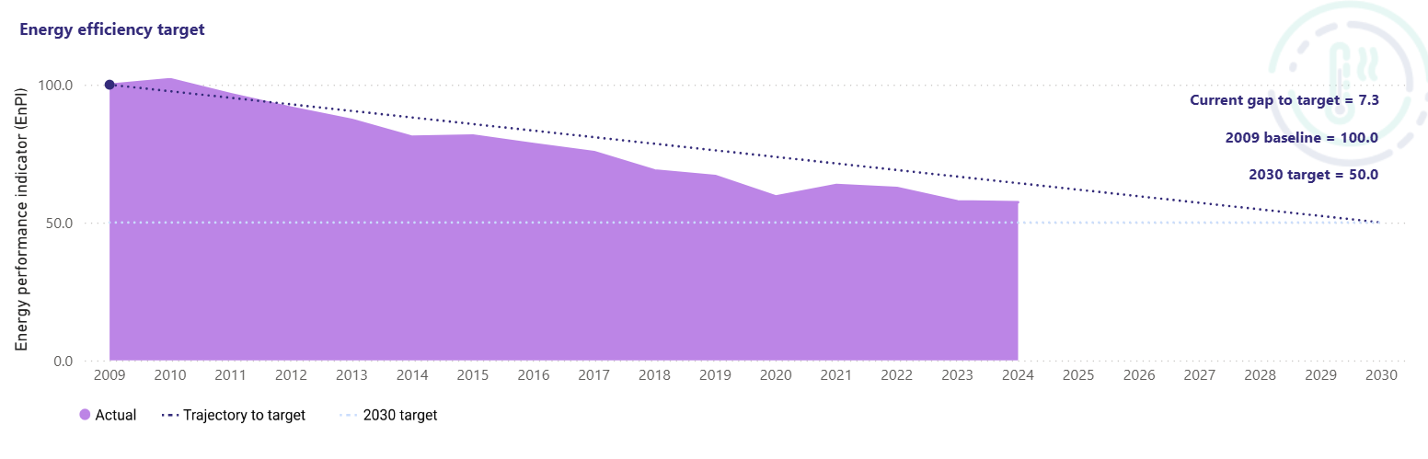
The gap-to-target graph below shows the Council’s energy performance from 2009 (the baseline year) to 2024, and our progress towards meeting the target of 50% improvement in energy efficiency by 2030.
Gap-to-target graph for Kilkenny County Council’s energy efficiency from 2009 to 2024

Based on the provisional data for 2025, Kilkenny County Council must improve its energy efficiency by an additional 4.4% in the next 5 years to reach the 2030 energy efficiency target. This equates to reducing the energy consumption by 913,228kWh.

Greenhouse Gas Emissions
Kilkenny County Council’s Total greenhouse gas emissions are composed of emissions from heating of buildings and facilities (thermal), transport (fleet) and electricity.

Total CO2 Emissions
Kilkenny County Council achieved a decrease in Total greenhouse gas emissions between 2024 and 2025. See table below.
Year | Total greenhouse gas emissions (kgCO2) | % reduction (compared to 2026-2018)
2024 | 3,201,204 | 36.9%
2025 | 3,047,566 (estimate) | 39.8%
By 2030 | 1,519,064 | 51%

This shows that in 2025 Kilkenny County Council achieved a 4.8% reduction in total greenhouse gas emissions (compared to 2024). Also, that the Council has achieved a 39.8% reduction in total greenhouse gas emissions since 2016-2018 (baseline years).
Based on the estimated 2025 Gap to Target, Kilkenny County Council must reduce total CO2 emissions by another 50.2% from the 2025 level in the next five years to meet the 2030 target. This is a reduction of 30.2% from the 2016-2018 baseline level or an additional 1,528,502kg CO2 to reach the 2030 target of 1,519,064kgCO2.

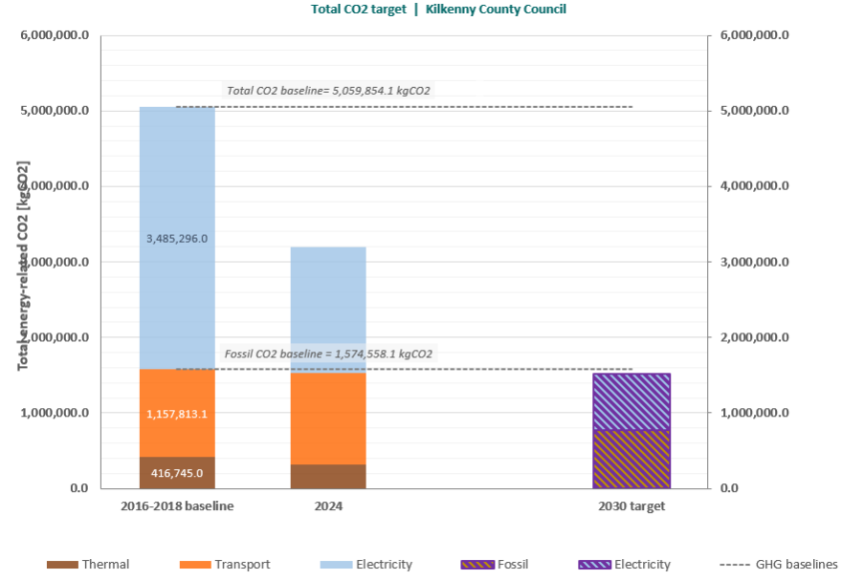

Illustration of Kilkenny County Council’s total greenhouse gas emissions in 2016-2018 and 2024, plus the 2030 target. The emissions from heating (thermal), transport (fleet) and electricity are shown in different colours, and together comprise Total Greenhouse Gas Emissions.

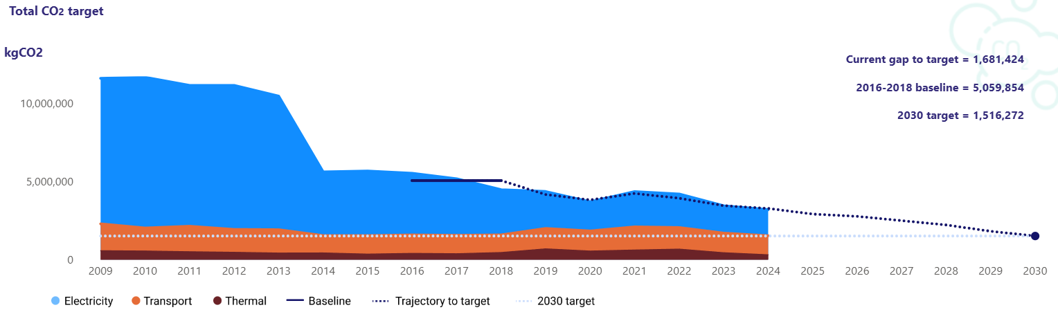
Total CO2 Gap-to-target graph (2024)

Fossil Fuel CO2
In 2024 fossil fuel CO2 emissions were 1,529,393kgCO2. This was 2.9% below the 2016-2019 baseline. In 2025 estimated fossil fuel CO2 emissions were 1,565,942kgCO2. This was 0.5% below the 2016-2018 baseline.
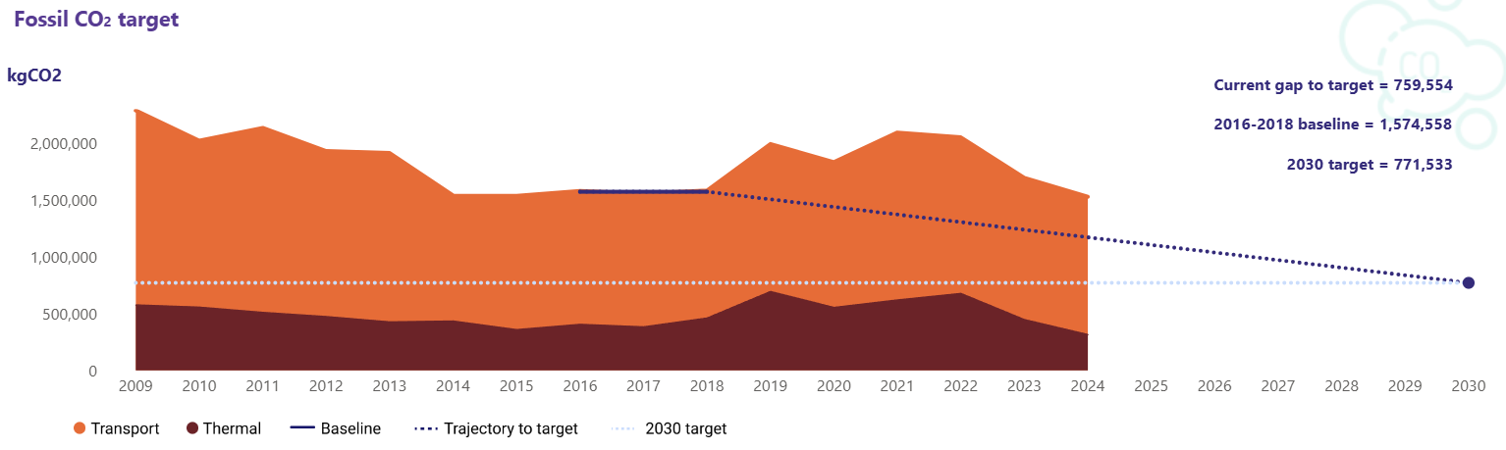
Fossil Fuel CO2 Gap-to-target graph (2024)

Looking specifically at the emissions from thermal (heating) and transport (i.e. not including emissions from electricity), Kilkenny County Council achieved the following in 2025:
- 2.4% increase in greenhouse gas emissions (compared to 2024)
- 0.5% reduction compared to the 2016-2018 baseline.
Based on the estimated 2025 Gap to Target, Kilkenny County council must save an additional 794,409kgCO2 in fossil fuel in the next 5 years to reach the 2030 fossil fuel target of 771,533kgCO2.
Fossil fuel CO2 emissions must reduce by another 50.7% from the 2024 level or 50.5% from the 2016-2018 baseline level.

Projected Emissions when Planned Council Projects Completed
Kilkenny County Council will undertake a range of key projects over the next 5 years to further reduce energy use and greenhouse gas emissions in order to meet the 2030 targets. These include:
- Public Lighting Energy Efficiency Project (PLEEP)
- Retrofitting of key Council building stock via Pathfinder Programme
- Electrification of vehicles and/or replacing diesel with HVO in Machinery Yard Fleet
The projects have the following expected impact on Kilkenny County Council GHG Emissions and Energy Efficiency:
- Upgrade of public lightings under PLEEP should bring the council energy efficiency to 56.2% in 2030 and thus the council should meet the 2030 energy efficiency target. This project should reduce the council total ghg emissions by 391,000kgCO2, which is equivalent to 25.6% of the gap to target identified above.
- Retrofit of the council buildings under Pathfinder should reduce the council total ghg emissions by 201,800kgCO2 which is equivalent to 13.2% of the gap to target identified above. In term of fossil fuel CO2 emissions, the retrofit of building should save 133,100kgCO2, which is equivalent to 17.3% of the fossil fuel gap to target identified above.
- Decarbonisation of the fleet by electrifying the city council fleet should reduce the council total ghg emissions by 36,500kgCO2 which is equivalent to 2.4% of the gap to target identified above. In term of fossil fuel the 35,000kgCO2 emissions reduction equates to 4.5% of the fossil fuel gap to target identified above.
- Decarbonisation of the fleet by switching the Machinery Yard from road diesel to HVO should reduce the council total ghg emissions by 536,300kgCO2 which is equivalent to 35.1% of the gap to target identified above. In term of fossil fuel the 536,300kgCO2 emissions reduction equates to 69.5% of the fossil fuel gap to target identified above.

Taking into account the expected decarbonisation of the grid, and after completion of the identified projects, in 2030:
- the council total CO2 emissions should be 1,069,386kgCO2, which is 78.9% below the 2016-2018 baseline
- the council fossil fuel CO2 emissions should be 642,029kgCO2, which is 59.2% below the 2016-2018 fossil fuel baseline
- the council energy efficiency should have improved by 60.6% compared to 2009 level

The gap-to-target graph below illustrates the Council’s projected emissions on course to meet the 2030 targets when the planned projects are completed.

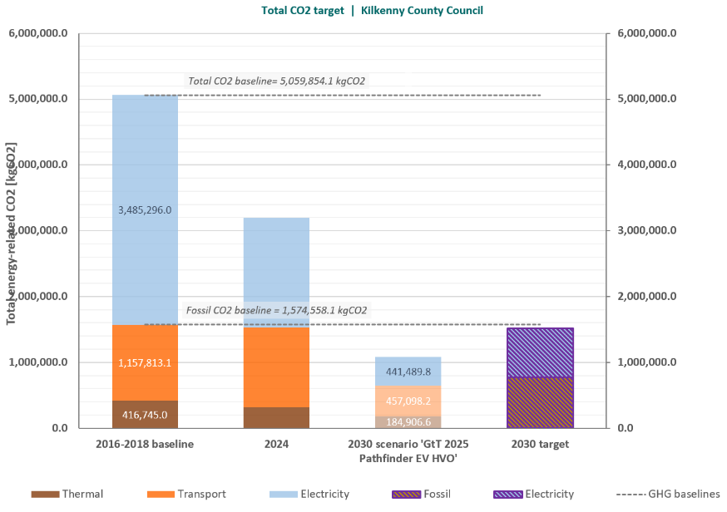

Mitigation Actions Commenced in 2024 and 2025
The Kilkenny County Climate Action Plan 2024-2029 includes many actions to support the Council to meet it’s 2030 targets on greenhouse gas emissions and energy efficiency and demonstrate leadership on climate action across the county. This includes the key measures outlined above in relation public lighting, buildings and fleet, and additional actions from every service area across the Council.
Some of the actions are solely mitigation, and some actions combine mitigation and adaptation measures.
In 2024 and 2025 the following mitigation actions were commenced:
*actions in brackets are actions that commenced in 2025, all other actions commenced in 2024
Mitigation Actions Commenced in 2024 and 2025
Action No. | Action Aim
2.1 | Participate in the national Smarter Travel Mark Programme and Smarter Travel Mark in Kilkenny County Council
2.2 | Review Local Authority business travel model and working arrangements to move towards the Avoid-Shift-Improve model, reduce emissions, energy use and reduce office space
2.3 | Develop and implement a Regional EV Infrastructure Strategy in collaboration with neighbouring local authorities.
2.4 | Develop a Fleet Decarbonisation Strategy for Kilkenny County Council Fleet. Ensure the strategy aligns with sustainability principles.
2.6 | Integrate transport and land-use planning to facilitate a reduction in transport demand
2.10 | Work with the NTA to enhance public transport options and connectivity to the surrounding area and regions
2.11 | Integrate transport modes and enable a shift to sustainable modes through the effective management of parking demand and development of park and ride/stride and multi-modal hubs.
2.13 | Implement the "Safe Routes to School Programme”
2.14 | Communicate, raise awareness and encourage participation in sustainable and active travel
2.15 | Explore feasibility of new Park and Ride locations on Regional and National Roads linked to Motorways & public transport
2.16 | Explore the feasibility of using new low carbon technologies for road reconstruction on regional roads; and for reducing waste through re-use of materials
2.18 | Develop a policy to reduce energy use in public lighting at pedestrian crossings
2.19 | Manage and maintain Kilkenny County Council's ISO50001 energy management system certification
2.21 | Implement an all-of-Council monitoring programme to track and report on energy use and emissions in all Kilkenny County Council assets
2.22 | Continue to deliver the Public Lighting Energy Efficiency Project (PLEEP)
2.23 | Participate in the establishment and support of local authority Regional South East Energy Unit
2.24 | Identify and implement a pipeline of projects for local authority assets to assist in achieving emissions and energy reduction targets
2.25 | Undertake a programme of energy reduction, retrofitting, and onsite renewable measures on Local Authority buildings, facilities and social housing
2.26 | Investigate the feasibility of local authority led/supported alternative heating systems and fuels including District Heating, Geothermal and Bioenergy.
(2.28) | Prioritise, facilitate and raise awareness about the value of retaining embodied carbon in developments
2.31 | Develop a planning policy which supports the re-use of existing buildings
2.33 | Achieve Home Performance Index (HPI) Gold Standard on all new Kilkenny County Council social housing
2.35 | Deliver a retrofit programme for Kilkenny County Council Social Housing
4.10 | Continue to collaborate with the South East Energy Agency to provide an online home energy information programme
5.2 | Develop and deliver a series of Business Showcase/Conference events, and positive Case Studies regarding decarbonisation/climate initiatives.
5.9 | Continue to transfer public services to online systems
5.10 | Undertake a programme of transferring relevant internal operations to online systems whilst driving down capacity requirements for data storage
5.13 | Provide, facilitate and promote public drinking water fountains in public spaces
5.14 | Undertake an audit of the waste produced by the Council's operations and services. Updated Council waste management policy with a view to promoting waste prevention, minimization and recycling.
(5.16) | Explore the potential to repurpose, upcycle and/or to use waste collected at Civic Amenity Sites, and other appropriate locations, to generate new products and enterprises, having due regard to the need to comply with relevant provisions of the Waste Management Act

In 2024 and 2025 the following combined mitigation and adaptation actions were commenced:
Combined (Mitigation & Adaptation) Actions Commenced in 2024 and 2025
*actions in brackets are actions that commenced in 2025, all other actions commenced in 2024

Action No. | Action Aim
1.1 | Ensure strong corporate governance by resourcing a Climate Action Steering Committee and Climate Action Office
1.2 | Provide climate action training, capacity building and knowledge sharing to Council Staff and Elected Representatives
1.3 | Develop and implement a Kilkenny County Council Green Public Procurement Strategy
1.5 | Internal audit monitoring of the management, reporting and delivery of statutory targets related to climate action within all relevant Service Areas in the Council
1.6 | Monitor, Report and Communicate on delivery of Kilkenny County Council climate actions and targets
1.7 | Climate proof Kilkenny County Council internal Financial Systems
1.8 | Collaborate with national, regional, and local stakeholders and partners on climate action delivery
1.15 | Incorporate climate and sustainability best practice in Kilkenny County Council Developments
1.17 | Develop and promote a Kilkenny Civil Defence Climate and Sustainability Policy
1.18 | Implement and promote a Kilkenny Fire and Rescue Service Climate and Sustainability Programme
2.5 | Adopt and implement the Kilkenny City Sustainable Urban Mobility Plan and Mobility Management Plans for other towns in the county
2.7 | Reallocate urban space towards the sustainable movement of people, and placemaking
2.8 | Encourage independent journeys for all
2.9 | Enhance permeability to support active travel
2.12 | Develop a cycle network for Kilkenny City and larger urban areas.
2.20 | Develop a Facility Management Strategy for Kilkenny County Council buildings and facilities
2.29 | Ensure best practise in energy efficiency retrofitting of traditional/heritage buildings
2.30 | Deliver sustainable and compact development
2.32 | Continue to add to the Vacant Sites Register and Derelict Sites Register
2.36 | Undertake a programme of energy reduction, retrofitting and onsite renewable measures on Local Authority buildings and facilities
(3.1) | Prepare a Tree Strategy and Policy for Kilkenny City to provide a long term vision for the management of public trees whilst taking measures to promote the use of native species over non-natives and having due regard for water quality and soil stability issues whilst undertaking the planning process.
3.2 | Promote and facilitate tree, woodland and hedgerow protection, planting and management on public and private land
3.5 | Identify and utilise environmentally friendly alternatives to herbicide use on Council land.
3.6 | Identify, map and utilise local authority owned land for habitat enhancement/restoration and nature-based solutions
3.7 | Implement Nature-based Solutions and biodiversity enhancement in new Kilkenny County Council developments
3.8 | Implement Nature-based Solutions and biodiversity enhancement through the planning process
3.9 | Provide biodiversity information and awareness on Council land, including at Dunmore Countryside Park
4.1 | Deliver the Community Climate Action Fund.
4.2 | Support communities to deliver local climate and sustainability actions, through grant schemes and programmes such as Sustainable Energy Communities, Tidy Towns, GAA Green Clubs, Green Schools and Heritage in Schools, Heritage Week, Heritage Grants, National Biodiversity Week, Creative Ireland and Cruinnui na nOg
4.4 | Support climate awareness and resilience through the Healthy Ireland Programme and other relevant health programmes.
4.6 | Design and deliver an arts programme which supports young people, communities and artists to creatively and positively respond to climate change
4.8 | Deliver an educational and awareness programme, through the Library Service, on climate action, sustainability, biodiversity and the circular economy
4.9 | Empower communities, through the Library Service, to reduce consumption and waste by facilitating the borrowing of books, tools and other items; hosting repair and up/recycling workshops; and providing makerspace technology (3D printers and sowing machines) to reuse and repurpose goods.
4.11 | Support and collaborate with the education sector to provide information, training and educational programmes on local climate action, and to undertake research
4.12 | Support climate action on farms through local authority policy and programmes
4.13 | Provide information and advice to communities, businesses and other stakeholders to support local climate action, via Council networks
5.1 | Develop and coordinate a new Sustainable Start-Up Business Module to the LEO Flagship 'Start Your Own Business' programme
5.3 | Provide climate and energy efficiency advice, training/mentoring and grants to the business sector
5.5 | Support local businesses and social enterprises to optimise opportunities in the green tech and circular/green economy
5.6 | Kilkenny Tourism CLG 'Green team' will develop sustainability awareness and training initiatives in collaboration with Failte Ireland, and green procurement criteria
5.8 | Develop a Digital Strategy for County Kilkenny which optimises and promotes digital solutions
5.11 | Monitor and report on air quality
5.12 | Adopt the Green Teams National Programme within Kilkenny County Council
DZ2 | Support Kilkenny City Sustainable Energy Communities (SEC's) in the DZ
(DZ3) | Building on the findings of the DZ Baseline Emissions Inventory, and the stakeholder engagement and Visioning work, develop a Register of Opportunities and a programme of actions for the DZ
DZ4 | Implement relevant Local Authority Climate Action Plan actions in the DZ

Climate Adaptation
The Climate Action Plan addresses how Kilkenny County Council is preparing for, and is adapting to, the impacts of climate change. This includes identifying the key risks faced by the Council and the actions that it will take to build resilience for the future.

Climate change poses risks to the Council’s assets and infrastructure, and to the delivery of its services, functions and responsibilities to the community and within the County.
Kilkenny County Council commissioned a Climate Change Risk Assessment as part of the preparation of the Climate Action Plan. The Risk Assessment analysed the impacts and the frequency of a range of climate hazards on the current and future provision of Council services, grouped under seven broad categories (Health and Wellbeing, Environment, Social, Financial, Reputation and Cultural Heritage). It identified the following as the three most significant future risks to the delivery of Kilkenny County Council services (based on predicted frequency and impact):
• River Flooding
• Extreme Precipitation
• Drought
Kilkenny County Council used this information to identify adaptation actions in the Climate Action Plan including; flood relief and flood forecasting measures, severe weather emergency planning, nature-based solutions/measures to hold and soak excess water, risk assessments of Local Authority owned heritage assets, and supporting climate resilience in communities and businesses in the county.

Planning for Severe Weather
The Kilkenny County Council Severe Weather Emergency Team examines operational needs and risks around severe weather events. The team are consistently aware of and are updated on the risks associated with climatic changes. They understand the importance of securing the functional and operational needs required to serve the community of Kilkenny during adverse weather events.
The Severe Weather Emergency Committee met 18 times in 2025 in response to 3 significant weather events comprising of snow, Storm Eowyn and wind/rain.

This is in comparison to 6 meeting in 2024.

Actions Commenced in 2024 and 2025
In 2024 and 2025 the following adaptation actions commenced.
*actions in brackets are actions that commenced in 2025, all other actions commenced in 2024

Action No. | Action Aim
1.9 | Deliver Flood Relief Schemes under the Catchment and Flood Risk Assessment Management (CFRAM) Programme, and Minor Flood Mitigation Works
1.11 | Annual review of Kilkenny County Council's Emergency Response Protocol for severe weather events, and Kilkenny County Councils Risk Register
1.12 | Review and update flood baseline data to inform Flood Relief Project Design
1.13 | Review the Council’s Health & Safety Policies and Procedures to take account of the impact of climate change on the welfare of staff
2.17 | Identify and implement actions to improve drainage on the Regional and local road network, and identify infrastructure at risk from climate events
(2.27) | To develop a policy on Disaster Risk Management and undertake a Climate Risk Assessment of local authority owned heritage assets
3.3 | Develop an Invasive Species Register and Treatment Strategy for Council land.
3.4 | Deliver a Pollinator Programme to protect and enhance pollinator habitats on Council owned land and in the wider county
3.10 | Assess feasibility of identifying waterbodies that are both particularly vulnerable to extreme climate events, and at risk of not meeting the requirements of the EU Water Framework Directive.
(4.3) | Work with communities to identify, map and record local cultural heritage sites / areas/traditions/practises where loss due to climate change is likely/inevitable

Delivery Across Services
Climate action measures have been identified by every service area in the County Council and included in the Climate Action Plan. Twenty eight service areas, across the five Directorates of the Council, were involved in and contributed to the Plan.
Below are case studies of some of the actions undertaken by different service areas across the Council in 2025.


Development at Croker’s Hill
Croker’s Hill Social & Affordable Housing development was completed in Spring 2025 and delivered 88, A2 rated, high-quality, sustainable, and inclusive residential units for Kilkenny County Council. The development includes a generous linear park incorporating attractive landscaping, and nature-based solutions—including swales, rain gardens, tree pits and bespoke rainwater-harvesting balcony systems. Community rooms and shared outdoor spaces benefit both residents and the wider neighbourhood. Overall, the project demonstrates excellence in design, sustainability, and social impact, creating a resilient and engaging place that will endure well beyond its required lifespan.
The Housing Department retrofitted 38 local authority houses in 2024 and another 38 in 2025 under the National Energy Efficiency/ Retrofitting Programme. Grant funding was received from the Department of Housing, Local Government and Heritage. Houses were retrofitted to a BER rating of B2/Cost Optimal Equivalent. This programme will continue in 2026.
Active Travel
The Callan/Thomastown Area Office implemented Mobility Management Plans in Callan, Thomastown and Graiguenamanagh. The delivery of these projects results in safer streets for all users, encouraging active travel and a reduction in carbon emissions.

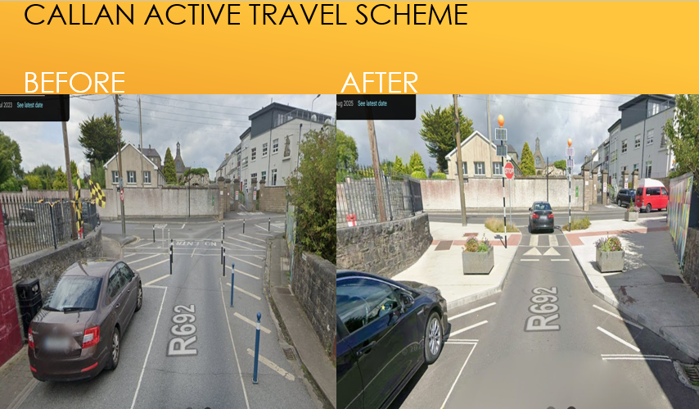

In delivering the Safe Routes to School Programme, road markings, crossing points and new signage has been implemented in a number of locations, with additional locations to be completed in 2026.

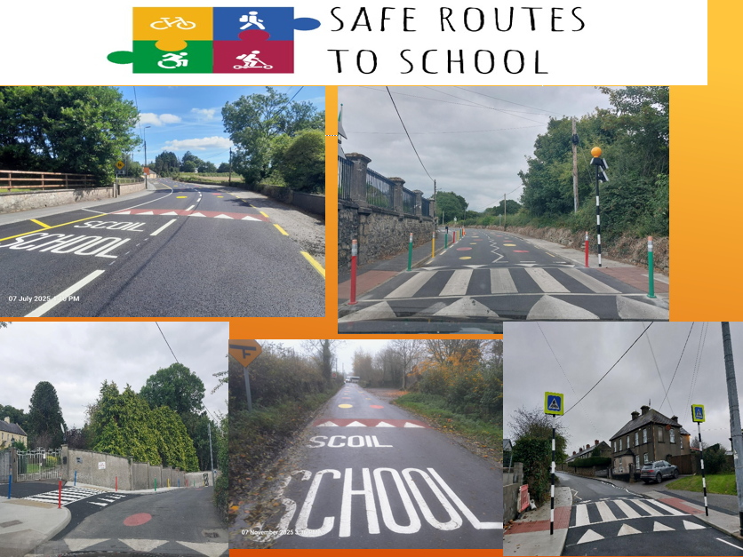

Nature based Solutions
Nature-based solutions and sustainable drainage systems were introduced in Graiguenamanagh. This infrastructure will improve drainage of surface water, improve water quality and reduce potential flooding across the road network. The planting scheme is visually attractive and will attract pollinators to the site.

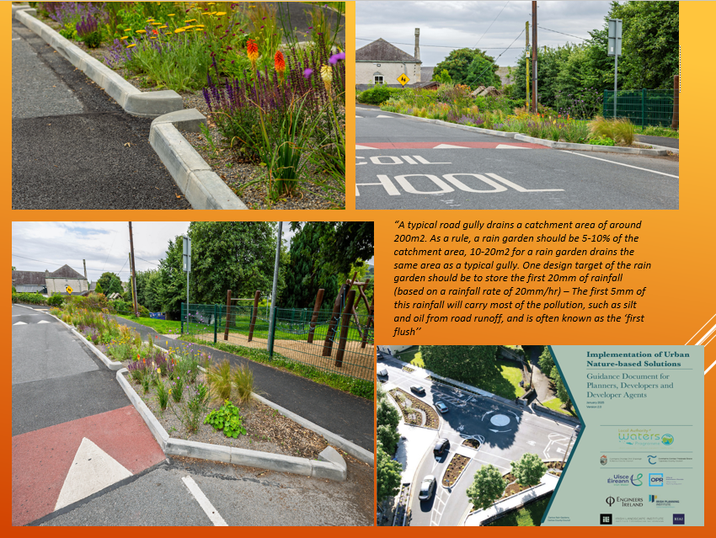

Council Fleet
In 2025 energy consumption and emissions from local authority fleet were a critical focus area. 2025 provisional data details that transport accounts for 37% of the energy consumption and 39% of the Greenhouse Gas Emissions.

The Climate Action Team worked with the Roads Section (Machinery Yard) to develop the first Fleet Decarbonisation Strategy for the Kilkenny County Council fleet.
The strategy addresses action 2.4 of the Kilkenny County Council Local Authority Climate Action Plan.
The document outlines the governing regulatory framework and provides an overview of current fleet operations. A detailed analysis of fleet data was undertaken to understand operational performance, and to compare this against targets. This process helped identify performance gaps and areas requiring improvement.
Actions were formulated to drive a reduction in GHG emission. Actions were based on research and observed performance, and that are relevant to the fleet inventory and operations. The strategy sets out 31 targeted actions across procurement, maintenance, and operations, each designed to address specific risks, challenges and opportunities in fleet decarbonisation. These actions range from piloting electric and alternative fuel vehicles, improving fuel management systems, and enhancing data tracking, to revising procurement policies and engaging service

users in operational planning. Each action is assigned a responsible party, timeline, and status, ensuring structured implementation and accountability across relevant departments.

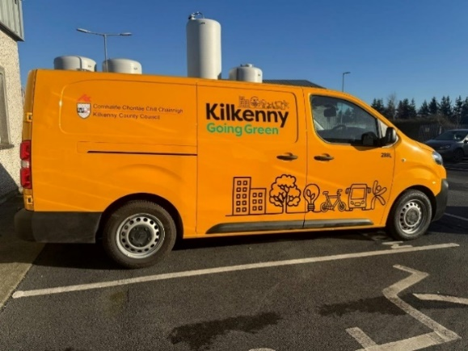
EVs are a suitable solution for the replacement of
Light Goods Vehicles (LGVs) in Council fleets.
The Machinery Yard trialled a number of fully electric vehicles in 2025, these included a utility vehicle for public realm activity, 4.25-tonne light-duty truck and large panel van. The intent of the pilots was to understand the real-world suitability, validate operational range, identity operational barriers and review the driver experience. The finding from the pilots will inform procurement decisions into the future.

Hydrotreated Vegetable Oil (HVO) continued to be used over 2025 replacing fossil fuels in 10 Council vehicles including the following:
o 2 Compact Sweepers
o 1 large Road Sweeper
o 2 large Relay Vans
o 2 Arctic Truck Tractor Units
o 3 no. 4-Axel Tipper Trucks

HVO is used as a straight swap from road diesel without impacting the performance of the vehicles. HVO has performed very well in terms of efficiency and emissions reductions. In 2025 replacing diesel with HVO resulted in an avoidance in emissions where the use of 41,642 litres of HVO resulted in the saving of over 100 tonnes of CO2e for the reporting period.

Emergency Services-Fire Service and Civil Defence


Kilkenny Fire Service were the first fire department in the country to welcome an Electric Vehicle into their fleet. This is a compact two-seater vehicle designed specifically to access the narrow streets, laneways and other restricted areas with the city. Despite its compact size, it carries 300 litres of water and features the HNE MFU 40/50 HiCAFS unit, the first installation of this Compressed Air Foam System in the country. The HiCAFS technology enables rapid, water-efficient firefighting, ideal for early intervention in confined and historic urban spaces. Featuring a 20 kWh battery, 190 km operational range, and a maximum speed of 35 km/h, the unit offers lower emissions and aligns with the Fire and Rescue Service’s Climate Sustainability Programme objectives.
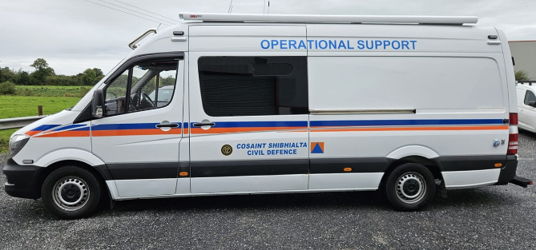
In 2025 Kilkenny Civil Defence secured funding from the Department of Defence to source an operational support vehicle, to supply a command post and welfare facilities for volunteers and staff while out on prolonged operations.
The vehicle purchased was a 2018 Mercedes Sprinter with a diesel engine which required no conversions to move to HVO (Hydro treated vegetable oil) as an alternative fuel source and therefore reduce emissions by 90%.
The vehicle is self-sufficient as it has been fitted with three large capacity Victron lithium batteries providing 8 hours of power. This allows the vehicle run all electronics, including kettles, television, hot water for hand washing and charging equipment.
When outdoors in daylight, the 2, 100w roof mounted solar panels facilitate battery charging.

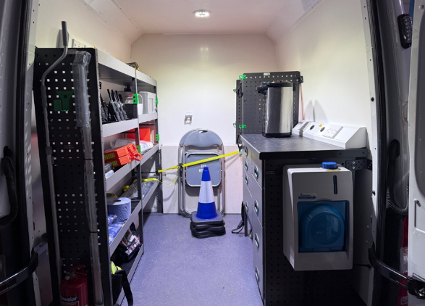
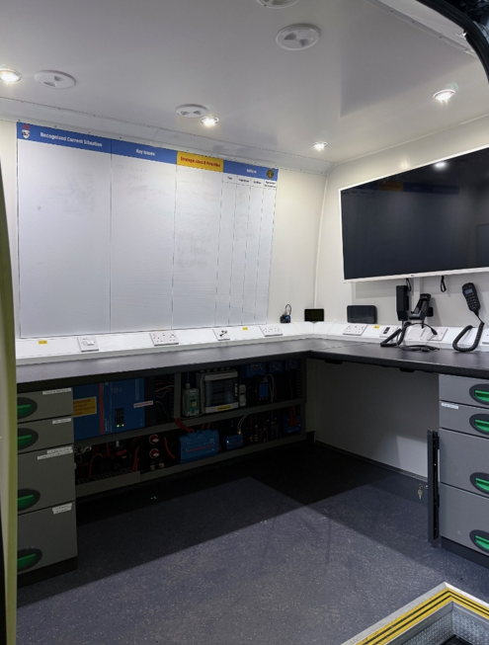

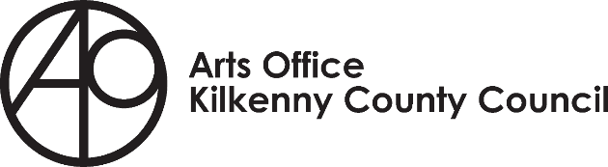

The Arts Office is very committed to climate action programmes as they understand, backed by science, that one of the most critical elements which will positively impact the climate crisis is behavioural change. Individually and collectively humans tend to only change behaviours long term if that behaviour aligns with our personal values.
Therefore, all the programmes work with personal values – through the process of making - they create spaces where people’s values come alive and thoughts and ideas become tangible experiences, fostering connectivity and change through dialogue, learning and creating together.

Waste Not Want Not – is a community arts programme that consisted of four distinct elements in 2025.
- Embroidery Workshops
- InFlow
- Repair to Care Day
- Community Embroidery Sampler

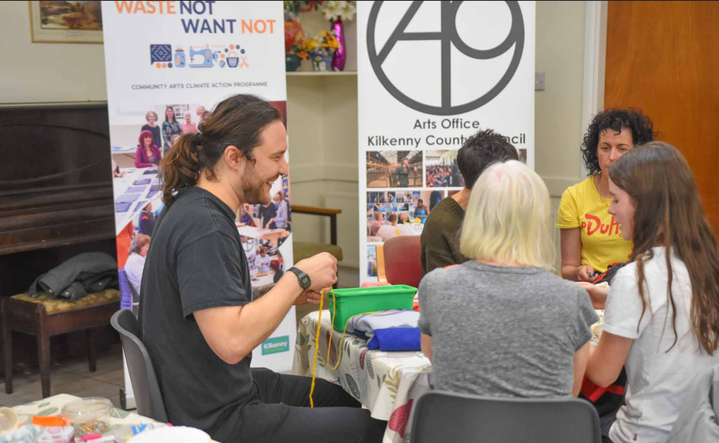
Each element of Waste Not Want Not included a series of textile-based projects and workshops based on repurposing and reimagining fabric waste streams. The programme supported individuals and local communities to understand and appreciate the personal power they have to undertake actions that will help to alleviate, support the Climate crisis and deliver on Sustainable Development Goals.

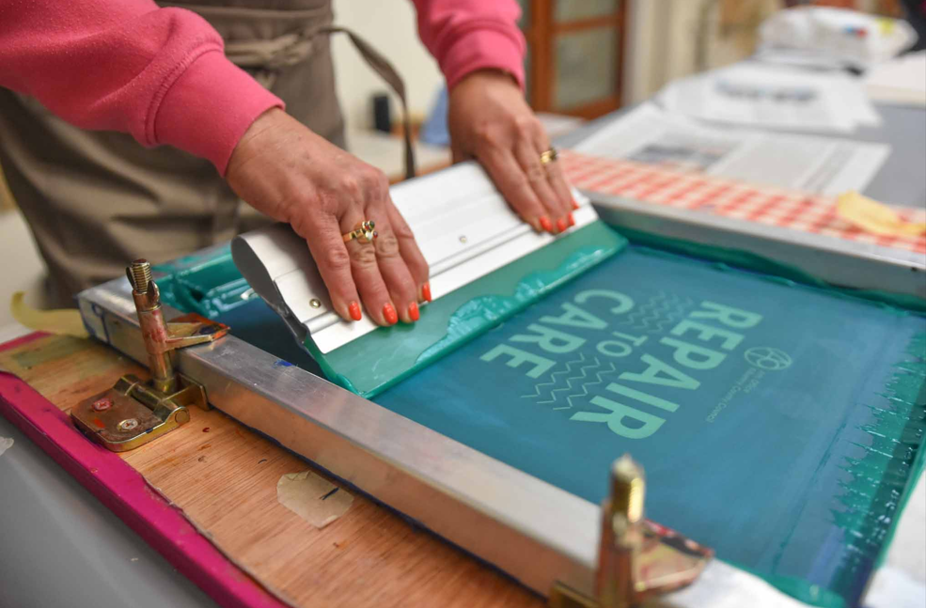
Repair to Care Day: was held to celebrate International Repair Day, promoting sustainability and creativity through textile and clothing repair. Participants in this free event were invited to bring clothing and textiles so they could learn hands-on mending techniques such as embroidery, crochet-hacking, sashiko – to mend denim, general textile upcycling, confetti fabric creation, screen printing on old clothing and tote bags and basic alterations. The event fostered a sense of community while encouraging people to reduce waste, cherish what they own,and take climate-conscious actions one stitch at a time.

Link to Inflow video: https://www.youtube.com/watch?v=xkNqHq6Uoqs&t=4s

Community Engagement and Activation
Kilkenny County Council has a key role to play in supporting communities to take climate action, and also in supporting climate resilience in these sectors. The Council will achieve this through delivery of its services, demonstrating leadership, collaboration and advocacy.
A significant number of the actions in the Plan address community engagement and activation. In particular, actions under Strategic Goal 4 (Communities: Resilience and Transition) and Objectives 4.1 refer:
Objective 4.1: Support and empower communities to adapt to the impacts of climate change and facilitate local climate action through education and awareness initiatives, well-being, cultural and creative programmes, and grants.

The Community Climate Action Programme
In 2025 Kilkenny County Council continued to work with community groups who were successful in receiving funding under Phase 1 of the Community Climate Action Programme a new Programme launched in 2024 by the Department of Climate, Energy and the Environment (DCEE) to encourage and support community groups to take climate action at a local level.
Kilkenny County Council had an allocation of €511,000 under this Programme to allocate to successful community groups and 22 Kilkenny communities received funding to deliver on a wide range of climate action projects which included; energy efficient lighting and heating, window replacement, insulation, PV panels, rainwater harvesting, shared bike schemes, bike parking and repair stations, community allotments, planting and nature enhancement measures.
The Programme was very well received by Kilkenny groups and applications submitted were almost 4 times the value of funding available which showed the huge appetite to take climate action at a local level.
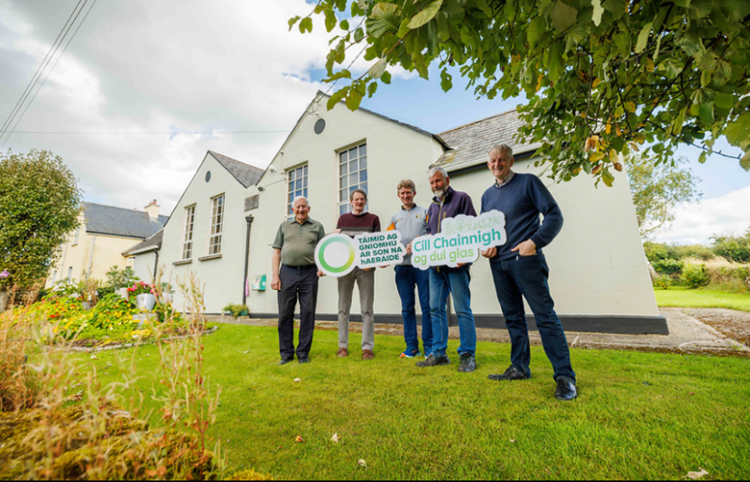

Tullahought Development Association received funding for roof insulation and upgrading single pane glass windows in their Community Hall. They also carried out planting and installed a composter in their community with funds provided under the Community Climate Action Programme.

Overview of Phase 1: Community Climate Action Programme allocations
Total grant funding requested from applicants | €1.8M | Total grant funding received from DCEE | €511,000
No. of grant applications received | 50 | No. of grants awarded funding | 22

A Community Climate Action Storymap which maps and showcases the communities and their projects was created as well as case-study videos to highlight the great work being undertaken, the positive impact this Programme is having in communities and to encourage other groups to do similar.

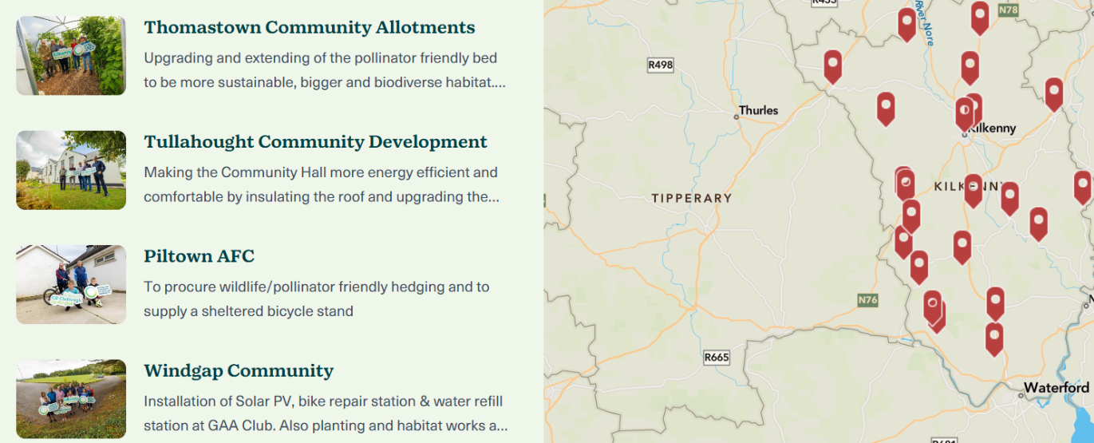
Kilkenny Community Climate Action Programme Phase 1 Storymap

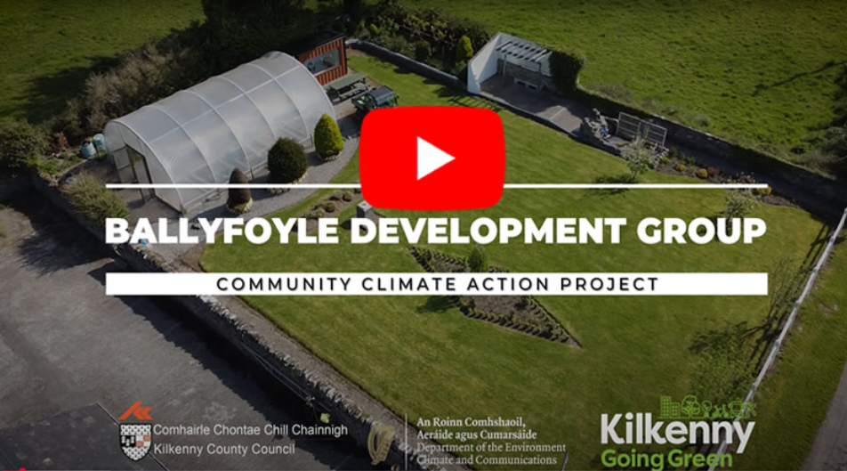
Ballyfoyle Goes Green

Details of the communities participating in Phase 1 of the Community Climate Action Programme:

Community Climate Programme Projects allocated funding in 2024
Group |  | Project
Paulstown Development Association (Hall) |  | Project completed October 2024 - Lighting upgrade
Inistioge Tidy Towns |  | Project completed October 2024 - Water refill station
Graiguenamanagh (Abbey Hall) |  | Project completed October 2024 - Solar PV and EV charger
Threefold Community Assset Westcourt |  | Project completed January 2025 - Installation of Polytunnel
Thomastown Allotments |  | Project completed January 2025 - Allotment works
Hugginstown & District Community Centre |  | Project completed January 2025 - Lighting upgrade
 | Coolagh Pattern Committee (Hall) | Project completed April 2025 - Community Garden
 | Castlecomer Enterprise | Project completed April 2025 - Heating & lighting upgrade, insulation
 | Callan Community Energy | Mobile solar powered trailer
 | Piltown AFC | Project completed July 2025 - Hedging & Bike Stand
 | Happe House & Millenium Court | Garden & Biodiversity planting
 | Kilkenny Walking & Cycling Group | Bikes and Helmets
 | Stoneyford Development (Community Hall) | Project completed October 2025 - Heating & lighting upgrade, insulation, bike stand & repair kit, balance bikes, pollinator planting
 | Lisdowney Community Centre & GAA Club | Windows, doors, bike stand, water refill station  planting
 | Tullaroan Development Association (Sports Facility) | Project completed October 2025 - Solar PV, flood lighting Upgrade to LED  Pollinator planting, Water Butts
 | Windgap GAA | Bike repair station, water refill station, solar PV
 | Iverk Agricultural Show | Project completed April 2025 - Heating & lighting upgrade, Rainwater harvesting tank
 | Tullahought Community Development (Community Hall) | Project completed July 2025 - Windows, Ceiling Insulation Works, composter, Pollinator planting
 | Kilmacow Community Centre | Project completed July 2025 - Solar PV, heating upgrade
 | Ballyfoyle Development Group (Community Hall) | Insulation, Lighting & heating upgrade, Bike Stands & repair Station, Wayfinder Map, Allotment Works, Tool Shed, biodiversity planting
 | Mullinavat Community Group (Community Centre & GAA) | Solar PV, EV Charging points, Lighting Upgrade, Water refill station, bike rack, pollinator planting
 | Urlingford Town Team (Hub & GAA Club) | Solar PV, water refill station and bike rack

In 2025, it was announced Kilkenny County Council would receive another allocation of €511,000 through the Department of Climate, Energy and the Environment (DCEE) for a Phase 2 of the Community Climate Action Programme. This opened for applications from 22nd October 2025 – 17th December 2025 with successful groups to be notified in April 2026. Once again, the Programme was oversubscribed.

Overview of Phase 2: Community Climate Action Programme allocations
Total grant funding requested from applicants | €1M | Total grant funding received from DCEE | €511,000
No. of grant applications received | 35 | No. of grants proposed for funding | 18*
*This figure is dependent on DCEE sign off and approval (estimate April 2026)

Over 55's Climate Course
The Kilkenny Age Friendly Programme’s six-week Climate Action Course commenced on Wednesday, 17 September 2025, at St Patrick’s Parish Centre, Loughboy, Kilkenny. Facilitated by Jacinta Barrins, the course aimed to raise awareness of climate change while empowering participants to take practical, individual actions to reduce their environmental impact.
Throughout the programme, participants were supported to identify and implement personal climate actions, with a follow-up session to reflect on the outcomes and impact of these initiatives.
The course also benefited from contributions by guest speakers from Kilkenny County Council and the South East Energy Agency (SEEA), who provided valuable information on available grants and home improvement measures designed to improve energy efficiency.
This initiative supports the objectives of the Age Friendly Strategy by promoting lifelong learning, environmental awareness and active participation within the community.
Appendix 1 Actions Delivering on Sustainable Development Goals
The tables below illustrate the actions delivered in 2025 and the SDG that they support.
Actions in Strategic Goal 1: Governance and Leadership which support delivery of SDGs
(Recurring and/or completed in 2024-2025)
SDG No. | SDG Theme |  | Actions/Our Performance Towards the SDG’s
  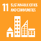  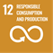         | Good health & well-being  Sustainable Cities and Communities  Responsible consumption and production  Climate Action  Life on Land  Peace, Justice and Strong Institutions  Partnerships for the Goals |  | - Ensure strong corporate governance by resourcing a Climate Action Steering Committee and Climate Action Office  - Provide climate action training, capacity building and knowledge sharing to Council Staff and Elected Representatives  - Develop and implement a Kilkenny County Council Green Public Procurement Strategy  - Internal audit monitoring of the management, reporting and delivery of statutory targets related to climate action within all relevant Service Areas in the Council  - Monitor, Report and Communicate on delivery of Kilkenny County Council climate actions and targets  - Climate proof Kilkenny County Council internal Financial Systems  - Collaborate with national, regional, and local stakeholders and partners on climate action delivery  - Deliver Flood Relief Schemes under the Catchment and Flood Risk Assessment Management (CFRAM) Programme, and Minor Flood Mitigation Works, incorporating nature-based solutions, where possible, whilst having appropriate regard to environmental protection requirements associated with flood resilience development.  - Annual review of Kilkenny County Council's Emergency Response Protocol for severe weather events, and Kilkenny County Councils Risk Register  - Review and update flood baseline data to inform Flood Relief Project Design  - Review the Council’s Health & Safety Policies and Procedures to take account of the impact of climate change on the welfare of staff  - Incorporate climate and sustainability best practice in Kilkenny County Council Developments  - Develop and promote a Kilkenny Civil Defence Climate and Sustainability Policy  - Implement and promote a Kilkenny Fire and Rescue Service Climate and Sustainability Programme
Actions in Strategic Goal 2: Built Environment and Transport which support delivery of SDGs
(Recurring and/or completed in 2024-2025)
SDG No. |  | SDG Theme |  | Actions/Our Performance Towards the SDG’s
  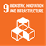    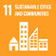    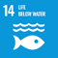     |  | Affordable and Clean Energy  Industry, Innovation and Infrastructure  Reduced Inequalities  Sustainable Cities and Communities  Climate Action  Life below Water  Life on Land  Peace, Justice and Strong Institutions |  | - Participate in the national Smarter Travel Mark Programme and Smarter Travel Mark in Kilkenny County Council  - Review Local Authority business travel model and working arrangements to move towards the Avoid-Shift-Improve model, reduce emissions, energy use and reduce office space  - Develop and implement a Regional EV Infrastructure Strategy in collaboration with neighbouring local authorities.  - Develop a Fleet Decarbonisation Strategy for Kilkenny County Council Fleet. Ensure the strategy aligns with sustainability principles.  - Adopt and implement the Kilkenny City Sustainable Urban Mobility Plan and Mobility Management Plans for other towns in the county  - Integrate transport and land-use planning to facilitate a reduction in transport demand  - Reallocate urban space towards the sustainable movement of people, and placemaking  - Encourage independent journeys for all  - Enhance permeability to support active travel  - Work with the NTA to enhance public transport options and connectivity to the surrounding area and regions  - Integrate transport modes and enable a shift to sustainable modes through the effective management of parking demand and development of park and ride/stride and multi-modal hubs  - Develop a cycle network for Kilkenny City and larger urban areas.  - Implement the "Safe Routes to School Programme”  - Communicate, raise awareness and encourage participation in sustainable and active travel  - Explore feasibility of new Park and Ride locations on Regional and National Roads linked to Motorways & public transport  - Explore the feasibility of using new low carbon technologies for road reconstruction on regional roads; and for reducing waste through re-use of materials  - Identify and implement actions to improve drainage on the Regional and local road network, and identify infrastructure at risk from climate events.  - Develop a policy to reduce energy use in public lighting at pedestrian crossings  - Manage and maintain Kilkenny County Council's ISO50001 energy management system certification  Develop a Facility Management Strategy for  Kilkenny County Council buildings & facilities  - Implement an all-of-Council monitoring programme to track and report on energy use and emissions in all Kilkenny County Council assets  - Continue to deliver the Public Lighting Energy Efficiency Project (PLEEP)  - Participate in the establishment and support of local authority Regional South East Energy Unit  - Identify and implement a pipeline of projects for local authority assets to assist in achieving emissions and energy reduction targets  - Undertake a programme of energy reduction, retrofitting, and onsite renewable measures on Local Authority buildings, facilities and social housing.  - Investigate the feasibility of local authority led/supported alternative heating systems and fuels including District Heating, Geothermal and Bioenergy.  - Ensure best practise in energy efficiency retrofitting of traditional/heritage buildings  - Deliver sustainable and compact development  - Develop a planning policy which supports the re-use of existing buildings  - Continue to add to the Vacant Sites Register and Derelict Sites Register  - Achieve Home Performance Index (HPI) Gold Standard on all new Kilkenny County Council social housing  - Deliver a retrofit programme for Kilkenny County Council Social Housing  - Undertake a programme of energy reduction, retrofitting and onsite renewable measures on Local Authority buildings and facilities

Actions in Strategic Goal 3: Natural Environment and Green Infrastructure which support delivery of SDGs
(Recurring and/or completed in 2024-2025)
SDG No. | SDG Theme | Actions/ Our Performance Towards the SDG’s
  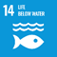   | Climate Action  Life below Water  Life on Land | - Promote and facilitate tree, woodland and hedgerow protection, planting and management on public and private land  - Develop an Invasive Species Register and Treatment Strategy for Council land.  - Deliver a Pollinator Programme to protect and enhance pollinator habitats on Council owned land and in the wider  - Identify and utilise environmentally friendly alternatives to herbicide use on Council land.  - Identify, map and utilise local authority owned land for habitat enhancement/restoration and nature-based solutions  - Implement Nature-based Solutions and biodiversity enhancement in new Kilkenny County Council developments  - Implement Nature-based Solutions and biodiversity enhancement through the planning process  - Provide biodiversity information and awareness on Council land, including at Dunmore Countryside Park  - Assess feasibility of identifying waterbodies that are both particularly vulnerable to extreme climate events, and at risk of not meeting the requirements of the EU Water Framework Directive.

Actions in Strategic Goal 4: Communities: Resilience and Transition which support delivery of SDGs
(Recurring and/or completed in 2024-2025)
SDG No. | SDG Theme | Our Performance Towards the SDG’s
      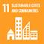  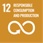  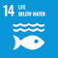       | Good health & well-being  Quality Education  Reduced Inequalities  Sustainable Cities and Communities  Responsible consumption and production  Climate Action  Life below Water  Life on Land  Peace, Justice and Strong Institutions  Partnerships for the Goals | - Deliver the Community Climate Action Programme  - Support communities to deliver local climate and sustainability actions, through grant schemes and programmes  - Support climate awareness and resilience through the Healthy Ireland Programme and other relevant health programmes.  - Design and deliver an arts programmes which supports young people, communities and artists to creatively and positively respond to climate change  - Deliver an educational and awareness programme, through the Library Service, on climate action, sustainability, biodiversity and the circular economy  - Empower communities, through the Library Service, to reduce consumption and waste  - Continue to collaborate with the South East Energy Agency to provide an online home energy information programme  - Support and collaborate with the education sector to provide information, training and educational programmes on local climate action, and to undertake research  - Support climate action on farms through local authority policy and programmes  - Provide information and advice to communities, businesses and other stakeholders to support local climate action, via Council networks

Actions in Strategic Goal 5: Sustainability & Resource Management which support delivery of SDGs
(Recurring and/or completed in 2024-2025)
SDG No. | SDG Theme | Our Performance Towards the SDG’s
  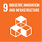  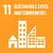     | Clean Water and Sanitation  Industry, Innovation and Infrastructure  Sustainable Cities and Communities  Responsible consumption and production  Climate Action  Peace, Justice and Strong Institutions | - Develop and coordinate a new Sustainable Start-Up Business Module to the LEO Flagship 'Start Your Own Business' programme  - Develop and deliver a series of Business Showcase/Conference events, and positive Case Studies regarding decarbonisation/climate initiatives.  - Provide climate and energy efficiency advice, training/mentoring and grants to the business sector  - Support local businesses and social enterprises to optimise opportunities in the green tech and circular/green economy  - Kilkenny Tourism CLG 'Green team' will develop sustainability awareness and training initiatives in collaboration with Failte Ireland, and green procurement criteria  - Develop a Digital Strategy for County Kilkenny which optimises and promotes digital solutions  - Continue to transfer public services to online systems  - Undertake a programme of transferring relevant internal operations to online systems whilst driving down capacity requirements for data storage  - Monitor and report on air quality  - Adopt the Green Teams National Programme within Kilkenny County Council  - Provide, facilitate and promote public drinking water fountains in public spaces

Actions in DZ Plan which support delivery of SDGs
(Recurring and/or completed in 2024-2025)
SDG No. | SDG Theme | Our Performance Towards the SDG’s
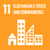       | Sustainable Cities and Communities  Climate Action  Peace, Justice and Strong Institutions  Partnerships for the Goals | - Support Kilkenny City Sustainable Energy Communities (SEC's) in the DZ  - Implement relevant Local Authority Climate Action Plan actions in the DZ

Including Environmental Social Governance (ESG) Frameworks and Corporate Sustainability Reporting Directive (CSRD) standards.

