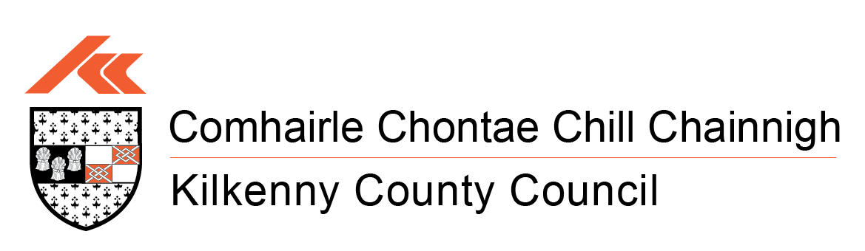
HOUSING DEPARTMENT
SELF HELP SCHEME – 2026
The objective of this scheme is to assist Local Authority tenants to carry out improvement works to their home which are deemed to be tenant responsibility.

Who Qualifies for the Scheme?
- Kilkenny County Council tenants who have their rent paid up to date and where the proposed works are considered desirable by the Council’s Engineer.
- Kilkenny County Council tenants who live in a house constructed before December 2018.
- New houses constructed between 2020 and 2026 will not be considered.

Works Covered under the Scheme?
External works
- Repairs/Replacement of Windows/Doors
- Repairs/Replacement and cleaning of Gutters/Downpipes
- External painting of house
- Repairs/Replacement of front and back Gates
- Provision of a shed
- Skip Hire
- Garden Maintenance, patio slabs, additional drainage

Internal
- Repairs/Replacement Doors/Presses
- Repairs/Replacement sink/Kitchen Presses
- Provision of Insulation to Attic Tanks, Pipe lagging and Cylinder Jacket
- Provision of tiling to bath and shower areas
- Provision new floor coverings
- Installation of new taps and shower heads
- Internal painting of house
- Replacement of internal doors

General Conditions of the Scheme
- Applicants must have an up to date rent account.
- Only works carried out after the grant is offered will be eligible for payment.
- Tenants are limited to one grant per year.
- A maximum of € 3,000 can be claimed per property every two years.
- Funding for this grant scheme is limited so it may not be possible to offer grants to all applicants.
- Applications must be received on the official application form within the defined deadline.

Who organises the Works to be done?
- Tenants are responsible for the appointments of contractors and must ensure all appropriate documentation are in order.
- Two quotations must be included with your application from two VAT registered contractors.
- Invoices presented must be for the total works and must be VAT inclusive.
- When the grant is awarded, only then should you arrange to have the works done.
- Invoices are sent to Kilkenny County Council. An inspection will take place by a member of Housing Technical Staff. Then payment will be made to you for 75% of the works to a max of €3,000.
- It is the responsibility of the tenant to arrange payment to the contractor.

Amount of Grant payable
- Kilkenny County Council will pay 75% of the cost of the works up to a maximum contribution of €3000.
- The minimum estimated cost of the proposed works must be not less than €250.


CC BY-SA

